Dean of Students’ Business Office (DOSBO) Purchase Requests

8.24.26– Last Updated

Background

Purchase Requests (PR) are accessible from the PR/Reimbursement form found in CampusGroups Terrier Central. Groups may submit a PR when they need to pay vendors or procure goods. This includes supplies, service subscriptions, and membership dues. Prior to submitting a PR, students are required to have a completed and approved Event Request from SLIC if the expense is in regard to an event. General business does not need an event request, although please make sure that your general business expense follows our guidelines.

While it is preferred for students ship to their own addresses, the SLIC office is an option. Please be sure to address to 775 Commonwealth Avenue B02, 02215 (SLIC, not Allocations Board).

How to Submit a Purchase Request (PR)
      - Only club officers registered in CampusGroups may submit a PR. These position holders will:
- Login to Terrier Central and go to the group’s dashboard. From there, access the Accounting Book or Budget Page.
- Click “Create Payment/Budget Request” in the Accounting Book OR “Request Payment” under the desired priority event on the Budget Page.
- Select “Purchasing/Spending” from the “Transaction Type” dropdown menu:

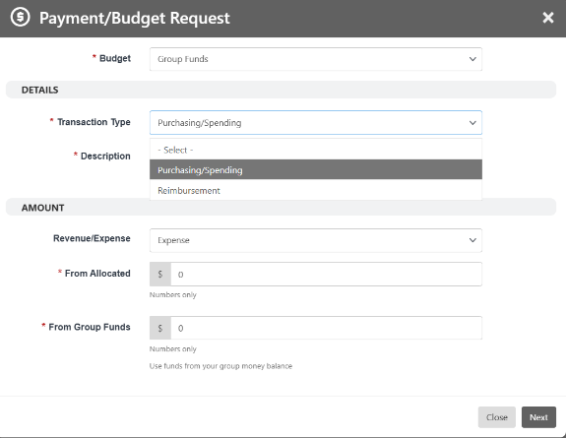

Completing the Form – Important Tips
      - The process of paying a vendor/supplier differs depending on their status and will need speciﬁc documentation and information. To assist with this, please see our chart with tailored directions for each type of purchase.

      - Timeline – Please allow for 14 business days to be approved.

Quick Guide
Category | Quick Reference
Purchase Requests | Submit PRs in Terrier Central. One vendor per request. Exclude tax (if they are MA based). Use the correct subject line format.
Filling Out the Form | Full amount only. Titles must be formatted correctly (Event or General Business). Missing details = denial.
Documentation | Always add context in the description. Attach event approval, and all necessary documents (W-9/invoices/etc.), and payee info
Timeline | Once an event is approved, please allow at least 2 weeks for processing
Vendors | Approved vendors get paid through BU's system (Ariba/Guided Buying). For Amazon, submit a wish list link (make sure it's public).
Gift Cards | Gift cards can only be purchased through Black Hawk Market (virtual only). Must include each recipient info and W-9.
Food & Catering | Use BU's tax-exempt ID. EzCater preferred. Outside restaurants need exceptions unless it's Otto or T. Anthony's.
General Reminders | Submit PRs as soon as your event is approved. Missing info = denial. Reimbursements are the last resort. Processed first-come, first-serve.

PR – Category Speciﬁc

Type of Requests | What You Need | Key Reminders
Approved Vendors | Event approval (unless a general business expense), itemized invoice/quote, payee contact info | One vendor per PR; exclude tax; subject line format required
Charity Donation | Must be a 501(c)(3) organization, needs a W-9 and donation form | Donations must come from group funds only; AB (event-based) funds cannot be donated
Conference Fees | Invoice, event approval, payment link/W-9 (if required) | PRs only for BU-approved conferences/events. If they request a check, then we will need their W9.
Honoraria | Event information, payee’s name and email, a brochure/flyer or invitation related to the honorarium. | One PR per recipient; note that honoraria are a thank-you gift, not salary
Membership Dues/Fees | List of members, invoice, payment link/W-9 (if a one-time check is requested), event approval | Schedule an appointment with an accountant if login is required and or each member’s information has to be entered manually.
External servicers/entertainers on campus | Event approval, servicer’s name, and email. | This includes DJ’s, photographers, videographers etc.
Venues/Off Campus Activities | Event approval, contract signed by BU, invoice (if the contract does not provide the cost breakdown), payment link and contact information. | If they want to be paid via a one-time check, they must provide a W9 (domestic parties) or a W8-BEN (international parties) also.
Gift Cards | Must include each recipient’s info and W-9, as well as event info. | Gift cards can only be bought through Black Hawk Market. It’s only for student winners from a raffle, trivia, etc. Please note these are only virtual cards, not plastic cards. AB does not cover gift cards.

Other key reminders: No alcohol and no personal purchases. For more in-depth breakdown of each PR type please reference the “Payment Procedures” page under Helpful Guides & Documents.

