Important Guidelines for Your Purchase Requests with Outside Vendors/Suppliers
7.28.26 Last Updated
--
Hi Student Leaders,
We hope your summer is going well so far!
As we are approaching the beginning of this semester, please read this email carefully as it contains important information about our purchase request policies specifically regarding outside vendors.
What to know before choosing your vendor:
• The SABO Office currently has a list of approved vendors for purchase requests. Please note that it is our preference and we highly encourage you to work with vendors in this list, as it will result in quicker processing and payment times.
• For non-registered suppliers, payment is typically issued within 7–10 business days after our office approves your student group’s purchase request. Once issued, checks may take an additional 5–10 days to arrive by mail. If you wish to work with a non-registered supplier, please inform them of these timeline details before anything is agreed upon.
What your purchase request must contain:
1. W-9 form: This form must be filled out if you are working with contract servicers or outside vendors who wants to be paid via a one-time check and is located within the United States.
a. All W9’s need be signed AND dated, and all required fields must be completed.
b. Please see the "W9- helpful tips" page for more details about the form.
OR
A W-8 BEN form: This form must be filled out if you are working with vendors/individuals located outside the United States. International servicers will be paid through a wire transfer*.
a. For vendors/individuals located outside the United States, we will also need a bank letter on bank letterhead or voided check, to validate their account.
2. Signed contract/ESP form AND/OR invoice/payment link:
a. If your PR is for a service, the form that must be included is a signed contract or ESP form if it's a payment for photographer completed through a SLIC event request.
b. If your PR is for a payment of goods, the form that must be included is an invoice and or a payment link.
Important guidelines about the invoice:
The most important thing to note is that the invoice must meet the requirements shown in the picture below. Otherwise, the purchase request cannot be processed.
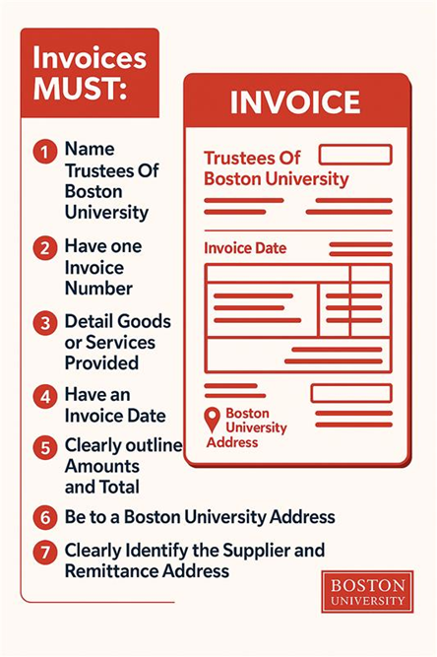
• The invoice must also be generated and sent by the vendor/individual you are working with.
• The address on the invoice must match the address provided on the W-9/W-8 BEN. If the vendor wants a check to be sent to a different address than the W-9, they should also have the “Remit to” address clearly stated on the invoice.
We understand that these procedures are very detailed and tricky, so we highly encourage you to reach out ahead of time if you have any questions. We are happy to speak about your specific student group’s purchase request to ensure you have all materials needed!
Additionally, if a vendor/individual would rather send any of these required documents to our office directly, you can note this in the purchase request or email us at sabo@bu.edu so we can assist in that process.
For a full list of all of our policies, please refer to our website.
If you have any questions, feel free to reach out to us at sabo@bu.edu.
All the best,
Dean of Students Business Office (DOSBO).

