
Caitlin Hamilton Marketing & Publicity, LLC
826 View Harbour Road
Knoxville, TN 37934
Phone/Fax: 865-675-3776
www.caitlinhamiltonmarketing.com

Caitlin Hamilton Summie, caitlin@caitlinhamiltonmarketing.com
Rick Summie, rick@caitlinhamiltonmarketing.com

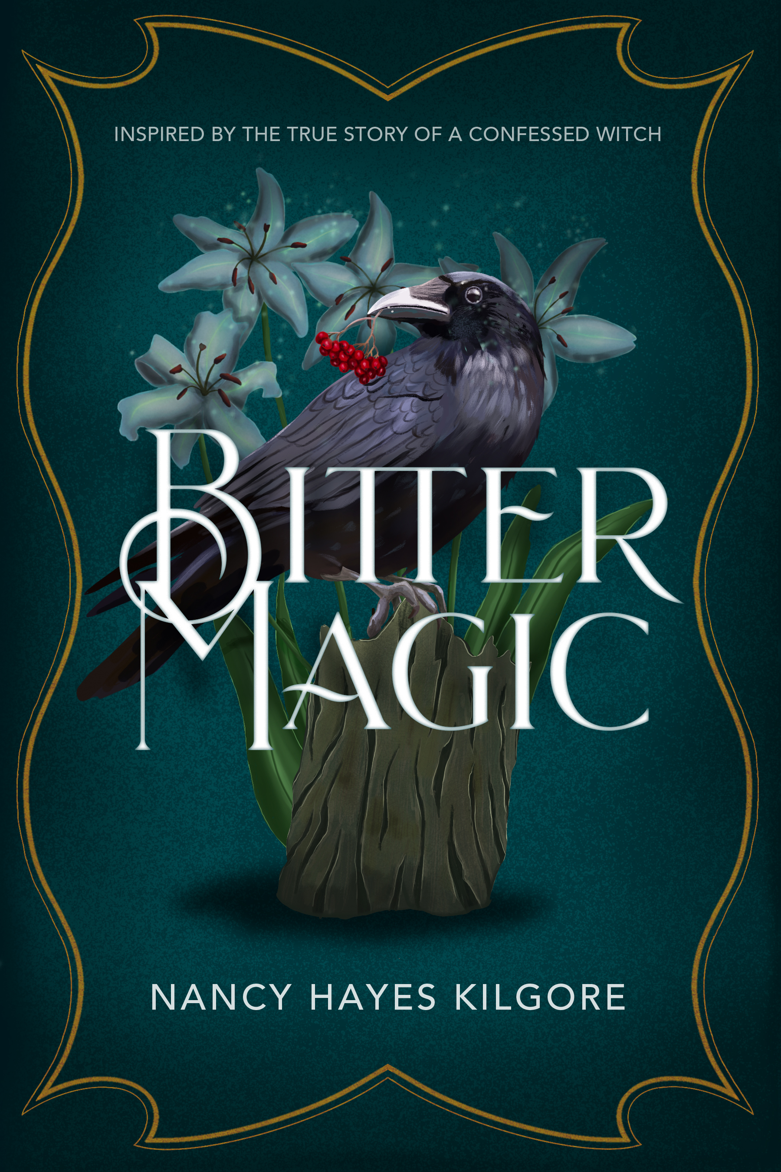
“This page-turning story will keep you up at night, wondering what's going to happen in a much more complex story than we usually hear about "the burning times." The heroine is a curious, likeable young woman, the "witch" an expert naturalist and healer who goes astray, and you'll never see a more thrilling version of the devil.”- Mary Dingee Fillmore, bestselling author of An Address in Amsterdam

“Compelling . . . A fascinating story made more so by the tie to the historical record and actual documents . . . a more complete, holistic portrait of a strange aspect of human history than other witch narratives.”- Ruth Linnaea Whitney, author of SLIM, a novel of Africa

“Kilgore‘s lyrical prose and talent for world building create a wondrous landscape in which the many-layered story unfolds.”
- Tracey Enerson Wood, bestselling author of The Engineer‘s Wife

BITTER MAGIC

a novel
by Nancy Hayes Kilgore

Nancy Hayes Kilgore’s powerful new novel, BITTER MAGIC (Milford House, an imprint of Sunbury Press, pub. date August 10th), is based on the life of Isobel Gowdie, who confessed to witchcraft in Scotland in 1662. During this time, witches were burned at the stake, but the historical record is inconclusive about what actually happened to Gowdie. Kilgore’s story springs from that silence to imagine what Gowdie’s fate might have been.

BITTER MAGIC is told by Isobel herself and also by Margaret Hay, a fictionalized seventeen-year-old noble woman. When Margaret stumbles across Isobel one day, it seems as though Isobel is commanding the dolphins in the ocean to jump. Margaret is enchanted. She becomes interested in Isobel’s magic, in fairies, and in herbal remedies; Isobel freely shares her knowledge. While Margaret worries that being around Isobel could be dangerous, she also respects Isobel’s medical
successes and comes to believe that acknowledging the efficacy of herbal remedies or believing in fairies does not challenge her Christianity.

Bitter Magic, page 2 of 2

But Isobel believes in more than cheery fairies and herbal medicine. She has dark wishes as well, unknown to most people. Isobel seeks vengeance against the local lord who executed her mother for witchcraft. More important, Isobel’s trance experiences (or are they dreams?) lead her to confess to a wide range of sins, including consorting with the devil. Then, during her trial, Isobel names thirteen others, calling them all witches. To her great shock, Margaret hears her own name. Can her tutor, a Christian mystic named Katharine, save them?

In this gripping and beautifully written tale, Kilgore’s characters debate whether Gowdie is fantasizing or a real witch, and whether young Margaret and the others are complicit. But their debate soon expands to consider the effects of Isobel’s poverty, being powerless, and ultimately the very nature of faith and forgiveness.

Nancy Hayes Kilgore, winner of the Vermont Writers Prize, is the author of two other novels, Wild Mountain (Green Writers Press, 2017,) and Sea Level (RCWMS, 2011,) a ForeWord Reviews Book of the Year. She has published in a She Writes Press anthology, in Bloodroot Literary Magazine, Vermont Magazine, The Bottle Imp, and on Vermont Public Radio. Nancy is a graduate of the Radcliffe Writing Seminars and holds a Master of Divinity degree and a Doctorate in Pastoral Counseling. She is a former parish pastor, a psychotherapist, a writing coach, and leads workshops on creative writing and spirituality. Find her online at nancykilgore.com.
Sunbury Press, Inc., headquartered in Mechanicsburg, Pennsylvania, is a publisher of hardcover, trade paperback, and digital books featuring established and emerging authors in many fiction and nonfiction categories. Our mission is to "Continue the Enlightenment." During the 18th century, a societal shift occurred based on the core values of a strong belief in rationality and science and the critical questioning of traditional institutions, customs, and morals. At Sunbury Press, we champion these core values, and support authors who challenge “the establishment,” regardless of their political or religious affiliation, socioeconomic status, or nationality.

###

RE: BITTER MAGIC
A Novel
By Nancy Hayes Kilgore
Milford House, an imprint of Sunbury Press
PUB. DATE: August 10, 2021
ISBN 978-1-620068-42-7, Fiction, Trade paperback, 227 pages, 6 x 9, $19.95


For more information, please contact:
Caitlin Hamilton Summie, President
Rick Summie
Caitlin Hamilton Marketing & Publicity, LLC
Phone/Fax: 865-675-3776
caitlin@caitlinhamiltonmarketing.com
rick@caitlinhamiltonmarketing.com

