# 

# 

# Online Program - REGISTRATION GUIDE

**Registration for Fall 2025 opens April 5, 2025 at 9AM EST**

Please register early as online courses fill up quickly. Please note online students have priority registration for online courses. All online students will be accommodated with a course that meets their program requirements. If you are on the waitlist it is not guaranteed that you will get a spot in your first choice request. All students will be offered an option that will allow them to progress in the program.

This following information will assist you in preparing for the next semester in the program.

**Before registering**:

* Resolve outstanding balances on your student account.
* Confirm your account is in compliance.

*Please note these outstanding matters can result in a hold on your account and may prevent you from registering.

**Which courses should I register for?**

All students follow a standard program plan to ensure completion of the requirements for the MSW degree. Program plans will vary depending on your major (Clinical or Macro), your track (HSE, TT, or AS) and your semester of entrance.

Standard program plans can be found [here.](http://www.bu.edu/ssw/students/current/olp/entering-cohort-program-plans/) Click [here](http://www.bu.edu/academics/ssw/courses) to access course descriptions. If you are following a revised program plan and need a copy, please contact [sswolp@bu.edu](mailto:sswolp@bu.edu).

**Any adjustments** **to your program plans** **must receive written pre-approval to ensure that you meet the requirements for graduation**. To request a revised program plan, please use the [Revised Program Plan Request Form](http://www.bu.edu/ssw/revised-program-plan-request/).

**How do I register?**

The [MyBUStudentPortal](https://www.bu.edu/mybu/?mc_cid=d7707631d8&mc_eid=fb90e9f5d0) is your portal to register for classes, review your transcript, update addresses, and pay tuition bills. It is advised to register for courses as early as possible to have the opportunity to enroll in your preferred live classroom section.

|  |
| --- |
| Log into the [**MyBU Student Portal**](https://www.us11.list-manage.com/track/click?u=b744a3332cb41d0e7ce5d3b0f&id=634d354381&e=fb90e9f5d0)   * Click on the Fall 2025 Registration Planning tile on the MyBU Student Portal Homepage. * Enrollment can then occur directly from classes added to the shopping cart via the planning process.  If classes have already been added to the Shopping Cart, they will also display on the Dashboard. * Click the three dots to access the Actions menu, then select Enroll or check one or multiple select box(es) and click the Enroll button in the top right corner of the page. This option allows registration for multiple classes at once. * If enrollment was a success, the class will be listed with a message indicating it has been Added to Your Schedule. |
| **PLEASE NOTE: Online course sections begin with O. When you register for an online course, you choose a specific section time for the Live Classroom session you want. In the example below, when you select CP756 O1 you will be enrolled in the CP756 course and the Live Classroom session time will be on Sunday 6:30-7:45 pm EST.**  Live Classroom  section time    **Learning Resources**  **Check Compliance** - [**Quick Card**](https://www.us11.list-manage.com/track/click?u=b744a3332cb41d0e7ce5d3b0f&id=e8d55d3403&e=fb90e9f5d0)  **Navigate to Registration** - [**Video**](https://www.us11.list-manage.com/track/click?u=b744a3332cb41d0e7ce5d3b0f&id=aeb4b7b7d8&e=fb90e9f5d0)  **Preparing for Registration** - [**Video**](https://www.us11.list-manage.com/track/click?u=b744a3332cb41d0e7ce5d3b0f&id=89f3606c05&e=fb90e9f5d0) and [**Guide**](https://www.us11.list-manage.com/track/click?u=b744a3332cb41d0e7ce5d3b0f&id=3d0f5eaa98&e=fb90e9f5d0)  **Methods of Registration** - [**Video**](https://www.us11.list-manage.com/track/click?u=b744a3332cb41d0e7ce5d3b0f&id=bad74ac951&e=fb90e9f5d0) and [**Guide**](https://www.us11.list-manage.com/track/click?u=b744a3332cb41d0e7ce5d3b0f&id=5cafc14221&e=fb90e9f5d0)  **Class Search -** [**Video**](https://www.us11.list-manage.com/track/click?u=b744a3332cb41d0e7ce5d3b0f&id=020cbf1f0d&e=fb90e9f5d0)and[**Guide**](https://www.us11.list-manage.com/track/click?u=b744a3332cb41d0e7ce5d3b0f&id=5d97292576&e=fb90e9f5d0)  **Schedule Builder -** [**Video**](https://www.us11.list-manage.com/track/click?u=b744a3332cb41d0e7ce5d3b0f&id=008fd5b4ad&e=fb90e9f5d0) and [**Guide**](https://www.us11.list-manage.com/track/click?u=b744a3332cb41d0e7ce5d3b0f&id=c14608a2ba&e=fb90e9f5d0) |

Online sections begin with O

For registration assistance please contact the **SSW Registrar** at[swreg@bu.edu](mailto:swreg@bu.edu).

**Waitlist**

If the course or section you want is full, you may choose to be on the waitlist. See the information below on how to join a waitlist. Please note adding yourself to the waitlist does not guarantee that you will be enrolled in that course or section. It is your responsibility to monitor your place on the waiting and reach out to your SSA to explore your options.

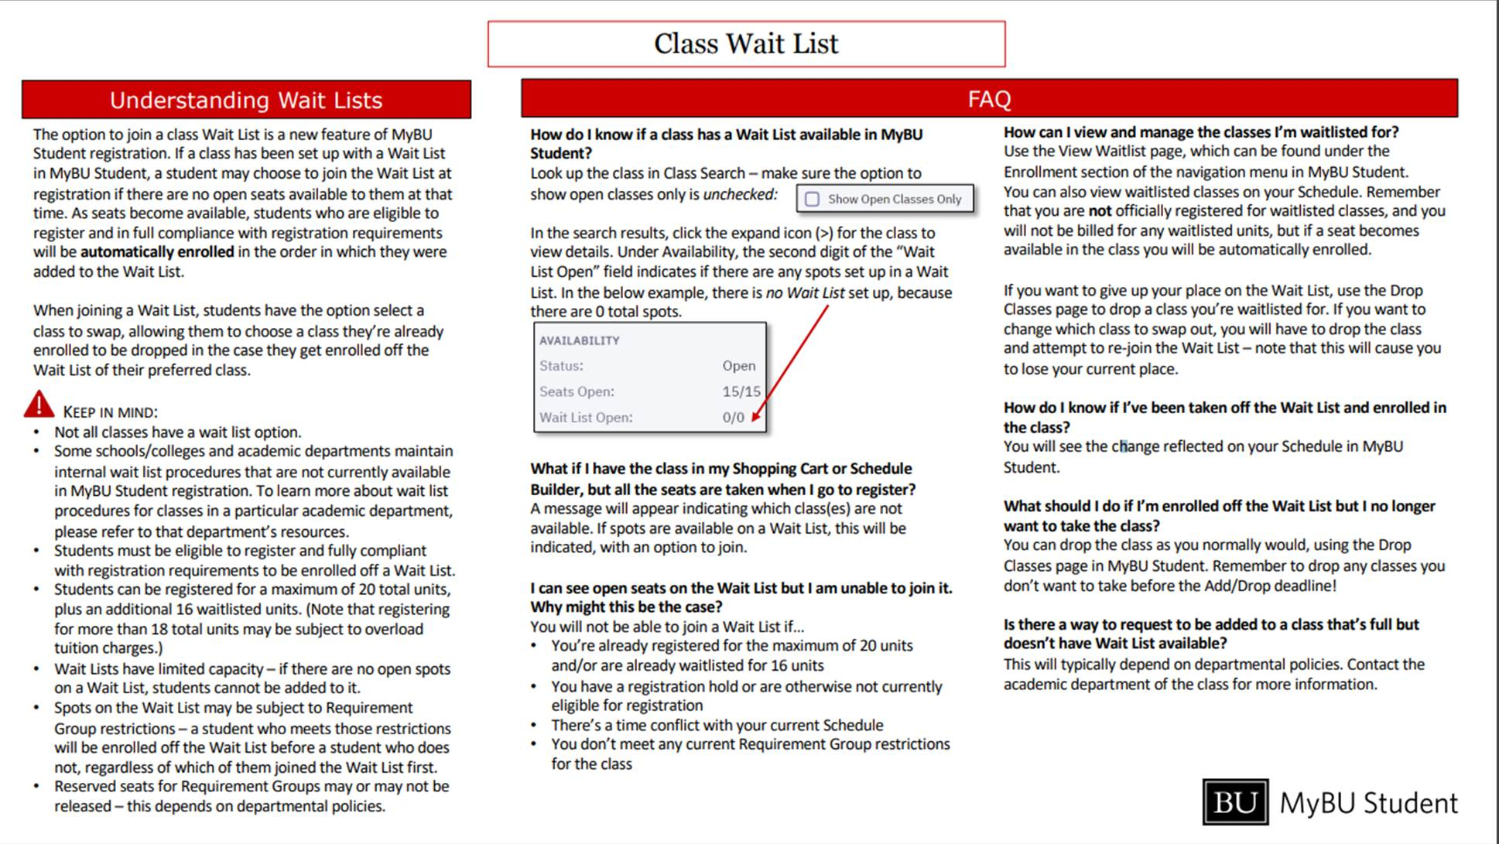

How do I pay for my courses?

After registering you will receive a tuition bill from [Student Accounts](http://www.bu.edu/studentaccountingservices/). Please contact the **Student Accounting Office** at

617-353-2264 if you have questions regarding your bill. You can check the status of your account and pay your bill via the BU [MyBUStudentPortal](https://www.bu.edu/mybu/?mc_cid=d7707631d8&mc_eid=fb90e9f5d0). You may also review your bill, learn about payment options, and monitor the payment deadlines and late fees on the [Student Accounts](http://www.bu.edu/studentaccountingservices/) webpage.

**Financial Aid** questions should be directed to [sswfa@bu.edu](mailto:sswfa@bu.edu). Please visit the [SSW Financial Aid page](http://www.bu.edu/ssw/students/current/financial-aid/) for information on the financial aid process, forms, and deadlines.

## Reminders

* **There is also a $60 part time graduate student service fee.**
* Please remember that in order to be eligible for financial aid students must be registered for at least six credits per semester.
* Federal loans will not be finalized until after you are registered for courses. You will receive more information about your financial aid status after you register.

**What do I do if I have to change my schedule?**

**Any adjustments** **to your program plans** **must receive written pre-approval to ensure that you meet the requirements for graduation**. To request a revised program plan, please use the [Revised Program Plan Request Form](http://www.bu.edu/ssw/revised-program-plan-request/).

**DROPPING or Withdrawing from COURSES**

Dropping or withdrawing may impact your status in the program and your eligibility for financial aid.

**Before dropping course(s)**

1. Pay close attention to the [Add/Drop deadlines](https://www.bu.edu/online/course-schedules/important-dates/) to avoid fees and tuition obligations.
2. Registration and other fees are non-refundable as of the first day of the semester.
3. Students can drop a course by the drop deadlines for possible reversal of charges.
4. After the drop course deadline, students can withdraw from a course. Withdrawing from a course means the course will remain on the student’s transcript as a “W”. Withdrawn students will not be eligible for a refund and will be required to pay for courses.
   1. Click [here](http://www.bu.edu/online/course-schedule/important-dates/index.html.) to view important deadlines including the **last day for 100% Tuition reimbursement** and **last day for withdrawing.**

**How to drop or withdraw from a course**

1. Prior to dropping a course, contact **our Financial Aid Office at** [**sswfa@bu.edu**](mailto:sswfa@bu.edu)to discuss Federal Stafford Loan obligations and any implications that may occur when dropping a course.
2. Notify the Online Program Team at [sswolp@bu.edu](mailto:sswolp@bu.edu)to discuss intentions in the Online MSW program and revising a program plan.
3. Inform the instructor, facilitator, and advisor about plans to drop the course.

**NOTE:** Students taking a leave of absence or withdrawing from the program must submit an official [Withdrawal/Leave of Absence Form.](https://www.bu.edu/ssw/files/2017/07/Writeable-LOA.pdf)  **Students who do not submit the appropriate paperwork by the withdraw deadline, will not be officially withdrawn and will be required to pay the course/semester’s tuition, and be graded in any active courses.**

***PLEASE NOTE:*** Click [here](http://www.bu.edu/online/course-schedule/important-dates/index.html.) to view important deadlines including the **last day for 100% Tuition reimbursement** and **last day for withdrawing.**

# ADDING COURSES TO YOUR SCHEDULE

If you need to add a course to your schedule due to a program plan adjustment or registration error you should follow the process outlined below. **Remember**, students may not add courses outside the prescripts of their program plans. Students interested in taking a course not listed on their program plan for the current semester must have written permission from **Online Program Team.**

## Before adding course(s)

1. Consult with our **Financial Aid Office**, [sswfa@bu.edu](mailto:sswfa@bu.edu) to discuss any financial implications that may occur when adding a course.
2. Add course by logging onto [MyBUStudentPortal](https://www.bu.edu/mybu/?mc_cid=d7707631d8&mc_eid=fb90e9f5d0). Follow the same steps outlined in the *How to Register* section.
3. If it is past the deadline to register via MyBUStudentPortal contactthe **SSW Registrar** at [swreg@bu.edu](mailto:swreg@bu.edu) and include the following information:
   1. Full Name
   2. BU ID
   3. Program: Online MSW
   4. Courses needed to add (i.e. HB720 OL)

Any requests to change sections once the course has started must be discussed with the Instructor of Record.

**When is the registration deadline?**

Fall 2025 courses begin on Tuesday, September 2nd. It is recommended that student register for classes before Day 1 of the Fall 1 term.

**Fall 2025 Calendar**

September 2 First day of Fall 1 classes

*October 13 Indigenous Peoples’ Day: classes follow course schedule

October 20 Last day of Fall 1 classes

October 28 First day of Fall 2 classes

*November 27 Thanksgiving: classes follow course schedule

December 15 Last day of Fall 2 classes

*\* Live classrooms sessions are held Sundays and Mondays from 6:00 – 10:00 PM EST. When there is a Monday holiday the live classroom sessions will be held on Tuesday.*

*The University, in scheduling classes on religious holidays and observances, intends that students observing those traditions be given ample opportunity to make up work. Faculty members who wish to observe religious holidays will arrange for another faculty member to meet their classes or reschedule canceled classes.*

# Important Contacts

## [MSW Online Program (OLP)](http://www.bu.edu/ssw/students/current/olp/)

Please be sure to keep [sswolp@bu.edu](mailto:sswolp@bu.edu) as a safe contact, as many communications will be sent from this address. Registration guides, program information, news, and events will be sent via email. For general inquiries please contact Nisa and be sure to inform her of any changes including change of name, address, or if you have any general inquiries.

## Nisa Thompson, Senior Staff Coordinator, School of Social Work

Email: [sswolp@bu.edu](mailto:sswolp@bu.edu)

**School of Social Work Registrar**

Please contact the SSW Registrar for assistance with adding, dropping, or withdrawing from classes.

Email: [swreg@bu.edu](mailto:swreg@bu.edu)

## BU Virtual

David and Ana are available to support you with navigating the Online Campus and with technical issues within your courses; connect you to BU resources; provide textbook information and Live Classroom technology

**David Field, Lead Faculty & Student Support Administrator** Email**:** [dfield2@bu.edu](mailto:dfield2@bu.edu)

**Ana Redden, Faculty & Student Support Administration** Email**:** [aredden@bu.edu](mailto:aredden@bu.edu)

## [School of Social Work Financial Aid Office](http://www.bu.edu/ssw/students/current/financial-aid/)

For question about the financial aid process, sources of aid and eligibility please contact the Financial Aid Office

## Email: [sswfa@bu.edu](mailto:sswfa@bu.edu)

**OLP Field Education**

For assistance with field education, regional advisors, integrative seminar, or E-Portfolio please contact Field Education. Primary contact for students with general inquiries related to Field Education and to submit documents related to Field Education

**Jenna Landsman OLP Field Education Administrative Coordinator**

Email: [sswolpFE@bu.edu](mailto:sswolpFE@bu.edu)

[**Student Accounting Office**](http://www.bu.edu/studentaccountingservices/)

For assistance with billing, payment deadlines, account inquires please contact Student Accounting.

Email: [studenta@bu.edu](mailto:studenta@bu.edu)

[**Technology Support**](http://www.bu.edu/tech/)

For desktop support, including issues with the Online Campus (Blackboard Learning Management System) and Zoom please contact Information Services and Technology and be sure to identify yourself as a distance education student.

Email: [ithelp@bu.edu](mailto:ithelp@bu.edu) Phone: 617-353-HELP (4357)

[**Disability and Access Services**](http://www.bu.edu/disability/)

To request a disability accommodation please contact the Office of Disability & Access and review the Policies and Procedures for requesting academic accommodations.

Email: [access@bu.edu](mailto:access@bu.edu)             

[**Veteran Service**s](http://www.bu.edu/reg/general-information/veterans-services/)

Support for Veterans can be found through the BU Office of the Registrar (**OUR**). Students should contact **OUR** for more information regarding educational benefits and programs.

Email: [veterans@bu.edu](mailto:veterans@bu.edu)