Guidance from SPH Epi - NIH Biographical Sketch Common Form with supplement (last update: 1/28/2026 12pm)

This is a living document. Guidance is evolving and we will update the document as we receive more info, the NIH FAQs grow, and after the first cycle is submitted.
This document is for those ready to create the NIH Biographical Sketch Common Form (i.e., you have an eRA Commons account, you have an ORCID ID, you have MyNCBI and all accounts are linked). This document is an abbreviated version of the NIH instructions. It is subject to change as NIH updates guidance. NIH guidance is available and you can access additional BU Training Materials with videos on how to navigate SciENcv.

Overview
The NIH Biographical Sketch Common Form consists of two parts. Each part has its own set of instructions and both parts are certified separately. SciENcv generates the two parts as ONE PDF:
- NIH Biographical Sketch Common Form (same name as overall document generated by SciENcv (NIH instructions)
- Biographical Sketch Supplement (NIH instructions)
Overarching guidance:
- There is no page limit for the NIH Biographical Sketch form (part 1 and part 2 combined).
- Do not flatten the PDF or modify it after SciENcv generates the PDF. Send the PDF to your research administrator as generated by SciENcv, otherwise Assist will get an error when the form is uploaded, which will prevent proposal submission.
- Do NOT include any personal information. E.g., home address; home phone
- Per FAQs: For any fields that allow narrative (i.e., Personal Statement and Contributions to Science), SciENcv does not support special formatting like italics, bolding, etc. Users can use all CAPS and/or line breaks. Please note that line breaks (like spaces) would add into the character count. Hyperlinks will not be supported.
- ENSURE your ORCID ID is linked with your eRA commons account, otherwise ASSIST will generate the following error, which prevents proposal submission (the system does not allow BU to hit the submit button if there are errors). Assist does not, unfortunately, tell us which biosketch is not matching, so please confirm for everyone.
  - NIH instructions on linking your ORCID ID
  - BU has instructions on trouble shooting any issues that arise with ORCID and eRA Commons here (scroll down to the video about trouble shooting):

How to get to the form: https://research.weill.cornell.edu/sites/default/files/guide_3_creating_common_forms_in_sciencv.docx.pdf

Part 1: NIH BIOGRAPHICAL SKETCH COMMON FORM
*Name: If you have published under a different name, you can state this in the Supplement section outlined below.
*Persistent Identifier (PID) of the Senior/Key Person: PID used must be an ORCID ID and must be linked to the individuals’ eRA Commons Personal Profile.
*Position Title: Current position
*Organization: Should be the organization where you would receive the award. If you are affiliated with BU and BMC and are submitting through BU, list BU.
Location: If State/Province is not applicable, enter N/A.


- Education and training listed in reverse chronological order by start date.
- Include all postdoctoral and fellowship training, a listing each separately.
- Also include the baccalaureate degree or other initial professional education.
- Required fields for each training are marked with an asterisk in SciENcv.

- List of all academic, professional, or institutional appointments and positions
- List in reverse chronological order by start date
- Begin with the current appointment
- Includes any titled academic, professional, or institutional position whether or not remuneration is received, and whether full-time, part-time, or voluntary (including adjunct, visiting, or honorary).
- Only list appointments and positions outside of the primary organization for a period up to three years from the date of application From the NIH FAQs, C. 1
  - 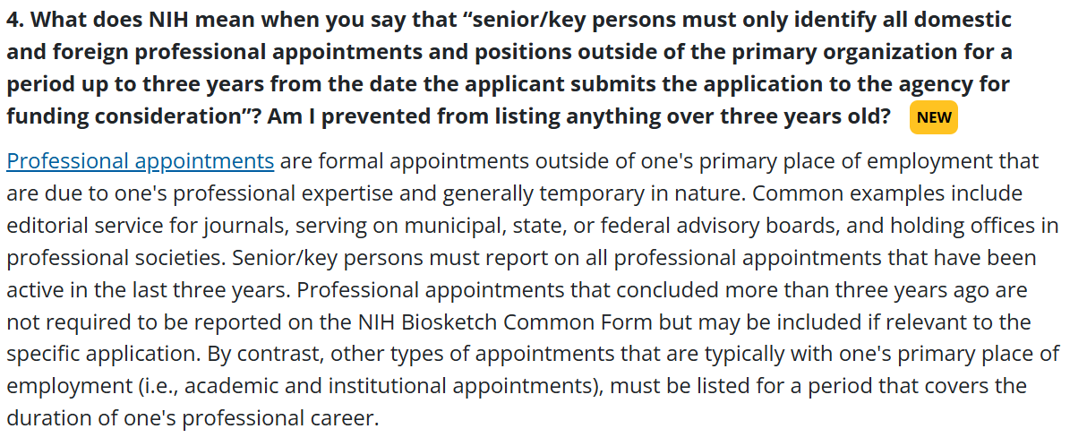
- Required fields for each appointment/position are marked with an asterisk in SciENcv.
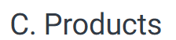
- (i) up to five products closely related to the proposed project
- (ii) up to five other significant products that highlight the senior/key person's Contributions to Science. (You can describe these in more depth when in more depth in the part 2: supplement)
- Acceptable products must be citable and accessible including but not limited to:
  - publications, conference papers, and presentations;
  - website(s) or other Internet site(s);
  - technologies or techniques;
  - inventions, patents, patent applications, and/or licenses; and
  - other products, such as data, databases, or datasets, physical collections, audio or video products, software, models, educational aids or curricula, instruments or equipment, research material, interventions (e.g., clinical or educational), or new business creation.
- Each product must follow the NIH Policy on Use of Hypertext in NIH Grant Applications and include full citation information including: if any of the below are N/A, enter N/A.
  - names of authors;
  - product title;
  - date of publication or release;
  - other persistent identifier (if available); and
  - other relevant citation information (e.g., in the case of publications, title of enclosing work such as journal or book, volume, issue, pages).
*Per email with Diane Baldwin sent on 1/21/2026 at 3:01 PM, "The links automatically generated in the Biographical Sketch Common Form in SciENcv are allowable."

Part 2: NIH BIOGRAPHICAL SKETCH SUPPLEMENT

- Instructions are provided within the SciENcv form; limited to 3,500 characters.
- Here is where you can indicate whether you have published or created research products under another name.
- Describe factors affecting past productivity (e.g., family care, illness, disability, military service)
- If you wish to explain factors that affected your past productivity, such as family care responsibilities, illness, disability, or military service, you may address them in this section.
- Specific guidance is provided for institutional research training, institutional career development, or research education grant applications.
*Do not provide citations in the NIH Biographical Sketch Supplement

- Instructions are provided within the SciENcv form; limited to 15 entries
- Description of up to five of your most significant contributions to science; instructions in the form indicate what to include
- Each Contribution to Science is limited to 2,000 characters
- You may refer to up to FIVE (5) products ALREADY listed in the Other Significant Products section of your Biographical Sketch Common Form (Part 1 – Common form C. Other Significant Products Highlight Contributions to Science). It seems odd that you cannot reference the first 5 citations closely related to the project, we will monitor the FAQs about it.
  - Recommended reference is “title, author’s last name, publication, year of publication”
  - Do not provide actual citations in the NIH Biographical Sketch Supplement (this instruction is specified in the SciENcv form itself, the NIH notice in the table highlighting changes, and in the NIH supplement instructions, pages 1 and 3)
- Descriptions may include mention of research products under development (including manuscripts not yet accepted for publication).
- Contributions do not have to be related to project proposed in application.
- Figures, tables, or graphics are not allowed.

Certification and Download
*To be accepted certification date must be within past 12 months from when application is submitted.
- Both sections are certified when all fields are complete and prior to download.
- Reminder - Required Disclosures: Consistent with NSPM-33, individuals are required to disclose contracts associated with participation in programs sponsored by foreign governments, instrumentalities, or entities, including foreign government-sponsored talent recruitment programs. Further, if individuals receive direct or indirect support that is funded by a foreign government-sponsored talent recruitment program, even where the support is provided through an intermediary and does not require membership in the foreign government-sponsored talent recruitment program, that support must be disclosed. Individuals must also report other foreign government sponsored or affiliated activities. In accordance with 42 USC § 19232, individuals are prohibited from being a party in a malign foreign talent recruitment program.
  - NSPM-33 Implementation Guidance Pre- and Post-award Disclosures Relating to the Biographical Sketch and Current and Pending (Other) Support provides info regarding pre-award and post-award disclosures: types of activities to be reported, where such activities must be reported in the application, when updates are required in the application and award lifecycle, and activies that are not required to be reported.
- All biosketches are certified within the SciENcv interface, with the certified version then downloaded as a PDF and attached in the application. The certification and associated statement are automatically added to the end of the biosketch.
- All required sections must be completed before the certified PDF download button activates. Applicants can download a watermarked draft version to preview the biosketch, share it with others for feedback purposes, etc., regardless of whether all sections have been completed.
- Applicants must agree to the statement as provided in SciENcv, please read carefully before certifying.

