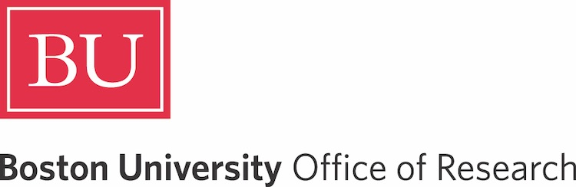
Research on Tap: The Framingham Heart Study

Thursday, April 9 | 4-6 PM| Kilachand

WELCOME

Kenneth Lutchen | Vice President and Associate Provost for Research
Donald Lloyd-Jones | Professor of Medicine, Boston University Chobanian & Avedisian School of Medicine; Director of the Framingham Center for Population and Prevention Science; and Principal Investigator of the Framingham Heart Study

PRESENTATIONS
Leveraging Genetic / Multi-omic and 75+ Years of Longitudinal Data in FHS for Alzheimer Disease Research
Lindsay A. Farrer, Professor, Medicine, Neurology, Ophthalmology, Genetics, Genomics, Epidemiology, and Biostatistics, Chobanian & Avedisian School of Medicine

Using continuous glucose monitoring (CGM) to Identify Hidden Dysglycemia in Individuals without Diabetes
Nicole Spartano, Assistant Professor, Chobanian & Avedisian School of Medicine

Investigating Brain Trauma, Alzheimer’s Disease and Related Dementias in the Framingham Heart Study
Jesse Mez, Associate Professor, Neurology, Chobanian & Avedisian School of Medicine

Vascular Function at Framingham Heart Study
Gary F. Mitchell, President, Cardiovascular Engineering, Inc.

Embracing the Digital and AI Reality
Rhoda Au, Professor, Anatomy & Neurobiology, Neurology, and Medicine, Chobanian & Avedisian School of Medicine; Professor, Epidemiology, SPH

Integrative Trans-OmicsTo Identify Molecular Clues to Disease
Daniel Levy, Professor, Medicine, and Preventative Medicine & Epidemiology, Chobanian & Avedisian School of Medicine

Musculoskeletal Research in the Framingham Study - So Much More than the Bare Bones
Douglas Kiel, Professor, Medicine, Harvard Medical School

LEGACY: Lifelong Endowment for Genomic and Cellular Discovery
Jessica L. Fetterman, Associate Professor, Vascular Biology, Chobanian & Avedisian School of Medicine

The Bidirectional Association of Atrial Fibrillation and Cancer in the Framingham Heart Study
Alexander Stanisic, Clinical Instructor Trainee, Medicine, and General Internal Medicine, Chobanian & Avedisian School of Medicine

Cardiometabolic Resilience in the Framingham Heart Study
Matthew Nayor, Associate Professor, Medicine, and Cardiovascular Medicine, Chobanian & Avedisian School of Medicine
Cardiovascular Resilience Evaluation and Cardiovascular-Kidney-Metabolic Syndrome in the Framingham Heart Study
Vanessa Xanthakis, Associate Professor, Medicine, and Preventive Medicine & Epidemiology, Chobanian & Avedisian School of Medicine
Genetics of Chronic Obstructive Pulmonary Disease (COPD)
George O’Connor, Professor, Medicine, and Pulmonary, Allergy, Sleep & Critical Care Medicine, Chobanian & Avedisian School of Medicine

Inflammation and Immune Health in Healthy Aging: Framingham Heart Study
Joanne Murabito, Professor, Medicine, Chobanian and Avedisian School of Medicine

FUNDING OPPORTUNITIES
Sophie Reilly | Assistant Director, Foundation Relations

Upcoming Events

RESEARCH HOW-TO

Strategic Communications: Building a Positive Media Presence
Thursday, April 16 | 12-1 pm Zoom

Meet the Funded: Building Authentic Relationships with Foundations

Monday, April 27 | 12-1 pm Zoom

Meet the Funder: RRF Foundation for Aging
Wednesday, April 29 | 12 pm Zoom

Learn more and RSVP:

bu.edu/research/events


Boston University Office of Research
One Silber Way, 9th Floor, Boston, MA 02215
617-353-2595 / research@bu.edu / @BostonUResearch

