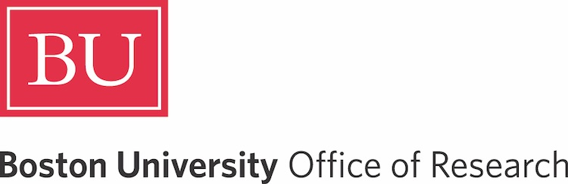
Research on Tap
AI and the Humanities
Wednesday, April 16 | 4-6 pm | Kilachand Center

WELCOME

Tom Bifano | Ad Interim Vice President & Associate Provost for Research  f
Wesley Wildman | Professor, Philosophy, Theology, and Ethics, CDS, STH

PRESENTATIONS

f
Platform Governance in the Age of Generative AI: Platform Interdependence in Policy Evolution

Chris Chao Su, Assistant Professor, Emerging Media Studies, COM

Artificial Storytellers

Daniel Munro, Assistant Professor, Philosophy, CAS

Topic Modeling of Video and Image Data: A Visual Semantic Unsupervised Approach

Ayse D. Lokmanoglu, Assistant Professor, Emerging Media Studies, COM

Understanding the Rhetorical Purposes of Generative AI Use

Pary Fassihi, Senior Lecturer, Writing Program, CAS

Student Perspectives on Generative AI in First-Year Writing: Lessons from a Pilot GAI Initiative

Christopher McVey, Master Lecturer, Writing Program, CAS

Collaborative Research Using Natural Language Processing and Large Language Models

Seth Villegas, Lecturer, CDS

Agency, Grasping, and AI

Michaela McSweeney, Associate Professor, Philosophy, CAS

Using Large Language Models to Create AI Personas for Replicating, Predicting, and Generalizing Media Effects Research

James J. Cummings, Associate Professor, Emerging Media Studies, COM

The Cultural Search

Juliet Floyd, Professor, Philosophy, CAS

f

CLOSING

Margarita Guillory | Associate Professor, Religion, CAS

Upcoming Events

RESEARCH HOW-TO
Unlocking NSF Funding Opportunities for Infrastructure and Instrumentation
Monday, April 28 | 1-3 pm

INNOVATOR OF THE YEAR
Air to Breathe – Pathways to Commercializing Academic Discoveries
Thursday, May 1 | 3-5 pm

Learn more and RSVP:

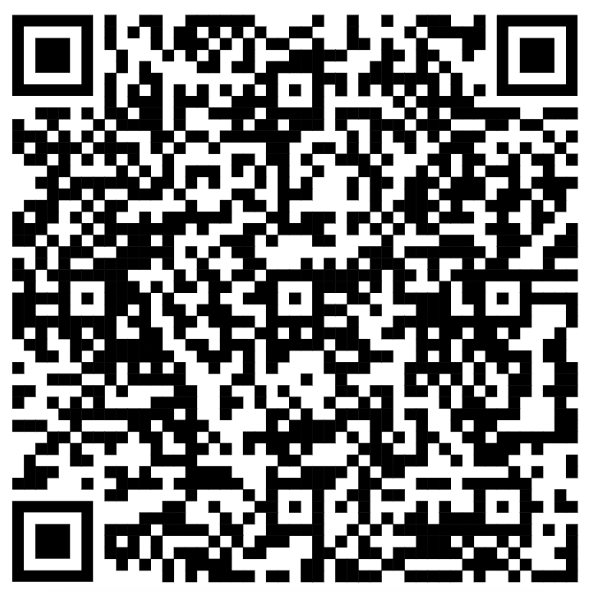


Boston University Office of Research
One Silber Way, 9th Floor, Boston, MA 02215
617-353-2595 / research@bu.edu / @BostonUResearch

