PlugIn Photovoltaic (PIPV) Systems: Safety Challenges, Standards, and Integration into Existing Electrical Infrastructure
Kumudha Tiriveedhi

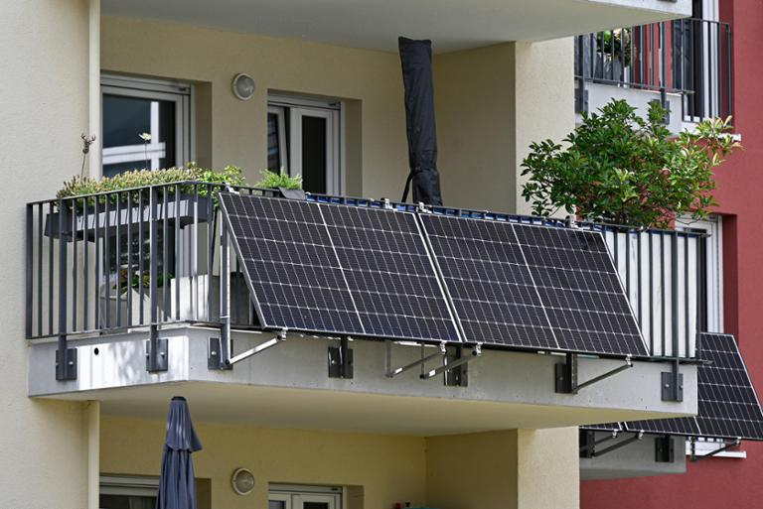

Table Of Contents
- Introduction
- Significance of PIPV systems
- Regulatory Barriers
- UL 3700
- Electrical safety
- Lack of Overcurrent Protection
- Touch Safety Risks
- Lack of Ground Fault Circuit Interrupters
- Utility Interconnection Barriers
- Case Study : Germany
- Case Study : CraftStrom
- Current Bills
- Conclusion

Introduction
Traditional solar energy systems include PV (Photovoltaic) modules, a mounting system and inverters (to convert DC current to AC current). The converted AC power is either distributed between different electrical equipment behind the meter feeding instantaneous load, or fed into the utility grid or stored in a battery. The installation normally requires a qualified professional electrical contractor using certified equipment that meets safety standards along with electric utility engineers reviewing grid interactive PV systems to verify adherence to local grid interconnection requirements. The product itself (PV panels) must meet strict code compliance and safety standards to ensure protection against fire/mechanical/electric shock hazards, (Shah, 2026).

Emerging from Europe, a new type of technology has emerged known as Plug in PhotoVoltaic or “PIPV”. These are systems that can be connected to a building’s wiring by using a cordplug connection to a standard receptacle. These systems export power into a common residential receptacle using a power supply cord and attachment plug. Marketed for residential applications as a plug and play solution, PIPV products are designed for consumer installation and offer a more affordable way to adopt solar energy at home. Some PIPV products are referred to as “balcony solar” because consumers often choose to install them on residential balconies, (Hu,2025).

However, unlike traditional PV systems, a major advantage of plugin photovoltaic (PIPV) systems is that they do not require installation by a licensed electrician, as they can simply be connected to a standard wall outlet. This convenience, however, also introduces important limitations because the power cord is not permanently wired into the home’s electrical system. In addition, many household electrical panels were not designed to accommodate the added load, which may increase the risk of overheating or fire hazards, (Brady, 2026). This concern is especially significant because there is currently limited standardization and regulation for these systems, allowing some products to bypass review and authorization by code authorities, while utilities often provide little or no oversight once the systems are in use.

These limitations necessitate a comprehensive review of the application of PIPV systems in relation to current standards, codes and existing infrastructure. These systems also require a thorough safety science assessment of the products and their installations.

Significance of PIPV systems
With typical system costs ranging from $1,500 to $2,500 and annual energy generation between approximately 1,500 and 2,500 kWh, homeowners can expect yearly savings of roughly $450 to $800 depending on local utility rates. This results in estimated payback periods of about 2.5 to 4 years, after which the electricity generated effectively offsets energy costs at no additional expense, (Stryker et al., 2025). These systems are typically limited to around 800 W to 1.2 kW, which constrains overall generation and export potential. In practice, most of the energy produced is consumed directly within the home, with maximum exports remaining below approximately 0.75 kWh per day and nearzero net export at typical adoption levels, (Brooks Engineering, 2025). However, unlike conventional solar systems, plugin systems may not qualify for certain state incentives or net metering programs, meaning their financial performance is primarily driven by avoided electricity costs rather than policy based subsidies. For example, in Massachusetts, the SMART program and tax credits require permanent interconnection. As a result, while these systems can be economically attractive, their ROI is highly dependent on local energy prices, system utilization, and regulatory context, (CraftStorm, 2025).

Regulatory Barriers
The adoption of PIPVs is influenced by electrical codes and standards, which determine whether systems are approved by the Authorities Having Jurisdiction (AHJs). The primary regulatory frameworks include standards from Underwriters Laboratories (UL), the National Electrical Code (NEC), and the International Residential Code (IRE). While AHJs regulate installations behind the outlet, plug in devices themselves are primarily governed through certification by Nationally Recognized Testing Laboratories (NRTLs), such as UL.
UL certification plays a critical role in ensuring safety, enabling insurance coverage, and meeting legislative requirements. However, certification is costly and time intensive, which can delay market entry for new technologies. Several existing UL standards are partially applicable but not fully suited to PIPV systems for instance, standards governing inverters, ground fault protection, and power control systems require updates to accommodate bidirectional power flow and plug based connections (discussed in Section 5). In response, UL has introduced an Outline Of Investigation of UL 3700, specifically intended to address these gaps, with the full standard being released later this year.
The National Fire Protection Association (NFPA) publishes the NEC, which governs electrical safety in U.S. buildings and serves as the foundation for state level codes. While the NEC does not directly regulate plug in devices, it significantly influences PIPV adoption through permitting and inspection requirements. A central challenge is that existing NEC provisions were developed for permanently installed systems and assume one directional power flow, creating uncertainty when applied to plug in distributed energy resources (DERs). Articles related to solar and grid-connected systems, such as Articles 690 and 705, do not explicitly address plug and receptacle configurations, often leading to rejection by default. Additional requirements, such as mandated disconnection methods and installation by qualified personnel, further complicate approval. Other provisions related to receptacles, flexible cords, and proper equipment usage can also conflict with plug in designs. For instance, restrictions on energized plugs, limitations on cable routing, and requirements to follow manufacturer instructions may not align with PIPV systems. Safety mechanisms like ground fault circuit interrupters (GFCIs) and Rapid Shutdown Devices (MLPE’s) present further challenges, as current standards do not fully support bidirectional power flow. These limitations may hinder not only PIPV deployment but also related technologies, such as bidirectional electric vehicle charging.
The IRC and related fire codes regulate residential construction and energy storage but are often outdated relative to newer technologies. While inspectors typically defer to the NEC, discrepancies and overlapping jurisdictions can create confusion. A significant barrier arises from how current codes classify batteries. Existing rules often treat all battery-containing devices as ESSs, subjecting even small plugin systems to stringent installation requirements. Fire safety standards further complicate deployment, particularly in multifamily housing, where regulations governing larger storage systems are applied broadly without distinguishing smaller devices. Additionally, the IRC restricts the placement of ESSs in habitable spaces, limiting the use of battery-integrated plugin devices such as appliances. Although newer standards are being developed to better address smaller, nonESS battery systems, current ambiguities force regulators to rely on inconsistent interpretations or exceptions, creating uncertainty for manufacturers and users.

UL 3700
UL Solutions has published UL 3700 as an Outline of Investigation (OOI), providing a formal testing and certification framework for plugin PV systems. While not yet a full consensus standard, UL 3700 is already being used by manufacturers in the U.S. as a basis for product evaluation and certification, though adoption is still in its early stages. This is a significant step to align organisations such as NEC, AHJ to align on consistent requirements which would enable faster and safer adoption of PIPV systems.

UL has also released a white paper highlighting key safety risks associated with plugin photovoltaic (PIPV) systems in the United States, concluding that their use on existing residential electrical systems is not supported without additional mitigations, (UL LLC, 2025). This is discussed in the “Technical Barriers” section.

Electrical Safety
- Lack of Overcurrent Protection
The National Fire Protection Association (NFPA) issues the National Electrical Code (NEC) which serves as the code for electrical safety and is widely adopted in the US. This includes the wiring systems, and any load installations.

Article 690 of the NEC establishes requirements for the installation of photovoltaic (PV) systems. However, these rules are written for permanently installed PV systems that are connected to premises wiring through dedicated electrical connections. They do not specifically address PIPV systems, which are connected into a standard outlet.
NEC overcurrent protection (Articles 210 and 240) assumes power flows from a single source to the load. A PIPV system plugged into a receptacle adds a second power source, allowing current to flow back into the circuit without being fully protected by the panel’s breaker. This can cause currents to exceed safe limits, increasing the risk of overheating, equipment damage, electric shock, and fire.
To explain this visually, Figure 1 demonstrates that if a circuit is overloaded with multiple loads, the circuit breaker would sense that and safely deenergise the circuit. However, in Figure 2, if there is a PIPV sending in extra current, the circuit breaker wouldn’t sense it in that case since it thinks that it’s “under the limit due to backfeeding by the PIPV”, creating a fire hazard.
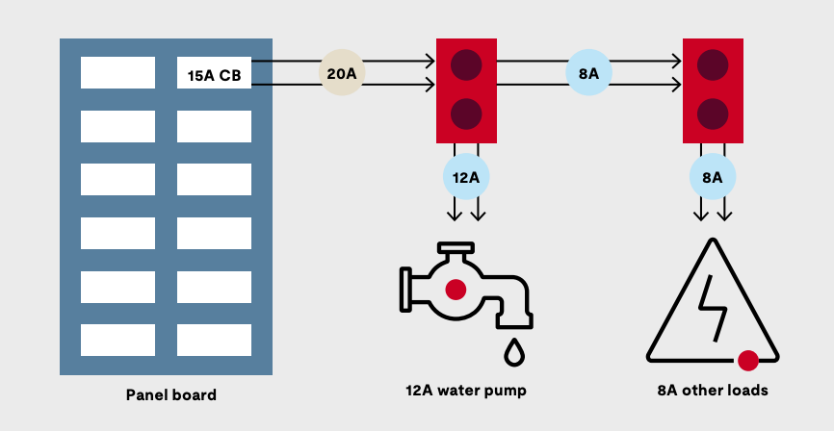
Figure 1. Circuit overloaded without PIPV
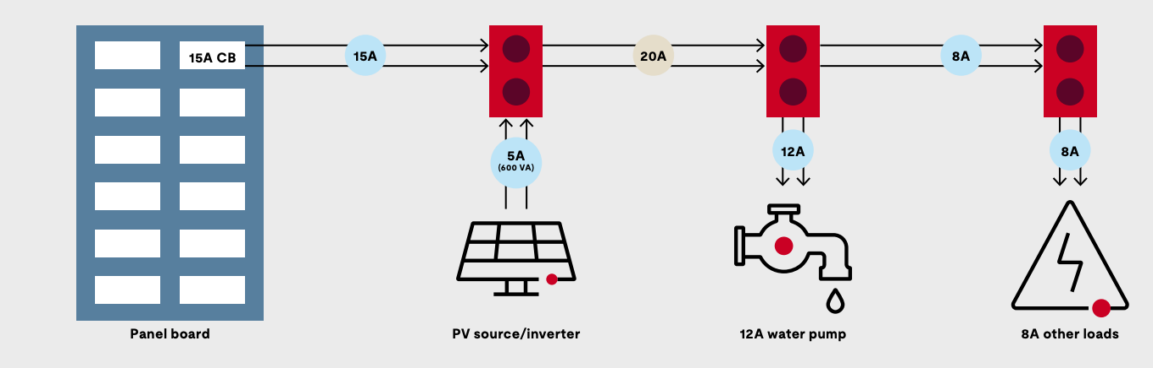
Figure 2. Circuit Overloaded with PIPV

However, according to the NEC section 705.12(B), it does permit an installation providing extra current as long as it meets the 120% rule in Equation 1.

$1.25 × (PV current+breaker rating)≤ 1.2 × busbar rating$ Equation 1

This is still considered to be safe as long as the utility power comes in at the end of the busbar while the solar PV connects at the opposite end with the loads separate in between. This means that the current from both sources flows toward the loads where the loads “absorb” current along the busbar so this prevents any one section of the busbar from being overloaded. However, this is hard to apply to a PIPV system since it It plugs into a random wall outlet in which the outlet is part of a branch circuit, not a panel busbar so there is no control over where loads are located and the PIPV source is not guaranteed to be at the opposite end which is hard to tell from the user’s end.

- Proposed Solution
UL has proposed some solutions to tackle this problem
- Dedicated Circuit with Unique Plug/Receptacle: The PIPV system can be installed on a dedicated branch circuit with no other connected loads. This ensures that all current is accounted for by the circuit’s overcurrent protective device. A uniquely configured plug and receptacle (incompatible with standard outlets like NEMA 515) prevents users from connecting the system to unintended circuits.
- Unique Receptacle with Integrated Overcurrent Protection : The first receptacle in the branch circuit has to be replaced with a specially designed PIPV receptacle that includes builtin overcurrent protection. This restricts connection to a single controlled location and ensures that any additional current from the PIPV system is properly monitored and interrupted if unsafe conditions occur.
- Unique Receptacle with Oversized Conductors : A dedicated PIPV receptacle has to be used in combination with largergauge (oversized) branch circuit wiring. This allows the conductors to safely carry the combined current from both the utility and PIPV sources, provided that system limits (such as maximum PIPV output and number of units) are enforced.
- Power Control System (PCS) with Unique Receptacle : A power control system has to be integrated that continuously monitors and regulates total current on the circuit. Systems evaluated under standards like UL 3141 can dynamically adjust or limit PIPV output to prevent overloads. A uniquely configured receptacle ensures the PIPV system is only used on circuits equipped with this protection.

- Touch Safety Risks
Inverters convert DC (direct current) power from solar modules into AC (alternating current) power so it can be used with appliances in a house, with a specific type called grid interactive inverters that are designed to operate in parallel with the utility grid.

Inverters are tested under standards like IEEE 1547 and UL Solutions 1741, which focus on keeping the electrical grid stable and protecting utility workers. However, these standards are designed for grid performance and safety of utility workers rather than a user who might touch the exposed plug, less than a second after unplugging. Although the inverter software is designed to shut off during grid failures, there is still a delay due to relay response time and reliability limitations.As a result, there is no guarantee that a disconnected inverter output circuit is immediately touchsafe, which is why qualified technicians verify the absence of voltage before handling equipment.

As a result, PV systems are designed with a fully enclosed output circuit, so the user can’t touch it without a tool to open equipment. This creates a key safety gap for plugin photovoltaic (PIPV) systems, where the inverter output is accessible through a standard plug interface to the user.

In addition, with traditional solar systems installed on roofs, they aren’t accessible to people and use locking connectors, so the risk of electric shock is much lower compared to PIPV which are made of glass/thin insulation that can easily expose the running DC voltage. This is why it’s essential to have GFCI protection (groundfault circuit interrupter) where it detects leaking current and prevents shock. But GFCIs are designed for standard AC circuits with one directional power flow. Plugin solar systems introduce both DCrelated behavior and bidirectional current flow, which these devices are not designed or tested to handle. As a result, their ability to reliably detect and interrupt faults may be reduced, requiring additional protection measures such as physical barriers or systemlevel controls. This issue will be discussed in more detail in Section 3 below.

A standard NEMA 515P power cord is designed to connect appliances (loads) to a power source and becomes safe when unplugged, as the plug blades are deenergized and can be safely touched. However, in plugin photovoltaic (PIPV) systems, this same plug is used as a power output, meaning that when the device is exposed to sunlight, it can energize the exposed plug blades and create a risk of electric shock. Although standards such as IEEE 1547 permit inverters up to two seconds to cease output during fault conditions like grid loss, this response time is not sufficient to ensure human safety. As a result, relying solely on inverter grid interaction functions or software based controls is inadequate for preventing shock hazards.

2. Proposed Solutions
Clearly defined touch safety limits must be established, supported by additional hardware based protection measures, specialized components, and more rigorous evaluation and testing.

- PIPV unique configuration plug and receptacle : A custom designed plug and matching outlet that prevent users from touching any live electrical parts.
- Accessible grid interactive/touch safe output circuit : The inverter includes extra safety features to make the electricity coming out safe to touch. This requires testing both the hardware and software to ensure it remains safe even if something goes wrong.

3. Lack of Ground Fault Circuit Interrupters (GFCI)
These devices are designed with the assumption that electricity flows in one direction, from the electrical panel to the appliance. However, a PIPV system introduces a second power source, sending electricity back into the circuit. This creates bidirectional flow that GFCIs are not designed or tested to handle. As a result, the GFCI may not function correctly, potentially allowing electricity to continue flowing without proper protection against electric shock.
In addition, conventional GFCIs may fail to interrupt power supplied by the solar system during a fault. Because the neutral wire often remains connected, it can still provide a path for current, even after the GFCI trips. In situations where the solar system produces more electricity than is being used locally, voltage on the circuit can rise, further increasing the risk of electric shock without triggering the expected safety response. Since PIPV systems can be easily plugged into standard outlet, such as common NEMA 515 receptacles, there is a high likelihood they may be connected to circuits that lack the proper protections for this type of power flow.
A related safety concern is known as “blinding” the GFCI. Under normal conditions, a GFCI quickly shuts off power from the utility when it detects a fault, protecting people from harm. However, with a PIPV system acting as a second power source, electricity can continue to flow even after the GFCI has tripped. This means the hazardous condition may persist for up to a couple of seconds, preventing the device from fully doing its job. This “blinding” effect introduces a serious and often unexpected risk for users.
3. Proposed Solutions
Unique, nonstandard plugs are required so PIPV systems cannot be connected to regular household outlets, and installing them only on dedicated circuits with properly designed and compatible protection. These measures help ensure that existing safety devices continue to work as intended and reduce the risk of electric shock for the public.
In addition, UL tested the behaviour of existing GFCI circuit breakers with backfeeding by a PIPV in 3 configurations to understand how fast the GFCI can shut power in the case of electric shock. To stimulate a human, they use a 500 ohm resistor to represent human body resistance. According to UL 943, a GFCI must shut off power within 28.6 ms. For the experiment with no PIPV, the GFCI shut off power in 12.6 ms but with a PIPV, configuration 1 (36.3 ms), configuration 2 (32.8 ms), configuration 3(36.7 ms) which were all not compliant.
However, a GFCI receptacle was also used for testing with these 3 configurations and was safely able to meet the requirements of UL 943. This is because a GCI circuit breaker only disconnects the hot wire, but the neutral line is still connected so the PV inverter can still use the neutral line as a return parth but a GFCI receptacle disables both so it completely removes the return path for current. This means to safely use PIPV, bidirectional GFCIs are required where all the return paths are removed, (UL LLC, 2025).
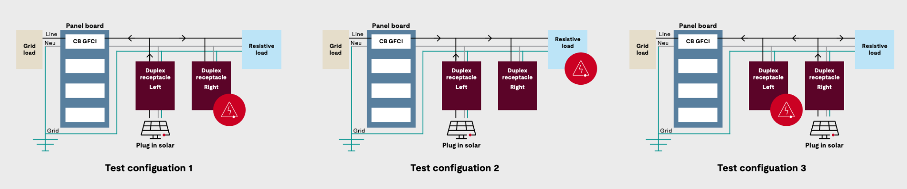

Figure 3. Test Configurations.
Utility Interconnection Barriers
Ratepayers enter into service agreements with utilities that define how electricity can be used and delivered. These agreements typically give utilities authority over devices connected behind the meter, including the ability to restrict installations or disconnect service if requirements are not met. For systems that export electricity, customers are usually required to complete a formal interconnection process, which can be time consuming and involves permits as well as compliance with existing codes and standards. This process is not well suited to plugin photovoltaic (PIPV) systems, which lack clear, standardized integration pathways (as seen in Figure 4). In addition, renters often face further barriers, as landlord approval is typically required for installation.
In some states, such as Utah, legislation excludes plugin solar systems from participating in net metering programs. As a result, excess electricity exported to the grid is not compensated, reducing the financial incentive for adoption.
From the interview conducted by Gerber, utilities have expressed a range of concerns regarding the adoption of plugin distributed energy resources (DERs), with perspectives varying by region. European utilities tend to focus primarily on safety concerns, including fire risk, liability, and incidents occurring behind the meter. In contrast, U.S. utilities also emphasize economic and operational challenges. These include potential revenue loss from reduced electricity consumption, as well as uncertainty in grid planning due to the distributed and mobile nature of plugin systems, which are difficult to track and model.
Despite these concerns, utilities recognize the potential benefits of PIPV systems. These systems can help reduce peak demand, delay the need for infrastructure upgrades, and improve overall grid efficiency, particularly when combined with energy storage or smart control technologies. Their location close to the point of use also offers advantages over centralized generation. Additionally, PIPV systems may create new opportunities for utilities through services such as demand response and dynamic pricing, (Gerber et al., 2025).
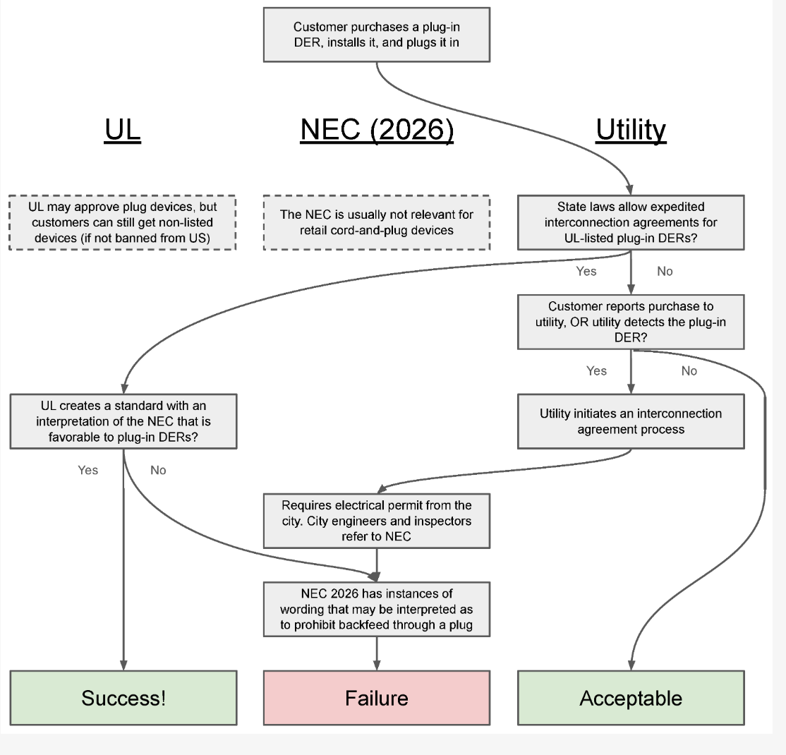

Figure 4. Current Regulatory Framework Map.

Despite the significant technical, regulatory, and utility interconnection barriers outlined above, the successful deployment of plugin photovoltaic (PIPV) systems in parts of Europe demonstrates that these challenges are not impossible to overcome. In particular, countries such as Germany have established clearer regulatory pathways and standardized safety requirements that enable the safe and widespread adoption of “balcony solar” systems. Examining Germany’s approach provides valuable insight into how standardized system level safety framework and utility alignment can support the integration of PIPV systems within existing electrical infrastructure. In addition, examining current PIPV products can help reveal how these systems are designed, used, and where key safety and regulatory gaps still exist.

Case Study : Germany
One of the main steps taken was the development of technical standards by Verband der Elektrotechnik, which formally allowed balcony solar systems. A key part of this was setting a clear export limit. Germany established a maximum inverter output of 800 VA, which helps prevent issues such as circuit overloading and breaker masking. This gives utilities confidence that these systems will not exceed safe operating conditions. At the same time, larger systems are still allowed, but they must limit their grid export to this threshold. Germany also distinguishes between systems that use standard household plugs and those that use dedicated energy plugs, with the latter allowing higher module capacities (up to 2000 Wp). This creates a balance between safety and flexibility.
Germany also addressed safety concerns at the system level. Plugin systems are required to include protections that prevent users from being exposed to live conductors, either through physical design or inverter based isolation. In addition, microinverters must automatically shut down during outages (antiislanding), ensuring that no power is fed into the grid when it is unsafe. This directly addresses concerns around backfeeding. Compared to the U.S., where GFCI protection may still leave a return path, European systems use residual current devices (RCDs) that disconnect the entire circuit, providing stronger protection, (Sbamueller, 2025).
Another major improvement was reducing administrative barriers. As of 2024, Germany simplified the registration process by requiring users to register their systems through a single national database, instead of going through complex interconnection agreements. The process was reduced from around 20 inputs to only a few key technical details, making it significantly easier for users to comply. This removes one of the main barriers seen in the U.S., where interconnection agreements are often lengthy and complex, (Rayner & Enkhardt, 2025).
Germany also addressed access issues, particularly for renters. In July 2024, balcony solar was classified as a “privileged measure,” meaning landlords and housing associations cannot unreasonably block installations. This directly expands access to renters, who are typically excluded from the rooftop solar market, (Reuters, 2024).
Case study : Craftstrom
Speaking with Ken Hutchings, Head of Business Development at Craftstrom, a company that develops PIPV systems, provides insight into an alternative approach to plugin solar: zeroexport systems. Unlike conventional gridinteractive systems, zeroexport systems are designed so that no excess electricity is sent back to the utility grid.
A key advantage of zeroexport systems is their ability to bypass traditional utility regulation. Because utilities only have jurisdiction up to the electric meter, systems that do not export power beyond that point are generally not subject to interconnection requirements. As Hutchings explains, if no electricity crosses the meter, utilities have no authority to review or approve the system. This was echoed by PG&E’s email to Craftstrom in Figure 5. This distinction allows zero export systems to be legally sold and installed without many of the regulatory barriers faced by conventional grid connected solar systems.
Despite this regulatory advantage, there remains a critical gap in safety validation. While individual components of the system are UL certified, there is currently no comprehensive systemlevel certification standard. Hutchings noted that this gap is expected to be addressed by the upcoming UL 3700 standard, which aims to evaluate plugin solar systems as integrated units rather than isolated components. This was also echoed by Bruce Johnson, from UL solutions that system level validation is still important even if the PIPV system doesn’t export to the grid, due to the risks identified in the “Technical Barriers” Section such as breaker masking, GFCI devices, etc.
Recent legislation in states such as Utah and Colorado has begun to permit plugin solar systems that export power to the grid without requiring utility notification, up to certain limits. However, this deregulation introduces new concerns. According to Hutchings, when systems backfeed without formal interconnection, liability may shift from the utility to the homeowner in the event of damage or injury. Zero export systems attempt to avoid this issue entirely by eliminating grid interaction, but they do not necessarily address all electrical safety risks, such as circuit loading or protection device compatibility .
Massachusetts currently recognizes zero export systems but does not exempt them from interconnection requirements. While zero export configurations reduce grid related risks by preventing backfeeding, utilities still require visibility into distributed energy resources operating within the system. Rather than fully removing interconnection requirements, Massachusetts policy could be adapted to create a streamlined approval pathway for certified zero export systems, balancing reduced grid impact with the need for system level verification and safety oversight.

In addition, Johnson mentioned that UL 3700 does not require zero-export functionality for certification, however, if a system includes zero-export features, it must still meet general safety requirements under UL 3700 and UL 1741, such as proper electrical ratings and protection against shock or fire. Overall, zero-export capability is not considered necessary for achieving safety certification.
A major barrier to adoption is not just technical or regulatory, but informational. As Hutchings emphasized, “There’s a tremendous amount of education needed”. Widespread misunderstanding of policies, system capabilities, and safety implications continues to create confusion among consumers, as current U.S. legislation prioritizes arbitrary wattage limits for plugin PV systems without adequately addressing the transfer of safety responsibility and liability to the end user.
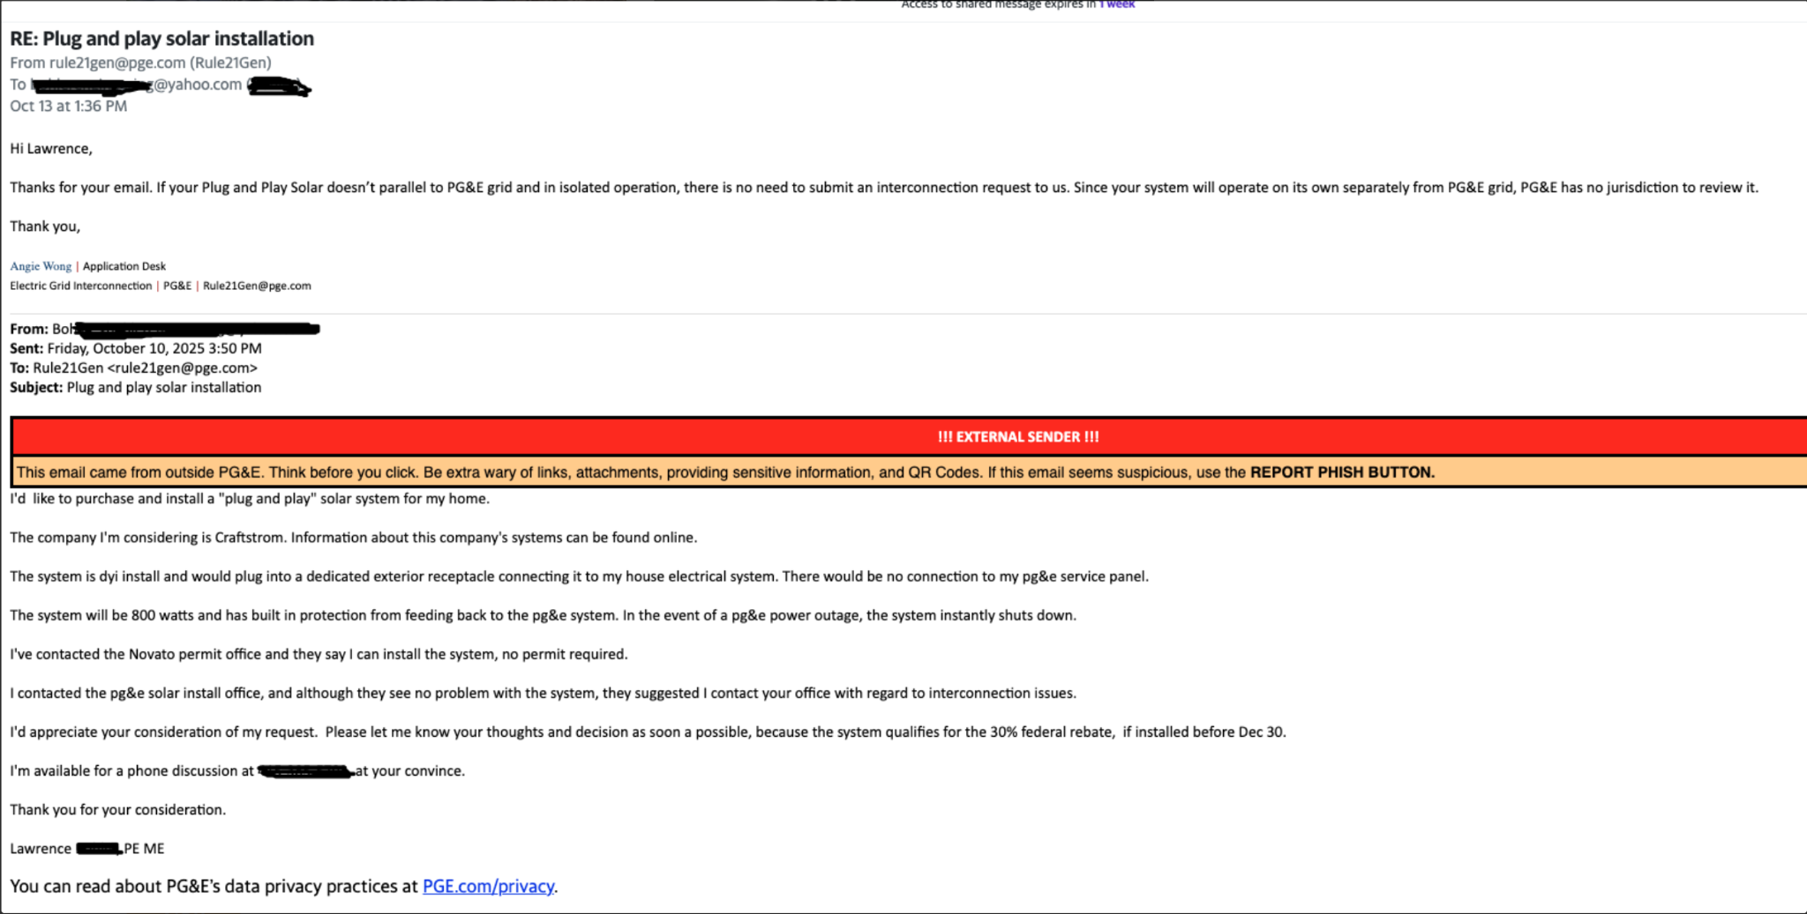
Figure 5. Email from Pacific Gas and Company to CraftStrom regarding no requirement for utility interconnection agreement.
Current Bills
Recent legislation in states such as Colorado and Utah reflects a growing effort to reduce barriers to plugin photovoltaic (PIPV) adoption, but also highlights key tradeoffs. Colorado’s bill is particularly progressive, as it explicitly allows “portablescale solar generation devices” up to approximately 1.92 kW and prevents utilities from requiring prior approval, additional fees, or unnecessary equipment for installation. It also protects consumer rights by prohibiting landlords or homeowner associations from unreasonably restricting installation and requires utilities to streamline interconnection tools such as meter collar adapters. These measures significantly lower regulatory and financial barriers, making adoption more accessible, especially for renters and urban residents. However, the bill still includes limitations, such as restricting one device per outlet, requiring safety features like antiislanding, and placing liability on the user, which reflect ongoing safety and infrastructure concerns, (C0-HB1007, n.d.).
In contrast, Utah has taken a simpler but more limited approach by allowing plugin solar systems up to about 1.2 kW without requiring formal interconnection approval. While this reduces administrative burden and encourages adoption, it often excludes these systems from net metering programs, meaning users are not compensated for excess electricity exported to the grid. As a result, financial incentives are reduced, and adoption is driven primarily by self consumption rather than broader grid participation, (Larsen, 2026). Overall, these policies demonstrate progress toward enabling PIPV systems, but also reveal ongoing challenges in balancing safety and integration with existing utility frameworks.
Conclusion
UL 3700 represents a critical step toward enabling the safe and standardized adoption of plugin photovoltaic (PIPV) systems in the US. By providing a system level framework that addresses key safety concerns, such as bidirectional power flow, touch safety, and compatibility with existing infrastructure, it helps align organizations like UL Solutions, code bodies, and Authorities Having Jurisdiction under a more consistent set of requirements. This standard has the potential to reduce regulatory uncertainty, streamline product certification, and support broader market adoption.
However, despite this progress, significant technical, regulatory, and utility related barriers remain. Existing electrical codes were not designed for plugin generation, utility interconnection processes are not well suited to these systems, and gaps in protection mechanisms continue to pose challenges. As a result, UL 3700 should be viewed not as a final solution, but as a foundational starting point. Continued experimentation,innovative engineering solutions, and the development of complementary policies and standards will be essential to fully realize the potential of PIPV systems. Moving forward, collaboration between manufacturers, regulators, utilities, and policymakers will be key to refining these frameworks and enabling safe, scalable, and equitable deployment of plug in solar technologies.

References
Brady, J. (2026, March 12). Easy-to-use solar panels are coming, but utilities are trying to delay them. NPR. https://www.npr.org/2026/03/12/nx-s1-5737287/solar-panels-utilities-energy-saving
Brooks Engineering. (2025). Plug-In Solar Utility Impact in the United States: A survey of regional issues based on widespread market acceptance. BrightSaver.
CO - HB1007. (n.d.). BillTrack50. https://www.billtrack50.com/billdetail/1935246/52930
CraftStorm. (2025). Regulatory requirements for residential Zero-Export solar systems by state.
Gerber, D. L., Ginsberg-Klemmt, A., Stoler, L., Shackelford, J., & Meier, A. (2025). Barriers to Balcony Solar and Plug-In Distributed Energy Resources in the United States. Energies, 18(8), 2132. https://doi.org/10.3390/en18082132
Hu, A. (2025, May 1). Balcony solar is all the rage in Germany. Why not in the US? Canary Media. https://www.canarymedia.com/articles/solar/balcony-panels-germany-utah
Hutchings, K. (2025, April 20). Personal interview [Interview with Craftstrom representative].
Larsen, L. (2026, April 21). How deep-red Utah helped launch a portable plug-in solar movement. Grist. https://grist.org/energy/utah-portable-plug-in-solar-law/
Rayner, T., & Enkhardt, S. (2025, April 13). New German allowances give further boosts for plug-in PV and storage. Energy Storage. https://www.ess-news.com/2026/04/10/new-german-allowances-give-further-boosts-for-plug-in-pv-and-storage/
Reuters. (2024, July 5). Germany gives apartment-dwellers legal right to solar power. Reuters. https://www.reuters.com/world/europe/germany-gives-apartment-dwellers-legal-right-solar-power-2024-07-05/
Sbamueller. (2025, March 17). How does Plug-in-PV in Germany work? – Alles über Steckersolar, Balkonkraftwerke & Solar! https://balkon.solar/news/2025/03/17/how-does-plug-in-pv-in-germany-work/
Shah, J. (2026, February 26). “Plug-In Solar” has faced major red tape in most states. That could soon change. World Resources Institute. https://www.wri.org/insights/enabling-plug-in-solar-states
Stryker, C., Miller Khaikin, S., Chou, K., Mayer, R., Gerber, D. L., Sachu Constantine, Philip A. Wight, Chirag Lala, Yakov Feygin, Josh T. Smith, & Nathan Phelps. (2025). Democratizing Solar. In Democratizing Solar. https://solarunitedneighbors.org/wp-content/uploads/2026/01/BrightSaver-WhitePaper-DemocratizingSolar.pdf
UL LLC. (2025). Interactions of Plug-In PV with Protection of Existing Power Systems.

Appendix 1 : Interview with Ken Hutchings, representative of Craftstrom
Interviewer: I'm a student at BU studying mechanical engineering, and for one of my classes I'm writing a paper on plug-in PV systems, and I'm working with Haskell Werlin from Solar Design Associates, and essentially writing this paper on plug-in PV systems, and it would be shared with the mass solar policy team, because there's an energy bill debate coming up this summer. So it would be for that. And I was wondering if it's okay if I ask you a few questions about your technology as well as the current market and regulations. Is that okay with you?
Hutchings: Yeah, that's fine. I'm fine with that. I've got a half an hour, and I'll give you a website to go to as well, because this has more of our stuff in it, if you need certifications or any of that. This one is pretty good, because this is what people don't understand about us. This is all on the website.
Hutchings: This is from PG&E (referring to Figure 5). Do you know who PG&E is?
Interviewer: Yes.
Hutchings: You know National Grid.
Interviewer: Yes, National Grid.
Hutchings: They're gigantic. They're in Northern California. So start asking your questions, and maybe we'll come back to this and I'll explain it.
Interviewer: Sure. I’ll start off with a question about your NEC smart breaker product. On the website, it said that it helps if you don't have a dedicated outlet to plug into. It helps monitor the line and turns off the line if there's an additional load. I was wondering how it addresses the problem where you're having multiple loads on the same circuit.
Hutchings: It's really easy. I'll show you. So you're familiar with a breaker box in a home? Power comes in from the street, it flows into each phase, and then there are breakers. The power comes in, goes through the breaker, then goes out to the home. So anytime you're breaking power, you're breaking power at the source. If it senses in the line that there's a surge, the breaker is going to pop.
So that's what this does. Our solar panels plug into this, and when they plug into this, they become the source of power for the line. If it senses a surge, it's going to pop the breaker. It's the same thing. You're protecting the line where power enters into the line. You have one breaker for the house, and if it detects anything it's going to pop, and if our system detects anything it's going to pop. So it's two safeties. It's quite easy. You're just breaking power at the source. This box is nothing more than a very fancy breaker.
Interviewer: Thank you for that. For the power meter, I think from what I understood is that you're trying to balance what you're getting from the solar panel to what you use in terms of consumption so that you prevent export to the grid. I was wondering how it validates that in real time. How do you know it would never export to the grid?
Hutchings: So these are CT sensors, and they sense power flow. One sensor goes here, one goes here, and cables connect to the power meter. One piggybacks into a breaker on one side, the other into the other side, and then there's a ground.
What the meter is doing is every tenth of a second, it's checking flow of electricity and demand. Anytime the home needs power, our system detects it and tells the panels to produce power. It produces up to the maximum amount for that system. If more power is needed, it pulls from the utility. If the home doesn't need power, the panels aren't producing.
It's on demand. It's like on-demand hot water. Most houses have a tank that keeps water heated constantly. On-demand systems only produce hot water when needed. It's the same idea. We only provide power when there's a need, up to the maximum, and we provide it first. If more is needed, it pulls from the grid. If not, it doesn't pull.
Interviewer: That makes sense. I also had a question about the power meter installation. It said it needs to be installed by an electrician. Is that true for the entire system or just certain parts?
Hutchings: It's just for this. You have to open the breaker box. Power comes in from the street into the panel. There's a master breaker, and if it's switched off, no power runs through the bars.
As a company, I can't tell someone to open their breaker box, install clamps on the mains, and wire it themselves because of the risk of electrocution. I couldn't tell a homeowner to do that.
What I tell people is that I'm not an electrician, but I installed mine in 10 minutes. I timed it so I could tell customers how long it should take, so they don't get overcharged. A lot of people probably install it themselves, but we have to say you need an electrician because of safety liability.
Once it's installed, you can expand the system indefinitely. It's modular, and you can add more components over time.
Interviewer: That makes sense. So the battery and everything else can be installed by the consumer?
Hutchings: Yes, it's very easy. It shouldn't take more than two hours for the largest kit, depending on mechanical ability.
Interviewer: I also had questions about regulations. Since there isn't a finalized UL standard for a full plug-in PV system, how has your company navigated selling in the U.S. market?
Hutchings: This is a big misconception. The laws being passed are for plug-and-play systems that export to the grid. We are a zero export system. We never push power back through the meter. Because of that, the utility has no jurisdiction over us.
You can do whatever you want on your property. The moment you go onto someone else's property, you need permission. The laws being passed allow people to plug systems in and export without notifying the utility, which creates liability.
If someone installs a system that pushes power back and it causes damage, the homeowner is liable. Insurance companies are going to have a problem with that.
Our system doesn't push back into the grid, so those laws are irrelevant to us. Our product is legal regardless. Utilities have no say in our system.
This has been confirmed by utilities like PG&E. They have no jurisdiction over a zero export solar appliance.
There is still confusion about limits like 1200 watts. That doesn't mean you can push 1200 watts back into the grid. Those laws were not written expecting that.
The future is likely going toward UL 3700, which will require metering to ensure no export.
Interviewer: That makes sense.

Interviewer: Okay, so like Echo flow, they violate our patent in Europe, but they have it here. Okay, so makes sense. So then, since you're not exporting to the utilities, that means you don't need to get permissions or any of the utility interconnection agreements, right?
Hutchings: Correct, because that’s what this email is showing. That email was gold for us, because we knew before we started selling in the states that the utility has no jurisdiction past the meter. That’s a common known thing in the industry, and our attorneys told us they have no jurisdiction.
This email from a large electric provider like PG&E is valuable, because there is so much noise out there and people don’t understand. I get asked continually if it is legal, and I have to explain why. It really comes down to trust. It’s no more than trespassing. Because we don’t trespass on the utility, they don’t have any jurisdiction over us.
Interviewer: Right, makes sense. Thank you for clarifying that. That answered a lot of my questions.
Hutchings: Yeah.
Interviewer: So then with regards to your products, you still have to get UL certifications, right?
Hutchings: Yes. All of our products are UL certified. If you plug something into your house and it is not UL certified and the house burns down, the insurance company is going to check. I have a background in insurance, so I’m familiar with how they operate.
All of our products are individually UL certified. There is just not a system in place for certifying the entire unit together. The individual components are certified, but when you put it all together, there is no system-level certification yet. That’s what UL 3700 is. Our engineers are on that UL board.
Interviewer: That makes sense. So UL 3700 is more of a system-level validation that’s going to come out?
Hutchings: Yes. You can look it up. It’s not finished yet. People think it’s finished, but it’s not. It’s going to happen.
From what I’ve been told, it’s going to require some kind of meter to ensure that power doesn’t push back into the grid.
Interviewer: Yeah.
Interviewer: I also had some questions about your primary customers in the U.S. Are they mostly renters?
Hutchings: No, they’re homeowners. About 50% of our sales are our largest kits, plus multiples of those kits. Our systems are modular, so you can install multiple units. You can install up to 2000 watts per phase, so typically 4000 watts for a home.
If you want more, you have to hardwire into the breaker box. If there’s no room, you install a subpanel and hardwire into that.
Interviewer: Okay, that makes sense. Is there a reason why renters aren’t purchasing these systems?
Hutchings: I don’t know why. It just hasn’t been our market. We haven’t sold many to renters or apartment dwellers. We have a few installations in high-rise buildings, but not many.
We originally thought we would sell a lot of smaller systems to renters, but that hasn’t happened. The smaller 800-watt kits are mostly sold to DIY users or people who don’t have space for larger systems.
Most of our customers are homeowners replacing traditional rooftop solar. Our system costs about one-third of traditional residential solar for the same amount of power, so homeowners are more interested.
Interviewer: Are there particular states or regions where adoption is higher?
Hutchings: The Northeast, California, and Hawaii. Electricity costs are higher in those areas, so the return on investment is faster, typically one to three years.
In California, it can be under a year if they have older net metering programs. But those programs are being phased out, because utilities don’t want to buy power from homeowners anymore.
Interviewer: You mentioned net metering. Is that the system where you can export power and get paid for it?
Hutchings: Yes. In California there’s NEM 1, 2, and 3. NEM 1 and 2 are better, and NEM 3 is worse. California is phasing out payments for exported power.
Interviewer: From your perspective, are there any changes to regulations that would make it easier for companies like yours to scale?
Hutchings: The biggest problem is misinformation. There is a lot of confusion, especially online. People don’t understand the laws or the difference between our system and others.
The laws being passed haven’t helped us. They’ve created more confusion. People think they’re limited to certain system sizes, like 1200 watts, but that doesn’t apply to us because we are zero export.
There’s still a lot of education needed. People don’t understand the laws or how the systems work. Other companies pushing export-based systems have added to the confusion.

Appendix 2 : Questions sent by Bruce E. Johnson, Regulatory Service Manager at UL solutions

- If a system guarantees zero export, is component-level certification enough, or do we still need separate system-level regulations? If so, how does UL 3700 address this?

The requirements of UL 3700 apply to PV systems that connect to premises wiring by means of a cord with a plug that is connected to a receptacle. The requirements apply whether the system exports to the grid or not.
The system‑level requirements of UL 3700 remain important even when there is no export to the utility, because the risks identified in our whitepaper—as well as additional risks addressed by UL 3700—exist regardless of whether the Plug-in PV (PIPV) exports power to the grid. For example, risks such as exceeding the ampacity of existing branch wiring (“breaker masking”), damaging or disabling legacy GFCI devices, and electric shock hazards from exposed PIPV plug blades are present even in non‑exporting configurations.

- How does UL evaluate claims of zero-export systems, and what level of reliability is required for certification?

UL 3700 does not require zero-export capability, but if this function is included in a product, it would need to meet basic safety requirements of UL 3700 and UL 1741 such as having appropriate current, voltage and power ratings, and preventing shock or fire risk. A detailed review of the specific zero export device would need to be studied to assess the potential safety hazards if it does not perform as intended. As noted, UL 3700 does not require zero export – our opinion is that it is not required for a safety certification.

- Can real-time control systems reliably prevent export under all conditions?

We can’t opine on the reliability of a product performing in “all conditions” as this is too broad and undefined. Requirements would be developed with input from industry and utilities, and the requirements would be based on a set of conditions that are expected to occur.

- To what extent does NRTL certification of individual components ensure overall system safety in plug-in PV systems?

Individual component certification assists in compliance of the overall system. However, component certification in and of itself does not mean the system is certified. The use of traditional off‑the‑shelf PV equipment that is certified only to individual component standards—such as UL 1741 for inverters or UL 61730‑1 and ‑2 for PV modules—is not acceptable when that equipment has not been evaluated for use as PIPV equipment or for compatibility with other components at the system level. The NEC requires that listed equipment be used in accordance with the manufacturer’s instructions.

- Do you see gaps where products can be compliant but still present risks?

As with any product, compliance establishes a baseline, but it doesn’t automatically address all system‑level or integration risks.

- How are plug-in solar systems currently being evaluated by AHJs if no unified system standard exists?

AHJs should be aware of the unique hazards associated with PIPV as explained in the UL Solutions White Paper (Interactions of Plug-In PV with Protection of Existing Power Systems). AHJs can require certification in accordance with UL 3700 and require installations are in compliance with manufacturer’s instructions and the adopted electric, fire and building codes as applicable.

