Boston University

Composting in Boston: Participation, Policy, and the Importance of Waste Outcomes

Marissa Wheeler
Research for Environmental Agencies
Richard Reibstein
May 8, 2026
- Introduction
Millions of tons of food are sent to landfills every year in the United States instead of being composted or reused. “In 2019 alone, EPA estimates that about 66 million tons of wasted food were generated in the food retail, food service, and residential sectors, and most of this waste (about 60%) was sent to landfills” (EPA). Landfills create air, soil, and water pollution and contribute to human health issues by releasing toxins and spreading disease. Composting food waste is a way to decrease the amount of pollution created from landfills (Siddiqua et. al).
This issue is closely tied to the nutrient cycle. The current waste system loses nutrients by sending large amounts of food waste to landfills. Composting helps return nutrients to the soil and reduces the need for extraction and transportation. In Massachusetts, waste disposal is actually increasing. In 2018, there were about 5.7 million tons of waste, and by 2023, that increased to 6.16 million tons. At the same time, about 30 to 40 percent of that waste is compostable food (“2023 Solid Waste Data Update”).
In Massachusetts, there are systems in place for composting, including curbside pickup and drop-off bins. However, participation is often inconsistent throughout the state. A lot of this depends on funding from the government, participation gaps, and lack of willingness and understanding of the need for composting. The escalating global soil nutrient crisis requires Massachusetts to improve its organic waste system by refining local infrastructure, accessibility, public education, and waste pathway regulations.
- Background
Nutrient cycling is a fundamental ecological process that involves the movement and transformation of essential nutrients through natural pathways, supporting the health and productivity of both terrestrial and aquatic ecosystems (Luo). Nutrients are lost through the harvesting of nutrients through mining and logging. Farmers have resorted to using fertilizer to yield greater amounts of crop, but this results in further pollution (Ayilara et al.). Moreover, “synthetic fertilizers lack the organic matter content of these amendments and cannot provide similar benefits, other than indirectly through promoting crop growth.” (“Wasted Food Pathways Report”). Artificial fertilizers cause plants to create more crops that lower nutrient density (Tiwari 2020).
Landfills are engineered pits that have a controlled decomposition process where anaerobic microbes break down waste and produce methane, carbon dioxide, and leachate. Leachate is a highly toxic, evolving liquid formed by waste decomposition and water infiltration. It mainly consists of dissolved organic matter, heavy metals, inorganic salts, xenobiotic compounds (those not expected to be found in living organisms) and chemicals like ammonia. Landfills are designed to contain and isolate waste through layered structures, including liners, drainage systems, and gas collection infrastructure. The bottom layer consists of clay to prevent the leakage of chemicals which would cause groundwater pollution. Above this is a drainage system that collects leachate from leaking past the bottom layer. The upper part of the landfill contains perforated pipes to help collect the leachate. The third layer consists of a gas collection system with extraction pipes, which collect methane that contributes to global warming. In a properly functioning landfill, the gas is trapped and transported to be used for energy collection. The fourth layer is where the waste is stored and compacted.
The Resource Conservation and Recovery Act (RCRA) regulations separate the management of hazardous waste from nonhazardous waste. Municipal Solid Waste Landfills take household waste (“Basic Information about Landfills”). Within this type of landfill, there are bioreactor landfills that process municipal waste anaerobically and aerobically. These are designed to accelerate the process of decomposition through the addition of moisture, which enhances the microbiological process. In aerobic bioreactor landfills, leachate, a highly contaminated liquid, is removed from the bottom layer and recirculated through the landfill. Air is also circulated to accelerate waste stability (“Bioreactor Landfills”). In an anaerobic bioreactor, re- circulated leachate is added to the waste to add more moisture. The waste is processed without oxygen and releases landfill gas. Methane is captured to lessen the amount of greenhouse gas emissions, which is used to produce energy. Industrial landfills take commercial and industrial waste, like concrete, bricks, and asphalt. These materials are less organic and often produce less methane. Hazardous waste landfills are used specifically only for the disposal of hazardous waste. These are more highly regulated and have more requirements to prevent leakage of hazardous waste (Siddiqua et al.).
Composting is the process of microorganisms breaking down organic material in the presence of oxygen (“Composting at Home”). This process relies on the balance of nitrogen-rich food scraps and carbon- rich dry leaves. Mixing in dry leaves, turning the pile, and venting air helps aerate the mixture. The pile is shredded to provide more surface area for microbes to decompose the material and more aeration. A mix with larger particles helps keep the pile aerated. Moisture is then added to the pile to allow for microorganisms to move around and more easily access the nutrients. The microorganisms also require a certain temperature (between 131 and 160 degrees Fahrenheit) for rapid decomposition. The EPA stated that “Compost contains essential plant macro- and micronutrients, including nitrogen (N), phosphorus (P), and potassium (K)” (“Benefits of Using Compost”). This results in a nutrient-dense soil amendment that can enrich crop health. This aerobic process differs significantly from the process of disposal in landfills. Composting reduces landfill use and methane emissions.
Anaerobic digestion is a process that breaks down organic matter without the presence of oxygen (“How Does Anaerobic Digestion Work?”). Biogas is produced in a sealed vessel and consists of methane, carbon dioxide, hydrogen sulfide, and water vapor. This can be used to create energy for heat and electricity. After the digestion process, digestate, composed of liquid and solid, is left over. Digestate can be used as a fertilizer, compost, or a soil amendment. However, the amount of digestate produced is less than the amount of compost that would be created. "Digestate typically has lower carbon content (as percentage of dry matter) and a lower C:N ratio than compost, likely limiting its potential (relative to compost) to sequester carbon and improve soil structure and health" (“Wasted Food Pathways Report”). Oftentimes, the digestate is disposed of instead of being used beneficially.
In 2023, the EPA published a report entitled From Field to Bin, which created a new wasted food scale. This prioritizes preventing and diverting food waste from landfills. The next preferred pathway is donating or upcycling food to feed people. Then they recommend that food waste that cannot be eaten by humans be used to feed animals. The wasted food that is consumed should be sent to compost, where nutrient-dense soil amendments can be created. Composting is “the most circular wasted food management option available for wasted food generated anywhere along the supply chain from production to consumers” (“Wasted Food Pathways Report”). Anaerobic digestion is another option that can be beneficial in diverting food waste. However, “depending on contamination and other limiting factors such as access to agricultural land and the seasonality of land application, digestate might be treated as a waste and disposed of (e.g., at landfill or by controlled combustion)” (“Wasted Food Pathways Report”). The EPA categorizes landfilling and incineration in the ‘Avoid’ tier because of the high level of methane emissions.
In order to reduce the amount of waste sent to landfills, the Massachusetts Department of Environmental Protection issued its first waste ban in 1990, banning materials that are easily recyclable and toxic waste products. In 2021, MassDEP expanded this waste disposal ban to limit the amount of textiles and mattresses. This contributed to increasing the amount of composting in Massachusetts.
- Methods
In an interview Grant Haas of Boston University's sustainability program stated that most of the composting is done through the dining halls. BU also provides two food waste drop off bins on the Fenway campus. They also started the Race to Zero Waste campaign to promote composting and recycling.
hThe City of Boston offers Project Oscar, which is a program that provides community food waste bins for Boston residents. These bins are picked up by compost haulers, including Black Earth Compost, and are mainly composted. They also offer free curbside pickup for Boston residents in buildings with 6 units or fewer, which is sent to anaerobic digestion. Madeline Montgomery of the program explained that "the program has been going since 2014... a lot of the locations early on were chosen because they're trying to find neighborhoods where there wasn't really composting infrastructure or neighborhoods where they thought that it could be a good reception to it." Close analysis of the locations and accessibility of Project Oscar bins, especially in more densely populated areas, revealed that some neighborhoods don’t have convenient access at all.
After these interviews, I expanded my research to Massachusetts as a whole to compare Boston to the rest of the state and better understand broader waste management challenges. I also conducted interviews with several composting organizations in New England, including Black Earth Compost, Bootstrap Compost, and CERO. Black Earth Compost is a private company that provides curbside pickup services, where people can subscribe to have their food waste collected and composted. They currently have 45,000 residents who signed up for compost pick-up. Black Earth also has four composting facilities in New England. Justin Sandler from Black Earth stated that "this is what we need to build throughout New England … lessens the trucking in (of food waste, and it lowers the compost delivery distance out, keeping the nutrients—it’s all about local nutrient sites.”
Bootstrap is a residential and commercial organic waste pickup service operating in Massachusetts, Rhode Island, southern New Hampshire, and New York. Andy Brooks states that “we have 2800 residential customers… we have really pivoted in the last few years to a commercial service, and we still continue to serve homes, and we want that market, but we're really going after schools and premium office commercial accounts, and we have, like, 300 of those.”
Within these organizations, I analyzed the availability of their pick up programs. Justin Sandler stated that "as a company, we need to be efficient, because we can't go to a town for two people... It's all about density. We need X number of people per square mile."
CERO is a worker-owned cooperative based in Boston that mainly works with businesses. Rhina Luna stated that “we work with businesses, institutions, and other commercial customers across the Boston area... We don't do the processing ourselves. Our piece is collection, transportation, customer support, contamination monitoring, and making sure the material ends up somewhere it can actually be used.”
The main goals for this project were to identify ways to return nutrients to soil, examine problems in the current waste management system, and understand the main barriers that prevent people from composting. The focus was both on Boston specifically and Massachusetts more broadly. This paper plans to prove that the problem with composting is a lack of knowledge, improper infrastructure, accessibility, and convenience.
- Data Analysis:
Soil Health and The Nutrient Crisis
According to the FAO's Status of the World's Soil Resources report, “a total of 33% of all soils are moderately to highly degraded” due to erosion, organic matter loss, and poor nutrient balance (Smith et al.). In 2025, the National Library of Medicine stated that over 60% of global agricultural soils now exhibit declining fertility indices, and 35% of these soils are suffering from severe compaction. Between 50% and 70% of synthetic nitrogen is lost to the atmosphere or aquatic systems because Nitrogen Use Efficiency (which measures how effectively crops use nitrogen) in major systems is trapped at only 30–50%. Additionally, 72% of intensively cultivated regions are experiencing critical depletion of Soil Organic Carbon (Xing et al.). A study at Oregon State found that compost releases an additional 40 to 67 pounds of nitrogen per acre, per year (Sullivan et al).
Policy and Diversion Attempts
State-level policy has proven that legislative bans are highly effective at forcing waste diversion. According to the Massachusetts Department of Environmental Protection, before the state implemented its initial commercial food waste ban in 2014, baseline diversion sat at just 100,000 tons annually. By 2022, that ban had successfully driven food waste diversion up to 360,000 tons—a massive 260,000-ton annual increase. Furthermore, the policy compelled the commercial sector to adapt, with the number of businesses separating food scraps jumping from 1,350 to over 3,100 in that same timeframe. As a result, food waste dropped from 26% of all trash in 2016 to 21.6% by 2022 (“Massachusetts Organics Action Plan”).
Landfills
In 2023, the total weight sent to landfills from Massachusetts was 6,160,000 tons, an increase of 500,000 tons, or 9 percent, from 2018. This increase was driven by increased disposal of Non-Municipal Solid Waste, which includes materials like contaminated soils. From 2018 to 2023, non-MSW disposal increased by 330,000 tons, a 29 percent increase. During this same period, municipal solid waste (regular trash from households and businesses) disposal increased by 170,000 tons, a 4 percent increase. Municipal Solid Waste landfills are the third-largest source of human-related methane emissions in the United States. The food waste management report on Quantifying Methane Emissions from Landfilled Food Waste states, “58 percent of the fugitive methane emissions (i.e., those released to the atmosphere) from MSW landfills are from landfilled food waste” (Krause et al.).
In 2023, the states that received the largest amounts of waste exported from Massachusetts were Ohio, New York, New Hampshire, and Alabama. The data tables in the report also show that Massachusetts exported Municipal Solid Waste to several other states, including Connecticut, Maine, Michigan, South Carolina, and Virginia. In 2023, Massachusetts was a net exporter of roughly 2,710,000 tons of waste that required disposal (“2023 Solid Waste Data Update”). This increased from the net export of 2,220,000 tons in 2020 (“2021 Solid Waste Data Update”). The Analysis of MSW Landfill Tipping Fees reports that tipping fees for Massachusetts are an average of $122.62 per ton (Environmental Research and Education Foundation).
Anaerobic Digestion and Composting
While anaerobic digestion (AD) produces energy, it “can recover only around 20 percent of the energy that was required to produce each unit of food" (Kenny and Stephenson). This proves that the benefits of anaerobic digestion “are small relative to the environmental impacts of food production; thus, they can do little to offset the environmental impacts” (Kenny and Stephenson).
Anaerobic digestion uses “20% to 95% of carbon in feedstocks to make energy... thus diminishing its carbon stock" (Kenny and Stephenson). The percent of carbon in municipal waste was reported to be 46.18 ± 0.1, while the percent of carbon in wasted food digestate was 26.98 ± 0.4.
Landfill rate “Of the three AD facility types, water resource recovery facilities with AD are most likely to landfill solid digestate or biosolids – 33% report landfilling some or all biosolids (Kenny and Stephenson).
Boston Infrastructure and Economics
Project Oscar has only 20 active drop-off locations for the entire city of Boston. They are in 17 different cities and towns, and Greater Boston has 101. By weight, "Jamaica Plain, the South End, and then the North End are the top three locations” (Camilla Elvis). She continued that “since October 1, across all 20 bins, we've had, say, 34 instances of contamination” (Camilla Elvis).
Project Oscar currently has “27,000 households that are participating” in the curbside pick up program (Madeline Montgomery) out of a total of 272,408 households in Boston. According to data from RentSmart Boston in the city of Boston archives, there are 29,244 households with 5 to 9 units. There are 23,893 households with 10 to 19 units and 54,179 households with 20 or more units. This means that there are approximately 107, 316 households with 6 units or more that are unable to participate in curbside pickup.
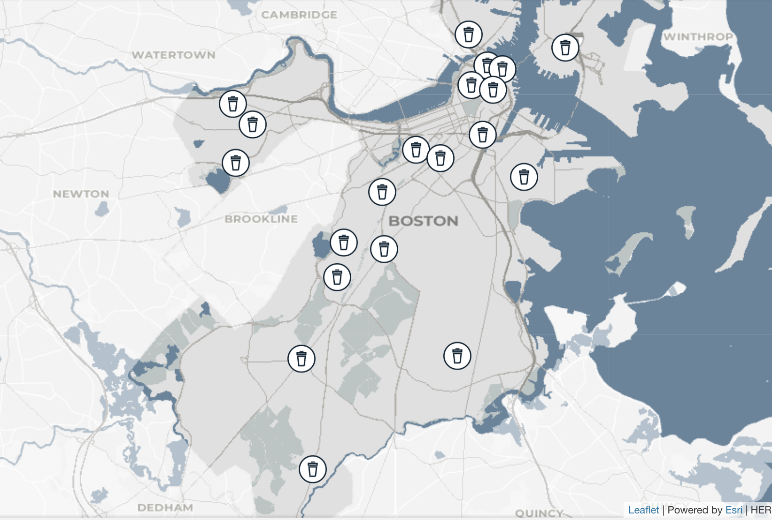
This map shows the Project Oscar bins in Boston. (City of Boston).
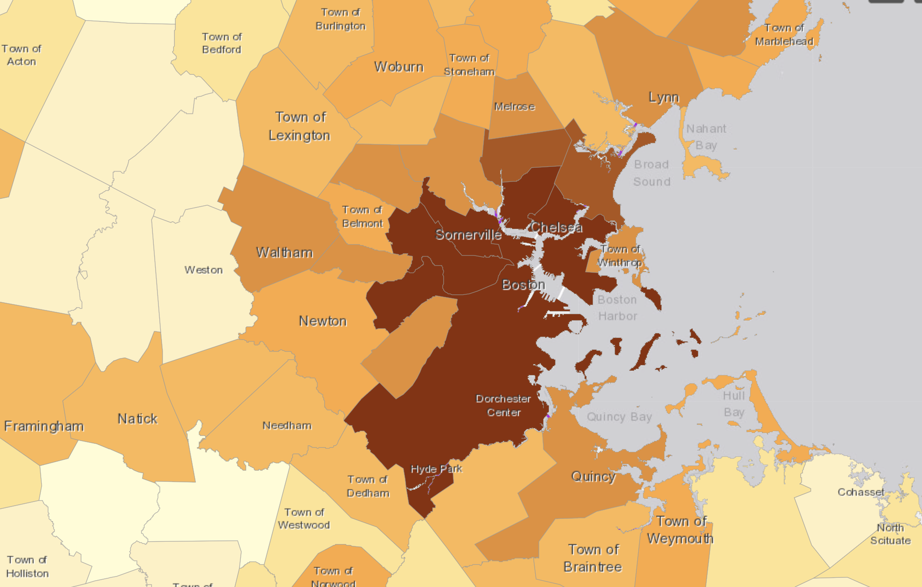
This map shows the density levels throughout Boston, with the darkest color being 20 + units/acre. (Residensity).
Additionally, in 2024, Boston University had 36,220 total students. Only 11,133 students were on a meal plan that year, which left 25,087 students to find their own way to compost.
- Discussion
The research found through interviews with municipal leaders, university sustainability members, and private compost owners that there are several major barriers to increasing composting. These barriers are categorized into four categories: infrastructure and convenience, public education and contamination, budget constraints, and mismanagement of waste diversion.
Infrastructure and Funding Constraints:
A crucial discovery from the interviews is that expansion of composting systems is delayed by a shortage of municipal funding. At Boston University, most of the composting happens “back of house” through the dining halls, but many students do not have dining plans and live off campus in Boston. The drop-off bins are reserved to one area in South Campus. Boston University Sustainability claims that expanding residential bins is “a little tricky with the budgeting, but ideally we'd have them along Bay State as well” (Haas).
The funding constraint is seen within the City of Boston, as the providers are restricted from expanding community compost bins. Project Oscar “definitely would love to see a lot more of these throughout the city, but budget is restricting us at the moment” (Montgomery). The program has only increased the number of bins by 16 over the past decade since the program started. The curbside pick program is also limited because of funding.
Private composting organizations face economic barriers. The routes that they pick up compost are limited by budget. Composting pickup services “need to be efficient” because they “can't go to a town for two people.” BlackEarth requires “X number of people per square mile.” (Sandler). Private composting companies also struggle since they charge a fee, while “the trash fees are just so cheap that no one thinks no one's gonna stand a chance” (Brooks).
Convenience:
The current composting infrastructure in Boston is highly inconvenient for residents. The limited number of Project Oscar bins suggests a correlation between low drop-off sites and lower rates of composting. The distance to compost bins decreases the incentive because of the inconvenience to residents. Montgomery claimed that the biggest barrier to composting was “distance - realistically, is a person going to travel a mile out of their way to drop off food scraps?” She continued, “having those bins in a more accessible area really improves the usage.”
While the City of Boston offers curbside pickup, they are not available to residents living in six or more units. Therefore, they have been “looking at the density maps, we saw that a lot of the folks aren't eligible for curbside food waste” (Montgomery). Boston residents in dense areas only have drop off bins as an option.
Residents who are willing to pay for private compost pickup in Boston still struggle to access the programs. The urban residents who try to subscribe to Bootstrap have to stop because “20% of the time… people complain or the building doesn't like it” (Brooks). Since the residents are not the owners of the units they live in, there are more obstacles to go through. CERO stated that “if it is inconvenient, then people will be less motivated to do something that already feels out of their routine. Bin placement often matters more than any amount of education. Make it easy, and people will do it.” (Luna)
Public Education and Contamination
Through the interviews, it was revealed that the lack of public education surrounding food waste decreases motivation and worsens contamination issues. Many people don’t understand where their food waste goes or how to compost correctly. CERO stated that “a lot of people use ‘composting’ to mean any kind of food waste diversion” (Luna). Black Earth Compost noted that “if people knew where their food goes, it would make them want to compost more” (Sandler). He highlighted that if residents comprehended that their food waste was being shipped to a “landfill in Alabama, where nothing is created,” they would participate in composting more. CERO stated that “transparency builds trust, and it helps people understand why sorting rules actually matter” (Luna).
Participation is reduced by the false impressions of composting. Bootstrap says that the biggest barrier to compost participation is “disinterest or a lack of understanding about why composting is important” (Brooks). Many residents are deterred by the thought that “it stinks… they're gonna have a rat problem… it's too complicated… too much of a burden” (Sandler). Public attention is broken by “a flooded news” where “there's so much happening in the world… people don't know where to start” (Sandler). To prevent this, we need “clear visuals and repeated reminders” (Luna).
This lack of education causes more contamination in the compost bins, which is a daily problem for compost collectors. Highly contaminated loads in the city of Boston “often get thrown away” (Montgomery).
To combat contamination, many composting organizations designate awareness programs in areas with high contamination. Project Oscar struggles to help residents become informed about the program due to their limited resources. Their local communication platform is “trying to reach the folks that we can” (Montgomery). The Project Oscar has done bus stop shelter ads for the “lowest 10 performing” neighborhoods, along with tabling and social media. They also hosted a free compost certification program with Mass Audubon’s Nature Center. Black Earth Compost also has an informative social media page. They also go to retirement, schools, and offer site tours. Bootstrap also writes blogs on their website, monthly mailer.
Haas stated that since he had “a dashboard of the residential compost bins on South Campus … we definitely noticed a few more sign-ups.” Education helps get the word out, but it is often insufficient without supplementary partners to help with outreach.
Landfills and Economic Incentives
Massachusetts is rapidly lowering the number of landfills in the state because of environmental regulations. This has caused an increased need to export waste to landfills across the country. This creates a massive economic strain because transportation costs for waste disposal are charged by weight. When Massachusetts is unsuccessful in waste diversion, they are paying to ship dense food waste miles away. Sandler argued, “we can save money. So it’s the economy and the environment.” Localizing waste diversion minimizes emissions and transportation costs.
Mismanagement of Waste Diversion
The interviews revealed that anaerobic digestion is useful when used and managed effectively. It is essential to determine what materials should go to aerobic versus anaerobic digestion. The digestate that is composted is significantly lower than the amount that would be produced from aerobic composting. Additionally, the nutrient level of digestate is lower than aerobic composting. Many compost organizations support composting over anaerobic digestion. Sandler agreed that, “you don't create compost with it, and our farmers need compost.”
CERO makes the decision on where to bring food waste based on the efficient locations and the condition of the waste. Luna says they “work with anaerobic digesters when it makes sense. The decision is mostly practical”. While Bootstrap Compost mostly does aerobic composting, they send food waste to anaerobic digestion for “logistical matters” that are based on “what's going to work for today?” (Brooks). Brooks agrees that aerobic composting is always preferred, and that it's only “a small segment of our total customer base.”
- Solutions
To address the infrastructural problems in Boston that limit the convenience for residents, the city must adopt a distance-based access policy. This would require cities and towns in Massachusetts to place bins within a certain radius of all residents. Additionally, the state must implement gradual participation targets to increase composting over time. By a certain date, “every town in Massachusetts needs 10% of their population to participate in composting” (Sandler). This would allow for a gradual increase in participation, rather than an abrupt mandate.
Supporting these mandates calls for more support of small composting groups to build their organizations. The City of Boston argues that “it's a big city, and it takes more than just us to, like, get the word out” (Montgomery). In order to increase outreach, composting organizations need more partnerships with groups that have a wider audience. Camila Elvis from Project Oscar stated that the “West End liaison… I've been trying to work with them.” Partnerships with the liaisons and with newspapers such as the City Pages.
Further, the state of Massachusetts needs to designate areas that are already regulated for composting. By “making the process faster and easier for people who want to own and operate composting facilities,” it will maximize composting in the state (Brooks). It will also help to integrate composting into everyday spaces. The state must put more composting bins in grocery stores, apartments, campuses, etc. This will help people in condensed areas who have limited composting options. These composting bins should include clear visuals to improve education and contamination levels.
The solution to the mismanagement of food waste is more regulation standards that follow the food waste hierarchy. A lot of the waste sent to anaerobic digestion should be reserved for compost. Massachusetts needs to control processed and unprocessed foods. Anaerobic digestion should be reserved for processed goods or waste that cannot be composted.
Finally, Massachusetts should continue to expand the waste ban attempts. CERO agreed that “the state's food waste regulations have helped create demand by requiring larger generators to divert organics” (Luna). By limiting the amount that organizations can send to landfills, it will continue to increase waste diversion awareness.
- Conclusion
To effectively combat the diminishing levels of soil nutrients, Massachusetts must expand local infrastructure, guarantee equitable access, increase public education, and increase waste pathway regulations. In the process of landfills closing in Massachusetts, continuing to export large amounts of waste is an unsustainable solution. Massachusetts needs to divert food waste locally to move away from landfill dependency. Composting as “the lowest hanging fruit” and “the easiest first thing to be done.” (Sandler). Ultimately, a graduated, targeted policy with community education and equitable infrastructure will allow Massachusetts to effectively restore nutrients to the soil that are now being lost to the sea or locked away in landfills.
Works Cited
Ayilara, Modupe Stella, et al. “Waste Management through Composting: Challenges and Potentials.” Sustainability, vol. 12, no. 11, 2020, p. 4456. MDPI, https://www.mdpi.com/2071-1050/12/11/4456.
“2021 Solid Waste Data Update.” Mass.gov, Commonwealth of Massachusetts, 2021, https://www.mass.gov/doc/2021-solid-waste-data-update/download.
“2023 Solid Waste Data Update.” Mass.gov, Commonwealth of Massachusetts, 2023, https://www.mass.gov/doc/2023-solid-waste-data-update/download.
“101 Cities and Towns.” MAPC, Metropolitan Area Planning Council, https://www.mapc.org/resource-library/101-cities-towns/.
“Analysis of MSW Landfill Tipping Fees 2023.” EREF Foundation, Environmental Research & Education Foundation, 2023, https://erefdn.org/product/analysis-of-msw-landfill-tipping-fees-2023/.
“Basic Information about Landfills.” EPA, United States Environmental Protection Agency, https://www.epa.gov/landfills/basic-information-about-landfills.
“Benefits of Using Compost.” EPA, United States Environmental Protection Agency, https://www.epa.gov/sustainable-management-food/benefits-using-compost.
“Bioreactor Landfills.” EPA, United States Environmental Protection Agency, https://www.epa.gov/landfills/bioreactor-landfills.
“Composting at Home.” EPA, United States Environmental Protection Agency, https://www.epa.gov/recycle/composting-home#whatcom.
“Diversion: How to Keep Waste Out of Landfills.” National Waste Associates, https://www.nationalwaste.com/blog/diversion-how-to-keep-waste-out-of-landfills/.
“How Does Anaerobic Digestion Work?” EPA, United States Environmental Protection Agency, https://www.epa.gov/agstar/how-does-anaerobic-digestion-work.
Kenny, Shannon, and Jenny Stephenson. From Field to Bin: The Environmental Impacts of U.S. Food Waste Management Pathways (Part 2). United States Environmental Protection Agency, Oct. 2023, https://www.epa.gov/system/files/documents/2023-10/part2_wf-pathways_report_formatted_no-appendices_508-compliant.pdf
Krause, M., S. Kenny, and J. Dixon. Quantifying Methane Emissions from Landfilled Food Waste. United States Environmental Protection Agency, 2023, https://www.epa.gov/system/files/documents/2023-10/food-waste-landfill-methane-10-8-23-final_508-compliant.pdf.
Luo, Yiyong. “Nutrient Cycling.” EBSCO Research Starters, EBSCO Information Services, 2023, https://www.ebsco.com/research-starters/earth-and-atmospheric-sciences/nutrient-cycling
“Massachusetts Organics Action Plan.” Mass.gov, Commonwealth of Massachusetts, Nov. 2023, https://www.mass.gov/doc/massachusetts-organics-action-plan-november-2023/download
“MassDEP Waste Disposal Bans.” Mass.gov, Commonwealth of Massachusetts, https://www.mass.gov/guides/massdep-waste-disposal-bans.
“Project Oscar.” City of Boston, https://www.boston.gov/departments/public-works/project-oscar#map--767486.
Rai, Sumit. Declining Nutrients from Our Plates. ResearchGate, 2022, https://www.researchgate.net/profile/Sumit-Rai-2/publication/359106733_Declining_Nutrients_from_Our_Plates/links/62dfc19e4246456b55e85004/Declining-Nutrients-from-Our-Plates.pdf.
“RentSmart.” Analyze Boston, City of Boston, https://data.boston.gov/dataset/rentsmart.
“Resource Conservation and Recovery Act (RCRA) Regulations.” EPA, United States Environmental Protection Agency, https://www.epa.gov/rcra/resource-conservation-and-recovery-act-rcra-regulations#nonhaz.
“Residential Density.” MHP Center for Housing Data, Massachusetts Housing Partnership, https://residensity.mhp.net/.
Siddiqua, Ayesha, John N. Hahladakis, and Wadha Ahmed K. A. Al-Attiya. “An Overview of the Environmental Pollution and Health Effects Associated with Waste Landfilling and Open Dumping.” Environmental Science and Pollution Research, vol. 29, no. 39, 2022, pp. 58514–58536. PubMed Central, https://pmc.ncbi.nlm.nih.gov/articles/PMC9399006/.
Smith, Pete, et al. “Status of the World’s Soils.” ResearchGate, https://www.researchgate.net/publication/385065480_Status_of_the_World's_Soils.
Sullivan, Dan M., et al. Interpreting Compost Analyses. Oregon State University Extension Service, Oregon State University, https://extension.oregonstate.edu/catalog/em-9217-interpreting-compost-analyses.
“Wasted Food and Landfill Methane.” EPA, United States Environmental Protection Agency, Oct. 2023, https://www.epa.gov/system/files/documents/2023-10/food-waste-landfill-methane-10-8-23-final_508-compliant.pdf.
“Wasted Food Pathways Report.” EPA, United States Environmental Protection Agency, Oct. 2023, https://www.epa.gov/system/files/documents/2023-10/part2_wf-pathways_report_formatted_no-appendices_508-compliant.pdf.
“Wasted Food Scale.” EPA, United States Environmental Protection Agency, https://www.epa.gov/sustainable-management-food/wasted-food-scale.
“Waste Diversion at EPA.” EPA, United States Environmental Protection Agency, https://www.epa.gov/greeningepa/waste-diversion-epa.

Interview Links
Andy Brooks from Bootstrap Compost: https://otter.ai/u/6pwRbXi507_uY-lOuyzO6ExRN4Y?utm_source=copy_url
Grant Haas from BU Sustainability:
https://otter.ai/u/A8vZayRJwe-2iHLMBf6bX1aZizQ?utm_source=copy_url
Justin Sandler from BlackEarth Compost:
https://otter.ai/u/nWjugxHKAC5YpSxpYMISW4zr3Gs?utm_source=copy_url
Justin Sandler site tour at BlackEarth Compost:
https://otter.ai/u/EAm9Z8cC2EZ7v6zGGAqrxE-iYPc?utm_source=copy_url
Madeline Montegomery and Camilla Elvis from Project Oscar:
https://otter.ai/u/DqSIOuVMu39K97ugwdGT-5AhvLI?utm_source=copy_url
https://otter.ai/u/epwo9YCl5614UlG8yzDsa4Sk-PI?utm_source=copy_url
Rhina Luna from CERO
https://docs.google.com/document/d/1BW-C5PhkIsPd2MoLYjk0IN2P8RbO-I8ncm1EPTHj-fw/edit?usp=sharing

