Tatiana Carrido Final Paper
EE538 May 4, 2025

Measuring Sound to Reduce Noise: Comparing sound recording smartphone applications to map out noise in the city of Boston

1 Introduction
A large and poorly understood component of pollution in the United States is noise. In 2022, the World Health Organization (WHO) released updated guidelines on environmental noise. These were based on the noise indicators from the European Union Directive 2002/49/EC (3) in the European Region. Sound pressure levels were recommended for road traffic, railway, aircraft, wind turbine, as well as yearly and weekly averages for leisurely sound sources. Night noise exposure sound levels were also recommended for transportation sources. In contrast, most of the sound level exposure limits in the United States are generally concentrated within a workforce setting. This can largely be attributed to the defunding of the Noise Control Act of 1972 and the Quiet Communities Act of 1978.
In 1972, the EPA announced a press release regarding the launch of a noise control program under the Noise Control Act. The Noise Control Act of 1972, signed by former President Nixon, granted the EPA primary jurisdiction around environmental noise. These responsibilities included coordinating Federal programs in noise research and control, labelling and setting standards for products linked to major sources of noise, and recommending regulations to the Federal Aviation Agency as necessary. In 1978, the Quiet Communities Act (QCA) amended the Noise Control Act to include grants to support the identification of noise problems, planning noise-control capacity, developing abatement plans for major stationary sources of noise, and evaluating techniques for noise control. Both mandates were defunded in 1982 during the Reagan administration, although they were never rescinded by Congress as are still “in effect” today.
Since the Noise Control Act of 1972 and the Quiet Communities Act of 1978 were defunded, most of the work towards upholding quiet and ambient communities has shifted to state and local governments. In addition, minimal studies have been made in the United States outside of the harmful effect of noise to human and animal health.
Noise mapping, a practice that involves a detailed analysis of sound in a specified area, may hold the key to mitigate excessive noise. The United States has been lagging to catch on to regional noise mapping, even though most European tools can be smoothly integrated into U.S. projects. Noise mapping enables a geographic view of noise that is essential to mitigating noise at problematic levels and developing solutions for communities at higher risk. However, without the support of legislation, it can be difficult to acquire noise mapping data without the participation of communities. This paper presents the results from one focus group based on their experience using two sound-recording applications—the National Institute for Occupational Safety and Health’s Sound Level Meter (NOISH SLM), and Noise Project, led by Cornell Lab of Ornithology researchers in collaboration with Independent Community Based Organizations (ICBOs).
Although previous studies exist that leverage smartphone applications to encourage community participation, this study aims to compare two different smartphone applications and identify key themes or features that can increase the long-term impact of pooled community sound data. This study includes the recruitment of participants, all of whom actively reside, commute, and live their day-to-day life within the city of Boston for at least three consecutive months at a time. The methodology of this study is meant to be replicated by communities who hope to find a low cost and high-level participation project to quantify and gauge sound perception in communities in both a quantitative and qualitative manner.

2 Methods

2.1 Case Study

Boston is the capital of the state of Massachusetts in the United States. Also referred to as “the youngest city in America,” 35% of Boston’s 653, 833 population is between the ages of 20 to 34 years old. Other than its demographic, another feature worthy of note is Boston’s expansive transportation network. Boston residents enjoy several options for travel under the Massachusetts Bay Transportation Authority (MBTA), including the commuter rail, subway, bus, and ferry. In East Boston, the Boston Logan Internation Airport offers direct flights to over 100 domestic and international destination. As a global gateway to Massachusetts and New England, Boston faces a heightened exposure to elevated sound pressure levels from the transportation sector alone.

2.2 NIOSH Sound Level Meter (SLM)

The NIOSH Sound Level Meter (SLM) was developed to measure workplace noise and aid the detection of hazardous noise by integrating professional sound level meters and dosimeters in one smartphone application. Some key features of the app include built-in metrics found in professional instruments, technical support from NIOSH hearing experts, as well as informational screens regarding hazardous noise levels, conducting noise measurements, selecting hearing protectors, and hearing loss guidelines. The application aims to help its users make informed decisions about their noise exposure and reduce the risk of occupational hearing loss.

2.3 Noise Project

Noise Project is a project supported by the National Science Foundation (NSF) under a grant entitled “Developing the Processes and Potential to Engage Historically Underrepresented Communities in Public Participation in STEM Research Through Authentic and Impactful Collaboration”. The mobile application prioritizes learning about noise pollution and equity through lens of wellbeing and social justice. One of the defining features of Noise Project is the Community Map, which allows users to view recordings from others and identify Noise Refuges, or areas that have low sound pressure levels.

2.4 Framework

This study adopted a two-fold approach: (i) to develop a sound map for the city of Boston based on measurements made by residents, (ii) to bring together said residents and discuss the key features between two sound measuring smartphone applications that are beneficial to sustaining long-term monitoring of sound exposure.

2.4.1 Data collection
Data collection lasted two weeks, from early to mid-April 2025. Participants were encouraged to make at least three recordings within this timeframe, at varying times throughout the day such as during active commute, walking between class and/or work, during meals in public spaces, etc.

2.4.2 Recruitment of Participants and Focus group

The focus group comprised of twelve university students, all within the 20-34 years old age range dominant within the Boston population. All students dwelled, commuted, and worked in Boston for at least three months at a time. The following questions were asked during the thirty-minute session:
- How easy was it to make a recording on NIOSH? On Noise Project? Describe any difficulties or conveniences encountered.
- What was your favorite feature of NIOSH? Of Noise Project?
- What makes noise recording apps different from other map generating applications? Do the apps work well to inform people about noise exposure?
- Is the app effective in the long-term? What are the pros and cons of using apps to monitor noise pollution? How does the app encourage changes in behavior?
- Describe how this study can impact community participation around noise initiatives/programs/policies.

3 Results

3.1 Sound map of the case study
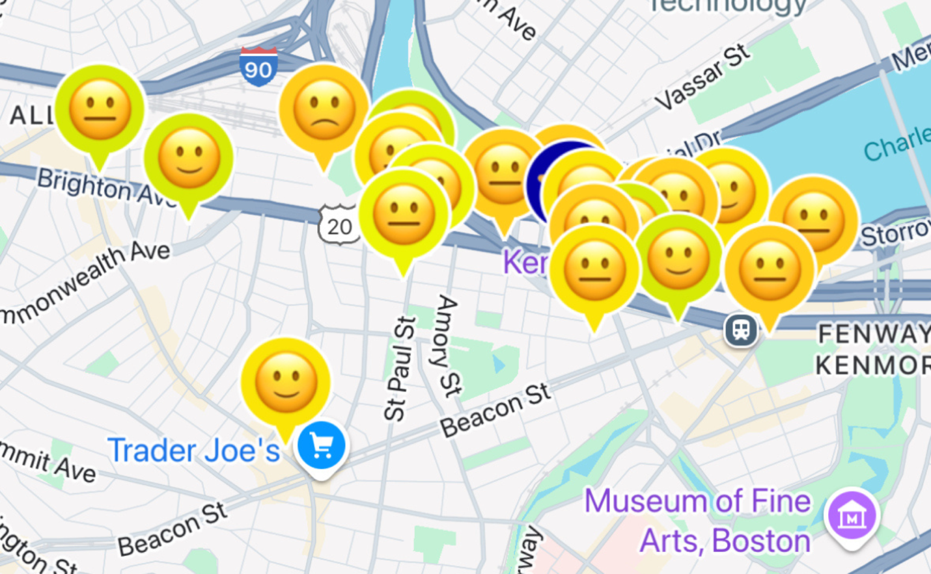
Figure 1. A map of the Boston University area after the study was conducted, including 21 data points post-data collection period.

3.2 Focus group insights and findings
After two weeks of data collection, the number of data points for Boston University was 21. Of the 21 data points, only one recording was identified as a Noise Refuge. In response to the five questions mentioned in the methods section, the following themes were identified when comparing both applications:
Intuitiveness
At least five of the participants voiced out that Noise Project felt “more intuitive to use” because of its user-friendly features. This included a sound meter, which compared live sound with similar sources such as rain, birds, traffic, and conversations in groups larger than two people. Participants also noted that recording on Noise Project felt guided and the recordings were automatically saved to their devices. In contrast, NIOSH SLM’s interface was slightly more challenging to navigate, as recordings were not automatically timed and users needed to manually save their recordings to retrieve them.
However, there were some remarks regarding the user interface of Noise Project that made participants question its legitimacy. For instance, Noise Project asks post-recording questions that can only be responded to using emojis. “Description emojis” allow users to give a general insight to the elements that can be found in the location, the mood of the space, and how the sound makes them feel. There is also an option to upload additional emojis if they feel like the ones shown by Noise Project do not accurately reflect the ambiance of the location. While this can be argued to maintain user anonymity, some participants felt that this approach was reductive and diminishes users’ ability to capture aspects of their recording beyond the sound measurement. On the other hand, participants found that the minimalistic and darker themed user interface of NIOSH SLM made it seem “more credible” and “legit”. There were minimal images used to denote features on the app beyond those needed to toggle between the app’s four main menus: Sound level meter, Saved, Noise info, and Settings.
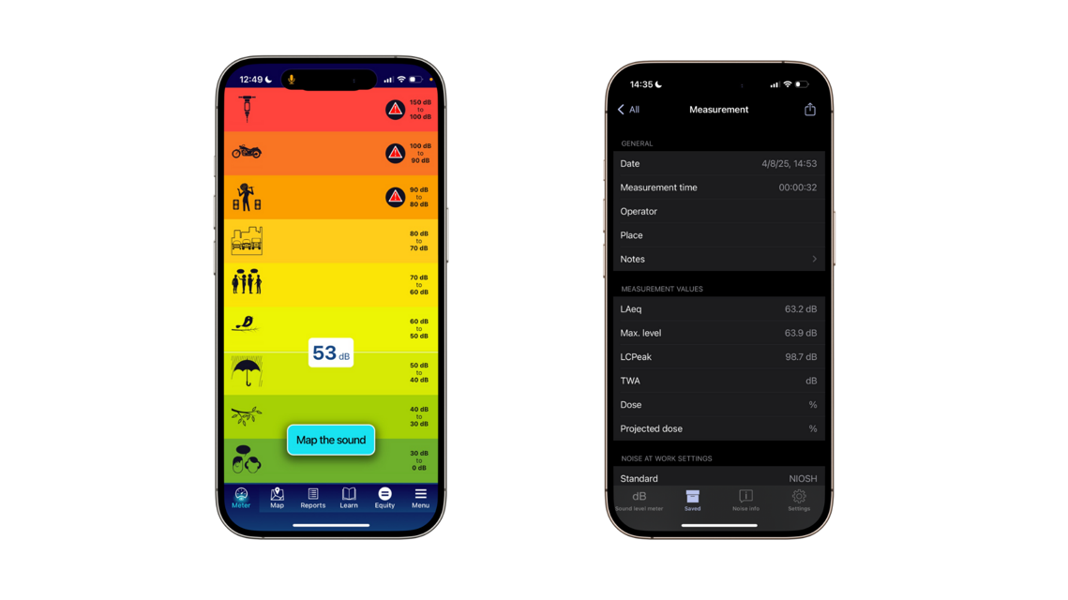
Figure 2. Side by side comparison of Noise Project (left) and NIOSH SLM’s (right) user interface.

Information
Participants made note of the differences in emphasis made by Noise Project and NIOSH SLM in terms of educating its users. They agreed that NIOSH focused on the long-term effects of sustained noise exposure, specifically with hearing loss. On the other hand, Noise Project promotes a reevaluation of the user’s relationship with sound and how it relates to well-being.
Introspection
This third theme has to do with how participants felt following data-collection and how they might act differently to mitigate their sound exposure going forward. One participant brought up the idea of using technology and even added sound to cope with noise. Headphones and other audio devices have been increasingly popular, especially with rapid improvements and increasing accessibility of noise-cancelling technology. Another participant talked about the option to integrate NIOSH SLM’s data with Apple’s Health app, which can then be used to notify users when their noise exposure is at potentially harmful level.
4 Discussion
This study accomplished two things: (i) populate the city of Boston with at least 21 sound recordings, and (ii), identify three key themes to compare two noise recording smartphone applications. These key themes can be helpful for future software updates as well as aid program developers when creating new smartphone applications targeting environmental noise. While this study accomplished its main objectives, the framework and methodology can be further improved in future studies.
One weakness of the study was that it did not prime participants on best practices when making sound recordings. In 2010, the European Commission and the European Environment Agency organized a 2-day workshop on target quality and input values requirements for noise mapping. The authors of this paper created a discussion document on good practice in the use of noise mapping software. The following were cited as major factors where users influence the quality of the results of noise mapping software: user’s knowledge of the standard, the clearness of the documentation of the standard, the user’s knowledge of the software, documentation of the software functions and its implementation of the standard, quality of the software implementation, documentation of software settings in calculation results, and the user’s analysis of quality and impact of the data. These findings suggest the importance of shared responsibility between method developers, software developers, and users for result quality and the need for good practice. For this study, one modification could be to time-bound recordings between 30 seconds to 1 minute, especially in the case of NIOSH SLM where users were free to record sound for as long as they liked. Another way to preserve the quality of recordings would be to tell participants to be mindful of weather conditions (avoiding rain and gusts of wind).
In addition, this study could be scaled to increase both the number of participants and length of the data collection period. To create a more holistic discussion, it would be beneficial to organize multiple focus groups and follow-up sessions, as opinions and insights may change as participants use the applications and learn from each other.
5 Conclusion
Leveraging community participation and facilitating discussions leads to validation, empowerment, and documentation. It is a reminder that individuals are not alone in their experience, and there is a way to move forward for communities that are heavily impacted by environmental noise. The use of free sound recording applications is one promising way that communities can not only engage with each other but also pool open-access data that can help residents make informed decisions on their exposure to harmful and elevated levels of noise.

References
Boston Redevelopment Authority. (2010). Boston By Numbers: Young Adults. Retrieved from
https://www.bostonplans.org/getattachment/3e12e127-55d0-4ae3-9927-254568ab3dc4#:~:text=Boston%20has%20the%20highest%20concentration,between%2020%2D34%20years%20old.
Can. A., Audubert, P., Aumond, P., et al. (2022). Framework for urban sound assessment at the
city scale based on citizen action. With the smartphone application NoiseCapture as a lever for participation. Noise Mapping, 10(1).
EPA. (n.d.). EPA History: Noise and the Noise Control Act. Retrieved from
https://www.epa.gov/history/epa-history-noise-and-noise-control-act
EPA. (1972). EPA to launch noise control program. Retrieved from
https://www.epa.gov/archive/epa/aboutepa/epa-launch-noise-control-program.html
Kaliski, L., Duncan, E., Cowan, J., (2007). Community and regional mapping in the United
States. Sound and Vibration, 41(9), 14-19.
Kephalopoulos, S., Paviotti, M., Anfosso-Lédée, F., Van Maercke, D., Shilton, S., Jones, N.
(2014). Advances in the development of common noise assessment methods in Europe: the CNOSSOS-EU framework for strategic environmental noise mapping. Science of the Total Environment, 482-483, 400-410.
Manvell, D., Hartog van Banda, E. (2011). Good practice in the use of noise mapping software.
Applied Acoustics, 72, 527-533.
Providence Noise Project. (n.d). Federal Noise Law. Retrieved from
https://providencenoiseproject.org/laws/federal-law/

Appendix
Participant | Intuitiveness | Information | Introspection
Participant 1 | Noise Project told you how long to do recording. It shows the comparison next to the level of noise and pictures to say what the noise would be to understand the type of noise the person is experiencing. NIOSH didn’t specific how long it needed [to record]. It doesn’t save automatically, and the abbreviations weren’t intuitive, but this also made it seem more legit. |  | Noise Project encourages changes in behavior when the noise is related to other more macro problems.
Participant 2 | [Noise Project] was a lot more accessible. It used lay people terms which made the report a lot more understandable. | NIOSH focuses on hearing disorders and hearing loss. Noise Project focused more on connecting noise with well-being.
Participant 3 | [Noise Project] was almost oversimplified. The emojis were cute but how comprehensive can your report be when you cannot say exactly where the source is coming from |  | I noticed that when I had to take out my headphones to make a recording, that I have been putting on music to block out noise. Using headphones helps control the noise that we are exposed to, but when we aren’t wearing them, we aren’t able to filter out noise as well.
Participant 5 |  |  | NIOSH asks if you want to share your data with Apple Health. This is an interesting integration since Apple also monitors your headphone audio levels.

EPA. (1972). EPA to launch noise control program. Retrieved from https://www.epa.gov/archive/epa/aboutepa/epa-launch-noise-control-program.html
Providence Noise Project. (n.d). Federal Noise Law. Retrieved from https://providencenoiseproject.org/laws/federal-law/
EPA. (n.d.). EPA History: Noise and the Noise Control Act. Retrieved from https://www.epa.gov/history/epa-history-noise-and-noise-control-act
Perfect Pollution Services. (n.d.). Noise Mapping. Retrieved from https://www.ppsthane.com/blog/noise-mapping
Kaliski et al. Community and regional noise mapping in the United States, p. 14
Boston Redevelopment Authority. (2010). Boston By Numbers: Young Adults. Retrieved from https://www.bostonplans.org/getattachment/3e12e12755d04ae39927254568ab3dc4#:~:text=Boston%20has%20the%20highest%20concentration,between%2020%2D34%20years%20old.
National Institute for Occupational Safety and Health (NIOSH). (n.d.). Noise and hearing loss: NIOSH sound level meter app. Retrieved from https://www.cdc.gov/niosh/noise/about/app.html
Noise Project. (n.d.) The Noise Project: We’re changing the way science is done. Retrieved from https://noiseproject.org/
Participant 1, refer to Appendix
Participant 1, refer to Appendix
Participant 1, refer to Appendix
Participant 3, refer to Appendix
Participant 2, refer to Appendix
Participant 3, refer to Appendix
Participant 5, refer to Appendix
Manvell, D., Hartog van Banda, E. (2011). Good practice in the use of noise mapping software. Applied Acoustics, 72, 527-533.

