Empowering Community-Based Development and Maintaining Housing Affordability

A project of the Boston University course “Research for Environmental Agencies and Organizations”, produced by Will Chang under the supervision of Rick Reibstein.

This report provides an overview and discussion of policy options for action to prevent the displacement of low-income residents, a necessary complement to efforts to develop low-income neighborhoods, without which the efforts cannot be expected to benefit existing residents.

Introduction
Across the country, entire communities are being priced out of their homes. Compared to the overall rate of inflation between 1990 and 2016, the national median rent is rising 20 percent faster and median home price by 41 percent (Harvard 2018). The main factors driving this sharp increase are more expensive building materials, labor, and stagnating productivity gains. Boston faces a greater challenge: the median household income in Boston is the same as the national figure, but housing prices are 2.5 times more expensive. For lower-income individuals and households in the Boston area, paying for housing can mean cutting down on essentials like food, descending further into debt, or having to face homelessness. The human cost of unmitigated gentrification cannot be overemphasized. Housing instability is a public health crisis that is correlated with more negative nutrition, healthcare, educational outcomes, and economic opportunity (Harvard 2018). In a statement to the National Low-Income Housing Coalition, U.S. Representative Ayanna Pressley of Massachusetts reaffirmed that “So long as there is a national housing shortage, the American Dream remains largely deferred.” (NLIHC, 2019).

The standard definition of “cost-burdened” is spending more than 30 percent of pre-tax income on housing. Those spending more than 50 percent of their income on housing are classified as severely cost-burdened. In the Mayor’s Imagine Boston 2030 report, 21 percent of Bostonians are severely cost-burdened. Twenty-three percent of Bostonians are living in poverty, with higher rates in the Jamaica Plain and Dorchester areas. As the Boston area continues to develop new housing and business units, it is crucial that legislators, organizers, and responsible developers work in tandem to mitigate the effects of gentrification, or this unacceptable level of suffering will only be worsened. Increases in home and rental prices are far outpacing the incomes of residents. The citywide median housing cost for Boston increased by 36 percent between 2010 and 2015. In more vulnerable communities, increases in housing costs are even higher: 50 percent in Mattapan, 52 percent in East Boston, and 70 percent in Roxbury. If there is no corresponding increase in assistance from policymakers and organizations, the community residents will undoubtedly be displaced, and well-intentioned efforts to improve the lives of people living in less desirable conditions will fail.

There are policies being proposed today that illuminate a path forward. U.S. Senator Cory Booker has proposed several policies to change the declining status quo. One policy is granting tax credits of the difference between the rent and earnings for households who spend more than 30 percent of income on housing (the definition of cost-burdened). Booker claims that this plan will provide eligible families with a median tax credit of $4,800 and bring 9.4 million people out of poverty. There is also the stick and carrot model for stimulating socially conscious development in cities. Booker proposes denying more than $16 billion in annual federal infrastructure and transportation funding to cities that aren’t “demonstrating progress towards reducing barriers to affordable housing.” (Medium, 2019). According to Booker, indicators of progress “include reduced restrictions on lot size, fewer parking requirements, and allowance of accessory dwelling units and multi-family homes, among others.” (Medium, 2019). Booker also proposes guaranteed legal representation for residents facing evictions and protections from landlord retaliation. It was estimated in 2010 that 90% of landlords have legal representation and 10% of tenants do (Fordham Urban Law Journal, 2010). Unsurprisingly, tenants with lawyers are significantly more likely to successfully fight eviction.
Cities are also actively taking action in the face of a national housing crisis. Minneapolis recently voted to pass a wide-ranging reform to the city zoning laws as an innovative solution to the housing shortage. 75 percent of the city’s residents live in zones designed for single-family homes. The new plan, Minneapolis 2040, will redefine single-family neighborhoods to allow for multiple occupancy apartments, which is a big step towards opening up more housing units in the city. Oregon has passed the nation’s first state rent stabilization bill, limiting annual increases to 7 percent in addition to inflation. Exemptions are made for subsidized rent and any new construction in the next 15 years. The bill also includes tenant protections against landlords, requiring a 90 day notice ahead of rent increases and potential evictions. The New York Senate has passed legislation that abolishes loopholes that has allowed landlords to deregulate more than 155,000 units since the 1990s and raise rents substantially when a tenant moves out of rent-stabilized units (New York Times, 2019).
There are a variety of existing policy options to choose from: rent stabilization laws that prevent unreasonable increases in rent, legal protections for tenants, subsidies for smaller landlords to maintain quality housing, and expansions of housing assistance programs. It's important to keep in mind that achieving affordable housing is not a zero-sum game, with residents, landlords, and developers fighting for a slice of the economic pie. Rent stabilization laws need not eliminate the incomes of landlords and housing assistance is not socialism. Policy extremism detracts from progress and benefits no one except for those who profit from disarray. Gentrification is a deep-reaching issue that will require action from all operational levels and stakeholders. The following policies were selected to represent the wide range of possibilities that both policymakers and community members have available, from the grassroots level to municipality zoning laws.

Community Driven Development
Community Benefits Agreements
Community Benefit Agreements (CBAs) are legally enforceable contracts agreed upon between a coalition of community-based organizations and the invested developers. CBAs should be used in conjunction with existing processes (i.e. Inclusionary Development Policy, zoning laws) to ensure a fair, transparent development process. If implemented correctly, CBAs can help direct the development in a way that benefits all parties involved (e.g. the local community, investors, and developers). Not only do community residents receive site-specific benefits like local hiring and affordable housing, but developers can also benefit from faster entitlement approval processes. It is crucial that existing community members are given a voice in the process, even before development begins. Oftentimes, it is too late to change the direction of development once construction begins. For an effective CBA to develop, there has to be sufficient community leverage and engagement to sustain the negotiations and organizing across months of planning. The coalition of community organizations will need to work closely with the developers and municipal planning board to ensure that the development does not create excessive negative externalities (e.g.: pollution, food deserts, unaffordable housing). Theoretically, a CBA can also be prepared in advance by the community to attract specific investments such as in education, healthcare, or green space.
An example of a successfully implemented CBA is with the 10-acre, mixed use development adjacent to the Nashville Soccer Stadium in Nashville, Tennessee. It was signed in 2018 between Stand Up Nashville (SUN), a coalition of local community, labor, and faith organizations, and the stadium developer Nashville Soccer Holdings. As the first CBA signed in Tennessee, it guarantees that 20% of all housing units will be set aside as affordable housing for workers and families, a targeted hiring program that pays at least $15.50 an hour, affordable small-scale retail spaces, a childcare facility, community soccer programs, and equitable contracting (For Working Families, 2018). This is one of many successful instances of a CBA, including others in Milwaukee, New York City, Los Angeles, San Francisco, Oakland, Pittsburgh, Atlanta, and Denver.

Opportunity Zones & Environmental Justice Communities
The current development initiative of Opportunity Zones (OZs) was brought to our attention by the EPA’s Environmental Justice program. Established in the most recent tax reform package, the zones offer tax-incentivized funding opportunities in areas designated by the governor. Most notably, investments in OZs receive exemptions from capital gains tax that is proportionate to the length of time (10 percent exempt for a five year investment, 15 percent for seven years, 100 percent exempt for ten years or more). Opportunity Zones will have limited effectiveness in Boston, due to its intentionally sidelined designations (e.g. Harbor Islands, Franklin Park, small cemeteries). By sidelining the OZs, Governor Baker and Mayor Walsh hoped to slow the gentrification stemming from development. But leaders from investment-starved areas such as Mattapan see this as having thrown out the baby with the bathtub, such as City Council President Andrea Campbell who was shocked that no tracts from Mattapan were selected (WBUR, 2018).
Another zoning designation that is currently relevant is Environmental Justice Communities. In 2017, the Massachusetts Executive Office of Energy and Environmental Affairs established that a census block can be designated as an EJ community if it fulfills at least one of three criteria: a median low-income, a large demographic of minority groups, or low rates of English fluency. The same criteria can indicate areas that can benefit from the tax-incentivized investments targeted by Opportunity Zones. You can see the stark differences in zoning in the map below produced by Christopher Reyes, a previous student of this research class.
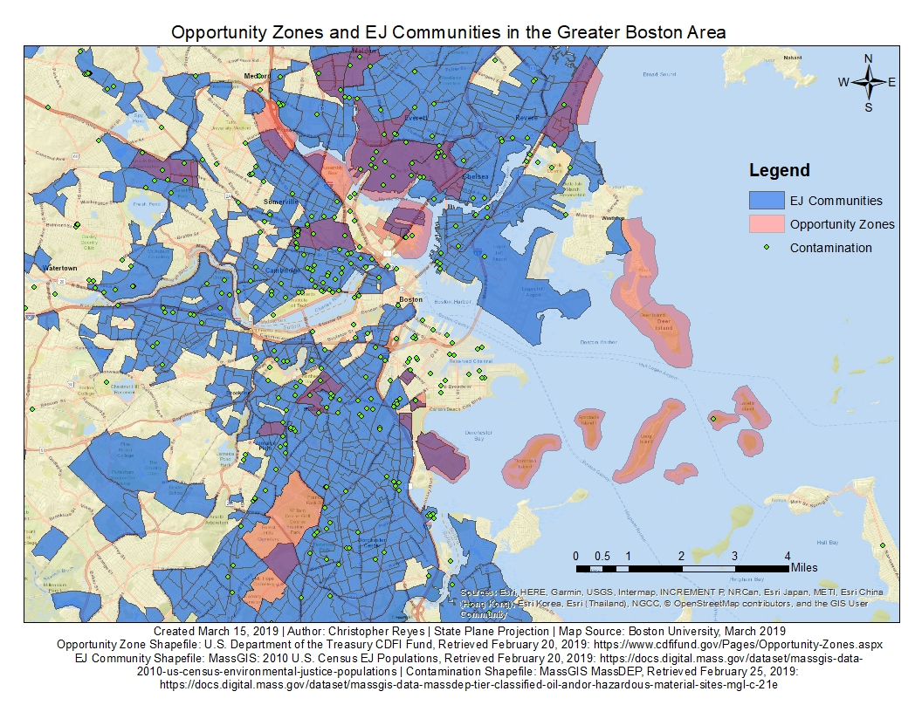
As it stands, Opportunity Zones present a mixed bag for both investors and community residents. The exact definition of OZ and EJ zones, and their implications for funding are still under debate in the State Senate. The regulations and tax codes are still in flux on the federal level as well. Currently the best thing for communities to do is align their permitting and zoning laws with the type of OZ investment that is needed (i.e. education, grocery markets, community centers); to engage their citizens in efforts to envision the kind of development the community should have; to increase public discussion of development proposals, and to seek to attract and reward the development that most benefits the existing community. Without this effort communities may find themselves with the choice of an up-or-down vote on a plan devised by someone else, with other goals than those the community may wish to have.

Community Land Trusts (CLTs)
By placing ownership of the land in a community-based nonprofit organization, the neighborhood is empowered to resist gentrification and direct investments as needed. Community land trusts (CLTs) offer a unique wealth building mechanism where individuals can own and build equity in homes, as opposed to rental assistance programs that simply provides housing. Like other affordable housing programs, CLTs will depend on public subsidies to offset the affordability it provides to cost-burdened individuals. The Boston Housing Authority (BHA) has a history of subsidizing affordable housing by developing on public property, which situates CLTs as a realistic policy option. CLTs were first incorporated into federal law through the Housing and Community Development Act of 1992, which paved the way for increased federal funding and public support. Today, there are an estimated 225 CLTs in the U.S. that provide approximately 12,000 owner-occupied units (Harvard, 2019).

The full potential of CLTs has not yet been reached. With the exception of five large outliers of CLTs that contain up to 2,765 properties, the average CLT portfolio contains less than 50 housing units each. Of the 225 CLTs, 60 are start-ups with no homeownership units. This demonstrates that land trusts are a scalable community development model that can bridge the gap between local residents and property stakeholders. The units can eventually be sold by the homeowner for a return on investment, but the selling price is required to be affordable for the next low- and middle-income homeowner. For example, the Champlain Housing Trust in Burlington, Vermont allows for the reselling of a housing unit for the original buying price plus 25 percent of any appreciation in value (Harvard, 2019). When the land is a shared resource that can be directly invested in by community members, the neighborhood benefits from the self-sustaining, collective wealth-building cycle. CLTs can and should be tailored to the community’s specific needs, such as incentivizing business investments from Opportunity Funds, the building of public parks, or community centers. The general concern regarding CLTs is the administrative burden that comes with larger properties, but if the staff is locally-based and oriented, it can be a resource for creating further investments in the community. The low foreclosure rates of CLTs and its offer of permanent affordability is promising enough for Boston to begin experimenting with letting communities take control of their land.

Economic and Workforce Development

Local and Equitable Hiring
Hiring qualified, low-income workers is a direct investment in the community that extends beyond providing affordable housing and job opportunities. Oftentimes when gentrification occurs, the local economy and job accessibility is out of reach of lower-income community residents. By placing qualified workers on the economic ladder, local workforce development efforts can tackle both financial and housing insecurity. The most effective hiring programs are thought to be those based on first source referral systems that connect previously unconsidered job-seekers with employers at development sites. Critics of such programs argue that hiring requirements can limit the number of developer bids and increase costs for operating businesses, but that does not take into account the long-term positive externalities. The concept of quality over quantity – and placing community interests in the foreground - should be applied to the incentivizing of developer bids.
In fast-growing cities such as Los Angeles and Seattle, targeted hiring programs have added millions of dollars in wages and tax revenues to local economics (Partnership for Working Families, 2008). For example, the Community Benefit Agreement (CBA) signed in 2004 with the Los Angeles Airport (LAX) modernization development guaranteed over 300 retail, food service, airline contracting, and other jobs to local job-seekers. Beginning in 2006, local hire requirements have been incorporated into all future lease and contract agreements. Targeted hiring policies can be applied to private developments that receive public investment such as government contracts, tax credits, or land subsidies. That makes it an especially promising policy option in Boston, where many private developments are subsidized by the Boston Housing Authority (BHA) with lower-cost public lands. Community Benefits Agreements can also be used as an effective vector in creating targeted hiring programs.

Zoning & Permitting
Sustainable and affordable development begins with the local zoning and permitting processes. Municipalities can anticipate the needs of community residents and prepare the infrastructure for multifamily residences with accessible public transportation. Denser housing units can also allow for greater flexibility in the preservation of green spaces and community centers. In this way, communities can preemptively set up the types of investment they would want to attract. Zoning laws can also influence the affordability of developments. Created in 2000, Boston’s Inclusionary Development Policy (IDP) is a step towards creating affordable communities through inclusionary zoning. It currently requires that eligible private development projects fulfill one of three policy options: have at least 13 percent of on-site units be affordable, have off-site affordable units, or have contributed to the IDP fund that builds affordable units elsewhere. As of 2017, the policy has directly created 2,599 affordable units and indirectly funded 1,414 affordable units (Boston Planning & Development Agency, 2018). The IDP affordability of thirteen percent is arguably too low. In San Francisco, an inclusionary zoning program was recently passed to increase the number of affordable units in a development to 25 percent, the highest in the country (All-In Cities, 2019). In Boston, the full potential of zoning policies in combating housing insecurity and gentrification has yet to be reached.

Rental Assistance Programs & Policies
The latest housing report by the National Low-Income Housing Coalition finds that the average Massachusetts citizen would have to work 91 hours a week at minimum wage in order to afford a 1-bedroom rental home at fair market prices, without spending more than 30 percent of income on housing. That is an impossible demand, even more so for lower-income households in gentrifying areas. Rental assistance programs will only become more necessary for individuals to afford housing. The state of Massachusetts currently offers three voucher programs as financial aid for renters, funded by the Commonwealth and U.S. Department of Housing and Urban Development (HUD). Lengthy waiting lists have largely rendered these assistance programs as a long-shot for households in need. Alongside expanding financial assistance for renters, there is also much room for improvement in the current model of landlord-tenant relationships. Inspiration can be drawn from the sweeping changes recently passed by the New York Senate that seek to improve tenant’s rights and rental accessibility. Financial barriers to renting were lowered, with security deposits limited to one month’s rent and an easier return process. Rental application fees were also limited to $20. These changes will greatly reduce housing insecurity among renters with access to less capital. Lawmakers should take into consideration the limited ability of smaller property owners to absorb costs of damages or owed rent, but that is where a well-functioning housing court system comes in. New York has reformed the eviction and notice system to give tenants the necessary information in a reasonable time frame, with extra consideration given to how evictions may affect the well-being of children. For single-parent families who are especially vulnerable, this increase in protections can make all the difference. Protecting the rights of tenants, affordability of rental prices, and solvency of landlords, should be a high-ranking priority for governmental planning and housing agencies.

Discussion
When a community faces rapid economic investment, it is the responsibility of policymakers to ensure that the lives of existing residents aren’t discarded in favor of more profitable developments and businesses. Even well-intentioned sustainable environmental improvements can produce negative outcomes if the existing community cannot access the benefits. Policymakers could do a great more to meet their responsibility to serve the lower-income people as well as the wealthy. There could be a great deal more effort to generate community engagement throughout the development process, by requiring more of developers and providing more assistance and outreach to residents. The policies above are implementable. They give a voice to the community and its needs. They strengthen coalitions and a sense of belonging.
It is clear from the current subsidy levels that there is insufficient action from federal housing programs. Even though the number of severely cost-burdened renters has risen by 6 million, the number assisted rose only by 950 thousand (Harvard, 2018). In total, the share of renters with assistance decreased from 29 percent to 25 percent. Aside from collaboration between public, private, and nonprofit sectors, a more robust response – from all levels of government - is needed to help the millions of households who simply do not make enough income to pay for increasing housing costs. More federal subsidies are needed to supplement state efforts, such as federal housing choice vouchers and low-income housing tax credits.
Any city that successfully achieves economic development without social displacement through community organizations and government assistance can serve as a source of inspiration and support for other cities across the country. Even a brief review of available policies shows that there are strategies that hold the promise of preventing displacement, while improving the environment in communities that need it. Cities can act to preserve the quality of life that people have worked so hard to maintain. The prospect of providing shelter from the damaging tides of gentrification is real, and merits exploration.
Summer, 2019

Works Cited
All-In Cities: An initiative of PolicyLink. Accessed on 20, June 2019. https://allincities.org/toolkit
City of Boston, Office of the Mayor. “Imagine Boston 2030: A Plan for the Future of Boston” June 2018. https://www.boston.gov/sites/default/files/imce-uploads/2018-06/imagine20boston202030_pages2.pdf
Cory Booker. “Cory’s Plan to Provide Safe, Affordable Housing for All Americans” 5, June 2019. https://medium.com/@corybooker/corys-plan-to-provide-safe-affordable-housing-forall-americans-da1d83662baa
Fordham Urban Law Journal. “Connecting Self-Representation to Civil Gideon: What Existing Data Reveal About When Counsel is Most Needed” 2010. https://ir.lawnet.fordham.edu/cgi/viewcontent.cgi?article=2321&context=ulj
Joint Center for Housing Studies of Harvard University. “Strategies for Sustainable Growth in Community Land Trusts” March 2019. https://www.jchs.harvard.edu/sites/default/files/harvard_jchs_palmer_strategies_sustainable_growth_community_land_trusts_2019_0.pdf
Joint Center for Housing Studies of Harvard University. “The State of the Nation’s Housing 2018” http://www.jchs.harvard.edu/sites/default/files/Harvard_JCHS_State_of_the_Nations_Housing_2018.pdf
National Low-Income Housing Coalition. “Out of Reach” 2019. https://reports.nlihc.org/sites/default/files/oor/OOR_2019.pdf
New York Times. “Landmark Deal Reached on Rent Protections for Tenants in N.Y.” 11, June 2019. https://www.nytimes.com/2019/06/11/nyregion/rent-protection-regulation.html
WBUR. “Federal Tax Program Is Eyed For Growth In 13 Boston 'Opportunity Zones’” 13, Dec. 2018. https://www.wbur.org/bostonomix/2018/12/13/boston-opportunity-zones

