WATER QUALITY REPORT: NEPONSET RIVER WATERSHED
Yunhan Chen
Summary
Based on monthly sampling data of 40 sites within the Neponset River Watershed over the period of 2007-2017, provided by the Neponset River Watershed Association, we performed a preliminary data analysis on water quality with R and Excel, and mapped the results with ArcGIS.
Results of this work include visual identification of hotspots according to extent and frequency in the watershed. Data indicates the presence of E.coli is exacerbated in wet weather, while phosphorous levels are high in both wet and dry conditions. The analysis also points to the hypothesis that in precipitation events E.coli and dissolved oxygen levels are significantly exacerbated by runoff in the first 24 hours, but the effect appears to dissipate over the 72 hour period conventionally used to define wet weather. Phosphorous levels are not significantly different in wet or dry weather, suggesting that the runoff may have similar levels as what is found in the water body.
- Overview
  - Temperature and pH
Within the watershed, air temperature can vary from place to place greatly even on the same day. However, due to the limited amount of data available, it is hard to spot any temperature trend over the ten years.
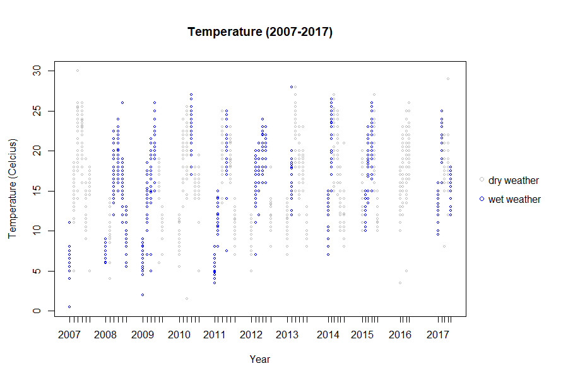
Figure 1 Temperature of Sampling Sites (2007-2017)

The pH generally stays within the 6.5-8.3 range as regulated by the EPA. But there are incidents that the water body gets more acidic, which lasts throughout the period. There are also incidents that the water body gets more alkaline, but the problem has not reoccurred since 2010.
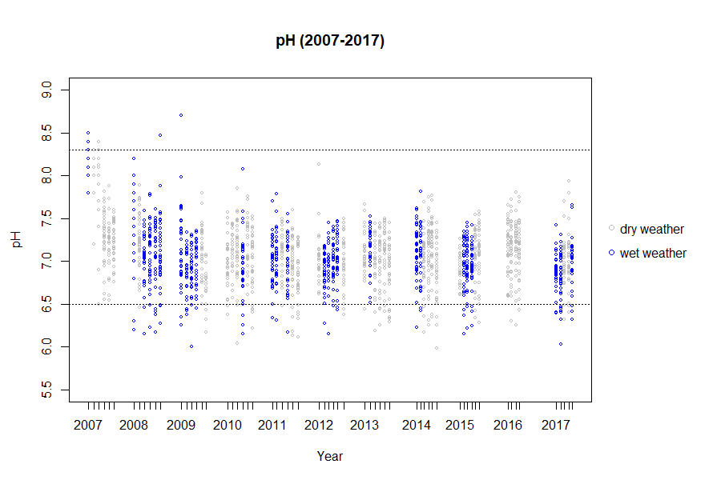
Figure 2 pH of Sampling Sites (2007-2017)

  - E.coli
During wet weather (defined by total precipitation greater than 0.1 inches in previous 72 hours), the water body has a higher average E.coli concentration, which exceeds the secondary contact recreation limit. The difference between wet and dry weather is statistically significant (p<0.05). The E.coli concentration level during dry weather also exceeds the primary contact recreation limit, but is below the secondary contact recreation limit.
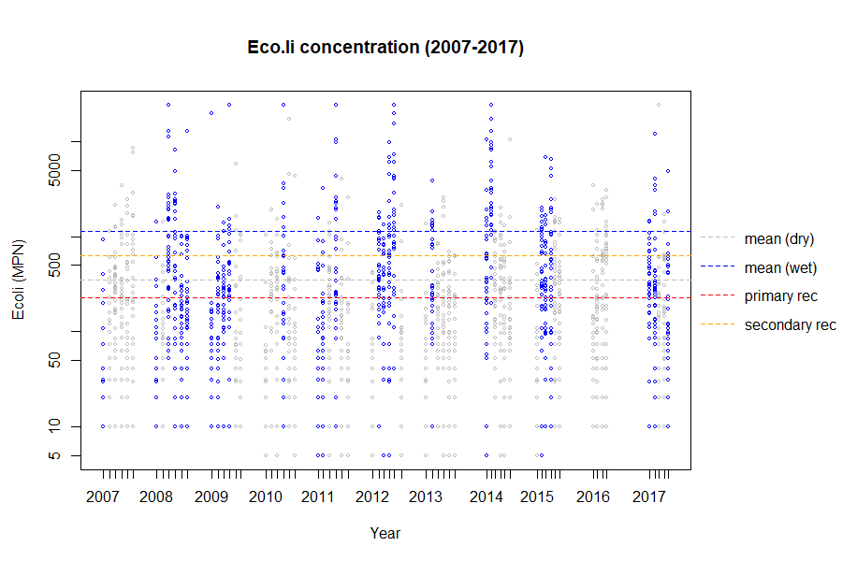
Figure 3 E.coli Concentration in Dry/Wet Weather conditions (2007-2017)

The E.coli concentration is positively correlated with precipitation in the 24 hours before sampling, while negatively correlated with the total precipitation in the 72 hours before sampling. That is, with increasing precipitation in the 24 hours, the E.coli concentration is likely to go up, while with increasing precipitation in the 72 hours, the E.coli concentration is likely to go down. The first figure below does not show a clear trend due to huge variation among sites, but in the second figure, the number of cases exceeding the limits have decreased.
Due to limited data coverage, we come up with the hypothesis that precipitation can have a two-fold effect on E.coli pollution: Rainfall will first flush E.coli from non-point sources down into the river; If the rainfall continues, it will dilute the E.coli that has entered the water.
Table 1 Correlation Statistics Table for E.coli vs. Precipitation
Statistics | Precipitation in 24h | Precipitation in 24-48h | Precipitation in 48-72h | Precipitation in 72h
T | 5.0823 | -2.8387 | -1.436 | -3.1713
DF | 882 | 882 | 882 | 882
p-value | 4.55E-07 | 0.004634 | 0.1514 | 0.00157
Correlation coefficient | 0.1686775 | 0.0951509 | -0.04829604 | -0.1061801
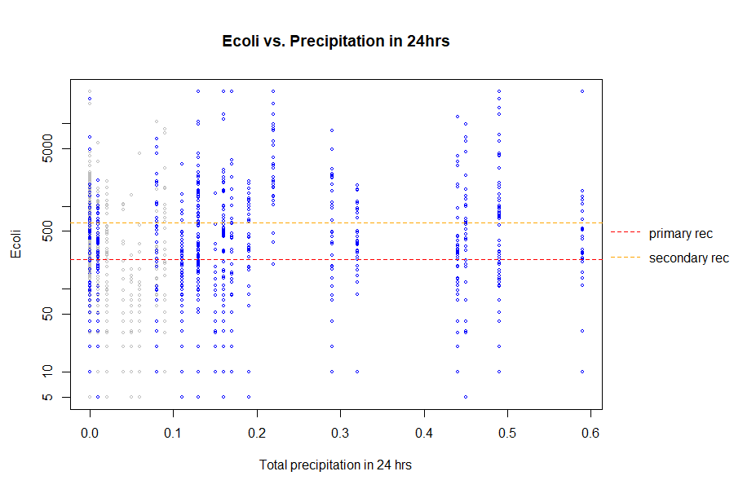
Figure 4 E.coli Concentration vs. Precipitation in the 24 Hours
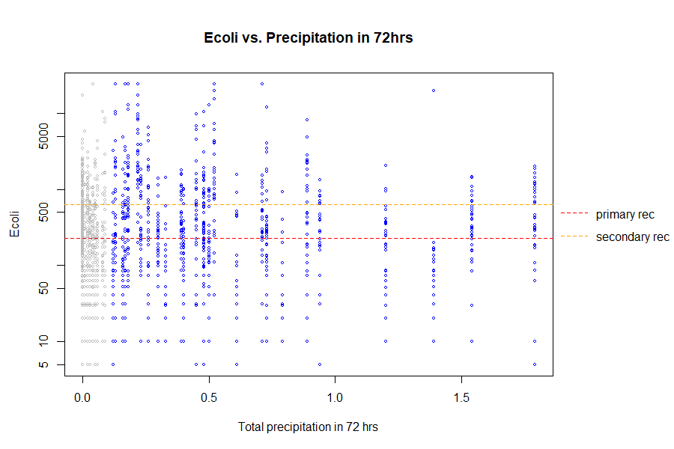
Figure 5 E.coli Concentration vs. Precipitation in the 72 Hours
E.coli concentration is significantly different between the two types of water bodies. Ponds have a lower mean concentration level (p<0.05) than streams (including streams, tributaries, and mainstreams, both fast and slow moving).
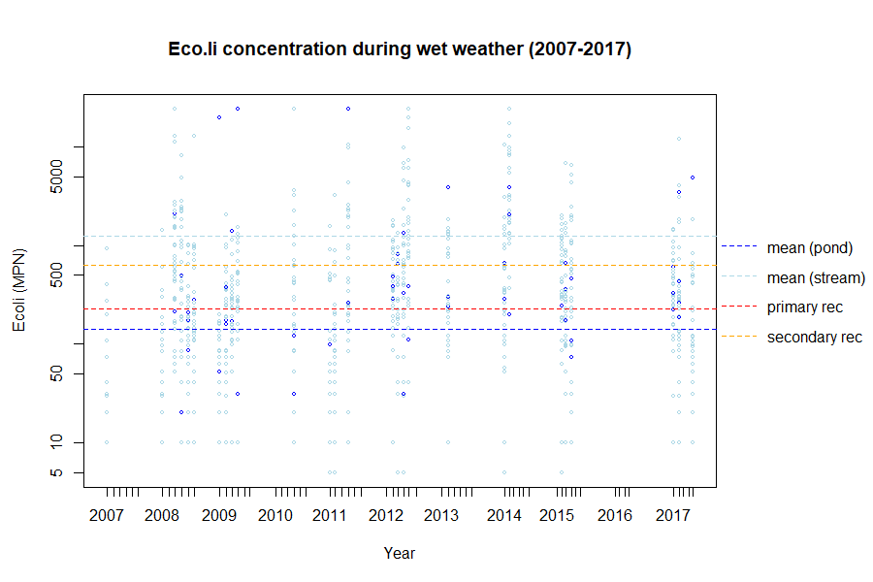
Figure 6 E.coli Concentration during Wet Weather (2007-2017)
  - Phosphorus
Phosphorus level does not vary significantly between different weather conditions in general, as well as when categorized by the types of water bodies.
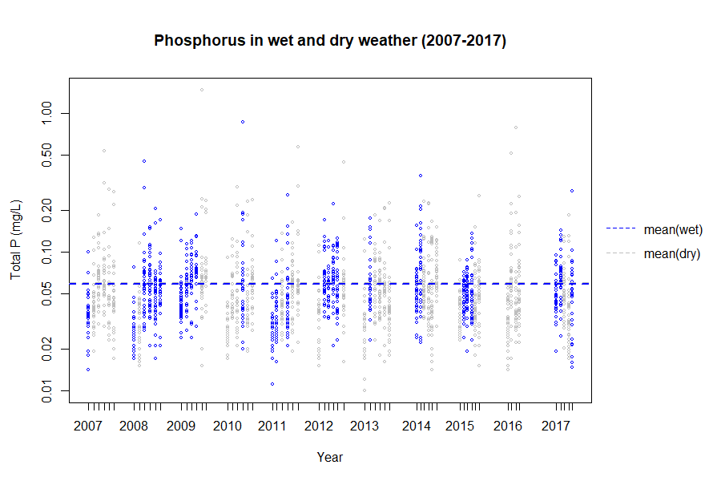
Figure 7 Phosphorus Levels in Dry/Wet Weather Conditions (2007-2017)
The average phosphorus levels of both the ponds and the streams have exceeded the environmental limits. The ponds, though have a lower average concentration level, exceed a lot more given its lower environmental limit.
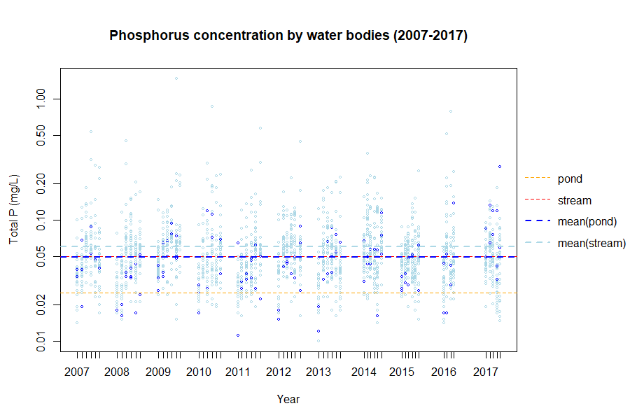
Figure 8 Phosphorus Concentration by Water Type
The phosphorus concentration level is positively correlated with the precipitation within 24 hours, and negatively correlated with the precipitation within 72 hours, but to a lower extent.
Similar to E.coli, it could be because that runoff brings more phosphorus into the watershed and continuous runoff will dilute it.
Table 2 Correlation Statistics Table for Phosphorus vs. Precipitation
Statistics | Precipitation in 24h | Precipitation in 24-48h | Precipitation in 48-72h | Precipitation in 72h
T | 4.3095 | -3.4033 | 0.07508 | -2.7388
DF | 882 | 882 | 882 | 882
p-value | -1.82E-05 | 0.0006958 | 0.9402 | 0.006291
Correlation coefficient | 0.143604 | -0.11385 | 0.002528 | -0.09183
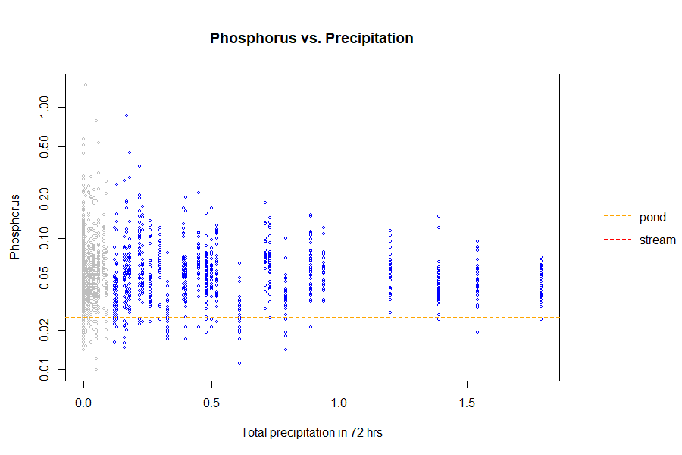
Figure 9 Phosphorus Concentration vs. Precipitation in the 72 Hours
  - Dissolved Oxygen
The average level dissolved oxygen remains above the environmental limit in wet and dry weather conditions. The difference is statistically significant (p<0.05) but the difference itself is rather small (~0.2).
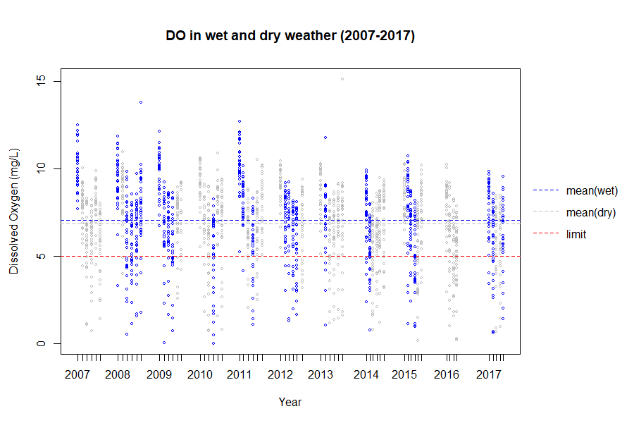
Figure 10 Dissolved Oxygen in Wet/Dry Weather Conditions
The average level of DO varies greatly by water type. The average level of DO in ponds is below the environmental limit.
Since DO decreases with rising water temperature, we have also looked into the relationship and found that under natural conditions it would be impossible for the DO level to reach below 5mg/L solely because of the temperature. Low DO level in this case, could be partially because of the temperature, but when combined with high phosphorus level, can indicate the possibility of eutrophication in the ponds.
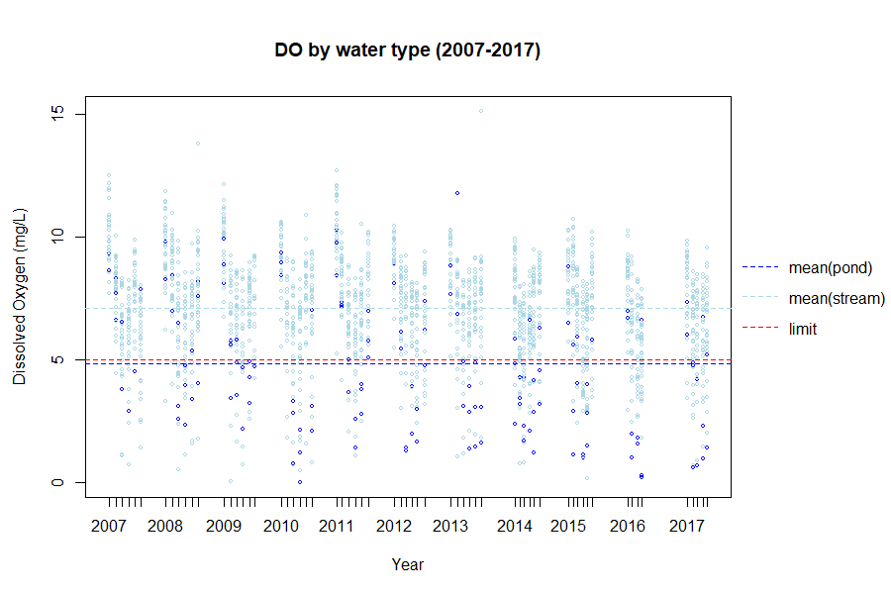
Dissolved oxygen level is negatively correlated with precipitation within 24 hours, and negatively correlated with precipitation within 72 hours.
Table 3 Correlation Statistics Table for Dissolved Oxygen vs. Precipitation
Statistics | Precipitation in 24h | Precipitation in 24-48h | Precipitation in 48-72h | Precipitation in 72h
t | -5.5287 | 9.779 | -1.0879 | 7.1992
DF | 882 | 882 | 882 | 882
p-value | 4.25E-08 | 2.20E-16 | 0.2796 | 1.30E-12
Correlation coefficient | -0.18302 | 0.312757 | -0.03641 | 0.235588
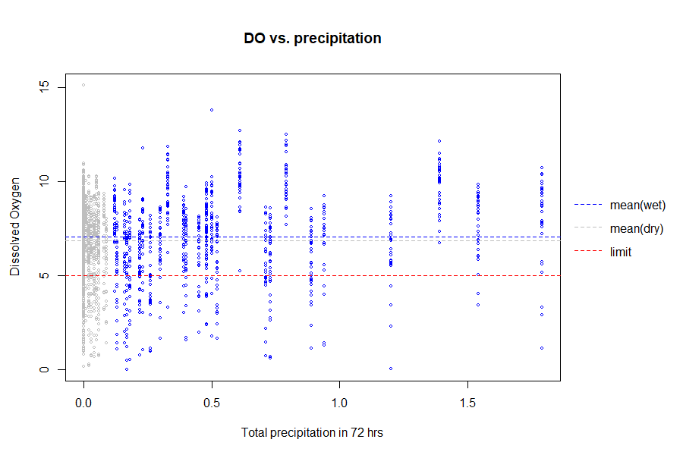
Figure 11 Dissolved Oxygen vs. Precipitation in the 72 Hours
Linking all the findings together, we are now more inclined to believe that runoff in the first 24 hours could bring more pollutants from non-point sources into the river, which also decreases the DO level, while continuous runoff will dilute the pollution, bringing DO up to normal.
A potential research focus in the future can be how precipitation can affect the discharge of non-point sources.

- Exceedance Mapping
As shown in the map below, sampling sites are more disperse spatially while hotspots are more concentrated in certain areas.
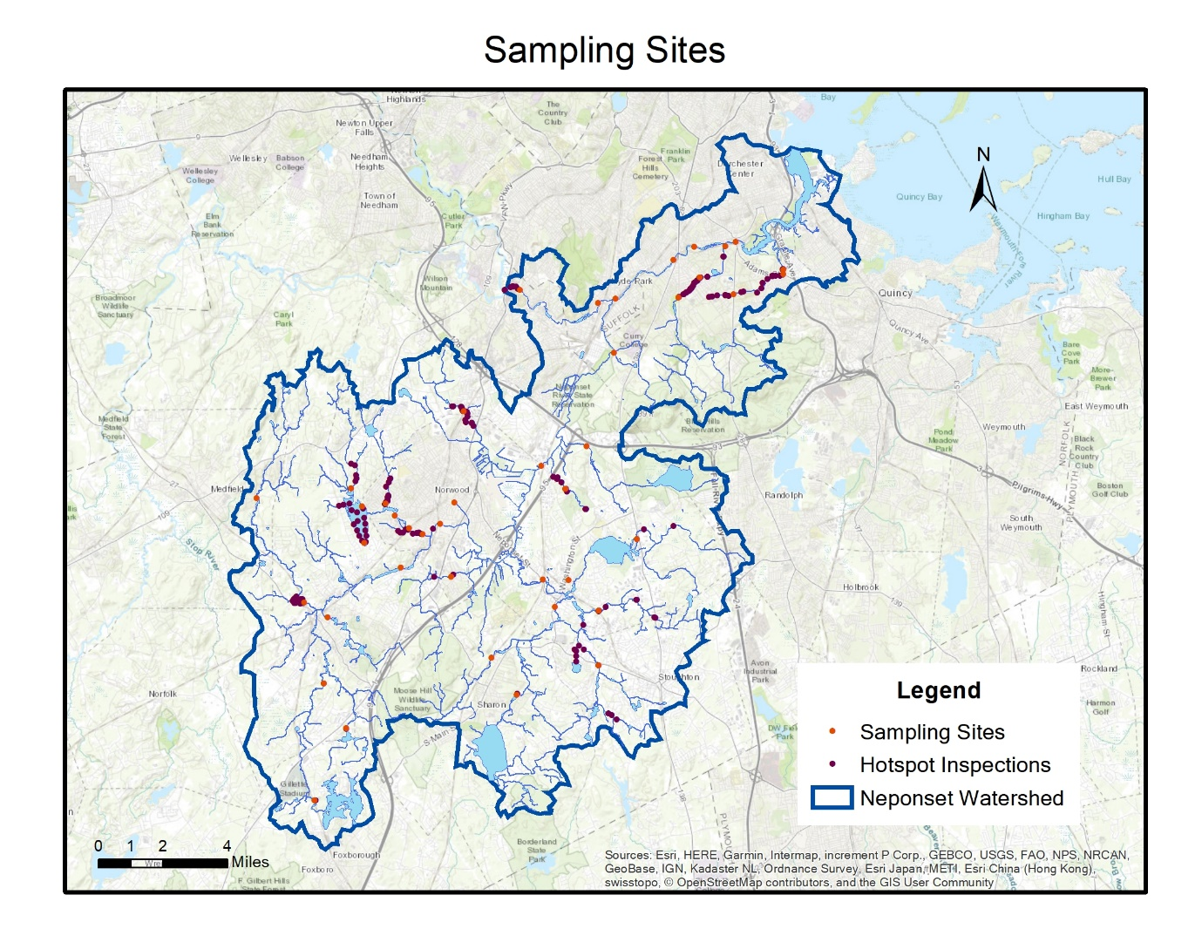
Figure 12 Map of Sampling Sites and Hotspots

  - E.coli
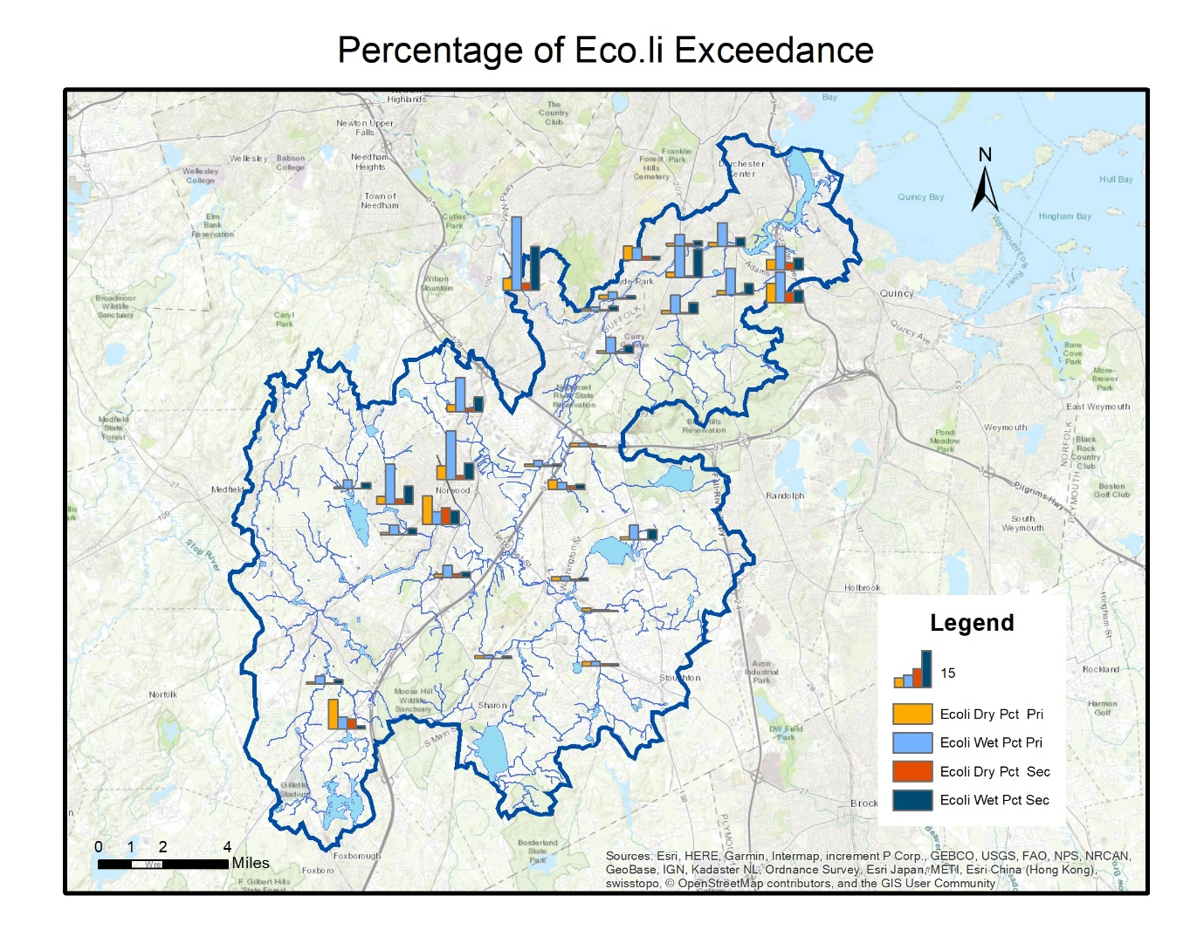
Figure 13 Map of E.coli Exceedance (Percentage)
The map above shows how much the mean E.coli level of each sampling site exceeds the primary and secondary contact recreation limit. Warm colors indicate dry weather conditions and cold ones indicate wet weather conditions. The height of the bar indicates the magnitude of exceedance.
The northeast part of the watershed, particularly Unquity Brook, Pine Tree Brook, and Mother Brook, faces E.coli exceedance in dry weather conditions, and gets worse in wet weather conditions. The mid-west part of the watershed, Germany Brook and Pulgatory Brook face similar problems. This can be due to the runoff bringing fecal matters of pets and wild animals down into the watershed.
Hawes Brook in the mid-west and Ganawatte Farm Pond in the south face the opposite problem: higher concentration in dry weather, lower concentration in wet weather. It can possibly be an underground leakage from the sewage system, which requires further investigation in the future.
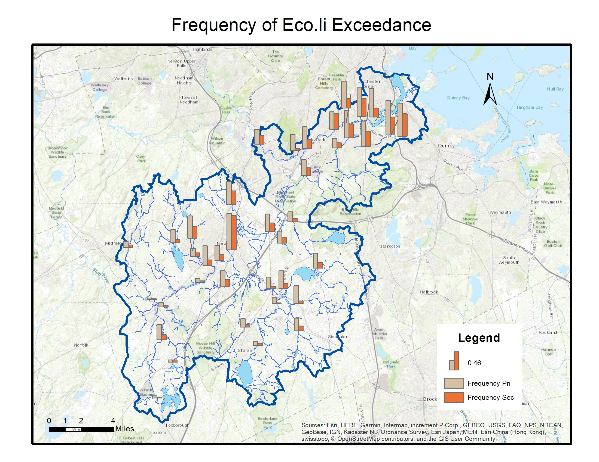
Figure 14 Map of E.coli Exceedance (Frequency)
The next map shows the frequency of exceedance, i.e. how many times each sampling site exceeds the limit comparing to the total times it is sampled. However, not only do those with higher levels of E.coli concentration tend to have more frequent exceedances, some of the sampling sites with lower magnitude of exceedance also seem to exceed frequently.
  - Phosphorus
The map below shows how much the mean phosphorus level of each stream sampling site exceeds the limit in dry/wet weather conditions. The majority of the sites have similar levels of exceedances in different weather conditions while there is also a small portion of them that face more severe phosphorus problem in dry weather conditions.
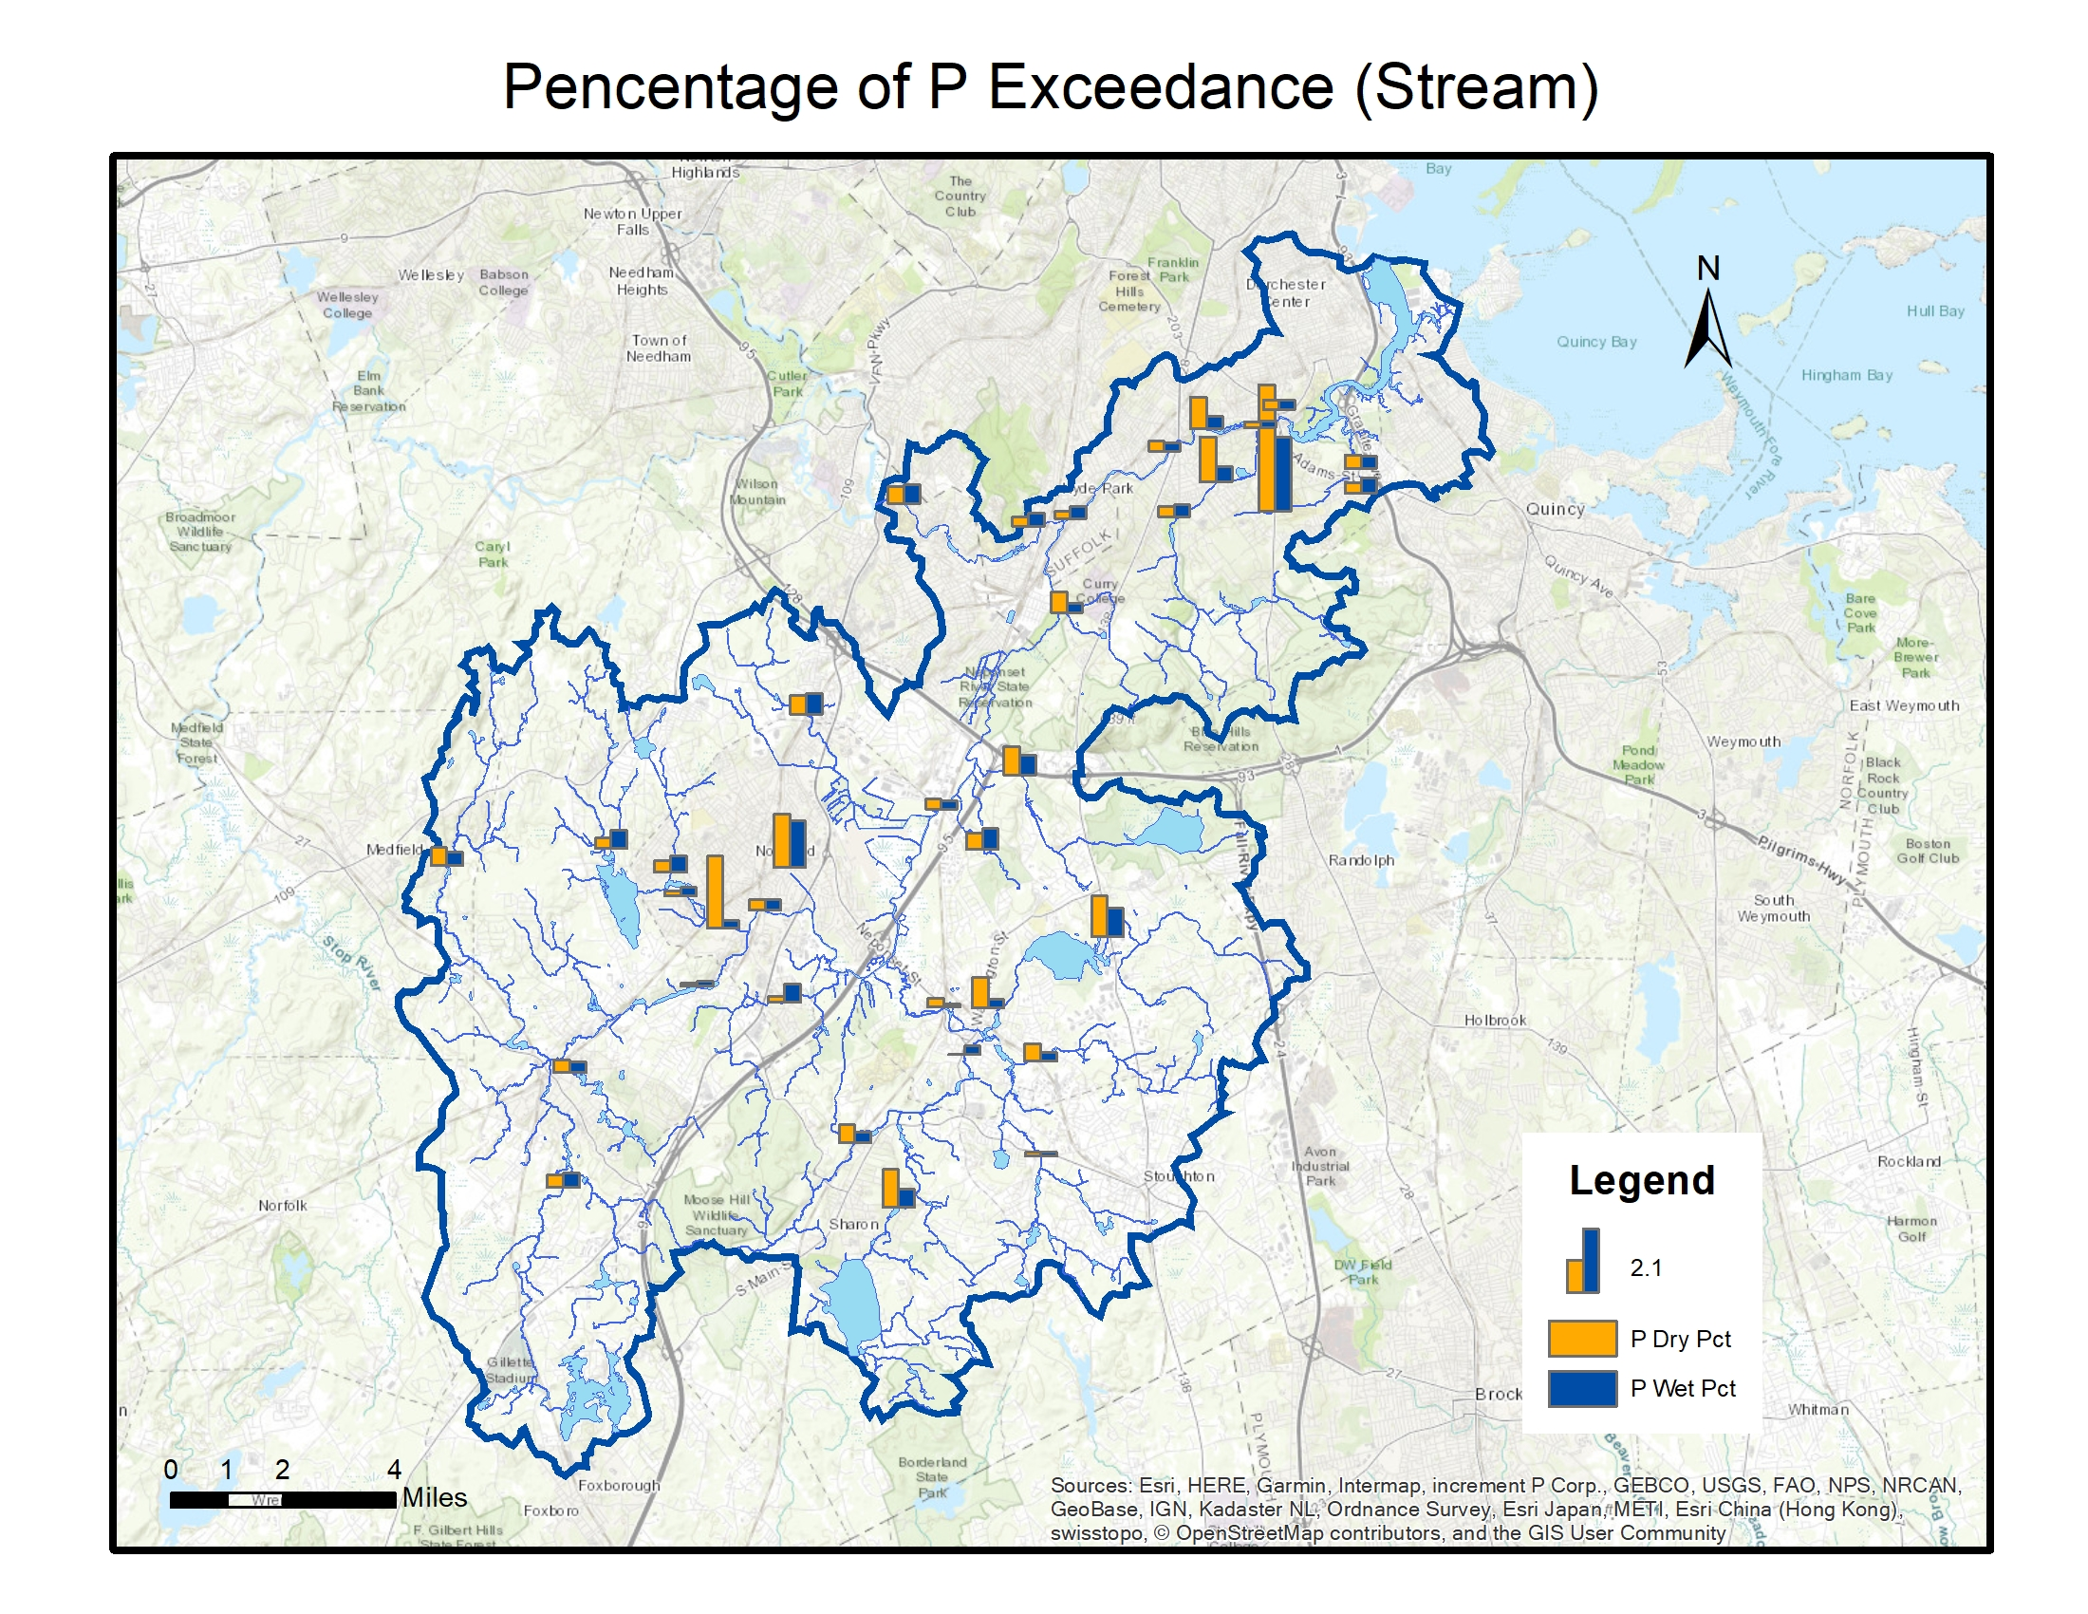
Figure 15 Map of Phosphorus Exceedance in Streams in Dry/Wet Weather (Percentage)
The next map shows the frequency of exceedance. More than half of the sites exceed the limit for at least half of the time and seem to be located all over the watershed, which indicates that phosphorus may be an ongoing problem for the whole watershed.
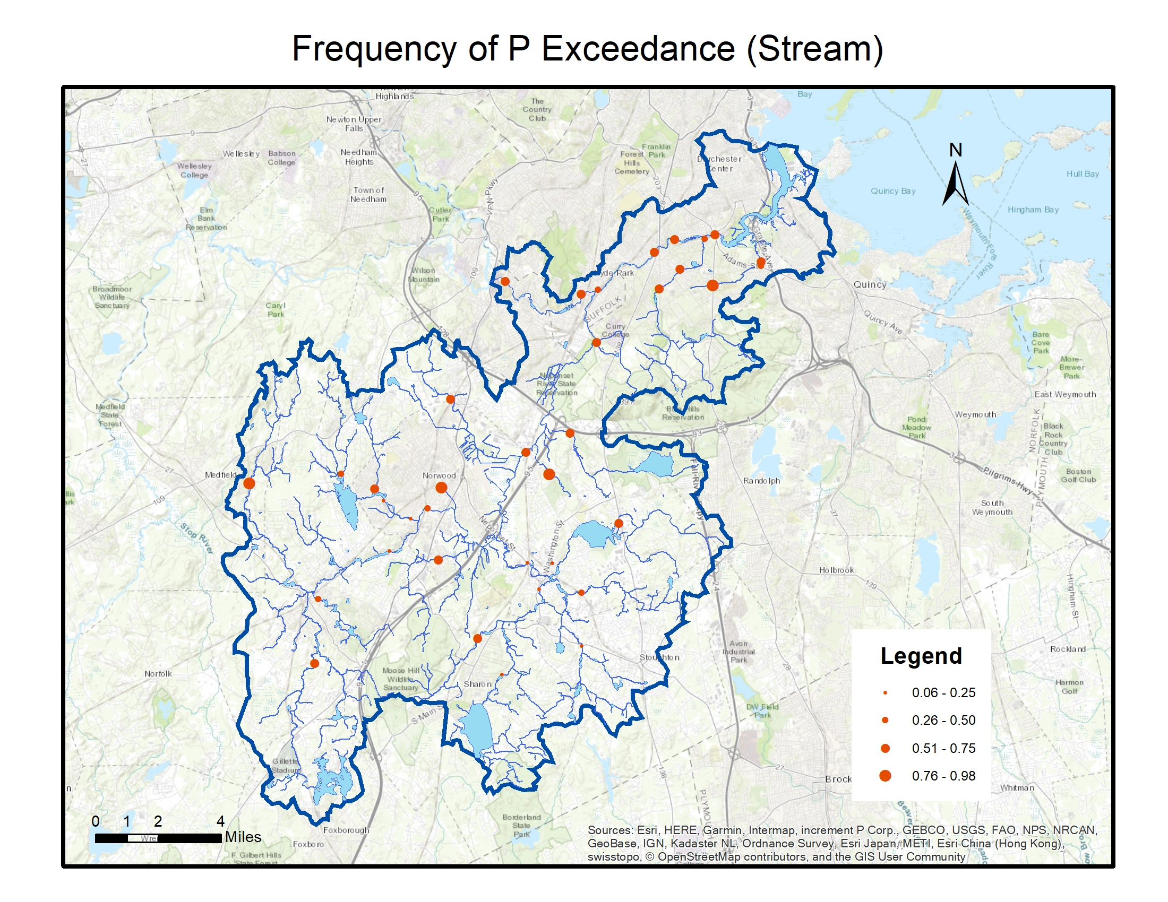
Figure 16 Map of Phosphorus Exceedance in Streams (Frequency)
The map below shows how much the mean phosphorus level of each pond sampling site exceeds the limit in dry/wet weather conditions. Turner’s Pond (uppermost) and School Meadow Brook (middle) have a higher magnitude of exceedance in dry weather and a lower one in wet weather, while Crackrock Pond (lowermost) faces the opposite.
However, the frequency of exceedance is similarly high among the three pond sites, reaching 90% of the time, which signals problem.
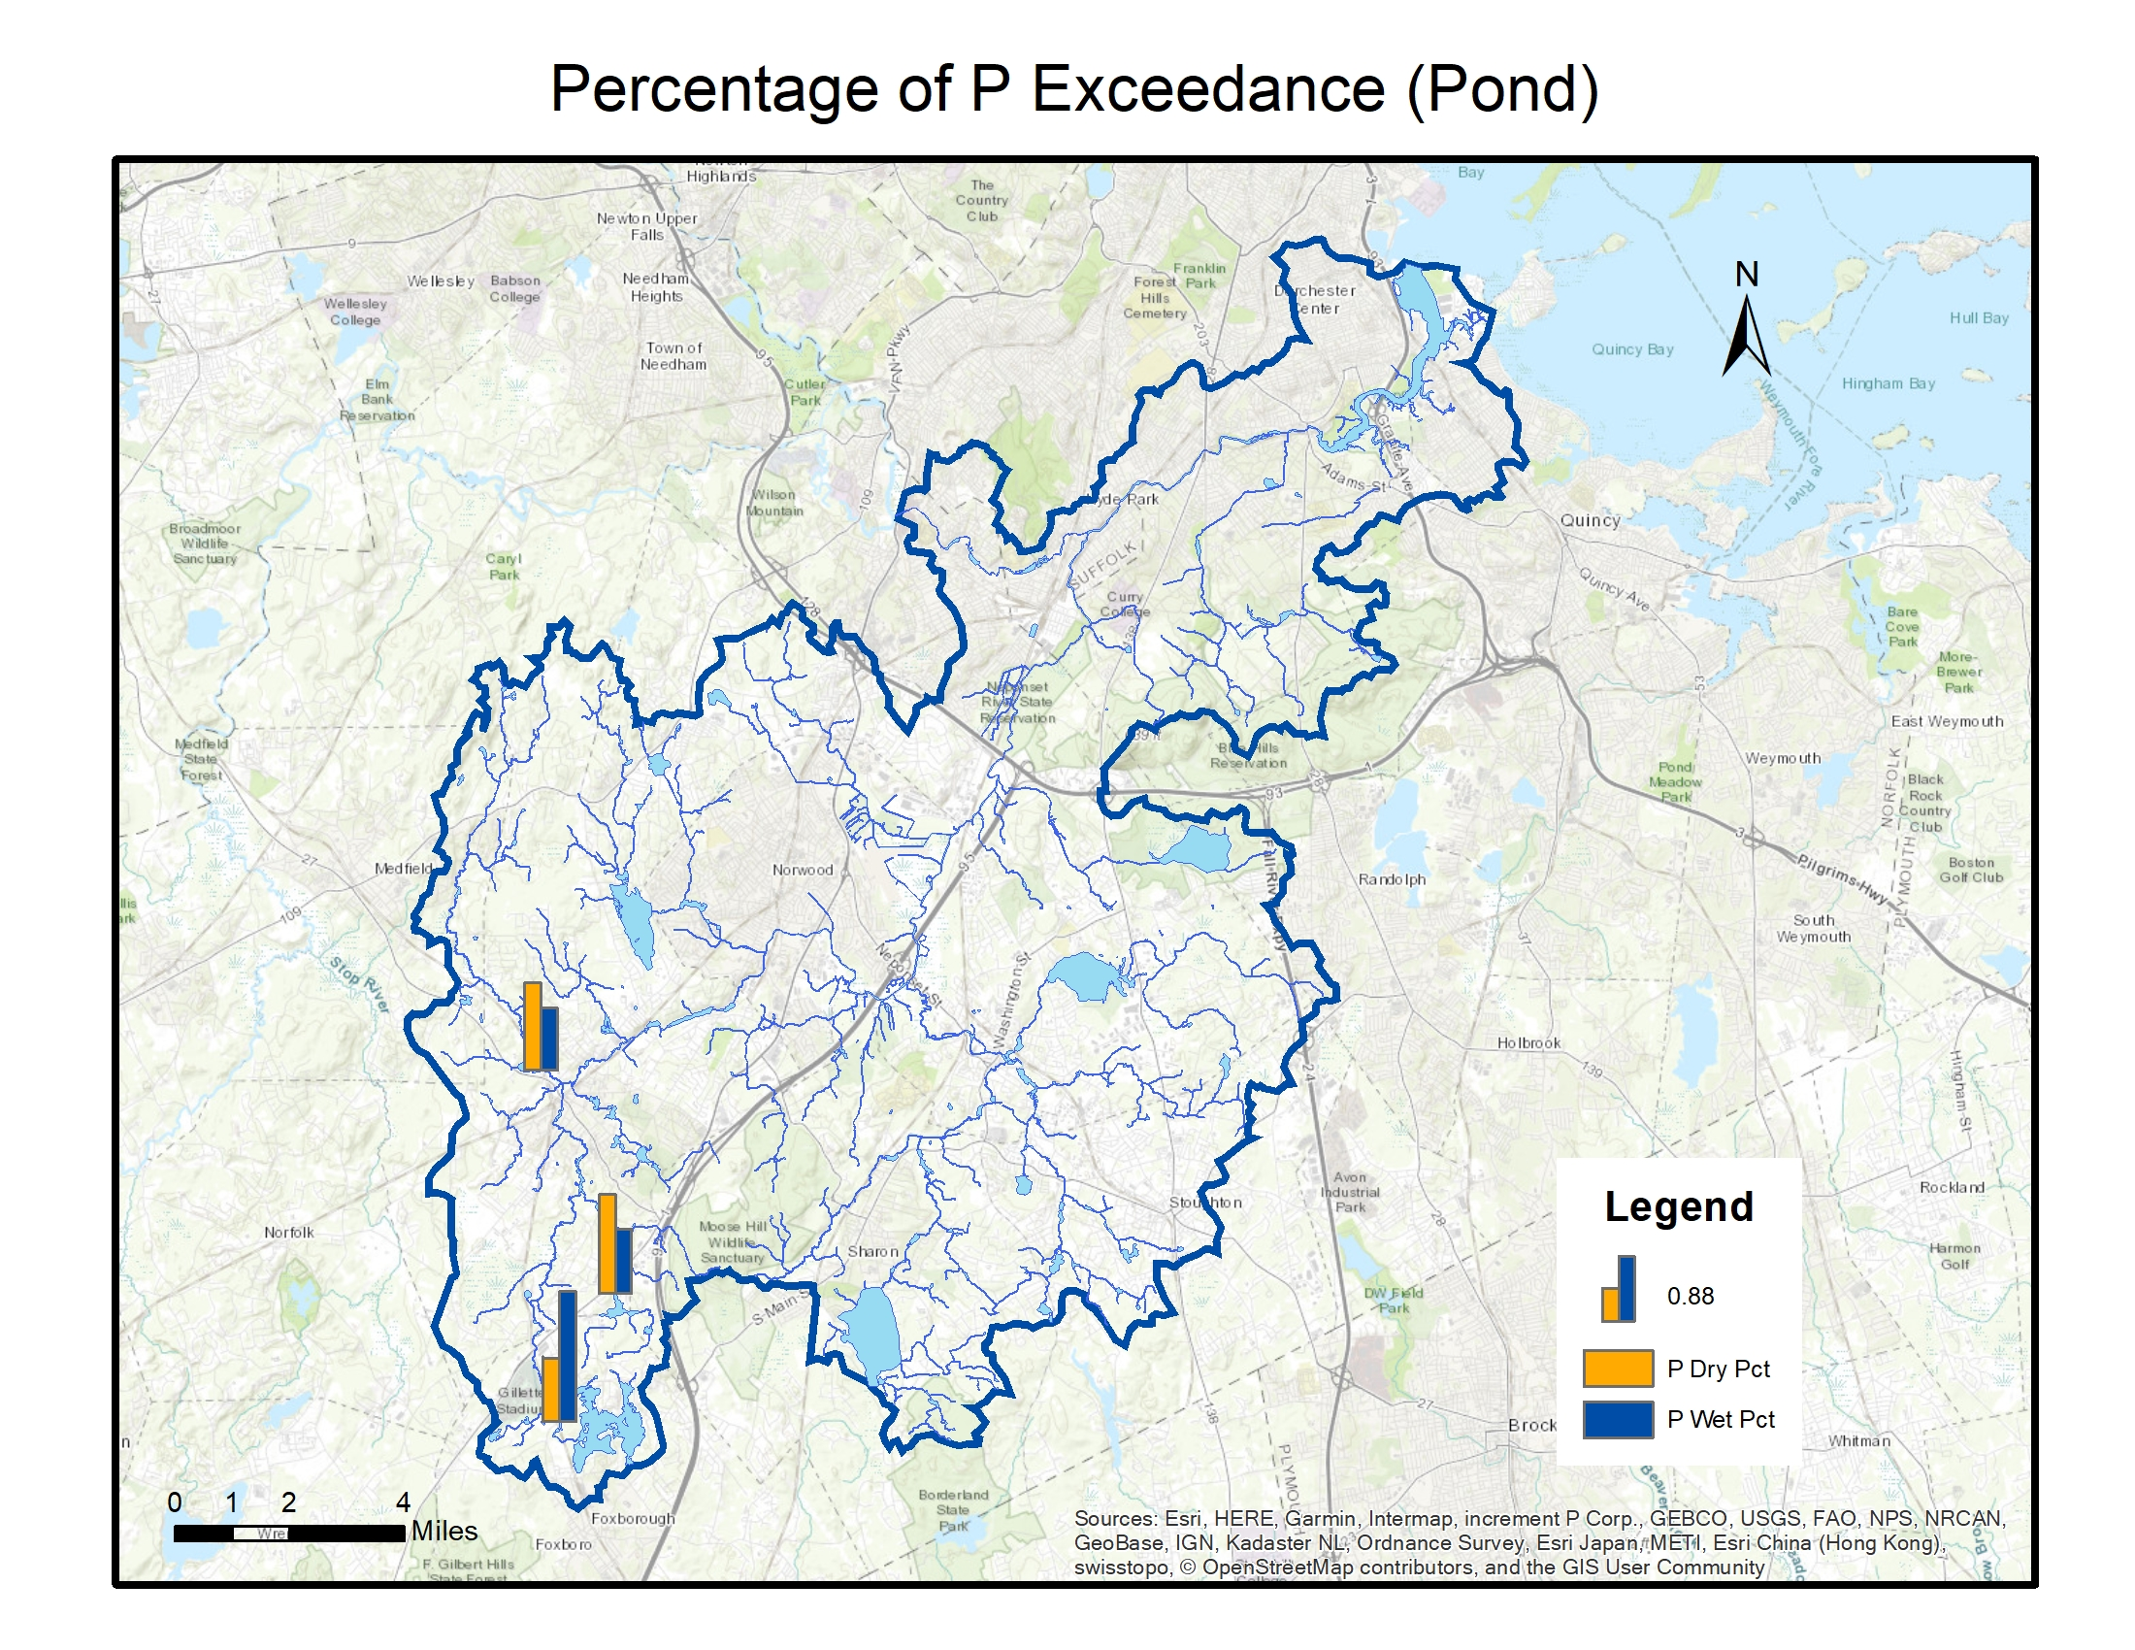
  - pH
The map below shows the frequency of exceedance for pH. Mine Brook and School Meadow Brook are the most frequent sites with water being too acidic.
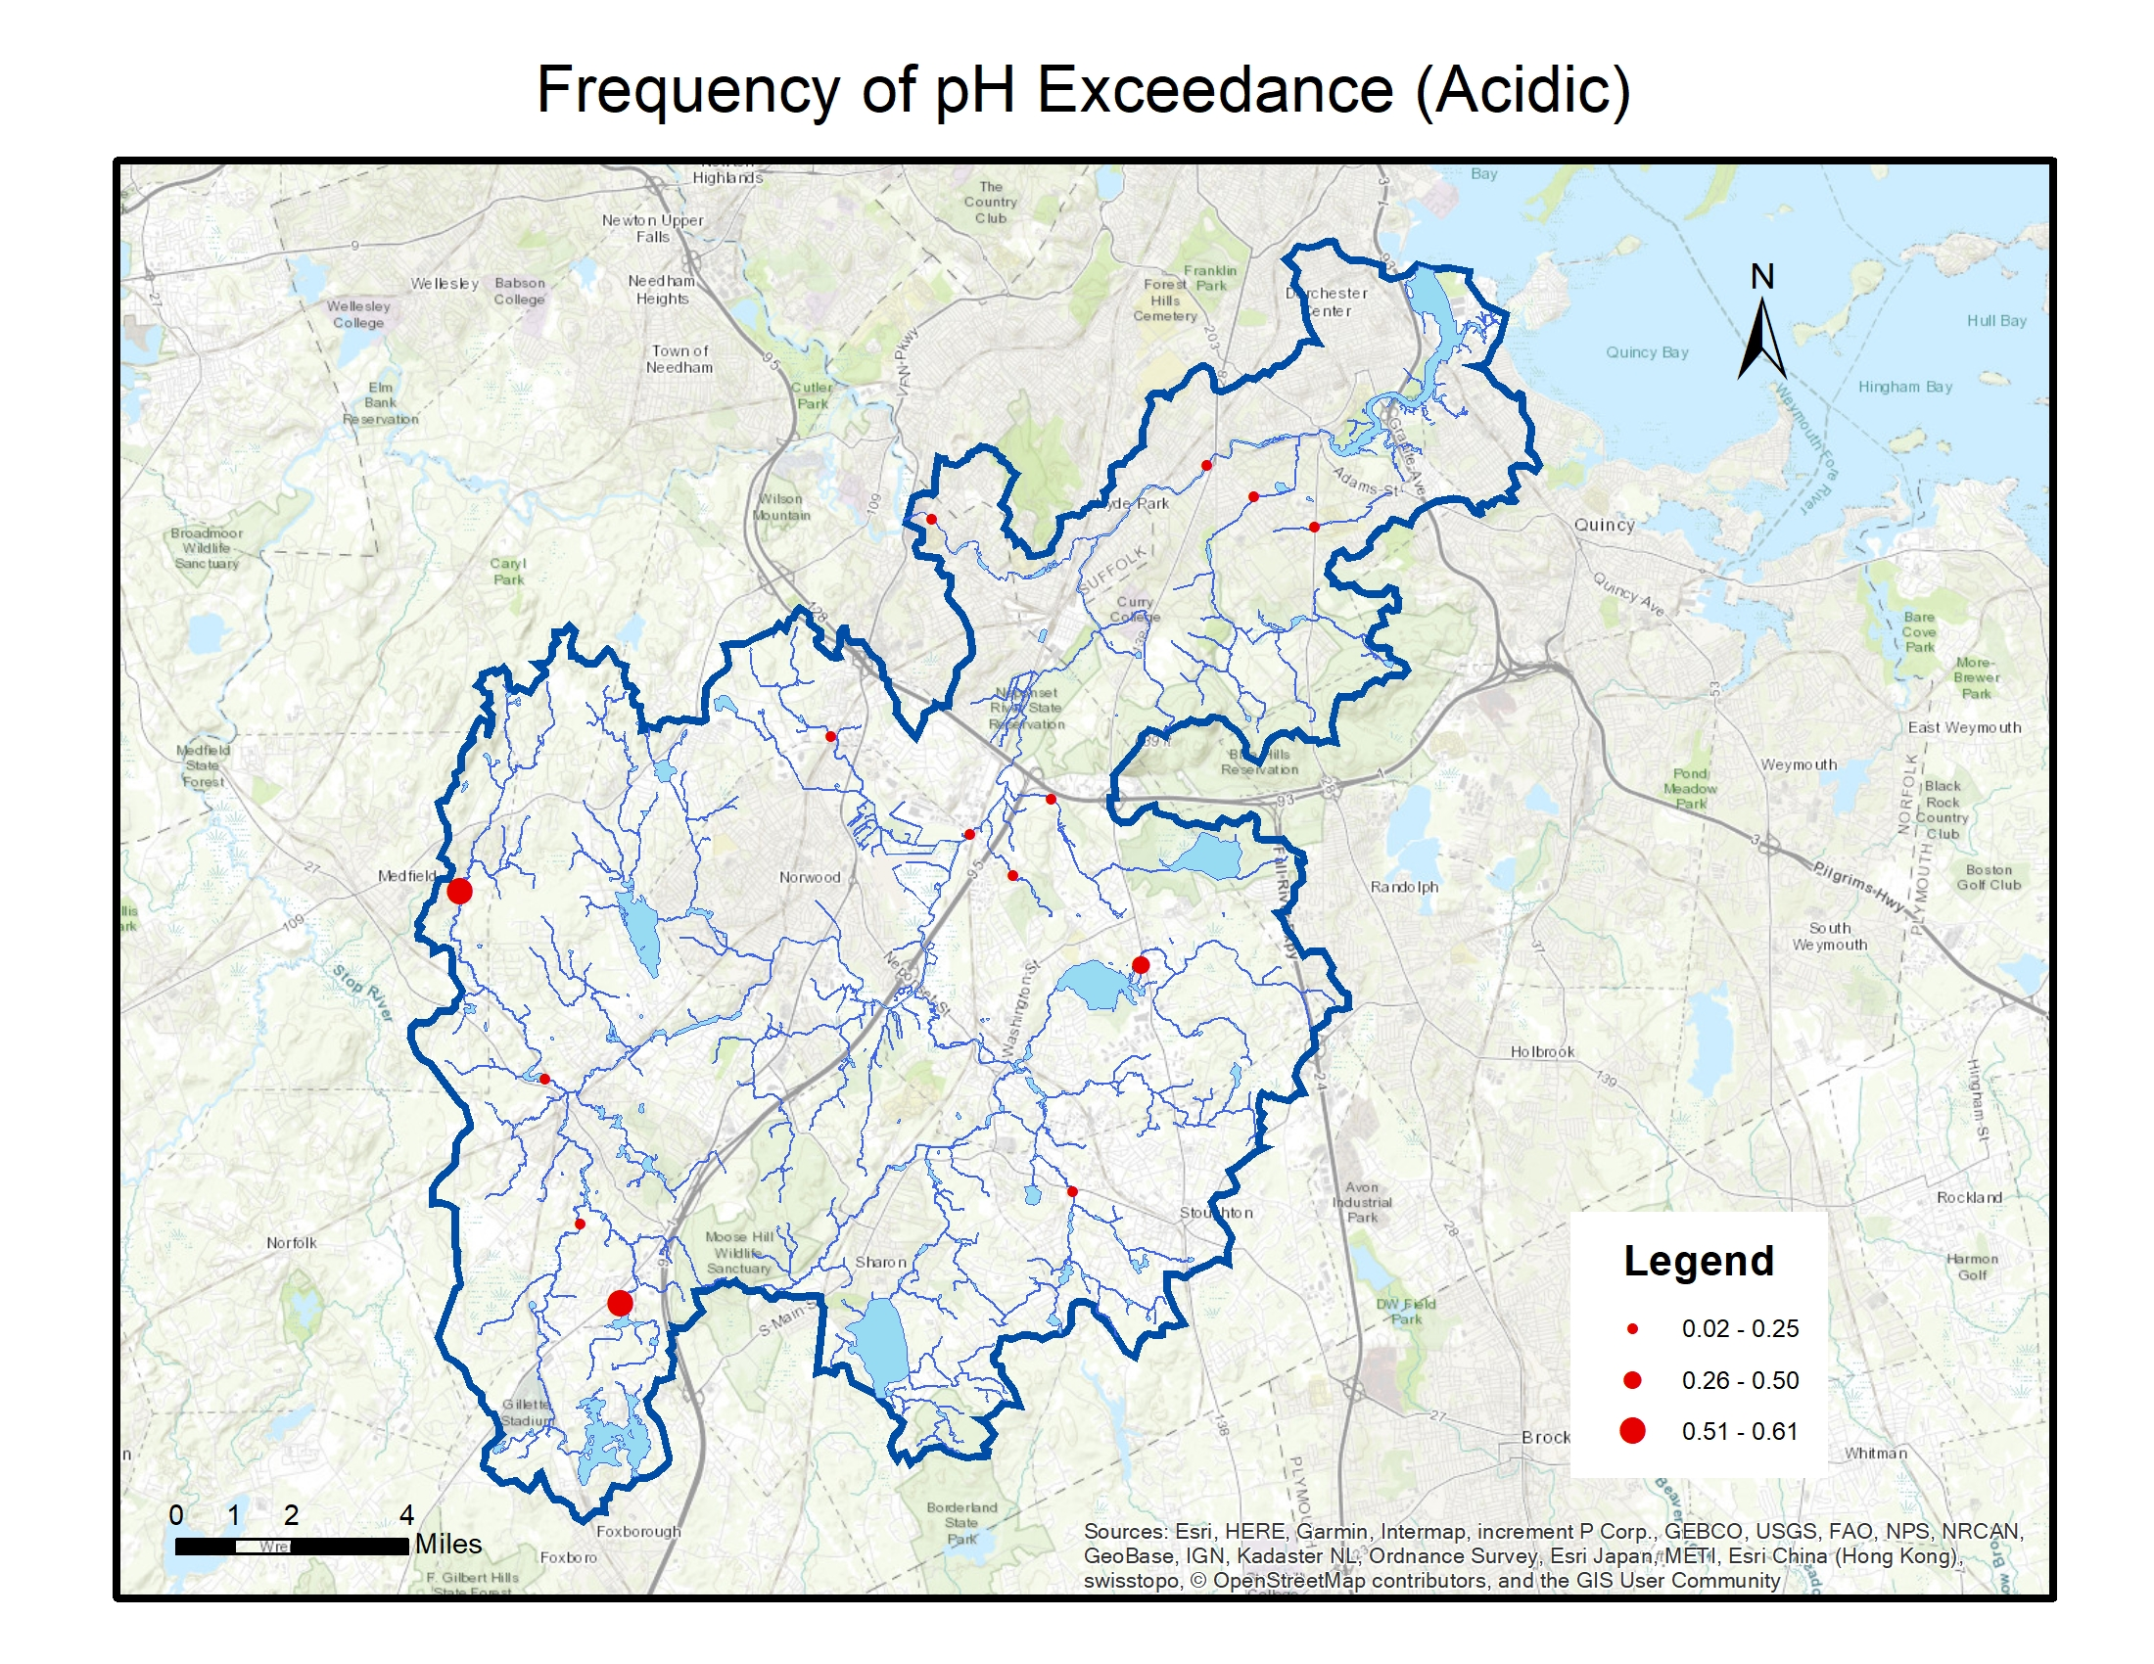
- Recommendations for Future Work
Examining the cause of exceedances in the field. NRWA has already identified a number of problems and potential causes through the hotspot program, and this effort can be expanded to the whole watershed. It is important to have a general overview the non-point sources around the brooks and ponds that we have pointed out.
Analyze other pollutant data. NRWA has a shorter record of measurements on phosphate, nitrogen, ammonia, and Chlorophyll. As the data base builds up, it can be useful to look at these parameters to better understand the water quality.
Testing more pollutants in the water. With enhancement of sampling capacity in the future, NRWA can potentially run tests on other pollutants and toxics, such as heavy metal and VOCs.
Explore scientific questions. With the enhancement of sampling capacity, NRWA can look deeper into how precipitation can affect discharge of pollutants over time.

The term “secondary recreation” is defined by the EPA as: “any recreation or other water use in which contact with the water is either incidental or accidental. These include but are not limited to fishing, including human consumption of fish, boating and limited contact incident to shoreline activities. Where designated, secondary contact recreation also includes shellfishing, including human consumption of shellfish”. See “ASSESSMENT METHODOLOGY GUIDELINES FOR EVALUATING DESIGNATED USE STATUS OF MASSACHUSETTS SURFACE WATERS” (https://www.mass.gov/files/documents/2016/08/tz/36wqara.pdf, accessed Dec 2018.)
The term “primary contact recreation” is defined by the EPA as: “any recreation or other water use in which there is prolonged and intimate contact with the water with a significant risk of ingestion of water. These include, but are not limited to, wading, swimming, diving, surfing and water skiing.”
Correlation statistics are calculated in R with Pearson method, using a two-sided test. P-values smaller than 0.05 is marked red and considered statistically significant. Other correlation statistics tables in the rest of the summary are generated with the same setting.
Results are from two-sample, two-tailed t-test in r.
The maximum DO level is 5.95 mg/L with a temperature level of 45 degrees Celsius. See “5.2 Dissolved Oxygen and Biochemical Oxygen Demand” by EPA (https://archive.epa.gov/water/archive/web/html/vms52.html, accessed Dec 2018).

