Who Runs, Who Wins?
A Case Study of Emerge America’s Alumnae

Rachel Bernhard, University of California, Berkeley
Shauna Shames, University of Rutgers-Camden
Rachel Silbermann, Analyst Institute
Dawn Teele, University of Pennsylvania

Though extensive research investigates determinants of women’s political ambition and electoral success, most prior studies tend to survey either those who have officially registered and run for office, or those just beginning to consider the possibility of a political career. As a result, we know relatively little about the factors that affect women’s decision-making and candidacies in between these two stages. Using a survey of graduates (n=702) from a national women’s candidate training organization (run through state affiliates), we examine variation in run and win rates among a highly trained and ambitious group of women using a most-similar design. We find that overall there is no single silver bullet explaining why women do not run, but there are certain identifiable situations, contexts, and barriers that make women more or less likely to do so. Organizations looking to promote, recruit, train, and field more female candidates can, we hope, use these findings both to identify and target the women most likely to run, and to address the social and political situations that would make others more likely to step up as candidates as well.

Paper prepared for the “Good Reasons to Run” Conference, November 10-11, 2017, at the University of Pennsylvania, Philadelphia, PA. Please do not quote or cite without permission from the authors.
Introduction

The road that a politically ambitious woman must travel in order to file papers with the state or local election authority has many forks. Whether the issue is fundraising, family time, or the possibility of other career opportunities, a political aspirant must say “yes” to the burdens of campaigning and to the possibility of life in the public eye many times before her name ever appears on the ballot. What factors keep women on the road to candidacy and which drive them off?

We study this question by looking at a very special group of women: those who have invested financial resources and many weekends in a training program for political candidacy run by Emerge America. Emerge America recruits and trains Democratic women to run for office in 23 states. Its programming is aimed at “building the farm team” for the Democratic Party by electing high-quality female candidates to state and local offices. Unlike organizations like Emily’s List, which provide endorsements and campaign funding, Emerge focuses on providing comprehensive training across multiple domains, including public speaking, fundraising, field operations, messaging, and ethics. Though the schedule of training varies across the state chapters, each state’s program requires at least 70 hours of trainings with a mix of national and local consultants and trainers. On average, these trainings cost $600 and require six weekend commitments. According to the organization’s website, 52% of Emerge alumnae have gone on to run for office, and 70% of those have won. A November 2017 press release by the organization suggests that success may be even higher in some elections: running in the off-cycle 2017 elections, 73% of Emerge graduates won the seats they sought.

To think through the factors that lead politically ambitious women to say “yes” to political candidacy, we fielded an extensive online survey of Emerge America alumnae in the fall of 2016. As of that date, Emerge had trained 2,083 women, 37 percent (702 women) responded to our call to participate in this survey.

Our survey asked Emerge alumnae to answer questions in five primary categories --- demographics, family/work situations, experiences with the Emerge training program, questions about potentially or actually running for office, and what would help or deter them. We also asked them whether they had run for office, and if so, whether they had ever won. We then compared the propensity of respondents to run for office and to win based on their self-reported personal characteristics. Overall, we do not find a single silver bullet that explains why women do or do not run, but perceive that a host of potential factors might add up to what Virigina Valian has called the “accumulation of advantage” for some political aspirants.

While studying just this group of women does not allow us to draw conclusions about women that are less ambitious, less trained, or that identify as Republicans, it does provide useful information for researchers and organizations interested in understanding which major obstacles to women’s candidacies still exist. This is what we might call a “hard case”: these women, who are already ambitious for office and had invested in training, should be the most likely to run; if they do not, the reasons why should interest us. Those who are interested in recruiting and training more women to run for office can use these findings to shape future interventions, both academic and practical.

Sample and Methods

The data for this project come from an original survey of alumnae of the Emerge candidate training program. From 2003 to 2016, across all state branches, Emerge ushered 2083 women through its program. This roster produced a list of 1953 alumnae with valid email address. Using this email database and Qualtrics, an online survey platform, we recruited Emerge alumnae to take the survey during a twelve-week period from May to August 2016 (with frequent reminders to increase participation). Respondents who clicked into the survey were presented with an informed consent protocol. They were assured that although our research team would share aggregate results with Emerge, answers from the questionnaire would be non-identifiable. Alumnae who had not finished the survey were re-contacted via email after three weeks, six weeks, eleven weeks, and in the final (twelfth) week. As a further impetus to take the survey, around eight weeks into the collection period alumnae also received a separate generic email from the Emerge state executive directors reminding them to take the survey, and, in an final effort to increase the sample size, in the last week of the survey all alumnae who had not yet taken the survey were contacted by phone by Emerge staff. In total, 702 women answered all or part of the survey. The survey received a final response rate of 37% if considering only those with valid contact information or 35% if including all known alumnae.

The fifteen-minute survey was designed to examine multiple theories about women’s decisions to run and the obstacles they face in winning having entered. In this paper, we use analyze two different outcomes: women’s decision to run (which we call the run rate), and the likelihood of winning among those who won (win rate). Where appropriate, we indicate statistically significant relationships using simple Z-tests of the difference-of-means between groups.

Demographic Characteristics

Our respondent sample of Emerge alumnae is unrepresentative of the general population: exclusively female, predominantly Democrats, and disproportionately educated and urban. It nevertheless provides a good mix in terms of age (the 40-49 group is the modal category, with the 30-39 and 50-59 range categories are also being well-represented). Looking at the respondents by race and ethnicity, we see that this sample mirrors averages in the U.S. population, except for Hispanics, who are underrepresented in the sample. Looking at the marital status of respondents, the majority are married, with another 9% cohabitating. The next largest chunk (20%) is single, and another 12% divorced.

We also asked survey respondents what year they graduated from the Emerge program; as we expected, those who had graduated more recently were the most likely to have answered. This could be because of one or both of two reasons: recent graduates are more likely to still be engaged with Emerge and its community, and there are more recent graduates as more programs have opened as time went on. Whatever the reason, the bulk of the sample graduated from the program between 2012 and 2016, but there are respondents from earlier cohorts as well. Looking at the data by both graduation year and race and ethnicity is interesting, as we can see that there is more racial diversity among respondents that graduated in later years.

Educationally, this is an overachieving group; the large majority has a college degree or more, with fully 40% having received a Master’s degree, and another 25% of respondents boasting of a professional or PhD degree. A few other demographic variables are perhaps of interest: more than 10% of the sample identified as LGBTQ, which corresponds with the proportion of this group in the population as a whole. We also note that 17, or about 2.5% of alumnae respondents are members or former members of the US Armed Services.

Who Has (and Has not) Run?

Of those who answered the survey, 45% reported that they had run for office. Although those alumnae who have run might be more likely to submit survey responses, Emerge’s internal documentation suggests that 52% of its alumnae run for office.

Key demographic factors correlate strongly with having already run, including being older, being out of the Emerge program longer, being married, owning your home, living in a rural rather than urban area, and being white. Many of these also correlate with each other; those who are older and married are also very likely to own their own home, for example, so certain variables “clump” together.

Generally, as we would expect given overall U.S. population demographic patterns and trends, those living in suburban and rural areas are older on average than city-dwellers, and those who are older are also less racially diverse. There are also evident selection biases in who takes the Emerge program training to start with; rural women may have already been more likely to want to run, and sought out Emerge training for that reason, while city-dwellers may be younger and/or more plugged into networks where they were recruited for Emerge training.

For those who had not yet run, we asked a series of questions to ask about what obstacles respondents perceived to becoming political candidates. Many of our most important findings in this area have to do with structural factors in these women’s lives; for instance, women who live closer to their state’s capitol buildings are more likely to have run for office (see also Silbermann 2015, which first noted this connection). Those who own rather than rent their home are strongly more likely to have run, similar to the finding above on married women being more likely to have run. Those who are well-established in relationships and geographic communities, in other words, are more likely than the younger, the more mobile, and those living on their own to have run, all of which makes perfect sense. Also, those who contribute more to their household expenses are significantly less likely to have run. Perhaps not as immediately obvious, women with children are significantly more likely to have run for office than those without – and this relates to the above findings on marriage and age, as part of the “clumping” we found.

Of those women who had not yet run for office, the large majority (over 80%) were actively planning to do so in the future. The average amount of time respondents were planning ahead for a run was about 2 years.

Beyond Demographics: What Deters Trained Women from Candidacies?

Small but persistent differences are easy to overlook in pursuit of a “silver bullet” that would explain women’s apparently-lower political ambition vis-à-vis that of men. Valian (2004) notes, “One might be tempted to dismiss concern about such imbalances as making a mountain out of a molehill. But mountains are molehills, piled one on top of another over time. Small imbalances add up to disadvantage women” (210). Similarly, Burns, Schlozman, and Verba (2001) finds “[a] long, cumulative pattern of gender-differentiated experiences in the principal social institutions of everyday life – the family, school, workplace, voluntary associations, and the church…” They conclude: [T]he gender disparity in citizen participation is the result of inequalities with respect to a large number of factors” (3). The same, we suggest, is true for women’s participation in electoral politics as candidates: “Success is largely the accumulation of advantage, exploiting small gains to obtain bigger ones” (Valian 2004, 210).

In examining women’s potential candidacies, what are the “molehills” that might pile up? Shames (2017) urges us to think about the “perceived costs” and “perceived rewards” of running and winning, and suggests a tripartite framing for the areas in which these costs/benefits occur. Here, although we realize these names are somewhat clunky, we will call these three arenas of potential costs and benefits: (1) Resource-Based/Time & Money; (2) Institutional/Political Environment, and (3) Psychological and Personality Barriers/Fears. For each area, we will explore the factors in our survey that relate to running and/or winning office among Emerge program alumnae.

Resource-Based/Time & Money

As multiple previous studies have noted, the “costs” of politics can be high for those contemplating candidacy (Fowler and McClure 1989; Moncrief, Squire, and Jewell 2001; Shames 2017); foremost among these are usually time and money, concerns usually exacerbated for women as opposed to men, and especially women with children. Silbermann (2015) notes an aspect of work-life balance often overlooked in candidate studies; she finds evidence that women, across states, are more likely to run for the state legislature if they live closer to the city where it is located. Our data, interestingly, shows the opposite (we find that those who run live significantly further from their state’s capitol), but this difference is explained by a simple selection effect; women who live far away must be deeply committed to a career in politics to drive to the Emerge trainings (usually in the larger cities), and by extension, are willing to deal with commute to the capitol as well.

The highly selective nature of our sample also washes out other differences we might have expected in the general population; we find no significant differences between those who have and have not run, or in those who have run and won or not, by amount of time the woman spends spent commuting or caring for family.

The most significant and predictive difference we found in the “resources/time and money” category is what we call the “Breadwinner Moms” effect (see Bernhard, Teele, and Shames forthcoming). Those women whose contributions make up more than 50% of the household expenses (“breadwinners”), and who are also mothers, are significantly less likely to run, even having gone through the time- and resource-intensive process of being trained by Emerge for candidacy (see Figure 1).

Figure 1: “Breadwinner Moms Effect”
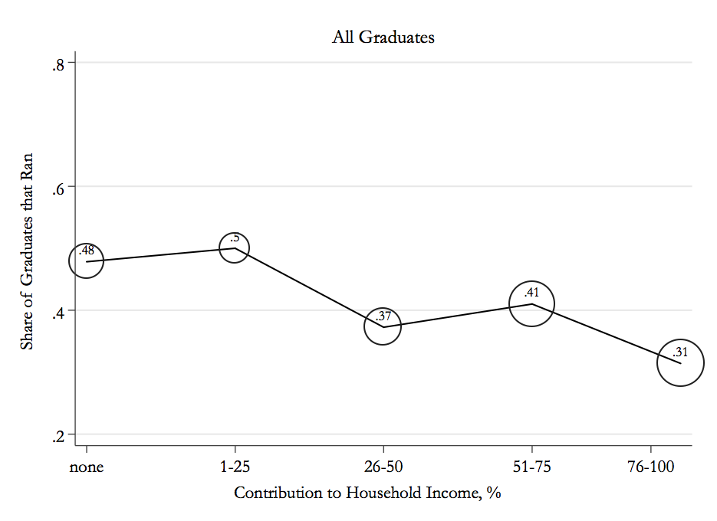

Note: The figure shows the share of graduates that ran for office based on their percentage contribution to household income. The size of the circles represent the proportion of overall respondents in each contribution bracket. Reproduced from Bernhard, Teele, and Shames (n.d.)

Other SES factors that we can examine with this survey, like total household income, leadership in occupation, and education, are not consistently predictive of either running or winning once breadwinning is taken into account in a multivariate regression.

Institutional/Political Environment

Campaigns, as Dittmar (2015) notes, are “gendered institutions,” and the institutional factors also play a role in winnowing the candidate pool. As Table 1 below shows, certain such factors seem to play a large role in shaping the expectations (and therefore willingness to run) of those in our sample. Considering the strength of the overall means first, we can see that the largest single factors that would encourage more women to run is more open seats and key endorsements, as from the retiring incumbent or another prominent political figure. These women also said that knowing their community would struggle without them would significantly increase their willingness to run. Having multimember districts also would seem to help (particularly for women of color and breadwinner moms, and the chance to “break the glass ceiling” by being the first woman to run seems appealing to a number of those in the sample.

Figure 3: Political Environment and Interest in Running

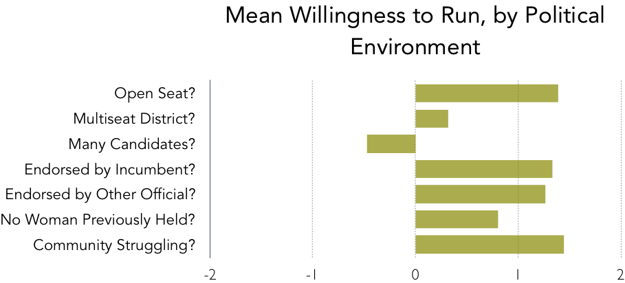
Note: The average response rate about willingness to run for office based on characteristics of the local political environment.

Table 1: Would This Make you More Likely to Run?
(Percent Saying Yes)

 | Mean Overall | Mean for Those Who Have Run | Mean for Women of color | Mean for Older Women | Mean for LBGTQ Women | Mean for Breadwinner Moms
Open Seat | 84% | 80% | 80% | 81% | 83% | 83%
Multi-seat race | 37% | 32% | 41% | 35% | 25% | 40%
Many candidates in the race | 12% | 12% | 15% | 12% | 8% | 14%
Incumbent endorsement | 87% | 83% | 83% | 84% | 89% | 86%
Other endorsement | 86% | 82% | 85% | 84% | 88% | 85%
No other woman had held seat before | 57% | 58% | 60% | 51% | 55% | 63%
My community would struggle without me | 87% | 86% | 87% | 84% | 86% | 88%

Psychological & Personality Barriers/Fears

Finally, it is important to know how the women in our sample are thinking about politics and candidacy, as perceptions about discrimination or other biases in the electoral environment can significantly predict non-running (even if such fears are exaggerated; see Shames 2017, Lawless and Fox 2005). One interesting finding from our study was that there are a large number of statistically-significant differences between what personality qualities these women thought they needed to have to be a candidate versus to be a leader (see Table 2 below).

Table 2: Qualities Required to be a Candidate/Leader (Percent Agreeing)

 | Quality in Candidate | Quality in Leader | Difference
Aggressive* | 21% | 11% | 10%*
Assertive* | 70% | 60% | 10%*
Compassionate* | 58% | 72% | -14%*
Decisive* | 62% | 69% | -7%*
Calm* | 54% | 61% | -7%*
Good Negotiator* | 52% | 70% | -18%*
Leadership Abilities | 85% | 83% | 2%
Honest* | 70% | 77% | -7%*
Independent | 38% | 41% | -3%
Knowledgeable | 81% | 83% | -2%
Nurturing* | 15% | 29% | -14%*
Sensitive* | 61% | 78% | -17%*

* Denotes statistically significant difference, p<.05

Figure 3: Which qualities do leaders as opposed to candidates need?

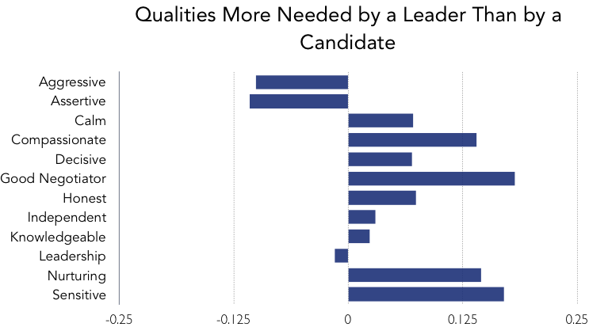

These women perceived substantial differences between the sort of personality that makes a good campaigner and that which makes a good governor. In particular, they tended to see campaigning as requiring stereotypically masculine qualities like aggressiveness and assertiveness, while they thought good leaders would have more stereotypically feminine traits like compassion, desire to nurture, and sensitivity. Women who ran were significantly more likely to report that leaders needed feminine traits but that candidates did not (p=.016). This is further evidence, to add to the existing literature, that women are cognizant of biases in the campaign environment.

In our survey, we have 16 variables that measure various fears (e.g., fear of not being taken seriously by voters, fear of racial discrimination, fear of losing work-life balance, etc.). If we sum all those up into an index variable that summarizes the level of fear these women have about running for office, we find that women who run are significantly more likely (p=.001) to run for office; indeed, the more fears women had, the more likely they were to run! There is no difference in level of fear based on win rates, which may suggest that these women update their concerns during the campaign process itself rather than based on the outcome of the election: women who run must deal with their fears and devise strategies to work around them, which is true for both women who win their contests and women who lose. In contrast, women who have not yet been through the experience of running may not have spent equivalent time facing these fears. Accordingly, we do not interpret this finding as suggesting that making women more fearful will encourage them to run! Rather, it is a post-treatment artifact of having been through a campaign.

Discussion

A perennial question for those interested in equal representation of women in public life asks why women decide to run. Though extensive research investigates determinants of women’s political ambition and electoral success, most prior studies tend to survey either those just beginning to consider the possibility of a political career (Lawless and Fox 2005; Shames 2017), or those who have officially registered and run for office (Moncrief, Squire, and Jewell 2001). As a result, we know relatively little about the factors that affect women’s decision-making on the road to candidacy. There is little consensus on the core obstacles that women face, and whether the challenges are primarily structural (about women’s work, family, and daily lives), institutional (about political contexts and factors), and/or psychological (for more review, see Shames 2017). Our study contributes to this issue area by looking at the highly motivated women that graduate from a national, federated women’s candidate training organization, Emerge America.

In studying this highly ambitious and well-trained group of progressive women, we identify factors that might prevent women from running and winning. We were particularly interested to find that fewer than half had actually run for office, despite paying on average $600 (though the cost varies by state, and Emerge offers financial aid) and investing several months in attending trainings. On the one hand, this is not a bad “uptake” rate for a training (most who attend, say, yoga teacher or bartender training do not pursue these as careers). On the other hand, for women who had invested significant time and money into candidate training, it is of great academic and real-life interest to know what would keep them in, instead of out of, the candidate pool.

We find that contextual factors like the nature of the seat matter for women’s decisions to run, as do family obligations and the share of a household’s income that is contributed by women.

[more to come!]

References

Bernhard, Rachel; Teele, Dawn; and Shames, Shauna: forthcoming. “Breadwinner Moms: The Critical Role of Resources in Women’s Political Ambition.” Working paper.

Burns, Nancy; Schlozman, Kay; and Verba, Sidney: 2001. The Private Roots of Public Action. Cambridge: Harvard Univ. Press.

Carroll, Sue and Sanbonmatsu, Kira: 2013. More Women Can Run: Gender and Pathways to the State Legislature. New York: Oxford University Press.

Dittmar, Kelly: 2015. Navigating Gendered Terrain: Stereotypes and Strategy in Political Campaigns. Philadelphia: Temple Univ. Press.

Duerst-Lahti, Georgia: 1998. “The Bottleneck: Women Becoming Candidates,” Women & Elective Office, Sue Thomas and Clyde Wilcox, editors. New York: Oxford University Press. pp. 15-25.

Fowler, Linda and McClure, Robert: 1989. Political Ambition: Who Decides to Run for Congress. New Haven: Yale Univ. Press.

Hawkesworth, Mary: 2003. “Congressional Enactments of Race-Gender: Toward a Theory of Raced-Gendered Institutions,” APSR 97(4), November: 529-550.

Harris-Lacewell, Melissa: 2005. “Contributions of Black Women in Political Science to a More Just World,” Politics & Gender 1(2), June, 341-350.

Jenkins, Shannon: 2007. “A Woman's Work Is Never Done?: Fund-Raising Perception and Effort among Female State Legislative Candidates,” Political Research Quarterly, 60(2): 230-239.

Lawless, Jennifer and Fox, Richard L.: 2005. It Takes a Candidate: Why Women Don’t Run for Office. New York: Cambridge Univ. Press.

Lawless, Jennifer and Fox, Richard L.: 2012. “Uncovering the Origins of the Gender Gap in Political Ambition,” working paper presented at Duke University (Durham, NC).

Moncrief, Gary; Squire, Peverill; and Jewell, Malcolm E.: 2001. Who Runs for the Legislature? Upper Saddle River, NJ: Prentice Hall.

Phillips, Anne: 1995. The Politics of Presence. New York: Oxford University Press.

Sanbonmatsu, Kira: 2006. Where Women Run: Gender and Party in the American States. Ann Arbor: Univ. of Michigan Press.

Shames, Shauna: 2017. Out of the Running: Why Millennials Reject Political Careers and Why it Matters. New York: New York Univ. Press.

Silbermann, Rachel: 2015. “Gender Roles, Work-Life Balance, and Running for Office,” Quarterly Journal of Political Science 10; 123-151.

Valian, Virginia: 2004. “Beyond Gender Schemas: Improving the Advancement of Women in Academia,” National Women’s Studies Association Journal 16(1); 207-220.

Valian, Virginia: 1999. Why So Slow? Cambridge, MA: MIT Press

Equal authorship. Thanks to Dorothy Kronick, Sue Thomas, and Yue Hou for inspiration, and enormous thanks to the national and state-level Emerge chapters that allowed and assisted in this data collection, especially Andrea Dew, Alisha Woodward and her team at the national office, and many state-level leaders as well. We owe special thanks to Frances Rosenbluth for her support, to Jennifer Lawless, Rosalyn Cooperman, and Jennifer Piscopo for their feedback on our preliminary findings, and to Chelsea Coccia, Radu Simion, Randi Stafford, and Alan Yan for their research assistance.
In addition to missing emails, many emails bounced initially; with the help of Emerge staff, eventually the number of missing emails was reduced to 50 and invalid emails to 76 bounces, for a total potential contact list of 1953 alumnae.
This project was exempted from full IRB review by both the Rutgers and the UC-Berkeley IRBs in April and May of 2016.
A full list of variables/questions is available in the appendix.
We also asked graduates a variety of open-ended questions about their decision to run and their experiences running, including why they decided to run (if run), what their greatest challenge running was (if run), and why they haven’t yet run (if no run).

