Sophia Sorcigli
Keylor Grant Reflection

My mother was born and raised in Georgia, during the Soviet Union, and shortly after the collapse, she made her way to NYC. She had given me the greatest gift as a child and young adult, which was the opportunity to visit this country, understand the culture, and understand the ways in which Georgia remains an important part of her life, and now my own. Studying international relations was rooted in this desire to better understand how to interact with the world around me, the people who inhabit it, and the cultures and differences that exist within all of us.

A part of the reason I have endeavored on this thesis project is to better understand the time period in which I have largely seen my own family members, and with time, come to realize how politics, culture, and development post the USSR collapse affected the larger Georgian community. Traveling to Georgia for the first time during the winter presented the country to me in a different light. Not only was it the beginning of Georgian holidays, but I also found Georgia in a very different state than when I had last left it in August. Democracy continuing to decay, I approached those weeks in January as an opportunity to ask the questions that Georgians themselves may have been fearful to address, a privilege I have been granted as a student at BU. Having the opportunity to outreach and meet with various actors in Georgia provided me with an insightful trip. Firstly, meeting with the United Nations House in Georgia and the European Union Mission in Georgia were both unique and unforgettable experiences as a fellow Georgian and IR student. The UN mission house in Georgia is located right across the street from my childhood home in Tbilisi, and for years on end I have only imagined what was contained within those diplomatic walls. This year, I finally had the chance to encounter it myself. At the UN house, I spoke with comms representatives, as well as Georgian members of the UNDP section of the UN house. We spoke on topics of democratic decay over time, the ministerial conflicts, the 2008 war, and how the UN mission has always remained the same, to prioritize the goals of democratic development within Georgia for Georgians. The EUMM’s work was quite varied from that of the UN, though a mission of the EU, their goals remain to serve as a third-party facilitator and mediator between Russia, Georgia, and the separatist regions of Abkhazia and Ossetia. The EUMM representative I had spoken with, was able to lay out just how their operations have kept Georgian borders at peace (to some extent). Talking with these organizations brought to light the ways in which foreign investment in Georgia has worked and also where it has lacked, where there is space to grow and where the international community can learn from its mistakes.

Following those conversations, were insightful interviews with University of Georgia professors who were prior government officials. Speaking with academics also broadened my scope when it came to Georgia’s recent history, much of which today lacks the personal perspectives that these professors were able to provide. From former employees of the Ministry of Defence in Georgia, to former leads on the NATO mission in Georgia, those conversations drove me to ask more questions on Georgia’s democratic path.

Finally, I finished off with the Rondeli Foundation Think Tank, where I spoke to Research fellows who were also former government officials under The United National Movement and into The Georgian Dream. Again, these interviews naturally flowed into conversations where I was able to hear about the day-to-day lives of these employees, what their realities within post soviet Georgia were like and to what extent state building was successful in their opinions. Overall this trip was able to continue to drive me to ask challenging questions and be okay with the fact that Georgia’s plentiful history, culture, and deep political polarization are still unsolved and the realities of these civilians as well as our conversations prove the extent to which Georgia remains on the path of development.

From my summers in Georgia, my family has consistently been a source of inspiration and information. I have learned much about Georgian culture, history, politics, and way of life merely from the time spent with them. This research project allowed me to bring my already acquired knowledge and direct it towards experienced professionals who may have had very different understandings of Georgia, Georgian history, and the Georgian identity. If I could undergo this research project again, I would have changed absolutely nothing about my study, the people I had the opportunity to speak with, and the places I had the opportunity to visit. If anything, I would have added on another week for continued exposure to the material and also would have hoped to have spoken with a current government official, though this would have been quite difficult under the current circumstances of the Georgian government.

—

Order of Images Below:

- April 9th, 1989 Memorial Square in front of the Parliment
- University of Georgia
- Graffati in Tbilisi
- Parliment House
- Rondeli Foundation
- UN House Tbilis

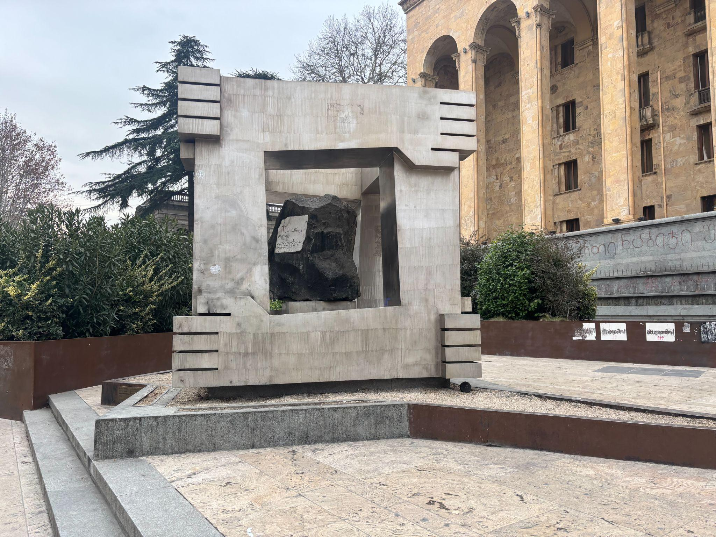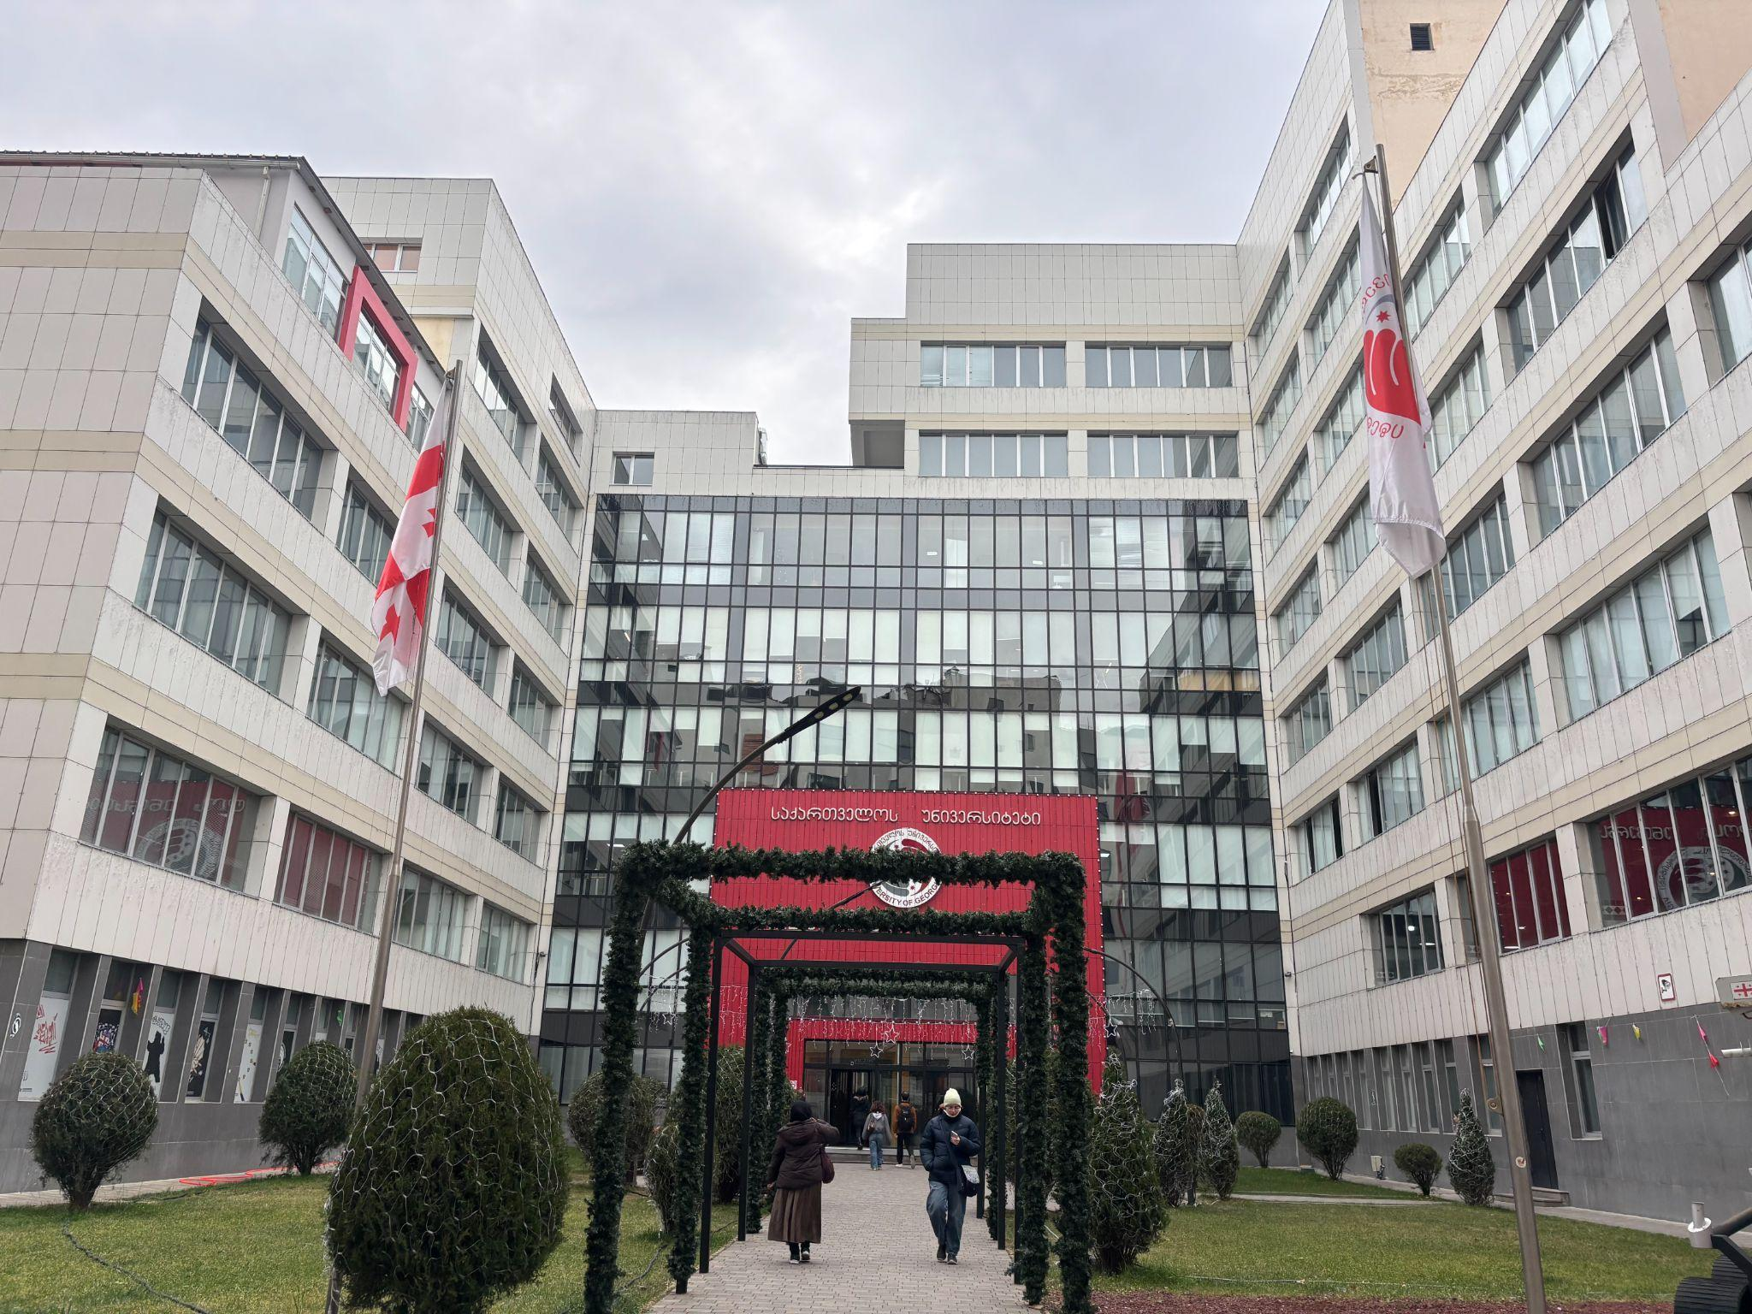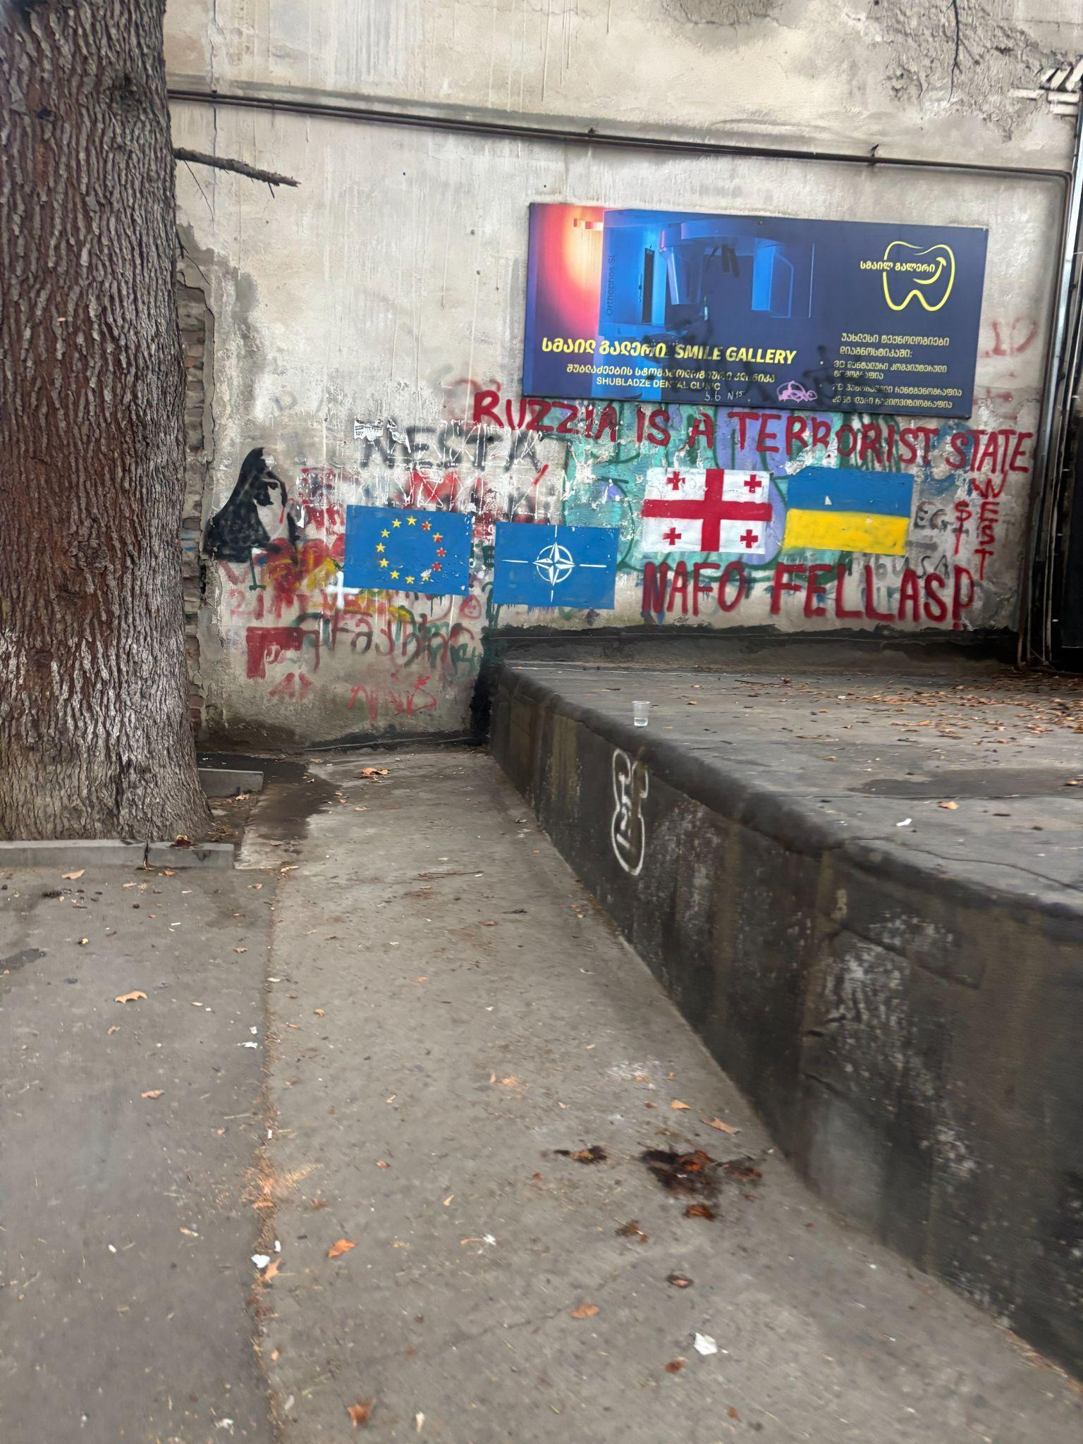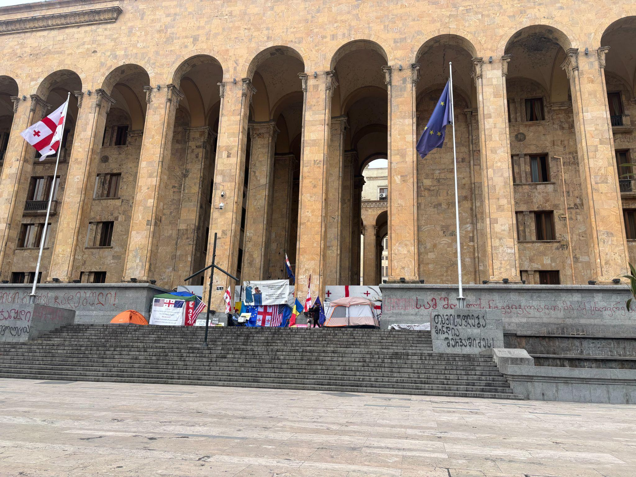
Parliament House
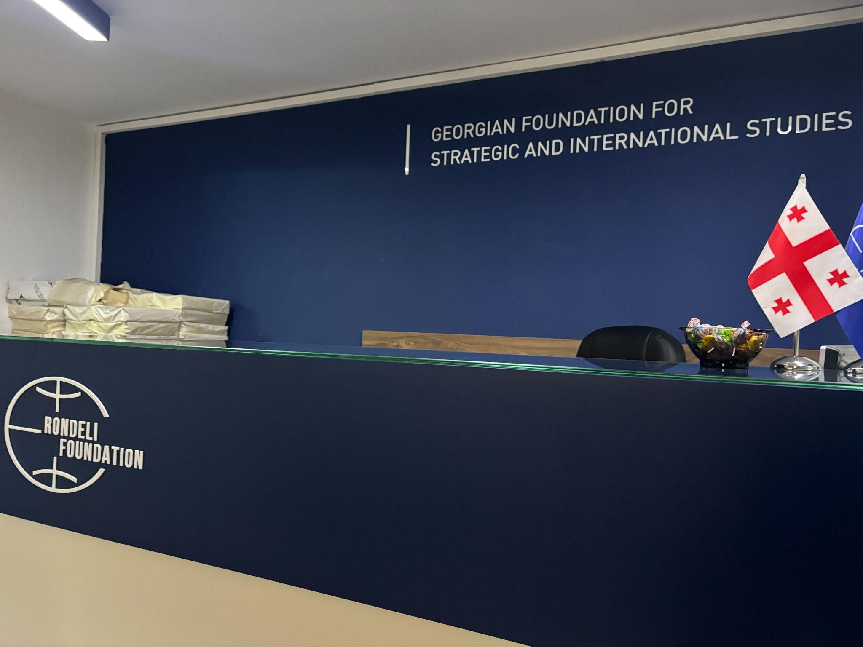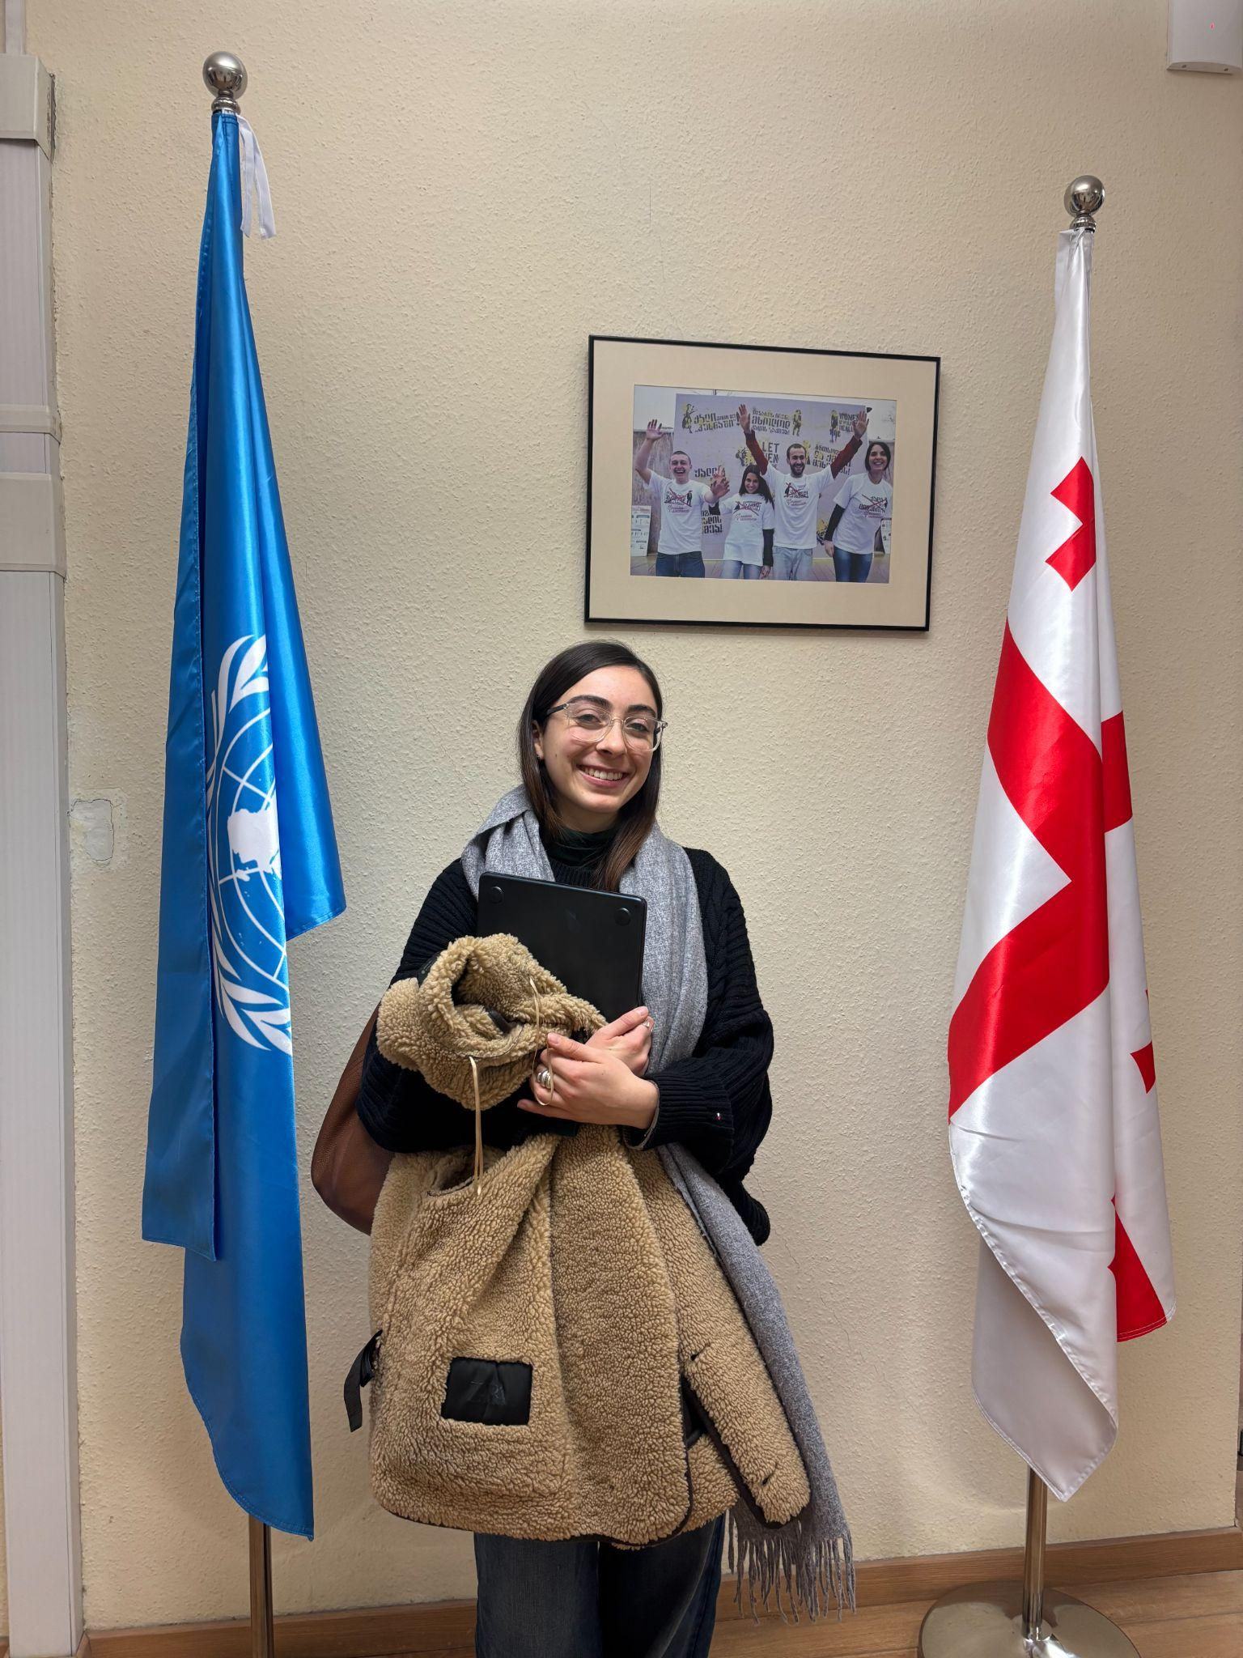UN House Georgia Tbilisi

