Chart Your Career – Quarterly Connects

Quarterly Connects are the on-going touchpoints that support manager-staff partnership and performance success. Use the template below to prepare and guide your quarterly conversations. The prompts reflect the annual performance review.
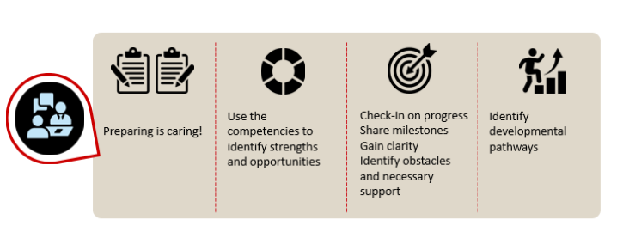
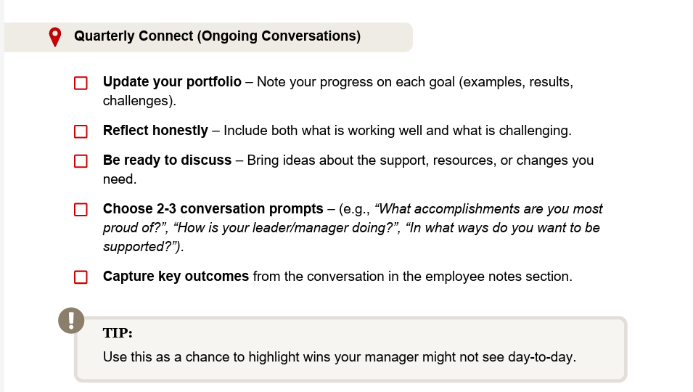

Pro Tips:
- Schedule quarterly connects ahead of time for the entire year.
- Identify a collaboration space for writing goals, gathering your achievements, and planning for improvements.

Your Quarterly Connects DO NOT need to be submitted into HR

Competencies: Please share how the core competencies were reflected in your work.

Core Competencies
- What were areas of strength? Where might you want to improve.
- What is your plan for further leveraging your strengths and making improvements?
- How do you want to be supported?

Pro Tips:
- Use the behaviors in the competency guide as examples.
- When discussing behaviors, note the consistency and independence with which selected behaviors are demonstrated.
- Check out the skills and knowledge section to help with improvement plans.

You DO NOT need to reflect on all six competencies each time

Performance and Professional Development Goals

Use this section to note the progress on each pre-established goal - both performance (doing) and professional development (learning) goals. To add more goals, please copy and paste this goal template and complete a separate entry for each goal. Please customize as needed.

Goal 1: [Describe your goal here or link to your goals document or collaborative space such as Microsoft Teams, Google Drive, etc.]

Note the status: Not Started _____ In Progress _______ On Track _______ At Risk ________ Needs to be Adjusted______________

Prompts to support your preparation:
- What have been the most significant accomplishments since our last check-in?
- What do you think are the most important next steps/items to focus on to meet your goals?
- What if any obstacles are you encountering right now?
- What support do you need to accomplish your goal? What opportunities have you had to pursue your professional development goals?
- What opportunities are necessary to help you further develop.
- Is there anything else you would like to discuss at our check-in?

Pro Tips:
- Write concise highlights to bring to your Quarterly Connect discussion.
- During the conversation, note what is important – dates, takeaways, agreements, and action items, can be helpful to remember.

