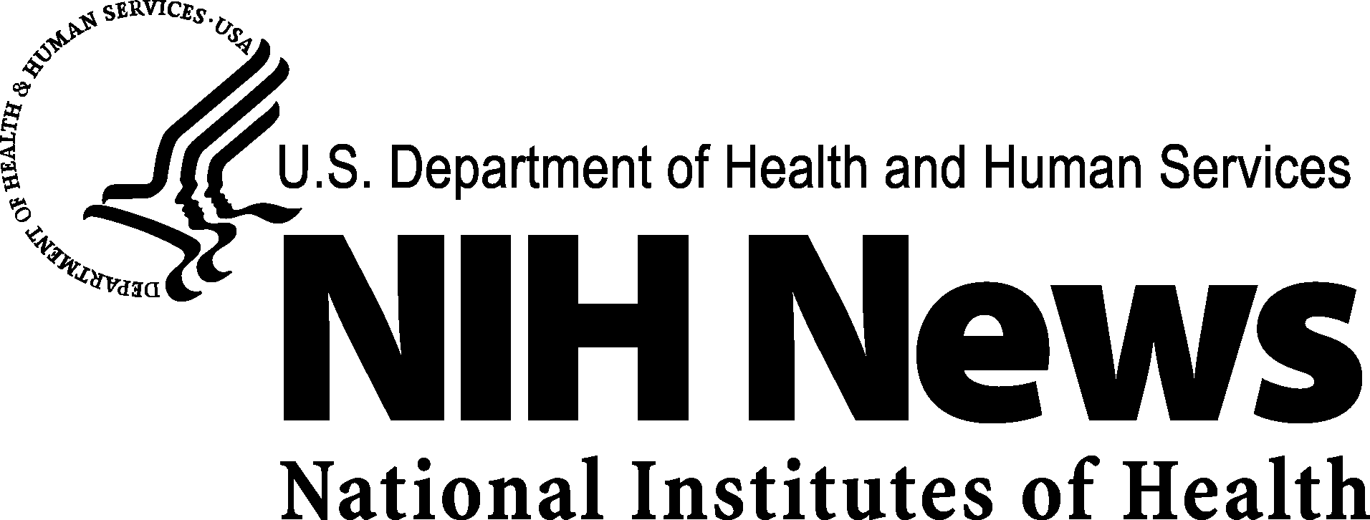

FOR IMMEDIATE RELEASE | Media Contact: NIAID News Office
Thursday, Nov. 29, 2007 | (301) 402-1663
 | niaidnews@niaid.nih.gov

STATEMENT
NIH Response to the National Research Council Committee Review of the NIH Draft Supplementary Risk Assessments and Site Suitability Analyses for the

National Emerging Infectious Diseases Laboratory, Boston University

The National Institutes of Health (NIH) supports medical research to improve the health of people around the world. The health and welfare of the public and of scientists conducting that research is of utmost concern to NIH. For that reason, NIH followed the National Environmental Policy Act procedures in preparing a Final Environmental Impact Statement and in issuing a Record of Decision on the NIH-supported National Biocontainment Laboratory project in Boston. The February 2006 Record of Decision affirms the safety of the National Emerging Infectious Diseases Laboratory at Boston University, a high-containment biosafety research laboratory that will focus on developing diagnostics, drugs, and vaccines for a variety of infectious diseases.
Following the Record of Decision, and in response to concerns raised in a federal court proceeding, NIH prepared a Draft Supplementary Risk Assessments and Site Suitability Analyses for the NEIDL, Boston University, to assess additional potential impacts of biosafety level-4 (BSL-4)-specific laboratory activities of particular concern to the Boston community.
In response to a State of Massachusetts court proceeding, the State Executive Office of Energy and Environmental Affairs requested that an expert Committee be established by the National Research Council (NRC) of the National Academies of Sciences to provide technical input on the draft NIH report. In their review, the Committee commended NIH for carrying out its federal charge to work with the Boston community to choose the pathogens for the BSL-4 risk assessment scenarios included in the report. As the Committee itself noted, however, the federal process led to the selection of pathogens for the study that do not address questions raised in the State proceedings.
As stated by the Committee, their overall conclusions about the NIH study “are based solely on the Committee’s technical review” of this single draft document and “should not be viewed as statements about the risks of proposed biocontainment facilities in Boston, or in cities more generally. The Committee acknowledges the need for biocontainment laboratories in the United States, including BSL-4 laboratories, and recognizes that BSL-4 facilities are being operated in other major urban areas.”
NIH appreciates the thoughtful and rigorous scientific review of this draft document by the NRC Committee and will consider their comments along with all others received from the Boston community and elsewhere.
The National Institutes of Health (NIH)—The Nation's Medical Research Agency—includes 27 Institutes and Centers and is a component of the U. S. Department of Health and Human Services. It is the primary federal agency for conducting and supporting basic, clinical and translational medical research, and it investigates the causes, treatments and cures for both common and rare diseases. For more information about NIH and its programs, visit http://www.nih.gov.

###

The National Institute of Allergy and Infectious Diseases
is a component of the National Institutes of Health,
U.S. Department of Health and Human Services



