Is the gravity the same everywhere on Earth?
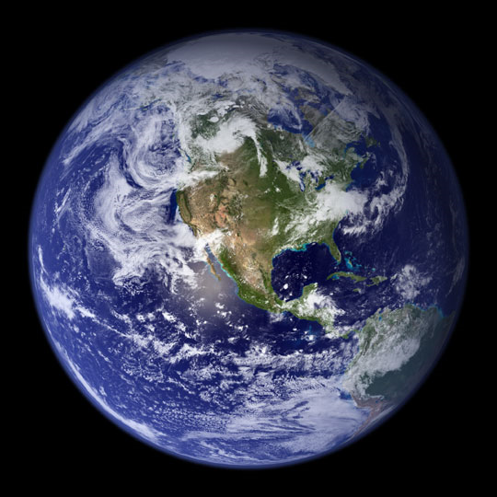
We know that the gravitational acceleration on Earth is roughly 9.8 m/s². But does it matter where you are on Earth? Could you feel lighter just by moving somewhere else? One way to feel lighter is to move further away from Earth’s center. The further away you are, the less Earth’s gravity pulls on you (or, the smaller g gets).
Earth has tall mountains (the tallest being the 8800 m tall Mt. Everest in Asia) and deep ocean trenches (the deepest being the 10,900 m deep Mariana Trench in the Caribbean). That sounds like a lot, but Earth is actually more perfectly round than a billiard ball (for comparison, the Earth’s radius is about 6,300,000 m!). Nonetheless, if you lived on the top of Mt. Everest, you would feel about 0.3% lighter than if you lived in Boston. This doesn’t amount to much; with my 162 pounds, I would weigh about 161.6 pounds on the top of Mt. Everest.
NASA chooses its rocket launch sites carefully!
It turns out your latitude (your position relative to the Earth’s equator) matters too. Imagine swinging a stone at the end of a string. As you swing it faster and faster, you have to apply a larger and larger force to keep it going in a circle. Now, every point on Earth’s surface rotates around the Earth’s axis once every day, but as shown on the drawing, they don’t cover the same distance. Objects near the equator (red) move further (and hence faster!) than objects further away (blue). In fact, the rotational speed of an object at the equator is roughly 460 m/s! Even though gravity’s pull doesn’t change, this slingshot effect helps launch objects from Earth’s equator, and as a result, the net pull towards Earth is reduced by about 0.65%, compared to an object at one of the poles. When you have to launch rockets into space and want to save on expensive rocket fuel, every bit counts. That’s one of the reasons why NASA launches its rockets from Cape Canaveral in Florida and Houston in Texas, rather than from Massachusetts!

