LHC – the particle collider in Geneva

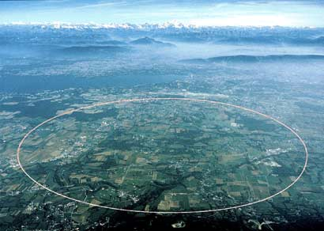
The LHC, or Large Hadron Collider, is a giant physics experiment in beautiful Geneva, Switzerland. Countries from all over the world are working together to make the experiment work. So, just how big is it? The main part of the experiment consists of a huge underground tunnel 27 km (about 17 miles) in circumference.
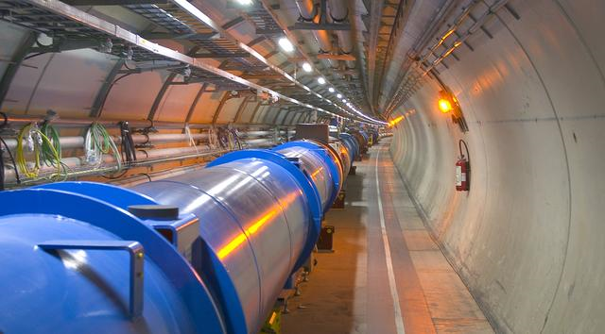
Inside this tunnel, physicists speed up particles to very high speeds. In fact, it only takes them 0.000090 seconds to go all the way around! To steer these particles zooming around, physicists use huge magnets cooled with liquid Helium to about –450 degrees Fahrenheit.
What can the LHC teach us?
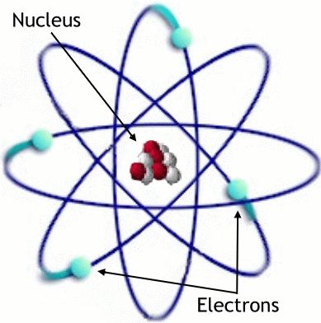

The atoms that make up the world around us are made up of three building blocks. In the center of the atom, a heavy nucleus contains protons and neutrons. Swirling around them are the much lighter and smaller electrons. But in addition to these building blocks, scientists have found dozen other particles.

Inside the LHC’s giant tunnel, scientists accelerate protons to very high speeds. They then smash them together. Collisions between really fast-moving protons can create a horde of other particles that the scientists study. This helps us learn how the nature of really small particles work, and also teaches us about how our universe is put together and has evolved.
Could LHC really make a black hole?

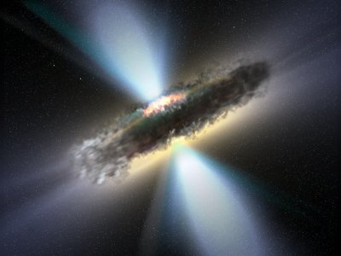
In some extreme cases in nature (when enormous stars explode, for example), the fundamental particles can be squeezed really close together, creating an immensely dense object. A black hole is an object so dense and heavy that, incredibly, not even light can escape it! (That’s where it gets its name)

Some people have raised concern that the experiments at the LHC could create a black hole right here on Earth, destroying the planet. However, after many thorough calculations and considerations, experts agree that we are safe from man-made black holes – at least ones that can destroy our planet!

