Physics Challenge Question 4: Traveling to the Moon

Due in class 10/5/2008

Part 1:
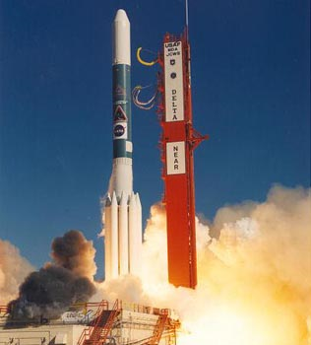
NASA is launching a rocket into space from Earth. This particular rocket burns its fuel for 5 minutes and then turns off its engines. At this point, the rocket keeps floating along through space at a speed of 10 km/s.
What is the rocket’s average acceleration during these first 5 minutes?

Part 2:
How far did the rocket travel during the first 5 minutes?

Part 3:
The Moon is approximately 3.8.10⁵ km from Earth.
At its final speed, how long will it take the rocket to reach the Moon?

Part 4:
The star nearest to us, called Alpha Centauri, is 4.1.10¹³ km away.
Could this rocket get a man to Alpha Centauri before he dies of old age? (This is a real obstacle to NASA’s plans of exploring other solar systems than our own!)

Part 5:
The rocket is half way to the Moon when its pilot suddenly notices he forgot his camera! He radios a second rocket crew on Earth and tells them to bring his camera and meet him on the Moon when he lands. Unfortunately, the second rocket can only accelerate at 3 m/s².
Can this second rocket make it to the Moon before the first one lands?

