Physics Challenge Question 9: The vertical jump

Due in class 11/24/2008

Note: In this problem, you will need to use what you know about motion (the 4 equations about velocity, acceleration, and displacement), as well as what you have learned about forces.

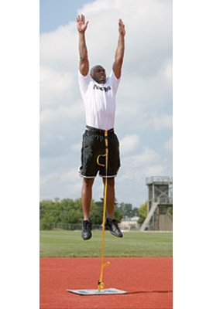
An exceptional standing jump would raise a person 0.80 m off the ground. To do this, a 61 kg person crouches 0.20 m and pushes off from the ground, exerting a force on it. By Newton’s third law, the ground pushes back with an equal and opposite force, which accelerates the person off the ground.

Part 1 (2 point)
What is the jumper’s speed just as he leaves the ground?

Part 2 (3 points)
What force must he exert on the ground to perform the 0.80 m jump?

