Physics Challenge Question 11: Levers

Due in class 12/15/2008

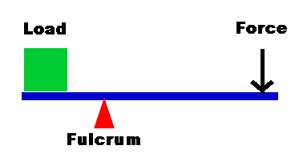Levers are a clever way of moving something heavy that you wouldn’t be able to move just by pushing on it. They’re used in many places in our everyday lives (including your skeleton). A lever consists of a “lever arm”, which is free to pivot about a point, or “fulcrum”. It relies on having the distance L₁ be larger than L₂. By pushing on the long arm, the force F₁ you apply gets multiplied, and a much larger force F₂ is applied to the load.
L₂
L₁
F₁
At first glance, it seems like you get “something for nothing” when using a lever; you apply a small force, and you’re able to move an object with a much larger force! On closer inspection, it turns out not to be so; the work done on the object matches exactly the work you put in. Here, we will derive the basic lever equation
$$\frac{F_{1}}{F_{2}}=\frac{L_{2}}{L_{1}}$$

Part 1 (1 points)
If you push the long end of the lever down a distance d₁, how much does the other end move up? (Call this distance d₂.) Express you answer in terms of L₁ and L₂.

Part 2 (2 points)
Assume that the work you do is equal the work done on the load. Express this assumption in terms of the forces F₁ and F₂ and displacements d₁ and d₂, and use your answer from part 1 to derive the lever equation.

Part 2 (2 point) (you can do this part without doing part 1 or 2)
If I gave you a lever arm 10 m long, where would you have to rest it on the fulcrum to lift a 1000 kg object off the ground? (I.e., what must the ratio L₁/L₂ be?) (Hint: The force you can exert is probably largest if you lean on it and push down with all your weight.)

