Physics Challenge Question 25: Interference of light

Due in class Thursday 5/21/2009

Part 1 (1 point)
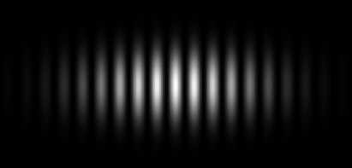
When light of just one wavelength (called monochromatic light) passes through a certain diffraction grating, the light appears bent, and a light pattern of alternating bright and dark spots is seen on a screen behind the grating (shown here).

Which areas on the screen correspond to constructive interference, and which ones to destructive interference? Explain.

Part 2 (1 point)
Do a little research about diffraction gratings. (Try typing in “diffraction grating” on Wikipedia if you are stuck!) What equation links the wavelength of the light to the spacing of the slits and the angle at which the maxima is seen?
(Assume the light is entering the grating at a 90° angle.)

Part 3 (1 point)
To figure out what grating you have, you take a known source of light (a Sodium lamp with wavelength 589.3 nm) and shine it perpendicular to the grating. You notice that the first bright band (apart from the middle one) appears at an angle of 0.1352°.
What is the slit spacing of the grating?

Part 4 (2 points)
Now that we know the properties of our grating, we can use it to measure the wavelength of an unknown light source.
A different light source yields a first maximum at an angle of 0.25° when entering the grating perpendicular. What is the wavelength of this unknown light? Can you see this light with your eye?

