Physics Challenge Question 5: Firefighting planes

Due in class 10/13/2008
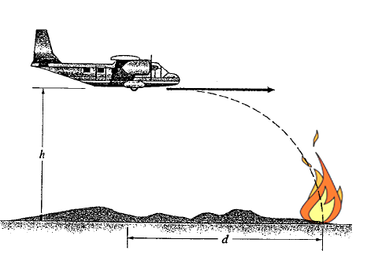
After the recent drought in California, wildfires are commonplace. To help fight the fires, the state uses planes to drop water and fire retardants on the flames. One such plane flies horizontally over a fire at a speed of 60 m/s and drops a giant water balloon to help extinguish the fire. It flies at a height of 200 m, as shown on the picture.
200 m
60 m/s

If you’ve ever tossed a ball straight up into the air inside a train or car moving at constant velocity, you will have noticed that its vertical motion doesn’t affect its horizontal one; that is, the ball moves along with you and the car and stays above your hand. This is an example of how horizontal and vertical motion are independent of each other. We will use this fact to help the pilot hit his target.

Part 1:
How long does it take for its load of water to hit the ground? (Hint: as gravity pulls the balloon straight down, you can ignore the plane’s horizontal motion to solve this part! You’ll need to know the gravitational acceleration, though.)

Part 2:
If the plane released its load when right over the flames, it would overshoot its target. It must release it a little earlier, marked by d on the drawing. How far before the fire must it release the water? (Hint: just like the ball thrown straight up into the air inside the car stays above your hand, the balloon stays right under the plane when falling!)

Part 3:
The pilot accidentally angles his plane slightly downward when releasing his water balloon, with the nose lower than the tail. He releases the water balloon from the exact same location as before. Will the balloon still hit the fire, overshoot it, or land short of it? You don’t need to do any explicit calculations, but use what you know about velocity and acceleration to justify your answer.

