Physics Challenge Question 1: Dimensions and estimates

Due in class 9/15/2008

In science, it is often helpful to be able to estimate numbers. The goal when doing estimations is not to reach a very accurate result, but rather to get an idea of how big or small the numbers involved are.

Question 1:
Denmark is a small Scandinavian country with a land area of roughly 42,000 km².
The land area of the United States is roughly 9,161,000 km².
How many times bigger is the United States?
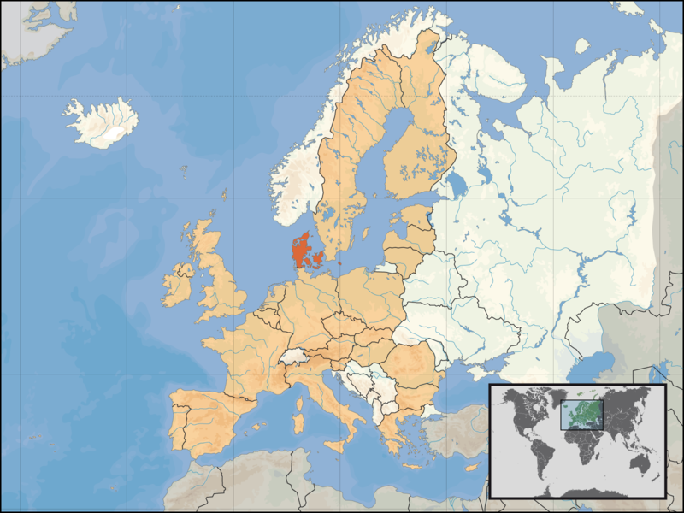

Question 2:
Although Denmark is pretty small compared to the US, it turns out to be pretty roomy. First, estimate how large an area a person takes up when standing. How many people could you fit in Denmark?

Question 3:
Could the entire world’s population fit in Denmark, if everyone were willing to stand? (You will have to look up some numbers if you don’t already know how many people are in the world. Be sure to show what numbers you use. For comparison, there are approximately 5 million people living in Denmark today.)

