Physics Challenge Question 6: A two-car race

Due in class 10/20/2008
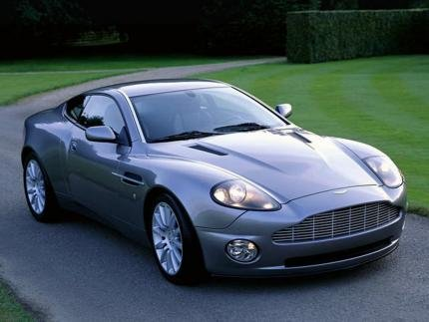

For a useful simulation to help you solve this problem, go to the website http://physics.bu.edu/~duffy/classroom.html, click on Physlets in the First Semester, and select A two-car race.

You’re driving your car towards an intersection. A Porsche is stopped at the red light. You’re traveling at 40 km/h (11.11 m/s). As you are 15 m from the light, the light turns green, and the Porsche accelerates from rest at 3 m/s². You continue at constant speed.

- How far from the stop line do you pass the Porsche? At what time, measured from when the light turned green, do you pass the Porsche?

- As the Porsche keeps accelerating, it eventually catches up to you again. How far from the stop line does it pass you? At what time, measured from when the light turned green, does it pass you?

- If a Boston police officer happens to get you and the Porsche on a radar gun at the instant the Porsche passes you, will either of you be pulled over for speeding? Assume the speed limit is 50 km/h.

