BIO BUGS PRE-LAB EXERCISE: Comparative Vertebrate Anatomy

In the same way that a dead body can provide forensic detectives with the clues to solve a murder case, the bodies of animals can tell us a lot about their ecology and evolution.

In this lab we will study the internal anatomy of the five classes of the vertebrates through hands-on examination of dissected whole specimens as well as prepared skeletons and skins. You will formulate hypotheses about the ecology of each dissected species based on your observations of the similarities and differences between each specimen. You will also learn how to use morphological observations to construct a phylogenetic hypothesis of the evolutionary history of each vertebrate class.

Before starting your investigation, you need to prepare by boning up on your vocabulary. Fill in the specific traits for the vertebrates in the chart below.
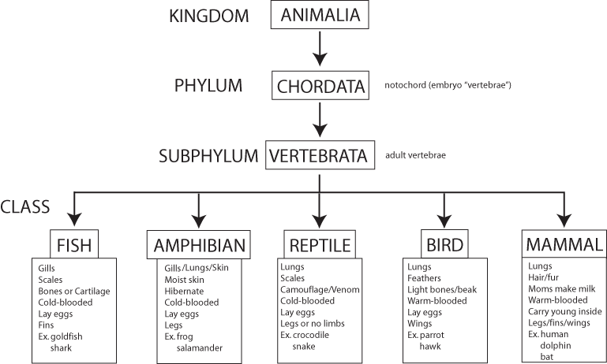
- Define the following terms:

Taxonomy: scientific way to classify living organisms based on similar traits

Phylogeny: the study of the evolutionary similarities among living organisms

Adaptation: a change in a physical structure or behavior that is beneficial for survival

- What is the function of the following organs?

Heart: pumps blood to the body

Lungs: exchanges carbon dioxide for oxygen

Large Intestine: absorb water after digestion; store waste

Kidney: filters waste from blood

Liver: important for metabolism; helps with digestion

Skin: protect the internal body from environment

- Vertebrates eat a variety of food. Match the following classification with its definition.

__b__ 1. herbivores a. eats insects
__c__ 2. carnivores b. eats plants only
__a__ 3. insectivores c. eats animals only
__d__ 4. omnivores d. eats both plants and animals

Congratulations Detective! You are ready to start your investigation!

