BIO BUGS PRE-LAB EXERCISE: Comparative Vertebrate Anatomy

In the same way that a dead body can provide forensic detectives with the clues to solve a murder case, the bodies of animals can tell us a lot about their ecology and evolution.

In this lab we will study the internal anatomy of the five classes of the vertebrates through hands-on examination of dissected whole specimens as well as prepared skeletons and skins. You will formulate hypotheses about the ecology of each dissected species based on your observations of the similarities and differences between each specimen. You will also learn how to use morphological observations to construct a phylogenetic hypothesis of the evolutionary history of each vertebrate class.

Before starting your investigation, you need to prepare by boning up on your vocabulary. Fill in the specific traits for the vertebrates in the chart below.
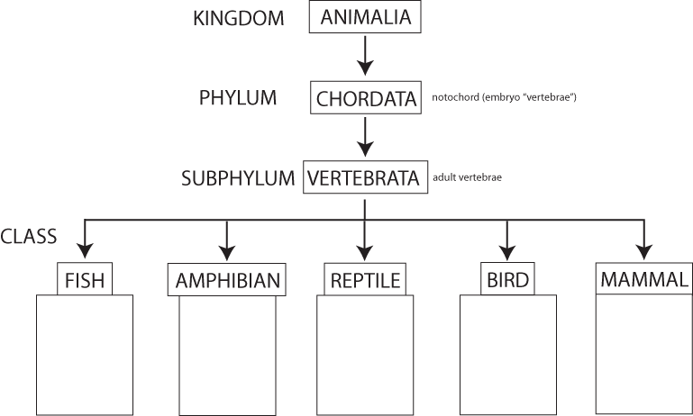
- Define the following terms:

Taxonomy: ________________________________________________________________________________________

Phylogeny: ________________________________________________________________________________________

Adaptation: ________________________________________________________________________________________

- What is the function of the following organs?

Heart: _____________________________________________________________________________________________

Lungs: ____________________________________________________________________________________________

Large Intestine: _____________________________________________________________________________________

Kidney: ___________________________________________________________________________________________

Liver: _____________________________________________________________________________________________

Skin: _____________________________________________________________________________________________

- Vertebrates eat a variety of food. Match the following classification with its definition.

_____ 1. herbivores a. eats insects
_____ 2. carnivores b. eats plants only
_____ 3. insectivores c. eats animals only
_____ 4. omnivores d. eats both plants and animals

Congratulations Detective! You are ready to start your investigation!

