
Gijs van Seventer
Environmental Health Seminar

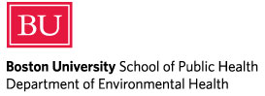
Bringing Climate Science to Public Health: Population-based Applications for Disaster Preparedness
Friday, November 2
Noon – 1 pm
BU Medical School, Room L210

Speaker:
P. Gregg Greenough, MD, MPH
Director of Research, Harvard Humanitarian Initiative
Attending Emergency Physician, Division of International Health and Humanitarian Programs in the Department of Emergency Medicine, Brigham and Women’s Hospital

Discussion of the interaction required between the climatic sciences and population-based methods of epidemiology and demography for translation into local and regional preparedness and response.
sph.bu.edu/ehseminars

