After Hospital Care Plan for: [patient name]

Discharge Date: [discharge date]

EACH DAY follow this schedule:

MEDICINES

What time of day do I take this medicine? | Why am I taking this medicine? | Medicine name  Amount | How many do I take? | How do I take this medicine?


Morning

Morning

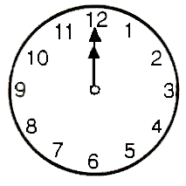
Noon
Evening
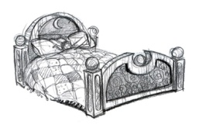Bedtime
Only if you need it for

Only if you need it for

[Insert Patient Name]

[Insert Primary diagnosis]

Date/time of appt

Provider name

Provider site information

Reason for appt

Provider phone number

Default (if applicable):
[Walking is a very healthy form of exercise. Please do your best to walk for at least 20 minutes every day.]

Default (if applicable):
[Eating food that is low in fat and low in cholesterol will help you stay healthy.]

REMEMBER you are allergic to [list medicine allergies].

[Insert pharmacy name, location, contact information]

{If applicable, include:}

TRY TO QUIT SMOKING: call [contact information]



Check the box and write notes to remember what to talk about with Dr. [PCP name]

Dr. [PCP Name]:
When I left the hospital, results from some tests were not available. Please check for results of these tests: [List tests done]

