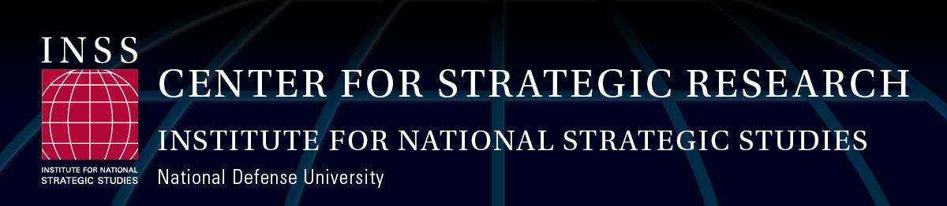

Western Hemisphere Security Internship – Spring 2015

The Center for Strategic Research (CSR) at the Institute for National Strategic Studies (INSS) at National Defense University (NDU) is seeking U.S. citizen interns to join its Western Hemisphere Team.
The selected Intern will work closely with Senior Research Fellow, COL John Cope (U.S. Army, Retired), on research projects focused on Western Hemisphere defense and security issues, and U.S. - Latin American relations. Past projects have included: U.S.-Colombia security cooperation, U.S.-Mexico security cooperation, Caribbean Basin Security, Public Security in Central America, U.S.-Brazil defense relations, U.S.-Chile defense relations. On-going research includes: enhancing civil-military relations and professional military education, strengthening the capacity of civilian personnel in Latin American defense ministries, coordination of military assistance in natural disaster response, counter-narcotics cooperation among the Americas, Africa, and Europe, as well as improving capabilities of the Organization of American States and other hemispheric and sub-regional multilateral institutions.
Intern will also assist with event preparation and execution for conferences and workshops attended by U.S. and foreign government officials (including diplomatic corps and military personnel), academia, and think-tanks. Intern will also serve as INSS-CSR Western Hemisphere Team representative at similar events on Latin American affairs hosted by other institutions in Washington, D.C.
Academic background and/or work experience in Latin American affairs, study and/or work abroad in the region is desirable. Spanish and/or Portuguese language proficiency is preferred. U.S. citizenship is required.
INSS is a collection of Department of Defense research centers established in 1984. The mission of the Institute is to conduct research in support of the academic and leader development programs at NDU, and to provide strategic support to the Secretary of Defense, the Chairman of the Joint Chiefs of Staff, and the Unified Combatant Commands.
To apply for this unpaid position, please send a resume, cover letter, and short writing sample (2-3 pages), addressed to the INSS Dean of Administration and Chief of Staff, also serving as the Internship Program Coordinator, Mr. Donald Mosser, at INSS_Intern_Program@ndu.edu. General questions may also be directed to Mr. Mosser at 202-685-3844 or Ms. Kacey Mahoney at 202-685-2335.

Application Deadline: November 23, 2014 (applications reviewed on a rolling basis).
Approximate Decision and Notification Date: Week of December 8-12, 2014
Approximate Start Date: January 19, 2015 (flexible)
Approximate End Date: May 29, 2015 (flexible)

