***If you are not located on the BUMC or BMC medical campuses, you must be logged into the BUMC VPN. BMC VPN will not work for this application process. ***
**Please Note BUMC VPN (particularly outside the United States) is subject to network providers who may block or restrict VPN access at their discretion. **
(Instructions for VPN setup)
Firefox & Google Chrome are the recommend browsers (please note to enable your pop-ups).
PLEASE CLICK HERE TO BEGIN YOUR APPLICATION FOR THE MINI SABBATICAL AWARD

- The first step of this application is to complete a Notification of Intent by clicking on the hyperlink above. By completing the steps of this Notification of Intent you will verify your demographic information and submit an intent to apply for this program. Firefox & Google Chrome are the recommend browsers (please note to enable your pop-ups).
  - If you have used WebCAMP before, you will be asked to verify your existing information. At the end of this request to apply, you can click ‘here’ (see arrow on image below) on the Initiate New Submission page to log into WebCAMP and begin your application.
    - You can also use the URL below at any time to take you to the WebCAMP homepage https://webcamp.bumc.bu.edu/webcamp
OR
  - If you have never used WebCAMP before, you will be prompted to choose a password. We recommend you use your BU Kerberos password to better remember upon login.
    - At the end of this request to apply, you will be sent an email with a link that directs you to WebCAMP login page, where you will be able to log in with your name and password. You must use this link for your first login.
  - You should receive email notification of your intent to apply.

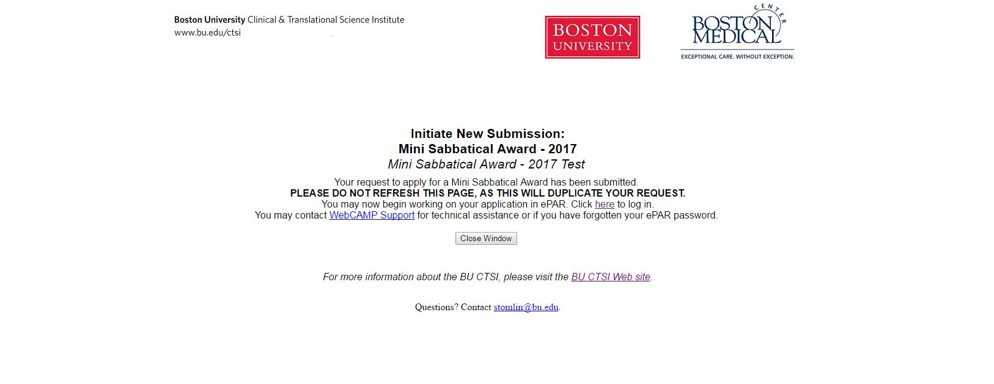

  - If you have never used WebCAMP before, you will be prompted to choose a password within this request to apply.
- Once you log into WebCAMP go to “Protocol Authoring and Review (ePAR)” to find your application.
  - Your application will be listed here.

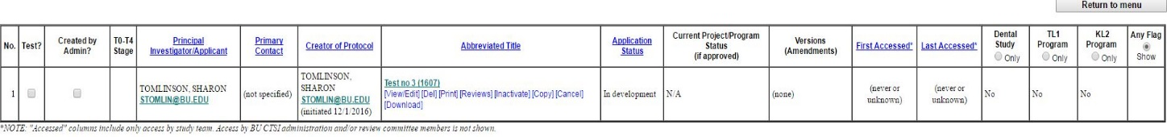
- Click on the Abbreviated Title or ‘View/Edit’ to open your application
- Application Status Page
  - This page shows you which sections are COMPLETE and INCOMPLETE in your application.
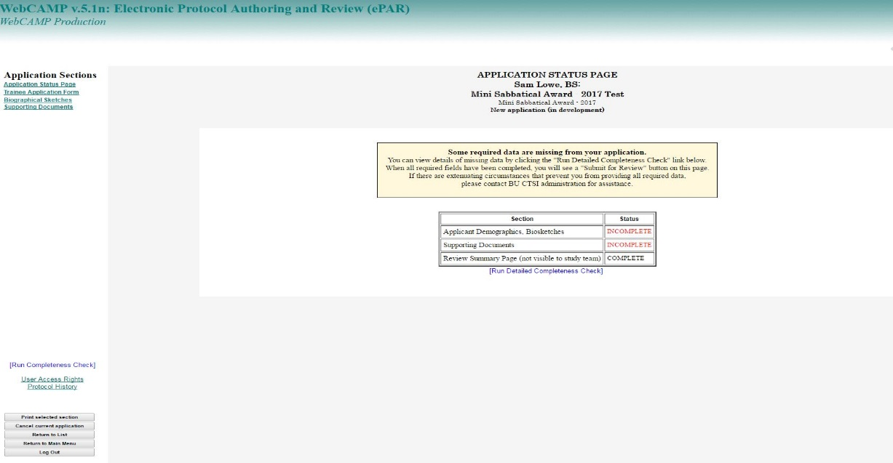

  - When you are finished your application, check back to this page to see if all the required information was filled out.
    - If any sections are INCOMPLETE, click the “[Run Detailed Completeness Check]” button to get a step-by-step Check of your application.
      - If anything still needs to be filled out, it will be highlighted in YELLOW.
      - The hyperlink will take you directly to the spot in the application in which you are missing information
- Trainee Application Form
  - Please fill out all information regarding your project.
- Biographical Sketches
  - Here upload a biosketch for each person listed in the “Select Investigator” drop-down list
- Supporting Documents
  - Please upload your Project Plan, Letter of Support, Letter from Host Institution, and Budget Justification here. For specific instructions for these documents, please refer to the RFA.
- Go back to (4) Application Status Page to click the ‘Submit’ button or re-run your completeness check.
  - If any sections are INCOMPLETE, click the “[Run Detailed Completeness Check]” button to get a step-by-step Check of your application.
    - If anything still needs to be filled out, it will be highlighted in YELLOW.
    - The hyperlink will take you directly to the spot in the application in which you are missing information
- To access WebCAMP at any point during your application process please use https://webcamp.bumc.bu.edu/webcamp while connected to the BUMC VPN.

