**Installation of Equipment Request in PMWeb**

***Why do I need to submit a request?***

*This process ensures stakeholders across the University portfolio communicate planned equipment changes in advance. In turn, the CPO team can provide guidance to ensure installations are feasible, cost-effective, and do not compromise building or research operations. The goal is to manage spending, prevent disruptions, and reduce the risk of equipment or building system failure.*

*Examples of types of equipment include (but are not limited to) the following:*

* *Incubators*
* *Cryogenic equipment*
* *Freezers, fridges*
* *MRI, CT, x-ray equipment*
* *Ultracentrifuges*
* *Tunnel washers, cage washers*
* *Lasers*
* *Fume hoods, biosafety cabinets*
* *Exhaust snorkels, gas cabinets*
* *Animal housing*
* *Lift/hoist equipment*
* *AV equipment*
* *Surgical lights, boom arms*
* *Athletic equipment*
* *Stoves, ovens*
* *Microscopes –* ***non-benchtop requiring >120V***

**How do I submit a request?**

1. Navigate to URL: <https://bu.pmweb.com/PMWeb>. Select “click here” as shown.

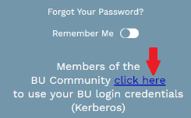

1. Log in using your BU username & Kerberos password.
2. You will arrive at the *projects*@BU Landing Page. Click the **Project Request** link.

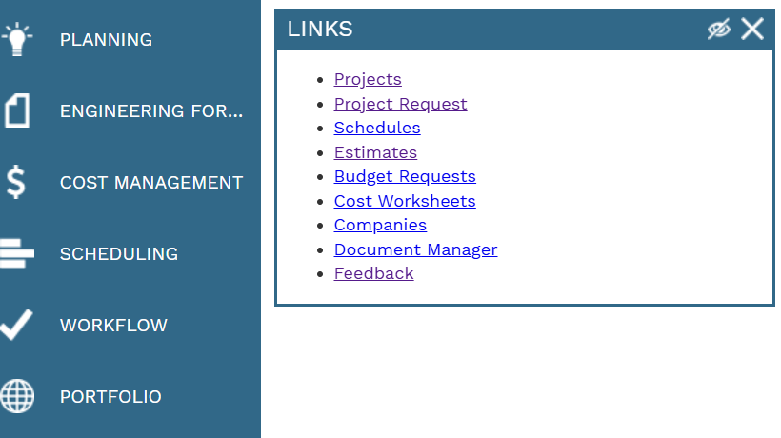

1. You will arrive at the Project Request List view. Click the Add  button at the top.



*(Note: if this is your first project request, skip this step.)*

1. The Project Request window opens.
2. Enter basic information 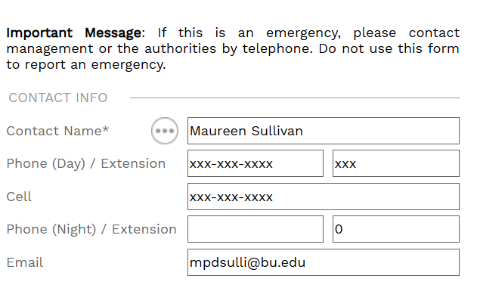
3. Select the street address where the requested work will take place from the **Location** drop down. TIP: The location field can be searched by typing the **street number or name in the box**.





1. Choose “Equipment Install Request” category from drop down. 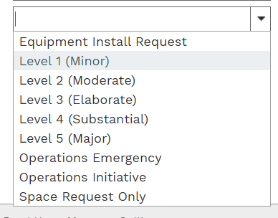



1. Enter a brief, informative name for the project in the **Description** field, for example **“Install autoclave.”**
2. Enter a more detailed description of the work you are requesting in the **Scope** section. EXAMPLE: Include as much information as possible such as location/Room #/vendor contact/sales contact etc. **The more detailed description the better.**
3. Click the save button  at the top of the page.
4. Click the “Attachments” view at the top middle of the page.  Drag **Specification cut sheet** , **Shop drawing (If available)** or **Quote**, if you do not have these specific documents please include an **order form** or **vendor/sales Representative contact** and hit save 



1. Click the “Specifications” view at the top-right of the page.





1. Enter additional information on the **Required Fields** tab. To edit these fields:
   1. Double click * requesting Unit **enter your unit from the drop-down menu.**
   2. Go to the **last * 4 questions.**
   3. Click the first line.
   4. Hold Shift and click the last line. *(The selected rows turn grey.)*
   5. Click the Edit button and **answer no to all 4 questions** to ensure this review moves forward. (This is NOT a project request it’s a review process only)

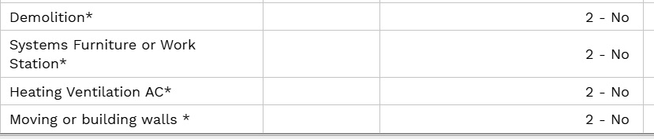

* 1. When done, click the **Update Records** button.

**Note:** Once you submit a request, you cannot alter the Department of the Project Request and will need to withdraw and re-submit.

1. To Submit the request:
   1. Click the Submit button at the top of the page.
   2. The Submit window opens.
   3. Click the Save and Exit  button.

*(The fields in the Project Request will be locked once the request has been submitted.)*

***A Project Manager from Planning Design & Construction will contact you and all parties needed to review the Installation of Equipment Request to move the purchase and installation of the equipment forward as quickly as possible.***

To request access please email [ithelp@bu.edu](mailto:ithelp@bu.edu). For other questions, please email Gerry Broderick ([geraldb@bu.edu](mailto:geraldb@bu.edu)).