2026 Playing Assessments Young Artists Orchestra CELLO
Please prepare and record the following excerpts for seating auditions. Only record the Contrabassoon excerpts if you can access that instrument. In addition, please perform and record one solo piece of your choosing.

Recording Instructions:
- Please use a phone or video recorder (laptop) to record the videos.
- Record in landscape mode. Make sure your face, instrument, and hands are visible.
- Place the phone or video recorder at least 3 feet away from you playing. Do not direct your sound towards your device.
- Introduce yourself before playing.
- All excerpts should be recorded in one take per instrument.
- Save the videos as MP4 with your name as the file name
  - name_bassoon_excerpts.mp4
  - name_solo.mp4
- Upload the videos

CELLO EXCERPTS

Rachmaninoff Symphonic Dances
Rehearsal number 14 to 17
5 measures before 43 to 3 measures before 44
Ravel Daphnis et Chloe Suite #2
Rehearsal number 216 to 220
Elgar Enigma Variations
I
3 measures after Rehearsal number 2 to 3
XII
entire [Cello Variation]
Dvorak Symphony No.9
1st movement
9 measures after Rehearsal no.7 - Downbeat of 9 measures after Rehearsal no.8
2nd movement
6 measures after Rehearsal no.1 - 7 measures before Rehearsal no.2
4th movement
pick up to 18th measure of Rehearsal no.9 to 8 measure before Rehearsal no.11
Rachmaninoff Symphonic Dances
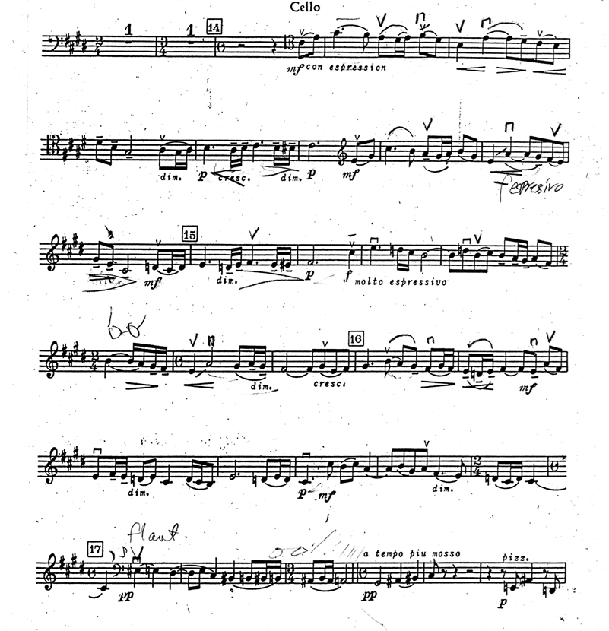

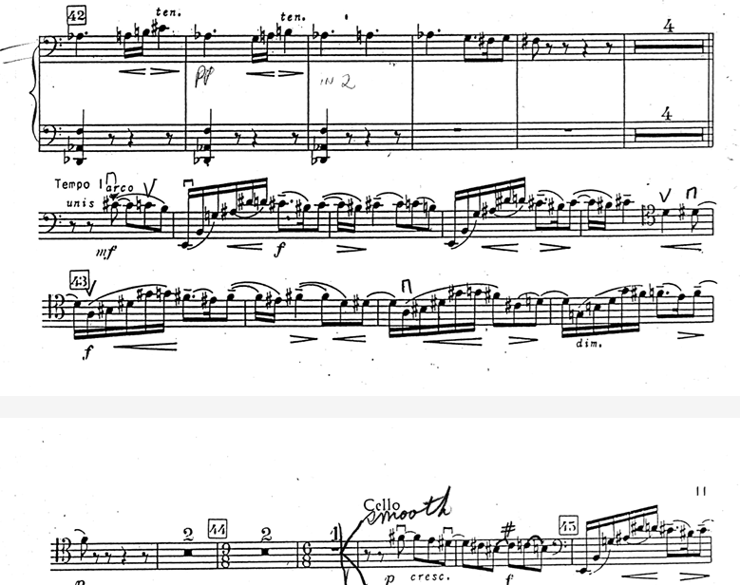

Ravel Daphnis et Chloe Suite #2
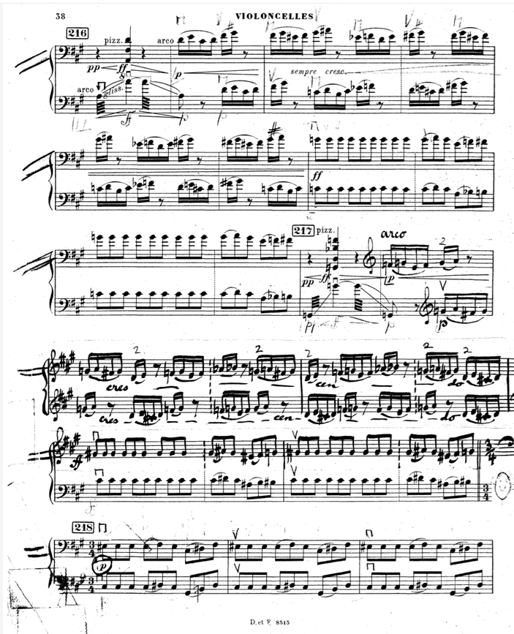

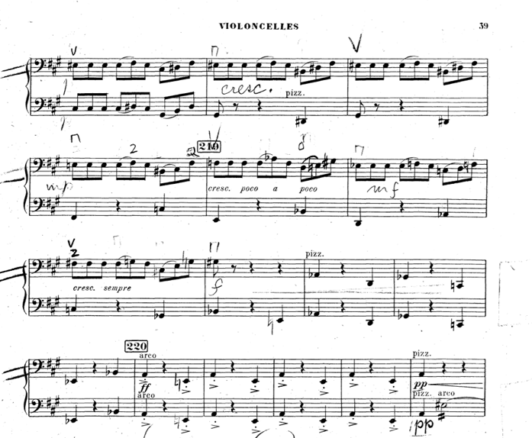

Elgar Enigma Variations
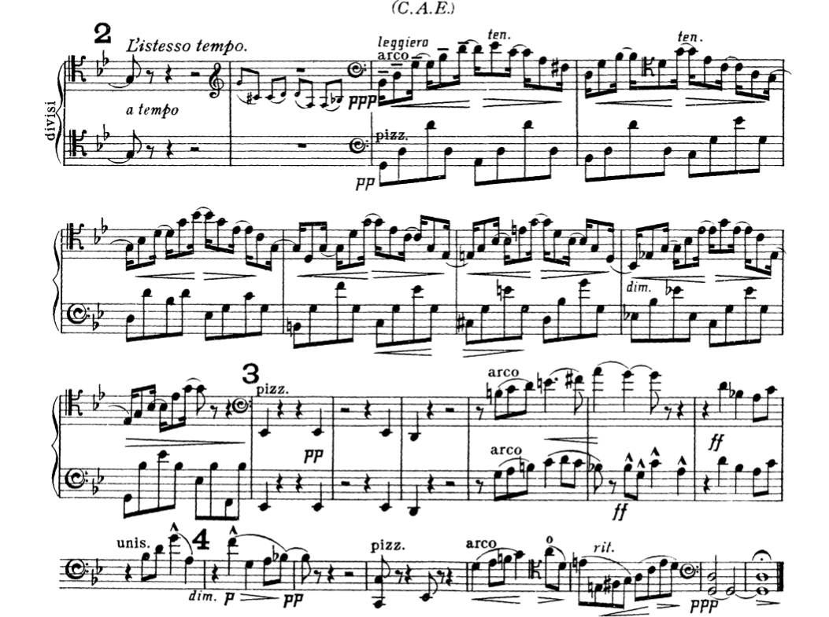
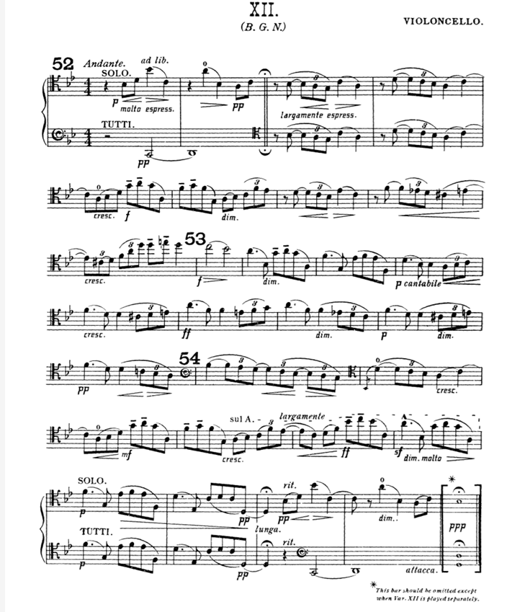

Dvorak Symphony No.9
