CELL-MET Presentation Video Recording Instruction

Filming Setup | Page 1
If You Want Another Person to Edit the Transcription | Page 1
How to Record | Page 2
How to Review the Video Recording | Page 3
How to Edit the Transcription | Page 3
How to Submit the Recording | Page 4

General Notes
- For security reasons, please be sure to log on to your institutional Zoom account: https://zoom.us/web/sso/login (enter “bostonu”, “fiu”, “umich”, “harvard”, “columbiauniversity”, “ucsu”, etc. – you should be able to use your institutional login)
- Throughout the process, the full screen mode is recommended. The navigation menu and various buttons in Zoom might be hidden if your window is small

Filming Setup
- Situate yourself in front of a plain wall, preferably in a light color (e.g., white, light gray, etc.)
- Choose a quiet indoor location, preferably with soft surfaces (e.g., carpets) to prevent echoing
- Adjust lighting in the room so that your face is visible in a small frame on Zoom (find out more about lighting: https://support.zoom.us/hc/en-us/articles/360028862512-Lighting-Concepts#h_b2f62fa0-0608-4b1d-a79d-bc89f83063cf)

If You Want Another Person to Edit the Transcription
- You will work in team with your “designated editor” (e.g., your student, RA, etc.)
- Ask the editor to create a Zoom meeting in his/her own account (the Steps 1-3 below), making sure you are added as Alternative Host and can join without the host (see the screenshot), and test-record (Steps 4-12). This step ensures that your editor can access the transcription of your recording from his/her own account:
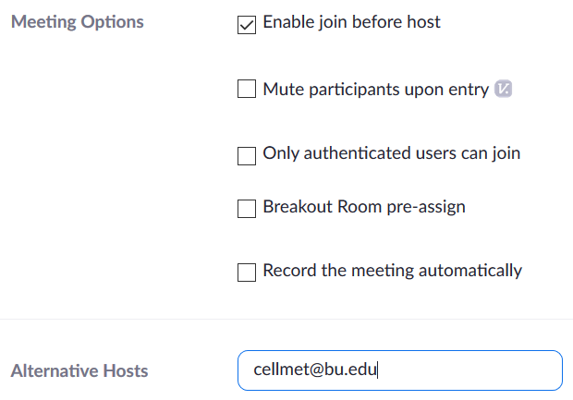
- To join the meeting, log on to your Zoom account (Step 1 below) first – then join using via Zoom link that the meeting host (your “editor”) shares with you
- After you record (Steps 5-12), the editor will review and edit the auto-generated captions saved in his/her own Zoom account (Steps 13-16) and share it with you and the admin (Steps 17-19)
How to Record
- Sign in to your institutional Zoom account: https://zoom.us/web/sso/login (enter “bostonu”, “fiu”, “umich”, “harvard”, “columbiauniversity”, “ncsu”, etc. – you should be able to use your institutional login)
- Schedule a new meeting: Meetings > Schedule a New Meeting > (edit details) > Save. Use the following naming convention: “CELL-MET Thrust XX 2020: Last Name of Presenter”
- Check Settings > Recording tab to make sure Audio Transcript is enabled, and the Cloud Recording options are properly set up (see below):

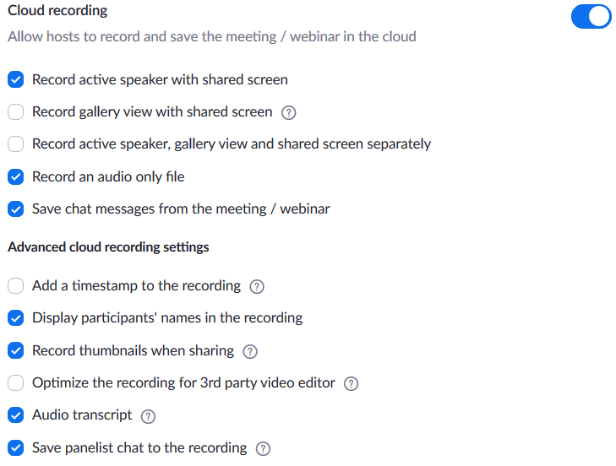

Also important:
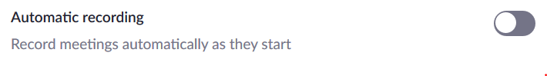
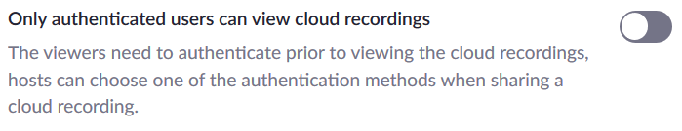
- Start the meeting: Meetings > Start > Zoom Meetings > Open Link > (test audio as needed, following the prompt) > Join With Computer Audio
- Check that the video is on (if not, “Start Video”) and the audio is not on mute (“Unmute”)
- Open up the PowerPoint presentation on your computer and set it on the Reading View or Slide mode (please maintain access to the browser / Zoom meeting controls on your screen)
- Return to Zoom and click on Share Screen at the bottom bar (if you don’t see it, look in the button that says “More”), specifying the PowerPoint file
- Start recording: Press the More button in the control bar (the bar has most likely moved from the bottom to the top – it pops out when you hover over the top of the screen) and select the Record to the Cloud (local recording will NOT generate auto-transcription). Test-record* a brief video and review (Steps 10-12) before starting to record the full presentation.
- End the meeting (again, from the “More” button in the control bar).

* If you record as Alternative Host (i.e., someone else set up the meeting for you), the recording file will most likely be saved in the main host’s Zoom account. Please coordinate with the main host when test-recording.
How to Review the Video Recording
- Once you finish recording, wait for an email notifying you that the video and the transcription are ready (it’s usually ready in a few minutes, but it could take much longer). If someone set up the meeting for you, the email and the recording may go to that person. Access the recording using the link in the email, or log back in to your Zoom account, go to the Recordings section, and click on the meeting that’s just been recorded
- Click on Shared screen with speaker view to review the video:
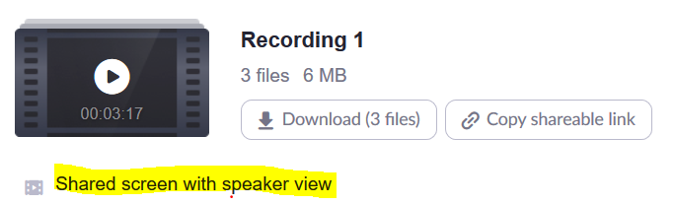

If the screen composition of your recording looks more or less like this screenshot, with you on the top right corner and the larger presentation frame on the left, move on to the Step 13:
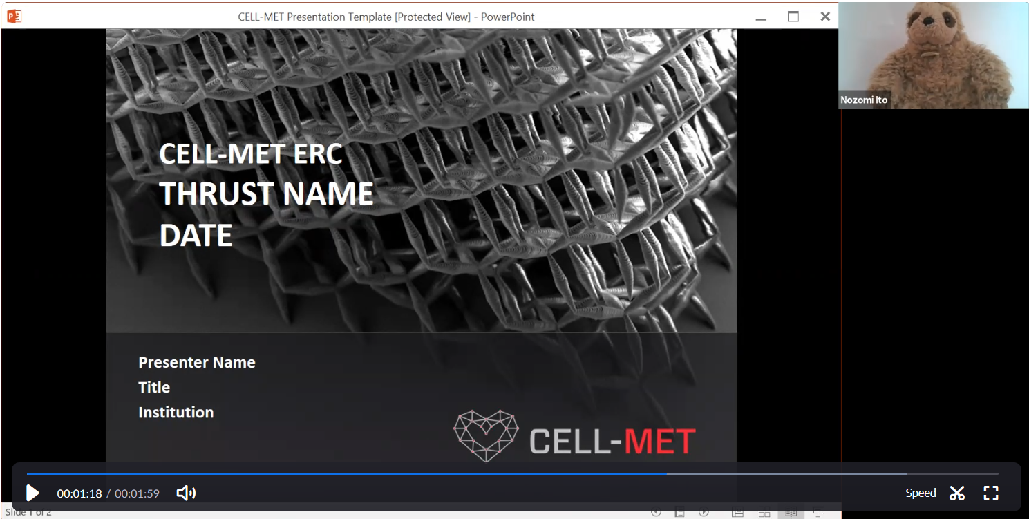
- If your test video looks very different, re-join the meeting, try adjusting the setting by clicking on the arrow (the pull down menu) next to the video icon in the control bar > Video Settings… > Recording. Make sure these boxes are checked, and re-test:

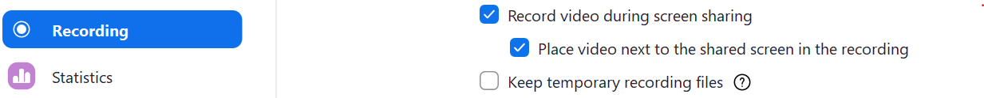

[How to Edit the Transcription]
- Go to the Recordings tab of the Zoom account and click on the meeting you’ve just recorded
- Click on Shared screen with speaker view and edit Audio Transcript next to the video by hovering over the remark you want to edit and clicking on the pencil sign that appears on the right. Save each edit
- Close the recording screen once all the edits are done
- Return to the Shared screen with speaker view to ensure the transcript reflects all the edits

[How to Submit the Recording] Please review & edit the transcription (Steps 13-16) before submission!
- Go to the Recordings tab of the Zoom account and click on the meeting in question
- Click on Share and make sure the link is shared Publicly, Viewers can download option is on, and the Password Protection is off (or else the password must be shared):

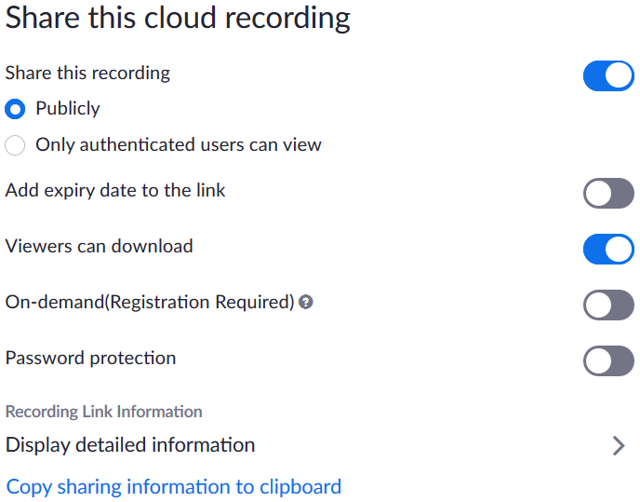

- “Copy sharing information to clipboard” and email the link. Any changes online (edit to the transcript, limiting the length of shared video, etc.) is reflected automatically, but if the recipients plan to use the link to download files (video, transcript or audio), you would have to notify them to make sure the latest version is downloaded.

