Azure™ cSeries
User Manual
for the c200 Boston University

NIR RGB CHEMI

BLUE LIGHT

WHITE UV LIGHT

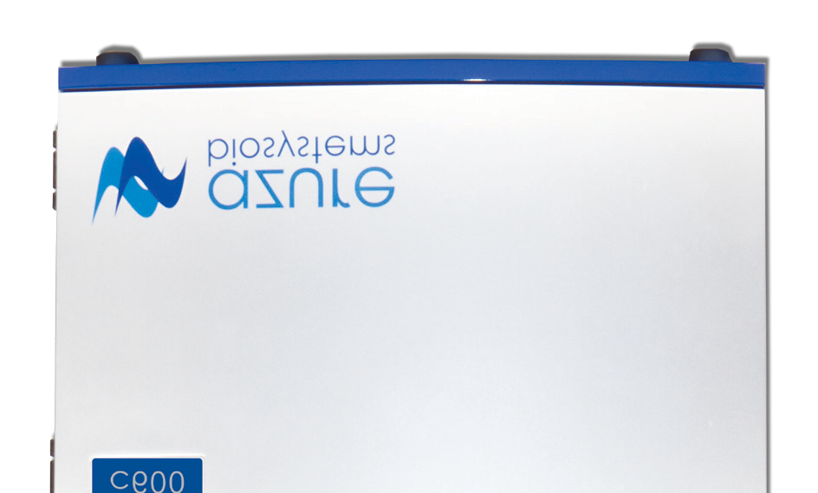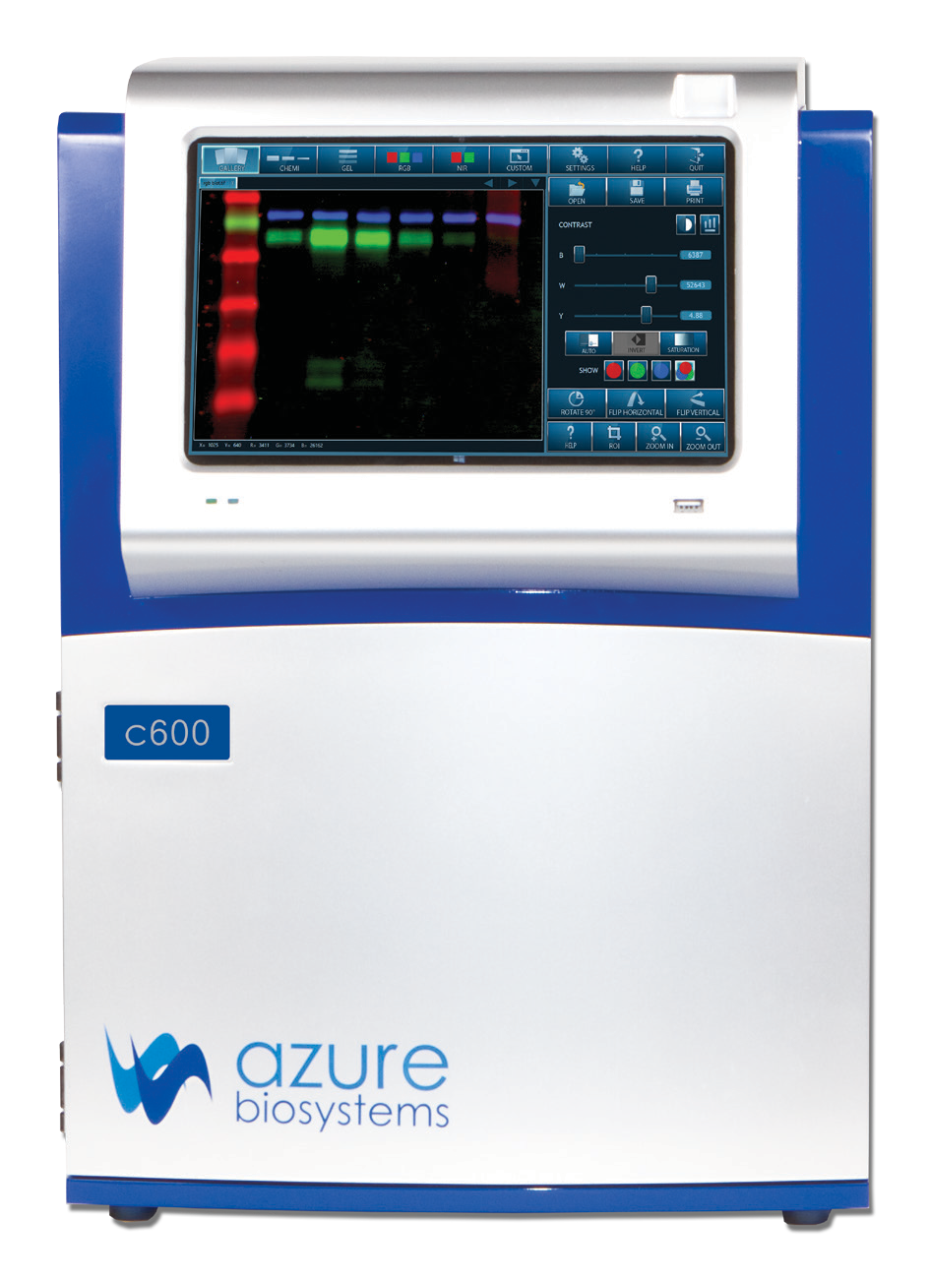

Azure™ cSeries User Manual Page

Rev 20170331

Safety and Regulatory Compliance

Important Safety Information
Please read these instructions before operating the Azure™ cSeries imaging system.

UV Safety Precautions

UV
CAUTION
Because U.V. radiation can cause serious damage
to unprotected eys and skin, we recommend to wear U.V. protection glasses or face shield.
The Azure™ cSeries system comes with a built-in Ultra-Violet (UV 200-400nm) Transilluminator. Exposure to UV radiation can cause permanent damage to the eyes and skin. The enclosure confines the radiation within the system and shields the user from exposure. The system is also equipped with a two-way safety interlock switch which automatically cuts off the power to the transilluminator when the door is opened during normal use.
The Azure cSeries imaging systems belongs to Class A equipment, and fulfills the limit values of table 3 but not table 4 of EN 61326:1997+A1+A2+A3. It may become necessary to defeat the safety lock or operate the transilluminator outside the system for service. In this case, be sure to use the following safety precautions:
- Always wear UV-protected eyewear that is specified by the safety equipment manufacturer as providing protection at the wavelength(s) used, making sure that the eyewear protects any areas where radiation may come through (UV sunglasses may not prevent UV radiation from coming in through the sides or around the lenses).
- Always cover all skin that may be exposed to UV light, especially the face, neck, hands, and arms.
- Always make sure that any UV protection devices (such as the safety switch on the light cabinet apparatus) are working properly. If not, discontinue use until the device(s) are properly repaired.
- Use only UV lamps in the transilluminator and ensure they are the correct size and voltage.

Electrical Safety Precautions
Be sure to take proper precautions when handling any electrical equipment. NEVER work on any live circuit, fixture, receptacle, or switch. Safety rules you should follow whenever working with any electrical appliance include:
- Always shut off power at the main disconnect before changing a fuse.
- Always shut off power to the circuit before repairing or replacing a switch, receptacle, or fixture.
- Always tape over the main switch, empty fuse socket, or circuit breaker you are working on.
- Always check that the circuit is dead before beginning work on it. Using a circuit tester or voltmeter can help you determine this.
- Always unplug any appliance before repairing it.

Protective ground terminal
The ground terminal, intended for connection to an external protective conductor for protection against electric shock in case of a fault, is located on the inside of the back panel.

For Research Use Only
This instrument is suitable for research use only. It must be used, therefore, only by personnel who know the health risks associated with the reagents that are normally used with this instrument.

Warranty
The Azure cSeries products are warranted against defects in materials and workmanship for one year unless otherwise outlined on your sales order or www.azurebiosystems.com/warranty. If any defect occurs in the instrument during this warranty period, Azure Biosystems, Inc. will repair or replace the defective parts at its discretion without charge. The following defects, however, are specifically excluded:
- Defects caused by improper operation.
- Repair or modification done by anyone other than Azure Biosystems or the company’s authorized agent.
- Use of spare parts supplied by anyone other than Azure Biosystems.
- Damage caused by accident or misuse.
- Damage caused by disaster.
- Corrosion caused by improper solvents or samples.

Voltage Setting Information
The Azure cSeries imaging system has a power supply that automatically chooses the correct voltage for your country or region.

CE Conformity
The following Azure™ Imaging Systems, models: c150, c200, c280 c300, c400, c500, c600 are in conformity with the provisions of the following EC Directives, including all amendments, and national legislation implementing these directives:
- Low Voltage Directive 2006/95/EC
- EMC Directive 2004/108/EC
And that the following harmonized standards have been applied:
• EN61010-1: 2001
• EN61326-1: 1997+A1:1998+A2:2001+A3:2003 Class A
• EN61000-4-2, EN61000-4-3, EN61000-4-4, EN61000-4-5, EN61000-4-6, EN61000-4-11

Protection category: IP20 according IEC 60529

Contact
Azure Biosystems, Inc.
6773 Sierra Court, Unit B • Dublin, CA 94568 • USA info@azurebiosystems.com • (925) 307-7127 • Fax (925) 307-7287

Table of Contents
- Introduction 5
  - Table of Specifications 6
  - Contacting Technical Support 6
- Installation and Setup 6
  - System Placement 6
  - Connecting to Power 6
  - Turning the System On/Off 6
  - Software Installation 7
  - Other USB Input Devices 7
- cSeries Capture Software Overview 7
  - Gallery 7
  - General Imaging 9
  - Gel Applications 10

Settings 17

Help 17

Quit 17

Tablet and Windows® Tools 17
Tablet Specifications 17
  - How to Power Off/Restart the Tablet 18
  - How to Access the Keyboard 18

Introduction
The Azure cSeries imaging systems offer high performance imaging for a wide variety of applications. The cSeries family of instruments includes the follow products: c150, c200, c300, c400, c500 and c600.

WHITE
LIGHT

BLUE
LIGHT

c200

UV

The Azure cSeries system includes the following key components:
  - Cabinet – The cabinet is a light tight image station. It includes the camera and lens, light sources, filter wheel, integrated tablet, and USBs for data collection.
  - Camera – High resolution camera, preinstalled in the system. A motorized 0.95 lens is included on the c300 systems and above. High resolution 6MP camera integrated in the system with a motorized lens included.
  - UV Transilluminator – The UV illuminator provides 302nm and 365nm trans illumination. It is mounted on a pull out tray.
  - EPI LEDs – The LED module allows you to take Blue Light, White Light, and Color images.
  - Filter Wheel – The 7 position filter wheel is automated. It includes the standard Orange filter for most UV fluorescent applications, and additional Red, Green, Blue, and/or IR filters for multichannel systems.
  - Integrated Computer – The PC is completely integrated for system control and image acquisition.
  - Orange Tray – For Visible dyes, the orange tray converts UV light into Visible light.
  - Blot Tray – Stored in the cSeries door, the Blot Tray is required for imaging all blots. For fluorescent blots, it is placed on the UV transilluminator. For Chemi blots, it can be placed on the UV transilluminator, or on the chemi shelf in the cabinet.
  - USB Ports – There are 3 USB ports for data transfer. One located on the front panel, and two on the lower right side of the cabinet.
  - USB Memory Stick – The Azure Biosystems memory stick contains files relevant to your imaging system.
  - AzureSpot Analysis Software – Please contact our technical support to receive your electronical license at support@azurebiosystems.com.

1.1 Table of Specifications
Image Resolution | 5.4M pixels (c150, c200);
Epi-illuminations | White LED; Blue LED;
Trans-Illumination | 302nm/365nm
Lens | 8mm/F1.2 (c200)
Maximum Field of View | 20 cm x 15 cm
Image output | 16 bit TIFF, JPEG
Working environment | Ambient temperature/humidity: 0 –30°C / 85%
Power requirement | 100-240 VAC, 4A
Dimensions (W x D x H) | 38 cm x 30 cm x 45 cm
Weight | 22 kg (49 lbs.)

1.2 Contacting Technical Support
For questions about installation, setup or general use of the system, please contact support@azurebiosystems.com or call (925) 307-7127, 9am-4pm Pacific time.

Installation and Setup

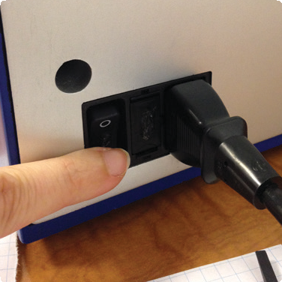Turning the System On/Off
The main power switch is located at the back panel, next to the power cord.
    - First, flip the power switch to On (l).

    - 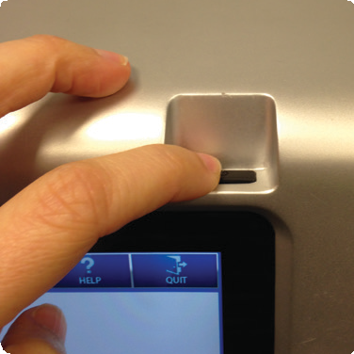To wake the integrated computer, press the power button on the right side of the screen.
To turn off the system, shut down the tablet by
- Swiping from the right to left on the right side of the screen.
  - Select SETTINGS.
  - Select POWER.
  - Select SHUT DOWN.
- Turn off power to the system using the power switch on the back of the instrument. Azure Biosystems recommends leaving the system on during working hours.

Software Installation
The Azure cSeries Acquisition Software is pre-installed. When the tablet is powered on, the software launches directly into the cSeries capture software application. If the software has been closed, double click on the desktop icon.
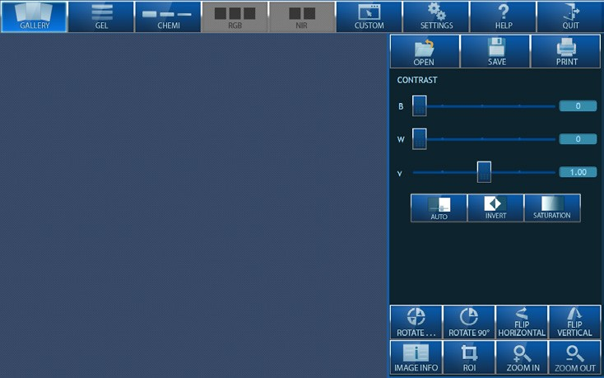Once the system is done initializing, the software displays the gallery tab, and is ready to use.

Desktop Icon

Other USB Input Devices
You may attach regulatory approved, Windows OS supported USB keyboard, USB mouse or other USB input devices to either the front or upper USB port. The lower USB port is a dedicated PC connection to run the system off of a laptop or PC.

C200 Capture Software Overview
Azure cSeries captures high quality images with an intuitive user interface. The icon based software allows you to program multiple different applications with the touch of a button. There is no need to focus on your sample, simply put your sample in the system, select an exposure time , then hit capture.

Gallery
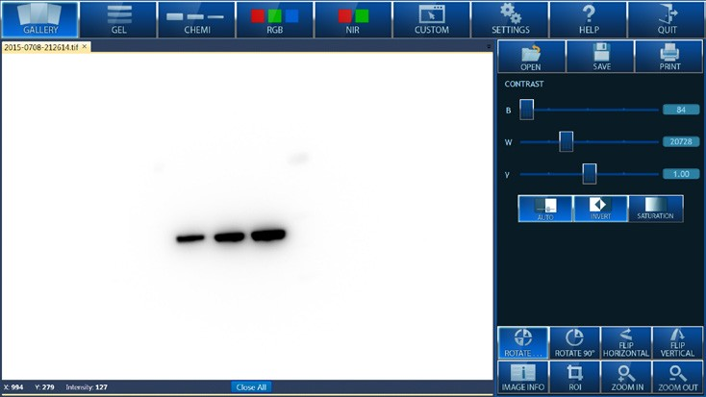The software opens in the Gallery window. This window is designed to Open, Close, Save, or Print your images. It also allows you to perform basic image editing on your opened image.

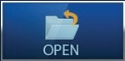OPEN – Use this icon to open an image that is stored locally, on a USB, or on the network.

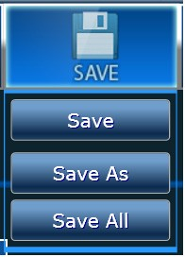SAVE – Save an image to a USB, the integrated computer, or to a network drive. Images can be saved as a TIFF or JPEG file. File names are automatically generated with the date and time stamp. You can overwrite this name by editing it in the displayed textbox. All images are saved as 300 DPI.
Note: Azure does not recommend saving images to the tablet computer, in order to maintain a fast processing speed for the application.

SAVE AS – Save a copy of a previously saved image with an alternate name, file type, or to an alternate file location.

SAVE ALL – Saves any unsaved images open in the gallery tab. The file names will be automatically generated with the date and time stamp.

PRINT – Print to a local printer connected to the system, or to a network printer.

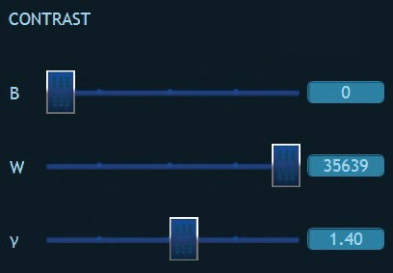CONTRAST – Manually adjust the black, white, and gamma settings for the displayed image. Recommended for chemiluminescent blots. Note: Adjusting these settings will not affect the raw data when saved as a
.tiff file. Only images saved as a .jpg will display with the adjusted contrast settings, as the .JPG file format alters the raw data. Azure recommends using .tiff formats for images that need to be quantified, and saving a copy as a .jpg with contrast adjustments for publication purposes.

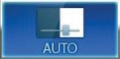AUTO – Adjusts the contrast of the image to show the greatest number of features. Note: Azure recommends cropping the image area of the sample before auto contrast for best results.

INVERT – Invert will display your image with dark and light pixels reversed. Invert also inverts the data values, so when an image is opened in another image editing application such as Photoshop or Powerpoint, the image appears the same as in the cSeries software. This does not change the data in anyway.

SATURATION – Selecting Saturation will show you images with intensities beyond the dynamic range of the camera.

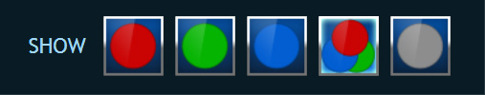SINGLE/MULTICHANNEL VIEWING – When a multicolor image is displayed in the gallery, you will have the option of viewing single channels, or all three channels at once. By default, the image is displayed as a multichannel image. Contrasting the image in the multichannel mode
will contrast all channels. To view one channel, select the button that corresponds to the color of the channel you wish to view. To go back to the multichannel image, select the multicolor button. To extract the image into its component grayscale images, select the grey button.

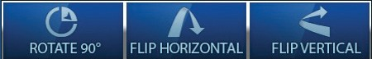ROTATE 90 DEGREES, FLIP HORIZONTAL, FLIP VERTICAL – By select one or
more of these icons, you can change the alignment of your image.

ROTATE – Allows you to rotate a small amount. This is ideal for slightly crooked gels. A green alignment tool will appear over your image.

IMAGE INFO – Displays the parameters for image acquisition including date & time, capture type, light source, exposure time, filter position, aperture, focus, bin level, calibration, software version, and comments.

ROI – Selects a Region Of Interest for further actions including Copy, Crop, and Autoexpose to Region (chemi only). Adjust the green highlight window to select a region of interest.

COPY ROI – Adjust the ROI box to select and copy a region of interest on a single channel image. After selecting another image of the same size, use the paste option to overlay the copied ROI.

CROP ROI – Crop out the desired image area. Adjust the ROI box, then select Crop ROI. A new image tab will open with only the selected area.

AUTOEXPOSE TO REGION – Adjust the box around the area you are interested in, and select Autoexpose to Region. A new chemi image will be acquired, with the autoexpose focused on the region selected.

CANCEL – Close these options.

ZOOM IN/ZOOM OUT – Increase or decrease the zoom factor on your image.

General Imaging
The Azure cSeries software is organized with a tab for each application type. The default settings have been optimized for the selected application. All tabs include the following features:

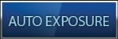EXPSOURE SELECTION – There are two options for exposure selection. AUTOEXPOSURE automatically determines the optimal exposure time using the full dynamic range of the camera. Or manually enter the desired exposure time in minutes, seconds, and milliseconds.

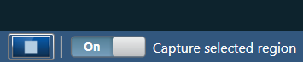LIVE VIEW – To start Live View, select the Play button located at the bottom of the Gel window. If Capture selected region is on, only the region selected will be captured. Adjust the area size by selecting and dragging the green corners.

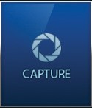CAPTURE – When you are ready to capture your image, the capture button tells the system to start acquiring an image.

Gel Applications
For applications that include EtBr, SYBR® Green, Coomassie Blue or similar, select the Gel tab. You will see the following user interface:

3.3A Imaging Workflow
- 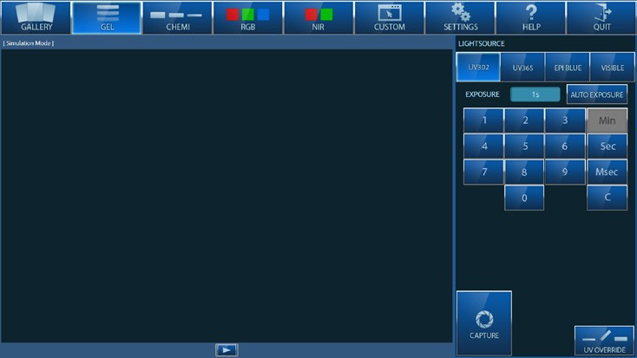Select a light source. You can select from UV 302, UV 365, EPI Blue or Visible. The correct emission filter will be selected automatically.
  - UV 302 – For dyes that are UV excitable, UV 302 will be the brightest and best light source.
  - UV 365 – For cutting bands out of a gel, UV 365
reduces the nicks that might be introduced into the DNA by UV 302.
  - EPI Blue – Select this light source for gels that are stained with dyes that excite in the blue range.
  - Visible – For dyes that are visible without additional excitation, use the Visible light source. When selected, the software will prompt you to use the Orange Tray, which converts the UV light into bright visible light to provide contrast to your image.
- Place the sample on the UV transilluminator, or on the Orange Tray for Visible samples.
- Select an imaging time.
- Manual Imaging times are entered using our keypad. For gels, we recommend setting exposure time to less than 1 minute.
  - 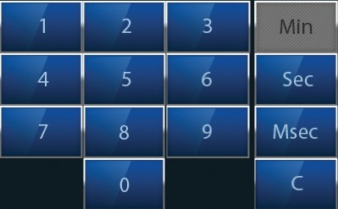For 20 seconds, hit 2 then 0 then SEC. To select 1.5 seconds, type 1 then S, and then 5 0 0 and MSEC.
  - To erase what you done, hit the C button, for clear.
- Or, you can select AUTOEXPOSE which will calculate the best imaging time for you image. Selecting autoexpose will grey out the keypad, enabling you to simply press capture.
- Maximum exposure time is 60 seconds.
- Hit CAPTURE. The software will direct the camera to collect the image, and the final image will be displayed in the Gallery tab.

3.3B UV Override and Stain-Free Workflow
- The UV override button was created for situations when you need to do longer exposures with the UV transilluminator without taking an image.
Select the UV OVERRIDE button.
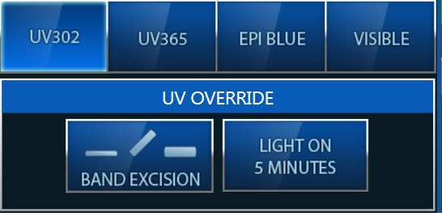BAND EXCISION – Override the safety switch for situations when a user needs to cut bands out of their UV excitable gel.
Care must be taken to avoid eye and skin exposure to the UV radiation.

WARNING: ALWAYS WEAR APPROPRIATE PROTECTION WHEN EXPOSED TO UV LIGHT.
The use of protective eyeglasses, mask, and/or gloves is strongly recommended.
After selecting the Band Excision button, pull out the override safety switch.
Select OK from the screen prompt, the light will remain on for 5 minutes, or until the band excision switch is pressed again. Capturing an image, or selecting another light source will also turn the light off.

- LIGHT ON 5 MINUTES – To have the light on for 5 minutes, first select your light source, then select light on 5 minutes.

Stain Free Workflow
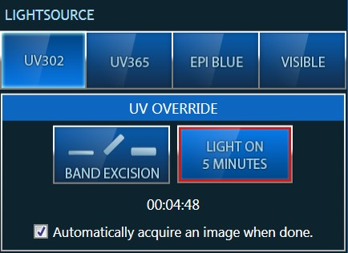When working with Stain-Free Gels, the gels must be UV activated prior to imaging. Azure supports a one step solution. With Stain-Free Gels:
  - Select UV OVERRIDE, then LIGHT ON 5 MINUTES, and check the box “Automatically acquire image when done”.
The UV light will activate the Stain-Free Gel for 5 minutes, then automatically capture the image when activation is complete.

For all blots, use the blot tray which is stored in the door.

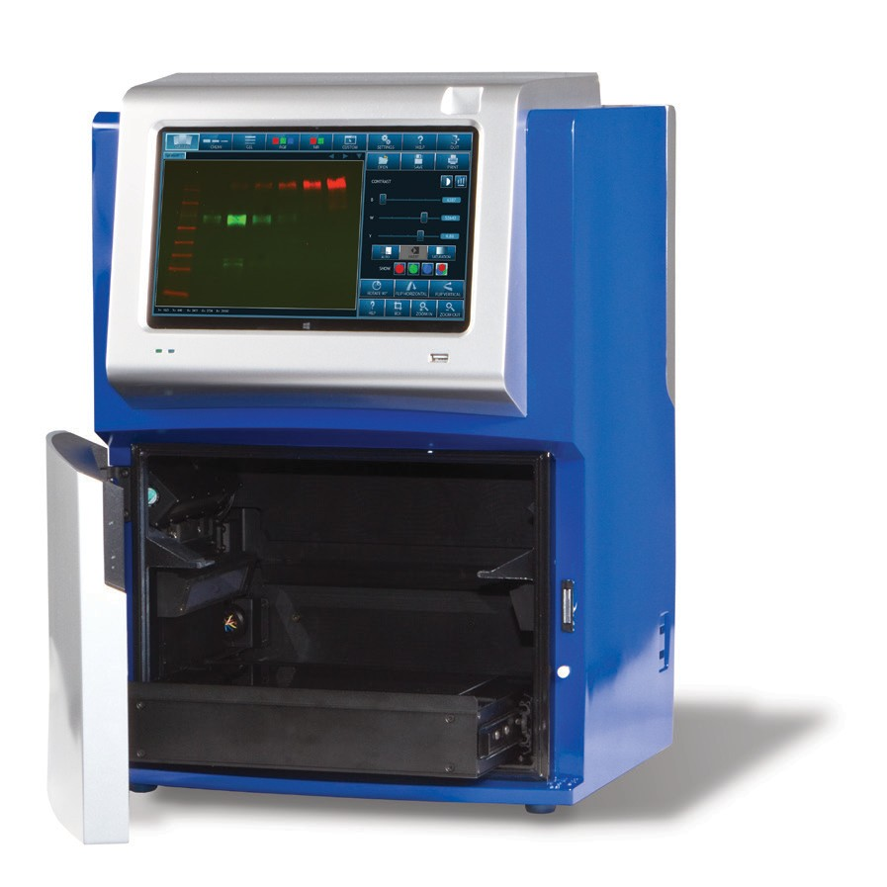Positions for blot tray:

Chemi Shelf (for chemi blots only)

UV Transilluminator (for all blots)

Custom Applications
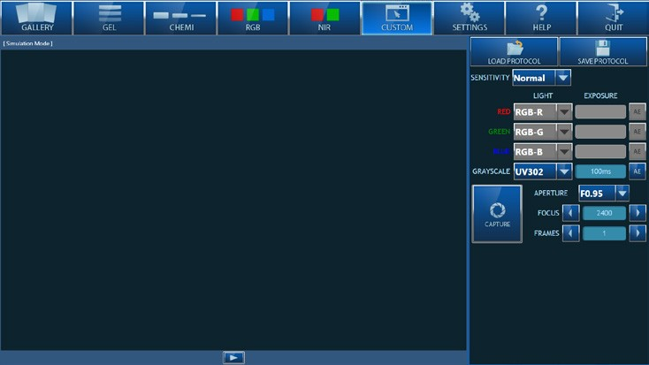The custom tab allows the users full flexibility when acquiring their image.

LOAD PROTOCOL – Load previously saved protocols, for quick image capture. SAVE PROTOCOL – Save custom settings for quick recall in the future.
Imaging workflow:
    - Select the sensitivity/resolution for your setting. To use the full camera resolution, select

LOWEST.
    - Select the light sources you wish to use.
      - If you wish to take a single channel image, select a light source next to GRAYSCALE.
      - If you wish to take a multichannel image, make sure the imaging time next to Grayscale is set to 0. Then, select the light sources you would like to image, next to the color channel you would like them assigned to. Set the exposure time for each channel.
    - Select the aperture setting: the smaller the number, the wider the aperture. For chemiluminescence, we recommend 0.95 for fastest light gathering. For UV applications, 2.8 is the recommended aperture setting. For RGB and NIR, 1.4 is recommended.
    - Adjust the focus settings as desired
    - Select the number of frames.

Help
The complete PDF of the user manual is accessible under the Help Tab. For further help, please email us at info@azurebiosystems.com.

Quit
Selecting QUIT will return you to the Windows 10 desktop.

