Dear ARC member,
I am writing to share some difficult news that may affect your ability to participate in our weekly zoom therapy groups from your home state. As you may recall, during the early COVID emergency, Massachusetts passed temporary laws allowing us to provide therapy by telehealth across state lines. These emergency laws have recently expired and now, in Massachusetts, we are forced to return to the pre-Covid practice of limiting telehealth therapy to those joining from within the state of Massachusetts. In other words, therapy may only be delivered by SLPs licensed and practicing in Massachusetts to individuals who are also within the state. We are prohibited from delivering therapy across state lines unless the SLP also holds a current license in that state. All ARC clinicians hold MA state licenses; thus, all weekly group participants, must also participate from MA. The twice monthly Aphasia Community Group with Jerry Kaplan does not fall into this rule and will continue to be open to you and all who wish to attend.
You may wonder why some aphasia groups across the country seem to have different rules and why the guidelines seem so varied. There may be a few different reasons for this:
- Some groups do not consider their service to be “therapy.” This is made clear by a notice at the start of the group, the facilitator may not be a licensed provider, and/or the group enrollment changes from week to week. These groups may be considered “support groups” even if they are called a movie group or a book club. The focus of the group is not on communication, but rather on being together and supporting each other. Examples of these groups are those provided by Virtual Connections or the National Aphasia Association.
- Some groups consider their service to be therapeutic but do not meet the criteria for “skilled therapy.” These groups may charge for enrollment and use licensed providers but will provide specific reasons for their exemption from the skilled therapy rule. Examples of these types of groups are those seen at the Adler Aphasia Center in New Jersey or the Aphasia Center of California.
- The states in which both provider and participant reside are members of the Audiology & Speech-Language Pathology Interstate Compact. This compact facilitates the interstate practice of speech-language pathology while maintaining public protection. This compact allows for practice across state lines.
Unfortunately, the Aphasia Resource Center cannot follow any of the three examples above for two reasons. First, Massachusetts is not a member of the compact, meaning we can’t provide skilled service across state lines. Second, we must consider our service to be skilled therapy because of our goal at the university to train our students on how to provide skilled therapy. We cannot legally certify training hours for the students in skilled intervention and violate the state laws which govern the therapy provision. All weekly and diagnostic sessions would fall into the category of skilled service, while the Aphasia Community Group is our support group.
We are all so sorry to turn anyone away from our programming, especially if you have found it to be beneficial in the past. We hope that the Massachusetts laws in this matter will change, and we will be able to welcome members from out of state in the future. In the meantime, we encourage you to reach out to the NAA to get connected to resources within your state. Please feel free to reach out to us if we can help in any other way: aphasiacenter@bu.edu

Sincerely,
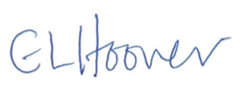
Elizabeth Hoover, PhD., CCC-SLP, BC-ANCDS, ASHA Fellow
Clinical Director, Aphasia Resource Center.

Audiology & Speech-Language Pathology Interstate Compact

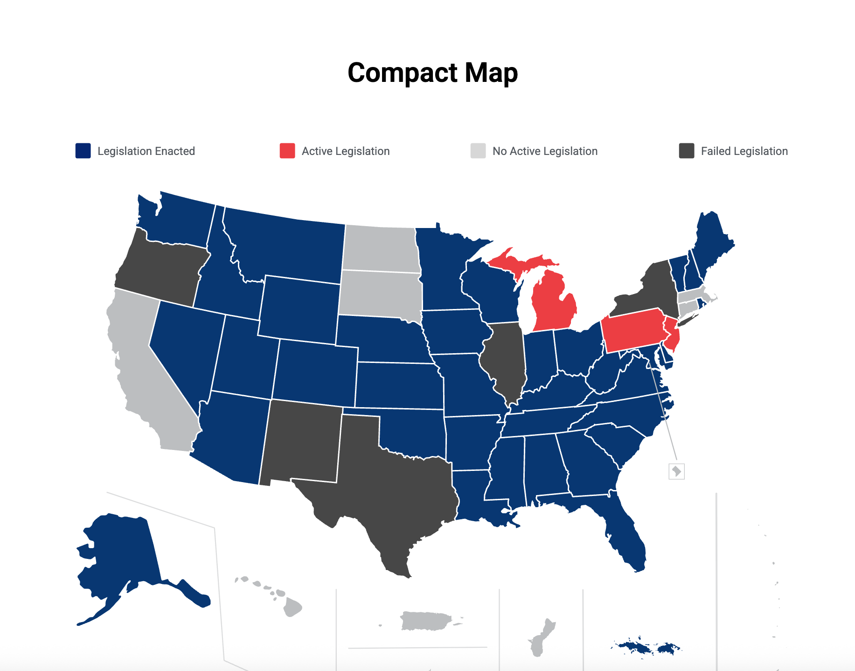
This compact facilitates the interstate practice of speech-language pathology while maintaining public protection. This compact allows for practice across state lines. If your state is listed below in blue, you can join groups in other blue states. Please contact the national aphasia association at www.aphasia.org for help in connecting with resources in your region.

