UROP Symposium 2019
Poster Information

UROP Symposium Schedule

October 18, 2019

10:00 am – 11:00 am
Poster set-up

11:00 am – Noon &
Noon – 1:00 pm
Poster Presentations –
GSU Metcalf Ballroom

1:00 pm – 1:30 pm
Poster Removal

Poster Printing

For large posters, allow at least 24 hours for printing at Fed-Ex.

Some departments have capabilities for large poster printing; check with your mentor.

UROP will not provide materials or funds for poster production.

Design Specifications
The total poster display area will be 42”h x 32’w, therefore your poster must fit within these parameters. If your poster exceeds the specified measurements, you may have difficulty displaying it.
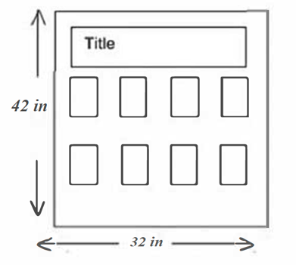
The poster display boards will provide a foam core surface onto which you can tack your poster. Tacks will be available.

Possible poster formats:
- A single-sheet poster printed on a large format printer
- One to 2 standard poster boards
- 8.5” x 11” PowerPoint prints with large banner title

Regardless of the format you choose, keep elements of symmetry and balance in mind. All posters should include a project title, your name (underlined), your advisor’s name and department, and an acknowledgment of funding sources. You must include the BU logo (found here) in the top right-hand corner of your poster and the UROP logo (found here) on the left-hand side of your poster. To see an example of the format with these logos, see here.

Limit your use of colors. It is fine to include color graphs or color photographs. Add titles like Table 1, Figure 1, for easy reference to any tables, graphs, or figures you include.

Use large, uncomplicated fonts. Print should be legible from at least three feet away. Limit the number of different print fonts that you use. Simplicity makes for better design.

Your poster is likely to include the following:
- A title that states the topic and overall conclusion of your work
- Your name, your mentor’s name (and department), any other authors
- An abstract in fairly large font
- A description of research goals and methods
- A presentation of results (figure titles should be statements of conclusions)
- A summary of major conclusions (with bullet points)
- Future directions for the research
- A (short) bibliography or list of references
- Acknowledgments (citing any help you received or sources of funding)
- You may have an accompanying handout for visitors to take away

On the day of the symposium be prepared to stand next to your poster for one hour (UROP will assign your time) between 11 am - Noon or Noon – 1 pm to explain your work and to answer questions. Professional dress is recommended. Your audience will be undergraduates, graduate students, parents (it is Friends & Family Weekend), faculty, alumni, and possibly graduate school, corporate, and foundation representatives.

