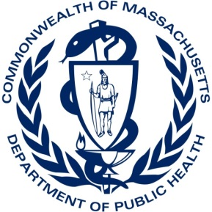

Massachusetts Health & Medical Coordinating Coalitions

A Health and Medical Coordinating Coalition (HMCC) will be a multi-agency coordination entity with associated staffing that supports Emergency Support Function 8 (ESF8) activities, public health and medical services, at a local and regional level. Core disciplines in the HMCC will be community health centers and large ambulatory care organizations, emergency medical service providers (public and private), hospitals, local public health and long-term care facilities. HMCCs will also reach out to include key ESF8 supporting partners such as home health, pharmacies, dialysis centers, mental and behavioral health providers, urgent care, and social services agencies. By June 30, 2017, one HMCC will be established in each of the six existing Massachusetts Department of Public Health Hospital Preparedness regions.

Each HMCC will conduct capabilities-based planning to advance regional health and medical capacity to prepare for, respond to, recover from, and mitigate the impact of large scale emergencies and disasters. Planning activities will be consistent with the healthcare and public health preparedness capabilities, as established by the Assistant Secretary of Preparedness and Response (ASPR) and the Centers for Disease Control and Prevention (CDC). HMCC staff will build strong connections with emergency management and public safety/first responder organizations within the region, as well as other public and private organizations with a role under ESF8.

HMCC Functional Activities
Each HMCC will be active across all phases of the disaster management cycle, and will be tasked with:
- Coordinating regional ESF8 planning, and assuring alignment with local plans
- Supporting local planning and preparedness
- Maintaining 24/7/365 capacity to support emergency response, with staff who will coordinate with DPH staff as well as voluntary response elements (e.g., Medical Reserve Corps, MA Responds, mutual aid)
- Providing multi-agency coordination, advice on incident management questions, and resource coordination as determined in regional plans
- Coordinating regional information sharing for situational awareness and common operating picture
- Supporting regional recovery operations following emergencies and disasters
- Participating in regional health and medical risk assessment and mitigation activities
- Participating in cooperative training and exercising of regional plans
- Conducting after action reviews and developing appropriate improvement plans

HMCC Plans will include:

- HMCC Concept of Operations
- Multi-Agency Coordination Plan
- Emergency Public Information & Warning Plan

HMCC Response Support information will include:

- State & local contact information
- Inventory of MOUs
- Resources Inventory and Request Processes
- Maps
- Regional Services Directory (schools, HHS-type services, etc.)
- 1 page “How to activate the region” quick reference sheet

March 2014 HMCC Facilitated Meetings 26 March 2014

