Functional Design Assignment

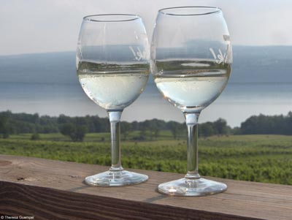

NYWINES.COM
Online Wine Store

Jayesh Ruparel
Boston University
MET TM648 OL
Professor: Kip Becker
Facilitator: Frank Cassidy
Submitted: August 9, 2009

Introduction
The below is a brief overview of the Project Charter and the overall background for the development of an eCommerce Web Site.
Company Information: NY Wines and Grape Foundation (NYWGF) is an organization engaged in promoting the wine making and grape growing region of the State of New York. The Association is formed through membership of local wineries, businesses, and NY state tourism.
Goal: NYWGF’s goal is to increase awareness and commerce for NY State winemakers and other businesses. Toward that end, NYWGF is collaborating with the very popular “Wine Enthusiast” magazine and has approved a project charter to create a Web based eCommerce site “NYWINES.COM” promoting NY State wines as well as the region as a tourist destination. The intended audience is world-wide, but, a specific emphasis will be placed on residents from the Northeast and Mid-Atlantic states. The schedule for completion of this site is November, 2009, in time for Holiday shopping.
Project Team: The project team comprises of several members from NYWGF, these include Marketing Manager, Business Manager, Information Technology support staff, Purchasing Officer, and Quality Assurance staff. Additionally, the Project Management and site development has been outsourced to ABC Creations (my employer). I am assigned the role of Project Manager and will be reporting to the Association’s Chief Marketing Officer (Project Sponsor). Other team members include technical resources from ABC, i.e. Graphics Designer, Media Director, Information Architect, Software Engineers, Database Administrators, Networking Personnel, and Quality Assurance staff.
Finally, a Steering Committee is formed for overall project oversight and direction, comprising of Project Sponsor, board members from the Association, Director of NY State Tourism, and Marketing Director from Wine Enthusiast.
Information culture: Overall the association operates in a semi-formal manner with each member updating association with their product information and promotions through e-mail. The support staff updates the current static web site as and when information is made available. A key aspect of the new site is to offer a self-serve function to each association member in order to place Ad, Promotions, and update Product Catalog including inventory information. Additionally, the site will provide key metrics to shoppers and wineries with regards to the overall sales, popular wines and categories, repeat sales, customer loyalty points, and effectiveness of promotions
Demographics: Given that this site’s primary purpose is to promote and sell wine from NY State region, the primary emphasis is on Adult population. Within that the most likely target audience will be males age 30 to 60. However, the site will offer content and links to attract audience across all demographics by promoting the region as a tourist destination with its beautiful Finger Lakes, Corning Glass Museum, Wine and Country Fairs, NACAR Racing, etc.
Audience: As stated earlier, the primary audience for the site will comprise of the Wine Enthusiasts and Shoppers, and a percentage of general population interested in traveling to the region. Secondary audience for the site will include Wine Makers and/or Merchants promoting and selling their products, NY State Tourism department, and the site Administration staff from NYWGF. Each of the audience group will have the ability to look at both Secured and Non-secured content. However, the security and access control definitions will ensure data segmentation so that shoppers do not see the content intended for Wine Makers and/or Merchants. And, also ensure data privacy and segmentation amongst similar user types.
Technology Requirements Overview
The below describes some of the key technology considerations for the design, development, and deployment of the web site:
Performance Requirements: Given that the site will be both Informational and promote Commerce, it should be reliable, ensure data integrity and data protection. Should be accessible by large audience from a desktop Personal Computer or a Netbook, hence support for PC operating systems such as Microsoft Windows, Apple MAC-OS, and/or Linux is a must. Further, support for the most popular browsers such as Internet Explorer, Firefox, and Safari. The site should be highly available (99.9% of the time), with adequate response time. Search and Page loads should take less than 1 (one) second from a typical broadband connection. The site should be scalable to support peaks and valleys of transaction load due to seasonal demands and/or special promotions.
Platform: The team will utilize Microsoft platform comprising of Microsoft Windows Advanced Server Operating System, Microsoft-IIS Web Server, Active Server Pages (ASP.Net) to support dynamic content, .Net Framework 3.5, and Client-side JavaScripting for data entry edits, validations, and error handling. Microsoft SQL Reporting Services for queries and reports. And, an interface with email Gateway to send various types of emails to shoppers and other users.
Database: Microsoft SQL Server 2008 database management system will be employed to collect and store data related to Shoppers and their personal information, Product Catalog, Order history, Inventory, Site Metrics, Ratings, Reviews, Ads, Promotions, and Security details. MS-SQL Server offers ease of administration and management, scalability through clustering options as the site grows, security through data encryption and replication capabilities enable data protection and ease of recovery.
Security: Since the web site will promote eCommerce transactions, Secured Socket Layer with 128 bit encryption will be utilized for added security and protection of information. SSL Certificate from Verisign or similar Certificate Authority will be acquired. Additionally, personal information including credit card transaction details will be encrypted and then stored in SQL Server database.
A well defined User-id, Password combination will be required for access to the site. Additionally, a detailed access control list will be required to ensure proper data segmentation and overall site operation.
Site Hosting: The complete site will be hosted externally with a proven hosting provider such as IBM, Net-Access, Verio, and BlueHost. Selection and decision of the hosting site will be made in advance by the Steering Committee.
Website Design – 7C Framework
Based on the above background information and overall technology platform decisions, the below are additional specifications with regards to the Web site design and development:
Context: The site’s primary audience includes Wine Enthusiast and Shopper interested in learning about the Wineries from NY State, purchasing products, and explore NY Wine region for a future visit. With that said, the look-and-feel of the site should be a combination of a traditional eCommerce site with a blend of travel and tourism. The site should be appealing, easy to use, with well defined navigation, balanced and well placed promotions and advertisements.
Content: Will comprise of both static and dynamic content. Static content will include Wine-making history, regional information, periodic messages from the association, newsletters, in-depth reviews from Wine Enthusiast and other reporters.
Whereas, the dynamic content will be the basis for eCommerce and online store. This includes content related to wines from various local wineries. The content will also include pictures of the Wineries, Logos, Bottles, and Labels at a minimum. Limited video-clips will be available from the Association and Sponsors. Additional content type will include data driven such as description of wine, comments from Wine Maker/Reviewers/Shoppers. Wine Enthusiast and other industry Ratings, Pricing (per bottle and case), Year/Age of Wine. This content will be grouped in product categories such as “Red Wine”, “White Wine”, “Sparkling”, “Specials”, “Ratings”, “Vintner’s Choice”, “Price-Groupings”, etc.
Additional content will be related to Secondary Audience such as Wine Makers and Association members for internal communication, wine catalog management, advertisements, promotions, and specials.
Community: In order to build Community feeling, site will offer a Blog for information sharing at large. Additionally, for each product a shopper will be able to offer comments and star ratings for previously purchased product. As well as send a recommendation email to friends/family and/or other registered shoppers. Shoppers will receive loyalty points and may exchange them for promotional products.
Customization: In the initial phase, site will allow user to look at their Purchase History and mark specific products as their Favorites. Whenever a user logs-in they will be able to click on a link called “My Favorites” displaying a list of Favorite wines and/or winery. Another option could be periodic shipment of pre-defined list of Wines, referred to as “My Usual”. Users can personalize home page by uploading up to three (3) pictures, for instance it could be from their visit to NY State Wine Region and/or their favorite winery. Cookies will be used to manage the site customization and personalization. Based on the information stored in cookies, whenever a user connects to the site personalized page will be displayed. Another, use of cookie will be for Auto sign-on or “Remember me”.
Communication: Site will offer most relevant and popular communication options to registered users. This will include Newsletter, email with specials and promotions, Birthday and/or Holiday greetings with a coupon or a link to a special. Recommendations and ratings from Wine Enthusiast, and a quarterly reminder to inactive shoppers. Users can opt-in or opt-out at any time from any and all communications. Additionally, Users can send feedback and comments to the NYWGF and/or individual wineries.
From technology implementation standpoint, the communication management will be a background process, with minimal user interface for end users to set their preferences.
Connection: Site will offer connection to other affiliate sites these include Wine Enthusiast, NY State Tourism, Finger Lake district Chamber of Commerce, Bread-And-Breakfast association. Also, links will be provided to the popular social networking sites such as Facebook, Myspace, and Twitter.
Commerce: Now to the most important aspect of the site, clearly, site is designed to promote online and offline commerce. From online perspective, it is the intent of the site to promote various wineries and their distinct wines from the NY State Region.
Toward that end, Site should offer the following key components: i) Effective and Efficient Search option to quickly find and purchase products based on various categories such as: “Red Wine”, “White Wine”, “Sparkling”, “Specials”, “Ratings”, “Vintner’s Choice”, “Price-Groupings” ii) Special pricing and packaging for Restaurants including private label iii) Cross-marketing of other products such as “Glassware”, “Wine Cellars”, “Corks”, “Bottle Openers”, and “Wine and Recipe Books” iv) Promote tourism, invitation to Wine-tours, Dinner events with local wine-makers, Wine Festivals, etc. v) Affiliate marketing relationship with the local Merchants, Bed-And-Breakfast
Payments processing for shipping, tax, and merchandise will be initiated through a secured Web Services connection to “Paypal” utilizing their standard Web Services interface, specifications available at Paypal.com. Payments will be settled through major credit cards, namely, Visa, Mastercard, American Express, and Discover. Another convenience option includes direct debit from registered user’s bank account.
On the other side of the transaction individual merchant will be credited for the transaction through an electronic payment gateway system as well. The association will retain 5% commission for facilitating the entire transaction, this cost will be incurred by the merchant.
Major Pages, Feature/Functions, and Use Cases
The below is a list of major pages and use cases for the site and is intended to provide highlights of the required features and functions on the site. Detailed description for each Use Case is outside the scope of this document.
Home Page Primary page where user will land, offers succinct information on what the site is all about, contains display ads, promotions, and navigation to all pages.
Search Function to offer Search on all Contents including and not limited to Products, Merchants, and Reviews. Available for all pages of the site.
Search Results Page A 3 column format page; 1st column displays search criteria, 2nd column lists matching products with a thumbnail picture, description, price, ratings and comments; and finally 3rd column offering Ads and Promotions. Search Results will be paginated similar to Google Result List.
Product Detail Page When a user selects an item from the Search Result list, user will be displayed a Product Detail Page that provides additional details on the product, a larger picture of the Wine Bottle, Winery information, additional specifications such as bottle size, case size, etc. Quick links to i) Professional reviews and ratings ii) Add to Shopping Cart button iii) Add a Review iv) Send email with product details to self or a friend and v) Send a message to winery.
Shopping Cart: Shopping Cart details will be stored through cookies on a user’s PC as well as in the database so as to ensure that the information is not lost due to inadvertent internet connection problem. Major functions for the shopping cart include: i) Add products, ii) Change quantity, iii) Add Favorites, iv) Calculate tax and shipping costs, v) Include Gift wrapping/message for each item, and vi) proceed to Checkout
Checkout: Checkout Pages should allow shoppers to do a final review and add/modify cart contents and quantity. Additional feature/functions include: i) Capture Shopper Name, Billing and Shipping Address, ii) Delivery options (standard, overnight, etc.), iii) Calculate final sales and other taxes and shipping costs, iv) Apply any discounts or reward points v) Provide estimated shipping or delivery date vi) Capture Payment details, vii) Initiate Payment Authorization, and viii) Display and email order confirmation number and other details.
Product Catalog: A self-service function to enable various Wineries and Businesses to manage their respective online catalog. This includes product names, SKU #, description, product category, image files, pricing information, ratings, and inventory details. Additionally, provide feature/functions to enable Advertising, Promotions and Specials for various products on Home Page, Search Results Page, and Winery page.
Backend Integration: In addition to enabling Payment processing through Paypal, it is expected that site will provide systems and process integration for Wineries and Businesses. This includes notification of new orders, changes to orders, financial/accounting interface, and customer relationship management (CRM) interface. This will also initiate individual Wineries to select, pack, and ship products to buyers. And, update the shipment information on the web site so that a user can track the order.
Marketing and Affiliate Relationships: AD Words and Paid Placements are expected to be in place with major search engines such as Google, Yahoo, and MSN; as well as websites of major Newspapers and publications such as New York Times, Boston Globe, Philadelphia Inquirer, Washington Post, New York magazine, and New Jersey magazine. The site should track all visitors directed to the site through any of these sources as well as provide statistical analysis on the effectiveness of each of these affiliates to increase traffic and commerce.
Metrics: In addition to the Metrics to track traffic from Affiliate sites. Overall the site will track key metrics: i) number of unique visitors, ii) individual page views, iii) stickiness, iv) acquisition rate, v) conversion rate, vi) retention rate, vii) cart conversion rate, viii) checkout conversion rate, ix) abandonment rate, and x) attrition rate.
Other Considerations: All pages should have common links for Search, Login/Logout, HELP, Contact Us, About Us, and My Account. Additionally, all secondary pages should have an option to go back to Home Page. Links to other sites should be offered in an effective manner from Home Page. My Account should allow shopper to change personal information and view order history.
Refer to Appendix A for site map, sample wireframes, and other technical considerations.
References:
Professor Kip Becker: Course TM648 Introduction to Ecommerce, MSPM Program Boston University

(L&S): Laudon, K. & Traver, C. (2009). e-commerce business, technology, society (5th ed) Upper Saddle River, NJ: Prentice Hall

Downloaded from http://www.newyorkwines.org/ on August 9, 2009

Downloaded from http://www.wineenthusiast.com/ on August 9, 2009
Appendix A.
- Site Map. The below is a representative site map and provides a list of functions on Home Page, as well as pages associated with Product Search, or when a visitor clicks on Specials and Promotions. Lastly, a set of pages and functions associated with My Account have been listed below:
- Process Flow. The below is a representative process flow of Product Purchase as a result of initiating Product Search, or clicking on Specials/Promotions.
- Home Page Layout: The below is a sample wireframe for Home Page. Some of the Global links such as My Account, Help, About Us and Contact Phone # will always be displayed in the upper right hand corner of Home and Subsequent pages. Further, a shopper can initiate Product selection through clicking on Menu Options such as Red Wine, White Wine, etc. or initiating through a keyword search, and/or by clicking on Promotions. Home page should also provide links to affiliate web sites and/or partner sites such as Wine Enthusiast, Finger Lakes Bed and Breakfast Association. Another function served by Home Page is to initiate interaction with visitor through Feedback form.
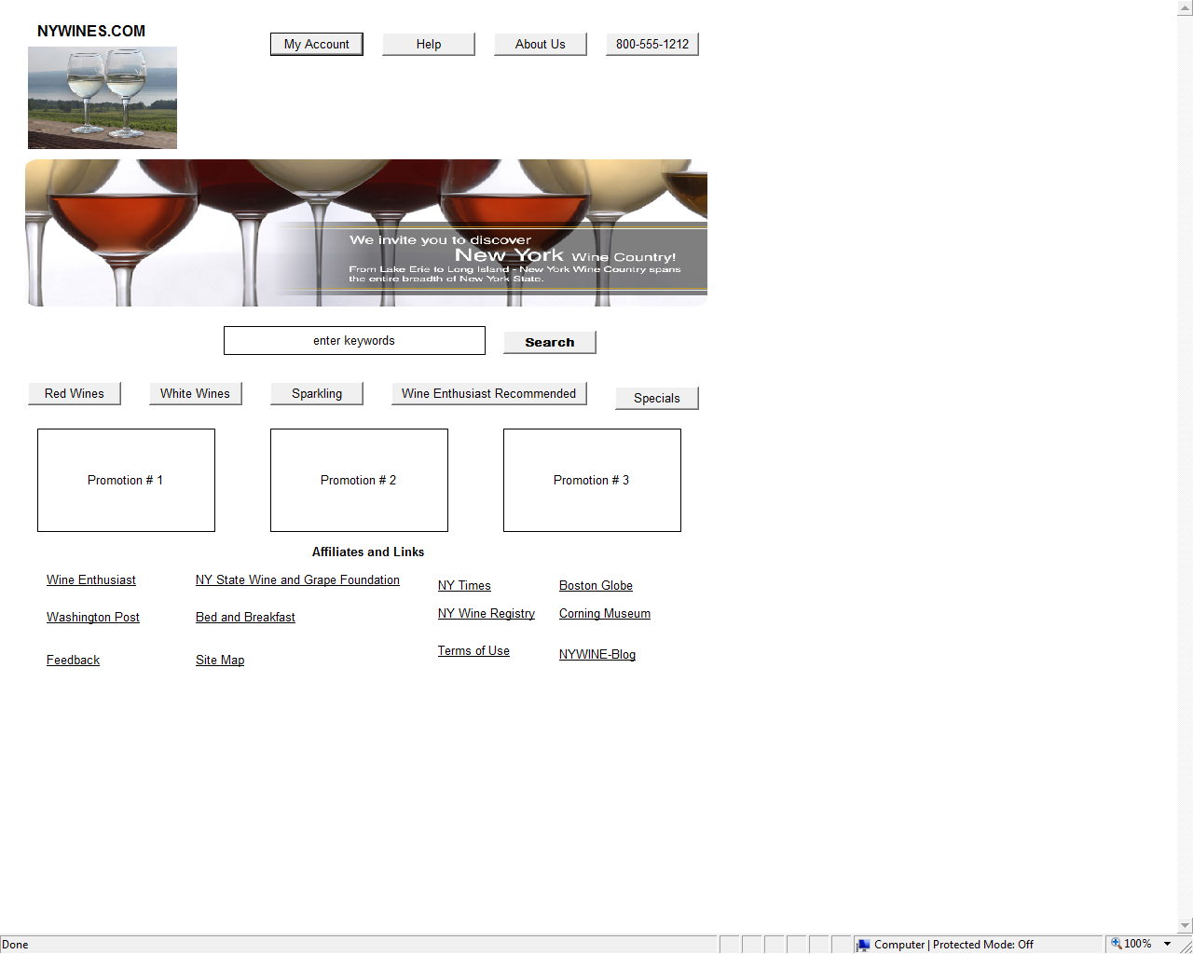

4) Search Results Page Layout: The below is a sample wireframe for Search Results Page. Primary functions of this page are to display search results based on Product Selection action from Home Page such as a keyword search. The page should allow a user to Refine Search or initiate a new search. Another feature on this page is to enable user to view their shopping cart. Promotions and Specials will also be displayed on this page and will be in the context of the Search parameters. As always, Global Navigation Links will be available in the upper right corner.
