PLEASE CLICK HERE TO BEGIN YOUR CREST APPLICATION
- The first step of this application is to complete a Notification of Intent by clicking on the hyperlink above.
  - By completing the steps of this Notification of Intent you will verify your demographic information and submit an intent to apply for this program.
  - If you have never used WebCAMP before, you will be prompted to choose a password within this request to apply.
  - At the end of this request to apply you can click ‘here to Log In’ on the final page to log in and begin your application.
    - You can also simply use the URL below at any time to take you to the WebCAMP homepage https://webcamp.bumc.bu.edu/webcamp
    - You should receive email notification of your intent to apply.

- Once you log into WebCAMP go to “Protocol Authoring and Review (ePAR)” to find your application.
  - Here all of your previous and current applications will be listed.
- Click on the Abbreviated Title or ‘View/Edit’ to open your application
- Application Status Page
  - This page shows you which sections are COMPLETE and INCOMPLETE in your application.
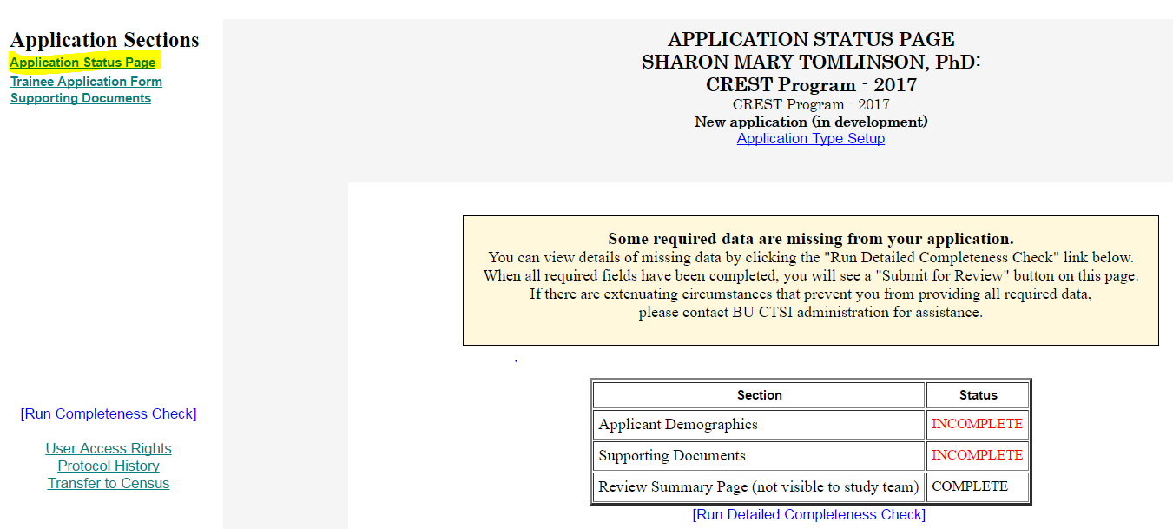
  - When you are finished your application, check back to this page to see if all the required information was filled out.
    - If any sections are INCOMPLETE, click the “[Run Detailed Completeness Check]” button to get a step-by-step Check of your application.
      - If anything still needs to be filled out, it will be highlighted in YELLOW.
      - The hyperlink will take you directly to the spot in the application in which you are missing information
- Trainee Application Form
  - Please fill out all information regarding your project.
- Supporting Documents
  - Please upload your CV, Degree Program Application, Essay Questions, and Letter(s) of Support here.
    - See “more info” button for pertinent information
- Go back to (4) Application Status Page to click the ‘Submit’ button or re-run your completeness check.
- To access WebCAMP at any point during your application process please use https://webcamp.bumc.bu.edu/webcamp.

