Accessing the student server folder in Windows 10
You must be connected to BU’s wifi (802.1x) or on the off-campus vpn (vpn.bu.edu).
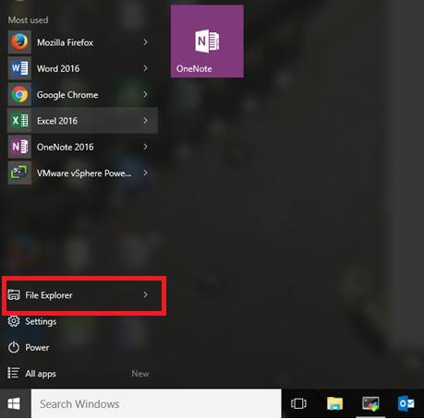
Click File Explorer
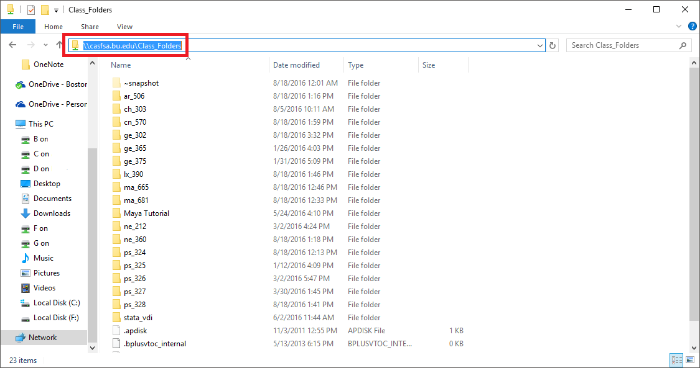
Enter in the path: \\casfsa.bu.edu\class_folders and press enter.
Double click the folder for your class. You may store your work under students – your username. This folder is also accessible from the computer labs in CAS 327 and 330.
If you do not have a folder, please stop by CAS 331 and request one at the front desk. We will ask for your course number and username.

