Lab 5: Searching for Extra-Solar Planets

Until 1991, astronomers only knew about planets orbiting our sun. Though other planetary systems were suspected to exist, none had been found. Now, thirteen years later, the search for planets around other stars, known as extra-solar planets or exoplanets, is one of the hot research areas in astronomy. As of May 2020, more than 4,000 exoplanets have been found in at least 2,800 planetary systems. So far, most of these planets are Jupiter-sized and larger, but as observational search methods improve, astronomers are finding planets of smaller sizes. With the launch of Kepler in 2009 and TESS in 2018, astronomers have been searching for Earth-like planets, a quest that will continue with several more satellite telescopes within the next ten years. While many planets somewhat like the Earth have been found, no perfect Earth analogues have been discovered to date.

Part I: The Radial Velocity, or Doppler Wobble Method

Currently about 20% of the known extra-solar planet candidates have been discovered through the radial velocity, or Doppler wobble method, although this number was a lot higher before Kepler and TESS. In this method, a planet (of relatively low mass) tugs on its heavier parent star as the two bodies orbit around their common center of mass. The tiny shifts in the star’s motion can’t be observed directly, but instead they are revealed in the star’s spectrum through the Doppler effect.
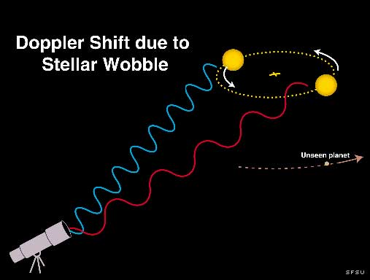
Caption: A star and planet system showing how the star orbits around the center of mass of the system, causing its light to be shifted due to the Doppler effect (the star’s orbit is greatly exaggerated here).

1. With a sketch, show how two of the Balmer absorption lines, at 656 nm and 486 nm, would appear if four equally spaced observations were made in one complete cycle of the star’s motion. (Be sure to show the direction of the observer in your sketch.)

2. By measuring wavelength shifts in the star’s spectrum, astronomers can determine the orbital parameters of the star and planet system, and estimate the mass of the planet. Note that precision spectroscopy is necessary. If observed from outside the solar system, the planet Jupiter would cause a shift in the sun’s spectrum of about 12 m/s. This is not much above the best errors in the method, which are now down to about 3-5 m/s.

The star and the planet are each orbiting around the center of mass of the star+planet system. Suppose you observe the star regularly over the course of a few years, which turns out to be long enough for at least one planet orbit. How do you expect the velocities of the star to change? That is, if you plot velocity vs. date, what do you expect to see if a planet is perturbing its star? Draw a sketch of what you expect over one orbital period.

3. Once we’ve collected data for 51 Pegasus from the telescope, compiled in Table 1 below, the first thing to do is look at it by plotting the date on the x-axis and the velocities on the y-axis.
Table 1: Data for 51 Peg
Date (JD-2450000) Velocity (m/s) Uncertainty (m/s) Phased Date
21.62 56.4 4.5 1.62
21.71 66.8 6.4 1.72
23.60 -35.1 5.1
24.64 -33.5 2.6 0.44
24.82 -22.7 3.7
27.65 -22.7 4.3
28.61 -44.1 4.7 0.21
28.66 -33.6 4.8 0.26
29.61 25.1 4.3
29.75 41.1 4.3
30.60 61.3 5.6 2.25
31.66 -2.5 5.0
31.71 0.8 5.7 3.31
31.75 -4.6 5.9
32.69 -38.8 4.7
33.61 2.7 4.4 1.01

To save time, we have done this for you: 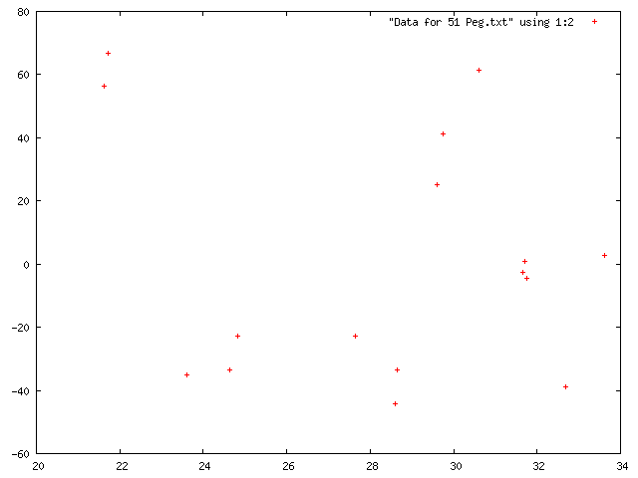

4. Describe this graph. Is it different from your expectations? Why? Can you conclude that there is or isn’t a planet present? Can you put any upper or lower limits on the orbital period of a possible planet?

5. Astronomers use an iterative method to estimate the period of the planet that best fits all the data. The method involves folding the data over itself, or wrapping it, so that the complete data set represents one orbital cycle. For 51 Peg, the estimated period is 4.2 days. Fill in the Phased Date column in Table 1 in the following way. We want all the Phased Date values to be between 0.0 and 4.2. Suppose our data starts at day 20. Subtract 20 from the first few dates and enter them in the Phased Date column. Continue down the column with the following adjustment: if any Phased Date is greater than 4.2, subtract an additional 4.2 from that date. So, after a while, you’ll be subtracting 24.2, then 28.4. We have filled in several phased dates already for you to help provide a check.

a. Plot the Phased Date (x-axis) vs. the velocities (y-axis). You should be able to draw a sinusoidal curve through the result.

b. Compare the period of 51 Peg’s planet to the period of Mercury around the sun.

6. To estimate the mass of the planet, you need to know its period, semi-major axis and its velocity around the star, together with the radial velocity of the star. We will calculate these step by step below.

It turns out that 51 Peg is about the same mass as the sun so to measure the semi-major axis, we can use Kepler’s 3rd Law (without Newton’s modification). If the period is measured in years, then we obtain the semi-major axis in A.U. from P² = a³.

a. Calculate the semi-major axis, a, of the planet around 51 Peg.

We can obtain the circular velocity of the planet, v_{planet}, with its distance from the star and its period: v_{planet}=distance/time = 2πa/P.

b. Calculate the velocity of the planet, v_{planet}, in m/s.

Because this is a simple center of mass problem, the masses of the star and planet are inversely proportional to their circular velocities:
M_{planet}/M_{star}=v_{star}/v_{planet}

The circular velocity of 51 Peg can be found from your second graph as half of the difference between the maximum and minimum velocities.

c. Determine the velocity of 51 Peg, v_{star}, from your graph. Use this to calculate the mass of the planet, M_{planet}

d.For scale, convert your mass to Jupiter masses (M_{J}=1.90x10²⁷ kg) and to Earth masses (M_{E}=5.97x10²⁴ kg)

7. Where does your planet fall on a plot that shows potentially habitable planets? 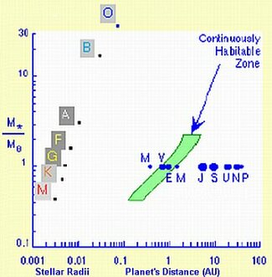
Caption: The mass of the star in solar masses is plotted against the distance the exoplanet is from the star. Note that the radii of stars of different spectral types are also indicated by the corresponding letters (O, B, A, F, G, K, M). These letters show the location of the zero subdivision of each spectral type, thus F5, for example, is between F0 and G0 (and not between A0 and F0). The approximate size and position of the planets of our solar system are shown along the horizontal line corresponding to a star with one solar mass (the Sun) and are labeled by the first letter of their names. [Richard Bowman, David Koch, Kasting et al. (1993).

Note that both scales are logarithmic. For example, the vertical scale is read as 0.1, 0.2,
0.3, 0.4, 0.5, 0.6, 0.7. 0.8, 0.9, 1, 2, 3, 4, 5, 6, 7, 8, 9, 10, 20 and 30.

The habitable zone is defined by where one would expect to find liquid water in that solar system.
a. Does 51 Peg’s planet fall within the continuously habitable zone?

8. Repeat questions 3 to 7 for HD 10697, whose data is given in Table 2. Because of the spacing of the dates, your first graph will be sufficient (you won’t need to calculate and graph the phased dates in question 4). You can determine the period of the planet from the graph. HD 10697 is 10% more massive than the sun but you can ignore this complication.

Table 2: Data for HD10697 = 109 Psc
JD - 2450000
Velocity (m/s)
Uncertainty (m/s)
367 -63.0 2.8
461 -98.8 4.2
715 -125.1 3.0
716 -134.8 2.8
806 -62.2 4.5
837 -49.8 5.1
839 -51.0 4.6
983 20.6 2.6
1013 29.5 3.0
1014 31.5 2.7
1044 40.7 2.9
1051 44.8 2.7
1068 57.3 2.9
1070 55.5 2.8
1072 51.5 3.1
1075 59.0 2.6
1170 75.7 4.1
1342 24.9 3.1
1343 28.0 2.7
1368 5.0 3.1
1374 0.0 3.0
1410 -25.3 2.9
1412 -34.7 3.2
1438 -56.6 3.1
1439 -53.0 3.0
1440 -46.9 3.2
1487 -111.4 3.7
1488 -97.2 3.7

a. Compare this planet to that of 51 Peg. Note that you need to calculate the period and semi-major axis of the planet, as well as the velocities of the planet and star before you can determine the planet’s mass and make this comparison.

9. Use the minimum error of 3 m/s to calculate how small of a planet mass you could detect for stars like 51 Peg and HD 10697. Could you detect Earth-like planets for either star? (Hint: suppose the velocity of the star was 3 m/s, what mass of planet would you detect?)

10a. The planet around 51 Peg is thought to have a mass of 0.468 x M_{Jup} while the planet around HD10697 is thought to have a mass of 6.12 x M_{Jup}. Calculate the percent errors in your measured masses of each planet.
Note that percent error = ((your value – true value)/true value)*100.

10b. On two side-by-side scaled drawing with the orbits of the inner planets and Jupiter (circular orbits will suffice), show the orbits of these two planets.

Part II: The Transit Method
Exercise A
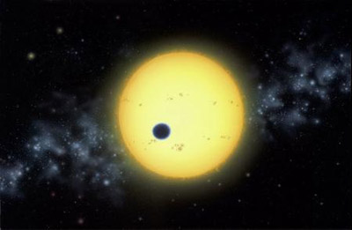
Caption: credit: Lynett Cook

The transit method is currently the most successful method of exoplanet detection, accounting for about 75% of discoveries.
In this method, a star is monitored in the hopes of catching a dip in its brightness as a planet moves across its face.

For this section, we will generate real data.

1. Sketch how the star’s light would appear before, during and after the transit (e.g. you can put Star Brightness on the y-axis and time on the x-axis).

2. Examine a transit in a darkened room. Measure the light intensity before the transit and during the transit. Use planets of two different sizes and estimate the size of each from your light intensity measurements using the equation below:
Fractional light drop = (exoplanet radius)²/(star radius)²

3. Measure the actual size of your exoplanet with a ruler. Compare your estimate of the planet’s size with the actual size by calculating the percent difference:
% difference = (observed size – true size)/true size * 100.

4. Comment on the agreement between your observed and measured values for your two planets.

Exercise B
For this section, we will use the simulated data below.
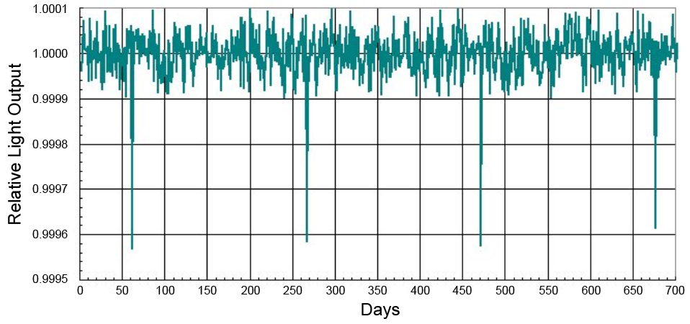
Caption: 700 days of observations of a star with spectral type K0.

1. Determine the period of the planet that appears to be orbiting this star.

2. Use Newton’s modification of Kepler’s third law, P²M_{star}=a³ (where the Period, P, is in years, the mass of the star, M_{star}, is in solar masses and the semi-major axis, a, is in A.U.) to estimate the semi-major axis of the planet’s orbit around its parent star. Note: you will need the mass of the star, from the appendix.

3. Does this planet fall within its parent star’s continuously habitable zone?

4. The size of an exoplanet in the transit method can be determined from the amount of light the planet blocks. The ratio of the light being blocked by the transit of the exoplanet to the total light usually reaching the telescope is equal to the ratio of the cross-sectional areas of the exoplanet and the parent star.

Since (area of a circle) = π radius², the fractional (or percentage) drop in light from the star as the exoplanet transits the star is simply equal to the ratio of the squares of the radii of the exoplanet and the star. (See the appendix for the star’s radius.)

Fractional light drop = (exoplanet radius)²/(star radius)²

From the simulated data, measure the fractional light drop and use it to estimate the size of the exoplanet in Earth radii.
Hint: Use the fact that 1 solar radius = 109 Earth radii, or simply convert all your sizes to meters and convert to Earth radii at the end.

5a. Even if a star has an orbiting planet, only in a very small percentage of cases will that planet make a transit across the disk of the star as seen from Earth’s perspective.

The probability of detecting an exoplanet with a circular orbit is given by the ratio of the star’s radius to the semimajor axis of the planet’s orbit:
probabililty (%) = (R_{star}/a)*100%

What is the probability of detecting this exoplanet?
Hint: Use the fact that 1 A.U. = 215 R_{sun}, or convert all your distances to meters.

5b. How can astronomers overcome the low probability of detecting planets using the transit method?

6. Discuss the strengths and weaknesses of the Doppler and transit methods for finding planets around other stars.
Appendix
I. Properties for stars on the main sequence of the H-R diagram.
Spectral Type | 05 | B0 | B5 | A0 | A5 | F0 | F5 | G0 | G5 | K0 | K5 | M0 | M5
Radius  (R_{sun}) | 17.8 | 7.59 | 3.98 | 2.63 | 1.78 | 1.35 | 1.20 | 1.05 | 0.93 | 0.85 | 0.74 | 0.63 | 0.32
Temperature  (K) | 35000 | 21000 | 13500 | 9700 | 8100 | 7200 | 6500 | 6000 | 5400 | 4700 | 4000 | 3300 | 2600
Stellar Mass  (M_{sun}) | 40 | 17 | 7.0 | 3.5 | 2.2 | 1.8 | 1.4 | 1.07 | 0.93 | 0.81 | 0.69 | 0.48 | 0.22
II. Data for our solar system
Planet | Semi-major axis, a (AU) | Period, P (year) | Average orbital velocity (km/s)
Mercury | 0.387 | 0.241 | 47.89
Venus | 0.723 | 0.615 | 35.03
Earth | 1.000 | 1.000 | 29.79
Mars | 1.524 | 1.881 | 24.13
Jupiter | 5.203 | 11.867 | 13.06
Saturn | 9.539 | 29.461 | 9.64
Uranus | 19.18 | 84.013 | 6.81
Neptune | 30.06 | 164.793 | 5.43
Pluto | 39.44 | 247.7 | 4.74
III. Miscellaneous Data
R_{sun} = 6.96 x 10⁸ m
R_{earth =} 6.378 x 10⁶ m
1 AU = 1.5 x 10¹¹ m
Bibliography
Richard L. Bowman and David Koch, Finding Exoplanets (A Simulation), http://www.bridgewater.edu/departments/physics/ISAW/ExoplanetMain.html
Guy Worthey, Discovery of Extra-Solar Planets, http://www.astro.lsa.umich.edu/Course/Labs/disc_extrasolar/Discovery-of-Extrasolar-Planets.pdf

