AN534: Advanced Topics in Human Behavioral Evolution

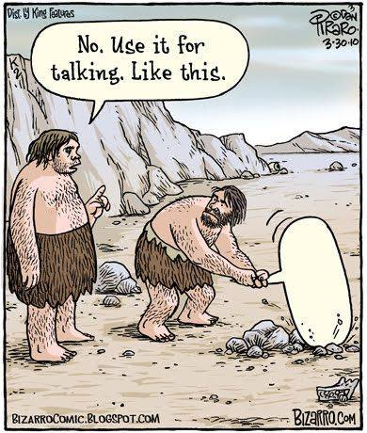

Mondays, 2:30-5:15pm.
Professor Carolyn Hodges-Simeon

Prereq: Consent of instructor. Topics in the behavioral evolution of Homo sapiens including social and sexual behavior, tool traditions, diet and hunting, language and intelligence, and locomotion. This course considers (inferred) behavioral transitions that characterized the origin of our genus and our species. NS 4 cr.

